**AUTOMATED TIMETABLE SCHEDULING SYSTEM USING BACKTRACKING ALGORITHM**

An Undergraduate Thesis

Submitted to the Faculty of the

Department of Computer Studies

Cavite State University-Cavite College of Arts and Trade Campus

Rosario, Cavite

In partial fulfillment

Of the requirements for the degree

Bachelor of Science in Computer Science

**HERNANDO JR. J. COSTELO**

**MICHELLE EMMANUEL S. GAETOS**

**JOHNUEL M. JAVIER**

**REN RUSSEL E. LAVILLA**

**LESTER D. QUIJANO**

June 2023

# APPROVAL SHEET

# BIOGRAPHICAL DATA

Hernando Jr. J. Costelo, the youngest among three siblings, was born on November 17, 1999, in Tejeros Convention, Rosario, Cavite. He demonstrated exceptional dedication and industriousness during his elementary years, earning recognition as the most hardworking student in his batch.

Throughout junior high school, he held various student officer positions at Tanza National Comprehensive High School. Continuing his education, he chose the TVL-ICT strand for senior high school, aligning with his interest in computer-related fields. This led him to pursue a Bachelor of Science degree in Computer Science at Cavite State University CCAT Campus.

Michelle Emmanuel S. Gaetos is the eldest son of Miss. Beverly Anne S. Gaetos, he was born on December 07, 1999 in Makati City. He has 1 sibling named Mican Paulo Martin S. Gaetos they are now residing in Tanza, Cavite.

He finished his primary education in Makati Elementary School last 2012, and secondary in General Pio Del Pilar National Highschool in 2016 and Finished Senior High School in 2018 in Saint Paul College of Makati.

In his Tertiary Education he pursued Bachelor of Science in Computer Science in a University Called Cavite State University CCAT Campus last 2018.

Johnuel Javier, born on August 11, 1998, in Sariaya, Quezon, is the eldest among the three children of Mr. Wilfredo Javier and Mrs. Carmen Javier. His siblings are named Micah Mhariey Javier and John Wheslie Javier. He currently resides in Tejeros Convention, Rosario, Cavite.

He completed his elementary education at Concepcion Pinagbakuran Elementary School in 2011. For his secondary education, he attended Lutucan National High School in Sariaya, Quezon, where he completed both high school and senior high school in 2018.

In the same year, he enrolled at Cavite State University CCAT Campus to pursue a Bachelor of Science degree in Computer Science.

Ren Russel E. Lavilla, the youngest child of Renato G. Lavilla and Consorcia E. Lavilla, was born on June 13, 2000, in Tingloy, Batangas. He has two siblings, Ren Rochelle E. Lavilla and Ren Rannie E. Lavilla, and they reside in Grand Riverside Subdivision, City of General Trias, Cavite.

He completed his primary education at General Artemio Ricater Memorial School (GARMS) in 2012, followed by his secondary education at Governor Ferrer Memorial National High School, graduating in 2016. He then finished his Senior High School education in 2018 at Luis Y. Ferrer Junior Senior High School.

Continuing his academic journey, he enrolled in the Bachelor of Science in Computer Science program at Cavite State University CCAT Campus for his tertiary education.

Lester D. Quijano, born on April 13, 2000, in Amaya, Tanza, Cavite, is the youngest child of Pedro Jr. L. Quijano and Merly D. Quijano. His siblings are Edmer D. Quijano and Kris Mae D. Quijano, and they reside in Bijia, Calibuyo, Tanza, Cavite.

He completed his primary education at Flaviana F. Arayata Elementary School (FFAES) in 2012 and his secondary education at Amaya School of Home Industries (ASHI) in 2016. In 2018, he successfully finished his Senior High School education at Amaya School of Home Industries (ASHI).

For his tertiary education, he chose to pursue a Bachelor of Science degree in Computer Science at Cavite State University CCAT Campus.

# ACKNOWLEDGEMENT

First of all, we would like to praise and thank almighty God for guiding us every time and giving us strength, hope and knowledge to finish this research.

We express our sincere gratitude to the following individuals for their unwavering support, guidance, and assistance throughout our journey:

We would like to express our gratitude to Dr. Lauro B. Pascua, our campus administrator. His dedication and leadership have greatly contributed to the success of our campus community.

We extend our sincere gratitude to Dr. Ariel G. Santos, our director of instruction. His guidance and expertise have played a crucial role in shaping our educational journey.

We would like to acknowledge our Depart Chairperson Mr. Aries E. Gelera for his contributions and support throughout our journey. His involvement and assistance have been greatly appreciated.

We also extend our heartfelt thanks to Mr. Karlo Jose E. Nabablit for his motivation and unwavering support. During challenging times, his encouragement and belief in us have been a source of hope and inspiration. We are grateful for his positive influence.

We would like to express our sincere gratitude to Mr. Raven M. Topacio for his invaluable assistance in completing our system. His expertise, guidance, and support have been instrumental in overcoming challenges and achieving our goals. We deeply appreciate his contributions.

Our Family and friends for supporting us financially and emotionally.

We would like to extend our heartfelt gratitude to the faculty members of CVSU CCAT Campus, particularly from the Department of Computer Science (DCS). Their expertise, guidance, and support have been instrumental in our journey, and we deeply appreciate their contributions.

We extend our heartfelt appreciation to all the students and IT experts who participated in the evaluation process and provided us with their honest assessments of our system. Your valuable feedback has been instrumental in shaping the development and improvement of our system. Thank you for your time, insights, and contributions.

**HERNANDO JR. J. COSTELO**

**MICHELLE EMMANUEL S. GAETOS**

**JOHNUEL M. JAVIER**

**REN RUSSEL E. LAVILLA**

**LESTER D. QUIJANO**

# ABSTRACT

**COSTELO, HERNANDO JR J., GAETOS, MICHELLE EMMANUEL S., JAVIER, JOHNUEL M., LAVILLA, REN RUSSEL E., QUIJANO, LESTER Automated Timetable Scheduling System using Backtracking Algorithm** Undergraduate Thesis. Department of Computer Studies Cavite State University-Cavite College of Arts and Trades Campus, Rosario, Cavite. June 2023. Adviser: Mr. Karlo Jose E. Nabablit

The research entitled "Automated Timetable Scheduling System using Backtracking Algorithm" was conducted from May 2022 to May 2023. The objectives of the study were as follows: 1) document and analyze the existing process of scheduling classes, 2) design and develop a web application that automate the generation of class schedules. 3) test the reliability of generated schedules based on testing conditions and the functionality of system modules. b) Evaluate the system using modified ISO-IEC 25010.

ATS System showcased its effectiveness and high satisfaction among IT Experts and end users. The system successfully achieved its objectives of automating class schedule generation and enhancing the scheduling process in educational institutions. It demonstrated reliability, functionality, and compliance with ISO-IEC 25010 standards. The positive evaluations from both experts and users highlight its value and efficiency.

By offering an efficient and user-friendly solution, the system improves productivity, streamlines scheduling processes, and enhances overall satisfaction in educational institutions. Its successful evaluation establishes it as a dependable tool for optimizing class scheduling and supporting institutions in effectively achieving their scheduling goals.

# TABLE OF CONTENTS

APPROVAL SHEET ii

BIOGRAPHICAL DATA iii

ACKNOWLEDGEMENT viii

ABSTRACT x

TABLE OF CONTENTS xi

LIST OF FIGURES xiii

LIST OF TABLES xv

LIST OF APPENDIX FIGURES xvi

LIST OF APPENDIX TABLE xvii

LIST OF OTHER APPENDICES xviii

AUTOMATED TIMETABLE SCHEDULING SYSTEM USING BACKTRACKING ALGORITHM 19

INTRODUCTION 19

Objective of the Study 20

Significance of the Study 21

Scope and Limitation of the Study 21

Time and Place of the Study 22

REVIEW OF RELATED LITERATURE 23

METHODOLOGY 33

Conceptual Framework 33

System Analysis and Design 37

Principles of Operation 43

Testing and Evaluation 44

Data Analysis…………… 48

RESULTS AND DISCUSSION 50

Web-Based System Design 50

Testing Results……………………………………………………………..62

Evaluation Results………………………….. 64

SUMMARY, CONCLUSIONS AND RECOMMENDATION 71

Summary…………………………………………………………………….71

Conclusion……………………… 71

Recommendation…………………….. 72

REFERENCES 73

APPENDICES 75

OTHER APPENDICES 100

# LIST OF FIGURES

Figures Pages

Figure 1. adjacent Placement of ‘c’ in “abc” Arrangement. 25

Figure 2. Automated College Timetable Generator 27

Figure 3. BSIU Automated Scheduling System 28

Figure 4. Web based Course Scheduling System 29

Figure 5. Androit Scheduler 30

Figure 6. Timetable Generator 31

Figure 7. Table of Comparison 32

Figure 8. Conceptual Framework 34

Figure 9. Research Framework 37

Figure 10. Backtracking Algorithm Implementation Flowchart 42

Figure 11. Test Case Form 44

Figure 12. Register Page………. 50

Figure 13. Log in Page…… 51

Figure 14. Admin Dashboard 51

Figure 15. Semester List………. 52

Figure 16. Adding Semester Page 52

Figure 17. Day List……… 52

Figure 18. Adding Day Page 53

Figure 19. Teacher List……….. 53

Figure 20. Adding Teacher Page 54

Figure 21. Course List….. .. 54

Figure 22. Adding Course Page 54

Figure 23. Section List……… 55

Figure 24. Adding Section Page 55

Figure 25. Subject List…… 56

Figure 26. Adding Subject Page 56

Figure 27. Room List…… 56

Figure 28. Adding Room Page 57

Figure 29. Faculty Loading List 57

Figure 30. Adding Faculty Loading Page 58

Figure 31. Automated Timetable Page 58

Figure 32. Automated Timetable Page with Generated Schedule 59

Figure 33. Adding of Manual Schedule 59

Figure 34. Generated Room Schedules 60

Figure 35. PDF Schedule for Room 60

Figure 36. Generated Teachers Schedule 61

Figure 37. PDF Teachers Schedule 61

Figure 38. Generated Course Schedule 62

Figure 39. PDF Schedule for Course 62

# LIST OF TABLES

Tables Pages

1 Testing Conditions 46

2 Compilation of functions requiring testing 46

3 Descriptive Interpretation of total score 49

4 Summary of Testing Results for Reliability 63

5 Summary of Testing Results for Functionality 64

6 Perception of IT Experts in the 65

functional suitability of the system

7 Perception of IT Experts in the Performance 65

Efficiency of the system

8 Perception of IT Experts in the Usability of the system 66

9 Perception of IT Experts in the Security of the system 66

10 Perception of IT Experts in the Maintainability of the system 66

11 Perception of IT Experts in the Portability of the system 67

12 Summary of Evaluation Results for IT Experts 67

13 Perception of End-users in the Usability of the system 68

14 Perception of End-users in the Effectiveness of the system 68

15 Perception of End-users in the Efficiency of the system 69

16 Perception of End-users in the Satisfaction of the system 69

17 Perception of End-users in the Context Coverage of the system 70

18 Summary of Evaluation results for End-user 70

# LIST OF APPENDIX FIGURES

**Appendix**  **Pages**

**Figure**

1 Email with attached checklist 76

2 Subject Offerings (BSCS) 77

3 Subject Offerings (BSCS) 2 78

4 Subject Offerings (BSInfoTech) 79

5 Subject Offerings (BSInfoTech) 2 80

6 Login Flowchart 81

7 Faculty loading Flowchart 82

8 Automated Scheduling Flowchart 83

9 Automated Scheduling Flowchart Pt.2 84

10. Automated Scheduling Flowchart Pt.3 85

11 Automated Scheduling Flowchart Pt.4 86

12 Use Case Diagram 87

13 ATS Entity Relationship Diagram 89

14 Faculty Loading Test Data pt.1 90

15 Faculty Loading Test Data pt.2 91

16 Faculty Loading Test Data pt.3 92

17 Generated Schedule for Teacher 93

18 Generated Schedule for Course 94

19 Generated Schedule for Rooms 95

# LIST OF APPENDIX TABLE

s

**Appendix Pages**

**Table**

1 Gantt Chart….. 96

2 Test Table for Reliability 97

3 Test Case for Login Module 98

4 Test Case for Faculty Loading 99

# LIST OF OTHER APPENDICES

**Appendix** **Pages**

APPENDIX A Routing Slip 102

APPENDIX B Letter of Request for English Critic 103

APPENDIX C Lettter of Request for oral outline review 104

APPENDIX D Letter of Request for final defense 105

APPENDIX E Letter of Request for Adviser and Technical Critic 106

APPENDIX F Evaluation form for End-Users 107

APPENDIX G Sample accomplished evaluation tool for end-users 109

APPENDIX H Evaluation form for Web-Developers 112

APPENDIX I Sample accomplished evaluation tool for it-experts 118

APPENDIX J User’s Manual 127

APPENDIX K Source Code 136

APPENDIX L Curiculum Vitae 247

# AUTOMATED TIMETABLE SCHEDULING SYSTEM USING BACKTRACKING ALGORITHM

**Hernando Jr. J. Costelo**

**Michelle Emmanuel S. Gaetos**

**Johnuel M. Javier**

**Ren Russel E. Lavilla**

**Lester D. Quijano**

An undergraduate thesis presented to the faculty of the Department of Computer Studies Cavite State University-Cavite College of Arts and Trades Campus, Rosario, Cavite in partial fulfilment of the requirements for the degree of Bachelor of Science in Computer Science with Contribution No.______________. Prepared under the supervision of Mr. Karlo Jose E. Nabablit.

CS-2023-02-010

# INTRODUCTION

Despite ongoing advancements in technology that have led to the computerization and automation of various aspects of university organization work, the process of creating course timetables still remains a manual and challenging task. The preparation of course timetables had a significant time constraint for academic colleges. It involves addressing multiple constraints and issues, such as classroom availability, teachers' subject preferences, the number of available teachers and classroom capacities, potential conflicts between rooms and courses, and scheduling conflicts between courses and instructors. Generally, course timetabling in many universities is prepared manually and the scheduling committee should consider all available facilities and resources, such as courses, instructors, rooms and laboratories. Moreover, the instructors, course and sections time were important constraints to handle. Therefore, based on all the mentioned constraints, course timetabling is a very exhaustive and time-consuming task. (Al-Jarrah et al, 2017)

Cavite State University CCAT Campus had offered nine courses, including BS Electrical Engineering, BS Computer Engineering, BS Computer Science, BS Information Technology, BS Hotel Management, BS Business Managements, BS Technical-Vocational Teacher Education, BS Education with two different Majors, and BS Industrial Technology with nine different Majors. As the campus continued to grow, the number of students increased, making the manual creation of course timetables a complex task to accomplish. In CVSU CCAT, the creation of class schedules was manually done by the faculty head or scheduling committee of each department. The manual scheduling process consumes more time as the plotting, revising, and arranging of schedules were done separately for each department. Each course had minor and major subjects, and the scheduling committee of each department had to wait for the major subjects to be plotted in the timetable before plotting the minor subjects.

Furthermore, the developers came up with an idea and proposed the development of a web-based Automated Timetable Scheduling System to reduce the difficult work of the faculty head or scheduling committee in creating schedules and to save time in the scheduling process. The web application aimed to generate an optimal class schedule for Cavite State CCAT-Campus within a short period of time.

## Objective of the Study

The main objective of the study was to create a dynamic web-based scheduling system capable of generating conflict-free class schedules.

Specifically, the study aimed to:

1. document and analyze the existing process of scheduling classes in Cavite State University – CCAT;
2. design and develop a web application that automate the generation of class schedules;
3. test the reliability of generated schedules based on testing conditions and the functionality of system modules.
4. evaluate the system using modified ISO-IEC 25101 software evaluation instrument;

## Significance of the Study

By utilizing a backtracking algorithm, the developed system significantly improves the efficiency of generating conflict-free class schedules. This implementation could effectively reduce the time required and minimizes the occurrence of human errors during the scheduling process. As a result, Cavite State University CCAT-Campus would be able to attain an optimal class schedule. Furthermore, the system may prove beneficial for the scheduling committee as it simplifies tasks such as adding, deleting, and updating critical information for the faculty loading process.

## Scope and Limitation of the Study

The study was focused on the development of web-based Automated Scheduling System for Cavite State University - CCAT Campus. The system was designed with features that allowed users to automate the generation of class schedules using a backtracking algorithm.

Web-Based System was designed for the scheduling committee as the primary target user. The system is specifically intended to generate automated schedules for the Department of Computer Science.

Web-Based System provides separate view pages for teachers, course year, sections, and rooms in the generated schedules.

Web-Based System generates schedules for full-time teachers and regular students. The output can be generated in PDF format for printing.

Web-Based System does not support multiple users; it was not designed to accommodate simultaneous access from multiple individuals.

The generated schedules cannot be updated directly due to the potential conflicts that may arise. Any changes to the faculty loading data require regenerating the schedule to ensure an optimal and conflict-free timetable.

Web-Based System does not consider irregular students and course schedules, limiting its applicability to regular students and full-time teachers only.

## Time and Place of the Study

The study was conducted from May 2022 to May 2023 at the Cavite State University-CCAT Campus.

# REVIEW OF RELATED LITERATURE

In this chapter the developers review studies, articles, software, case studies related to the development of the Automated Scheduling System. It also shows the relevant system, its features and method prior to the development of the automated scheduling system.

**Related Literature**

The developers extensively review various studies, articles, software, and case studies that are relevant to the development of the Automated Scheduling System. Their objective is to gain valuable insights and knowledge from these sources to inform and advance the development process of the Automated Scheduling System.

**Importance of using web application**

Web based application offers a wide variety of advantages compared to desktop application. Instead of installing the application or software to each of every computer your company or school has, it could be easily accessed through the use of internet. Maintaining a web application is a simple process since the host server could easily add or update data without the need to upgrade in every computer. (Khamooshi, 2019)

According to Souvik (2022), web application increase efficiency and reduce costs by automating the processes and task and reduce costs by allowing the user to add and update data through online, thus, it eliminates paper based manual data entry.

**Course Timetabling**

Course timetabling main objective is to assign a course to a specific time or set of time without conflicts to another course allotted time. It is also one of the university timetabling problems, it is resolved by meeting the specific constraints. This constraint is divided into two parts, the former is the hard constraints, and the latter is the soft constraints. (Burke and Petrovic, 2002). Hard constraints are the problems that must be satisfied solved to generate a great timetable while soft constraints are the desirable problems but not essential to be solve. (Houhandi et. al, 2019). According to Ben Moreland (2015), these are the examples of hard and soft constraints. For hard constraints, Room capacity which means the number of students assigned to the room must best equal to the seating capacity of the room. For soft constraints, A preferred teaching week which means the teacher could choose when to teach the subject to specific time and day.

**Introduction to Backtracking Algorithm**

Backtracking is an algorithmic technique that solves problems through a recursive approach. It involves constructing a solution incrementally, discarding any choices that violate the problem's constraints at each step. It can be considered as an improvement over the brute force method. The fundamental concept behind backtracking is to systematically search for a solution among the available options. Initially, we begin with one possible option and check if the problem can be solved using that choice. If a solution is found, it is returned. Otherwise, we backtrack and explore another option from the remaining choices. In some cases, none of the options may lead to a solution, indicating that backtracking cannot provide a solution for that specific problem. Backtracking can be viewed as a form of recursion, as the process of searching for a solution from the available options is repeated recursively until a solution is found or the final state is reached. In essence, backtracking eliminates choices at each step that cannot lead to a solution, continuing towards choices that have the potential to lead to the desired solution. There are three types of problem in backtracking decision, optimization and enumeration ([Upadhyay](https://www.simplilearn.com/tutorials/data-structure-tutorial/backtracking-algorithm), 2023)

**Backtracking: Non-Adjacent 'c' Placement in 'abc' Arrangement**

In backtracking, the initial step involves constructing a state-space tree. Subsequently, we explore all potential solutions and verify them against the provided constraint. Only the solutions that meet the given constraint are retained

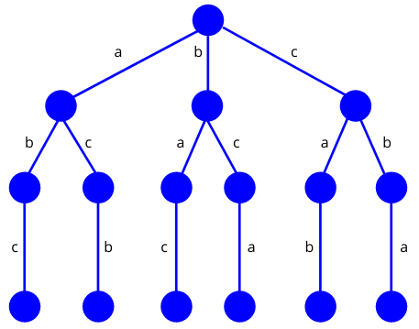

*Source https://www.baeldung.com/cs/backtracking-algorithmsGenerator*

Figure . adjacent Placement of ‘c’ in “abc” Arrangement.

In backtracking, the initial step involves constructing a state-space tree. Subsequently, we explore all potential solutions and verify them against the provided constraint. We retain only the solutions that meet the given constraint: For instance, considering the problem at hand, the possible solutions are: (a,b,c), (a,c,b), (b,a,c), (b,c,a), (c,a,b), (c,b,a). However, only the valid solutions that satisfy the constraint are included in the final solution set. In this case, the final solutions would be limited to (a,b,c) and (c,b,a) (Datta 2022)

**When to use backtracking algorithm?**

Backtracking finds applications in diverse problem-solving scenarios. For instance, it can be utilized to discover a viable solution for a decision problem. Additionally, backtracking algorithms have proven to be highly effective in solving optimization problems. In certain cases, it can be employed to identify all feasible solutions for an enumeration problem. However, it's important to note that backtracking is not considered an optimal problem-solving technique. Its utility lies in situations where time constraints are not imposed on finding a solution. ([Upadhyay](https://www.simplilearn.com/tutorials/data-structure-tutorial/backtracking-algorithm), 2023)

**Recursive Backtracking and Optimization**

Recursive backtracking is a technique used to solve challenging problems by exploring all possible solutions. According to Stanford University (2017) Backtracking algorithm can be applied to generate and count solutions, find specific solutions, or determine the best solution. Specific problems that can be tackled include generating permutations, subsets, combinations, and more. Backtracking can be effectively employed in three main scenarios:

1. Enumeration: Backtracking can generate and count all possible solutions to a problem. This involves systematically exploring different paths and choices to exhaustively generate all valid solutions
2. Existence and search: Backtracking can be used to find a specific solution to a problem or prove its existence. By systematically exploring different paths and choices, it can determine if a valid solution exists and locate it.
3. Optimization: Backtracking can assist in finding the best possible solution to a given problem. It explores different paths and evaluates their quality, making informed decisions to optimize the solution based on defined criteria.

**Related System**

This chapter entails a comprehensive examination by the developers of the related system, aiming to enhance their understanding of the automated scheduling system's development. Their primary focus is on the distinct features of the system and the methodology that was utilized before its creation.

**Automated College Timetable Generator**

This related system is a web-based automated college timetable generator, employing a genetic algorithm to automate the creation of college timetables. This dynamic system empowers users to conveniently update data, such as adding courses, teachers, and rooms, while effortlessly generating timetables.

The related web application serves as an invaluable reference for the developers, offering valuable insights into the system's process flow, including the utilization of CRUD functionality during the automation of the class schedule.

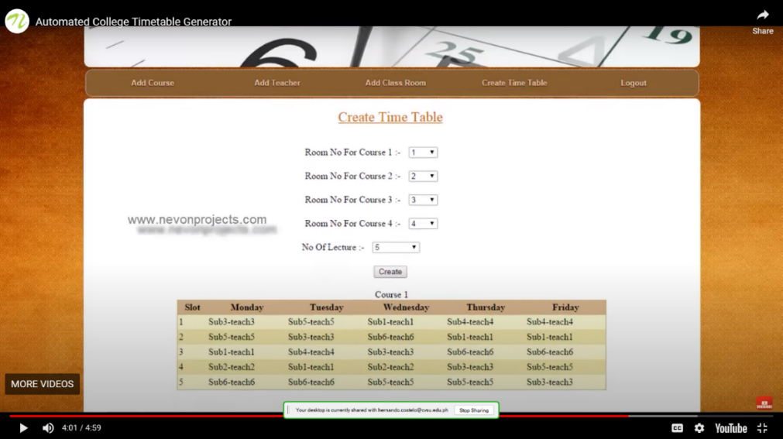

*Source: https: Automated College Timetable Generator*

Figure . Automated College Timetable Generator

**Bohol State Island University Automated Scheduling System Capstone Project**

This study designed an automated class scheduling system for Bohol State Island University and test its functionality in terms of speed, accuracy, data handling, security, stability, and adaptability in making class schedules. This system is a dynamic system because the admin /user could update the data in the database like add teachers, add buildings, add course and adding new user.

The developers regarded the related system as a valuable resource, enabling them to acquire valuable insights into testing methodologies for the automated scheduling system. This facilitated their understanding of effective approaches to assess the functionality, performance, and reliability of their own automated scheduling system. Additionally, it provided them with valuable insights on how to enhance the functionality for generated schedules through updates and improvements.

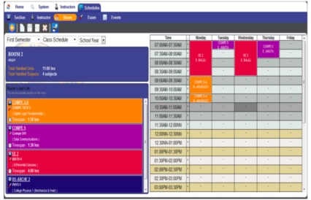

*Source: https: Automated Scheduling System Capstone Project*

Figure . BSIU Automated Scheduling System

**Web based Course Scheduling System using Greedy Algorithm**

In this study, a web-based system is introduced, specifically tailored for course scheduling in the College of Computer Studies at FEU Institute of Technology in Manila, Philippines. This system successfully handles course schedules and faculty assignments by utilizing a greedy algorithm.

By leveraging insights from the related system, the developers are able to enhance their own management functionality concerning the data utilized for automating class schedules. These valuable insights enabled them to identify areas for improvement and optimize their own system accordingly.

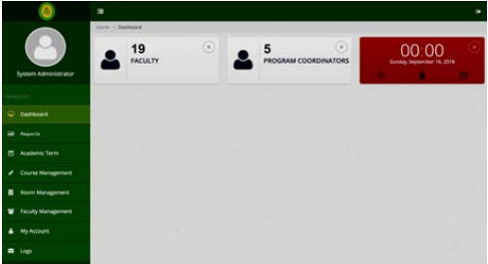

*Source: https://ijssst.info/Vol-20/No-S2/paper14.pdf*

Figure . Web based Course Scheduling System

**Intelligent Timetable Generator using Genetic Algorithm**

The related web application incorporates a genetic algorithm to generate university timetables, taking into account both hard and soft constraints. The primary objective of the project's development is to successfully address and integrate these constraints.

The developers relied on this related system to acquire valuable insights into solving the challenges posed by soft and hard constraints. Through studying and analyzing the related system, they aim to enhance their understanding and approach to effectively manage these constraints within their own system.

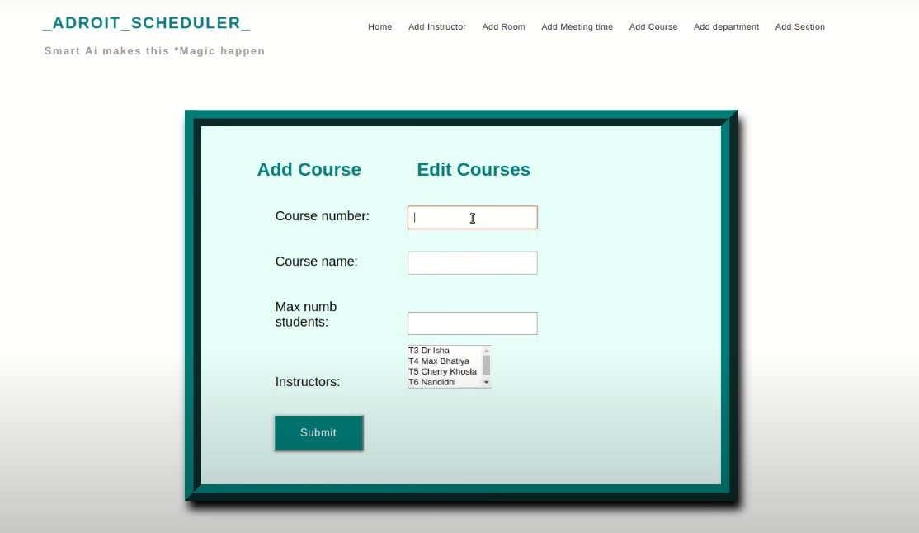

*Source: http://abhik.pythonanywhere.com*

Figure . Androit Scheduler

**Timetable Generator using Genetic algorithm.**

The Timetable Generator, a related system, utilizes a genetic algorithm to automate the generation of university timetables. The developers of this web application have opted for PHP as their programming language and have utilized the Laravel web framework.

The developers considered the related system as a valuable reference for their own system development, specifically in the context of using PHP. By thoroughly studying and analyzing the related system, they enhance their understanding and expertise in leveraging PHP to construct and enhance their web application for automated timetable generation.

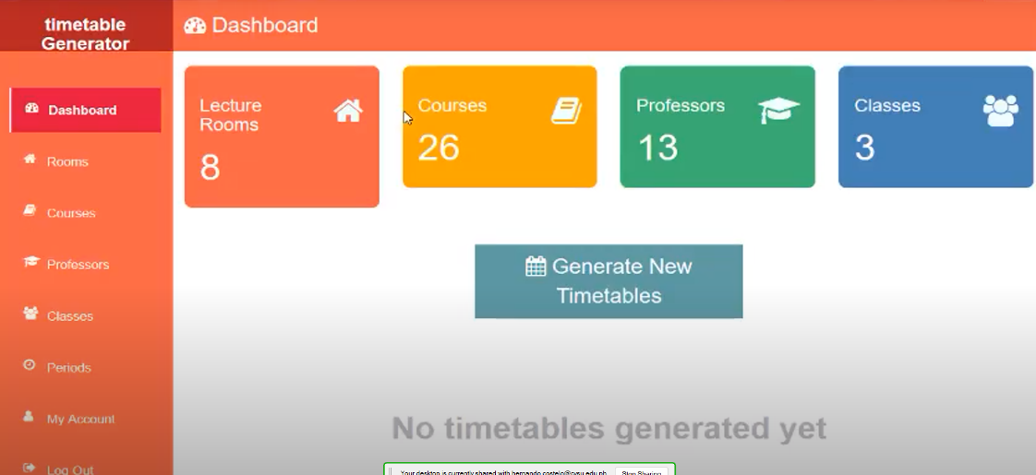

*Source: https://Timetable Generator*

Figure . Timetable Generator

**Synthesis and Justification**

The review of related literature proved to be an invaluable resource for the developers, offering valuable insights into the backtracking algorithm and genetic algorithm. By thoroughly examining existing literature on these topics, the developers gained a comprehensive understanding of the various stages and processes involved in both algorithms. This understanding played a crucial role in their decision-making process, as they needed to select the most suitable method for system development.

Furthermore, the review of related literature played a vital role in identifying the constraints associated with the existing scheduling process at Cavite State University CCAT Campus. This knowledge was pivotal for the developers, as it allowed them to effectively design the process flow of the system. By recognizing the limitations and challenges present in the current scheduling process, the developers were able to devise a more efficient and streamlined solution.

In summary, the insights derived from the review of related literature provided the developers with a solid foundation of knowledge. It equipped them with the necessary understanding of backtracking and genetic algorithms, aiding them in the selection of the most appropriate approach for system development. Additionally, it allowed the developers to identify and address the constraints of the existing scheduling process, ultimately contributing to the effective design of the system's process flow.

**Table of Comparison**

The researcher compared the features of proposed system to the other related system as shown below:

|  |  |  |  |  |  |  |
| --- | --- | --- | --- | --- | --- | --- |
| **Features** | **Automated College Timetable Generator** | **Bohol State Island University Automated Scheduling System** | **Web based Course Scheduling System using Greedy Algorithm** | **Intelligent Timetable Generator using Genetic Algorithm** | **Timetable Generator using Genetic algorithm.** | **Automated Timetable Scheduling System using Backtracking Algorithm** |
| 1. Generation of Reports | Checkmark with solid fill | Checkmark with solid fill | Checkmark with solid fill | Checkmark with solid fill | Checkmark with solid fill | Checkmark with solid fill |
| 2.  Faculty loading | Close with solid fill | Close with solid fill | Close with solid fill | Close with solid fill | Close with solid fill | Checkmark with solid fill |
| 3.  Admin Dashboard | Close with solid fill | Close with solid fill | Checkmark with solid fill | Close with solid fill | Checkmark with solid fill | Checkmark with solid fill |
| 4.  View Page for generated schedule | Close with solid fill | Close with solid fill | Close with solid fill | Close with solid fill | Close with solid fill | Checkmark with solid fill |
| 5.  Manual Schedule Integration | Close with solid fill | Close with solid fill | Close with solid fill | Close with solid fill | Close with solid fill | Checkmark with solid fill |
| 6. Convert Output to a PDF file | Close with solid fill | Close with solid fill | Close with solid fill | Close with solid fill | Close with solid fill | Checkmark with solid fill |

Figure . Table of Comparison

# METHODOLOGY

In this section, the study defined the research method used to conduct the research, which was categorized into three main categories: Conceptual Framework, System Analysis and Design, and the Principle of Operations.

## Conceptual Framework

The conceptual framework is an essential framework employed by developers to conduct research and analysis. It consists of three core elements: input, process, and output. The input represents the initial data or variables that are considered in the study. The process encompasses the methodologies and procedures used to analyze and examine the input. Lastly, the output refers to the outcomes.

**Manual Scheduling Process Information**

* Process flow of the manual scheduling
* Checklist of Programs offered at CVSU CCAT
* Faculty loading data

**Knowledge**

* Course Timetabling
* Backtracking Algorithm
* Web programming
* Database Management

**Software and Hardware**

* MySQL
* PHP
* HTML
* CSS
* JavaScript
* Boostrap5
* JQuery
* Figma
* TCPDF

**INPUT**

**Requirements Analysis Phase**

* Analyzed gathered information.
* Studied related literature and system
* Identified the constraints

**Prototype Cycle Phase**

* Design User-Interface
* Demonstrate and Refine UI
* Design Detailed System Diagrams

**Developing and Testing Phase**

* UI Conversion
* UI Coding
* Backtracking Algorithm Implementation
* Output Testing

.

**PROCESS**

**Automated Timetable Scheduling System using Backtracking Algorithm**

**OUTPUT**

Figure . Conceptual Framework

In the gathering phase, the developers collected relevant information about the existing manual scheduling process at Cavite State University CCAT Campus. This information served as a valuable reference and guide for the development of the WEB-BASED SYSTEM. Additionally, the developers compiled a comprehensive list of the system's essential requirements, as depicted in figure eight.

The conceptual framework process was divided into three distinct phases: requirement analysis, prototype cycle phase, and development and testing phase. These phases were essential in ensuring the successful development of the class scheduling system and to expedite the process and achieve quicker results, they employed the Rapid Application Development Model. This methodology emphasized prototyping as a means to swiftly introduce the product, rather than dedicating excessive time to planning.

During the requirement analysis phase, the developers focused on understanding the existing manual class scheduling process. They thoroughly examined related literature and studied various existing systems to gather insights and identify key constraints. This phase served as the foundation for the subsequent phases and helped establish the necessary parameters for the system's development.

Moving on to the prototype cycle phase, the developers took the requirements gathered during the analysis phase and began designing the user interface. They created a prototype of the system, which they presented to a technical critic for feedback and improvement. Incorporating the received input, the developers refined the user interface design, ensuring its usability and effectiveness. Additionally, they created the required diagrams that would guide the system's development, providing a visual representation of the scheduling process.

In the final phase, the development and testing phase, the developers transformed the prototype into a fully functional web application. They utilized software tools and technologies to convert the design into an interactive and practical system. As part of this phase, the developers implemented a backtracking algorithm to establish the necessary constraints for generating conflict-free schedules. Rigorous testing was conducted to ensure the reliability and functionality of the system, including the accuracy of the generated class schedules and the proper operation of the system modules.

By dividing the process into these three phases, the developers and developers were able to systematically analyze requirements, design a prototype, and ultimately develop and test a fully functional automated class scheduling system. This structured approach ensured that each phase built upon the previous one, leading to the successful achievement of their goal.

To ensure the reliability and functionality of the developed system, the developers conducted extensive testing. They meticulously assessed the generated class schedules for their reliability and checked the various system modules to ensure they operated as intended. This thorough testing phase was crucial in validating the system's generated output reliability and functionality of each module.

As a result of this comprehensive process, the output phase yielded significant achievements. The system effectively produced conflict-free schedules by incorporating the assigned constraints. This success was made possible by transforming the initial prototype into a fully functional web application, integrating the powerful backtracking algorithm, and conducting comprehensive testing. The developers were able to accomplish their goal of creating a reliable and efficient automated timetable scheduling system, offering a practical solution to simplify the scheduling process and enhance overall efficiency.

## System Analysis and Design

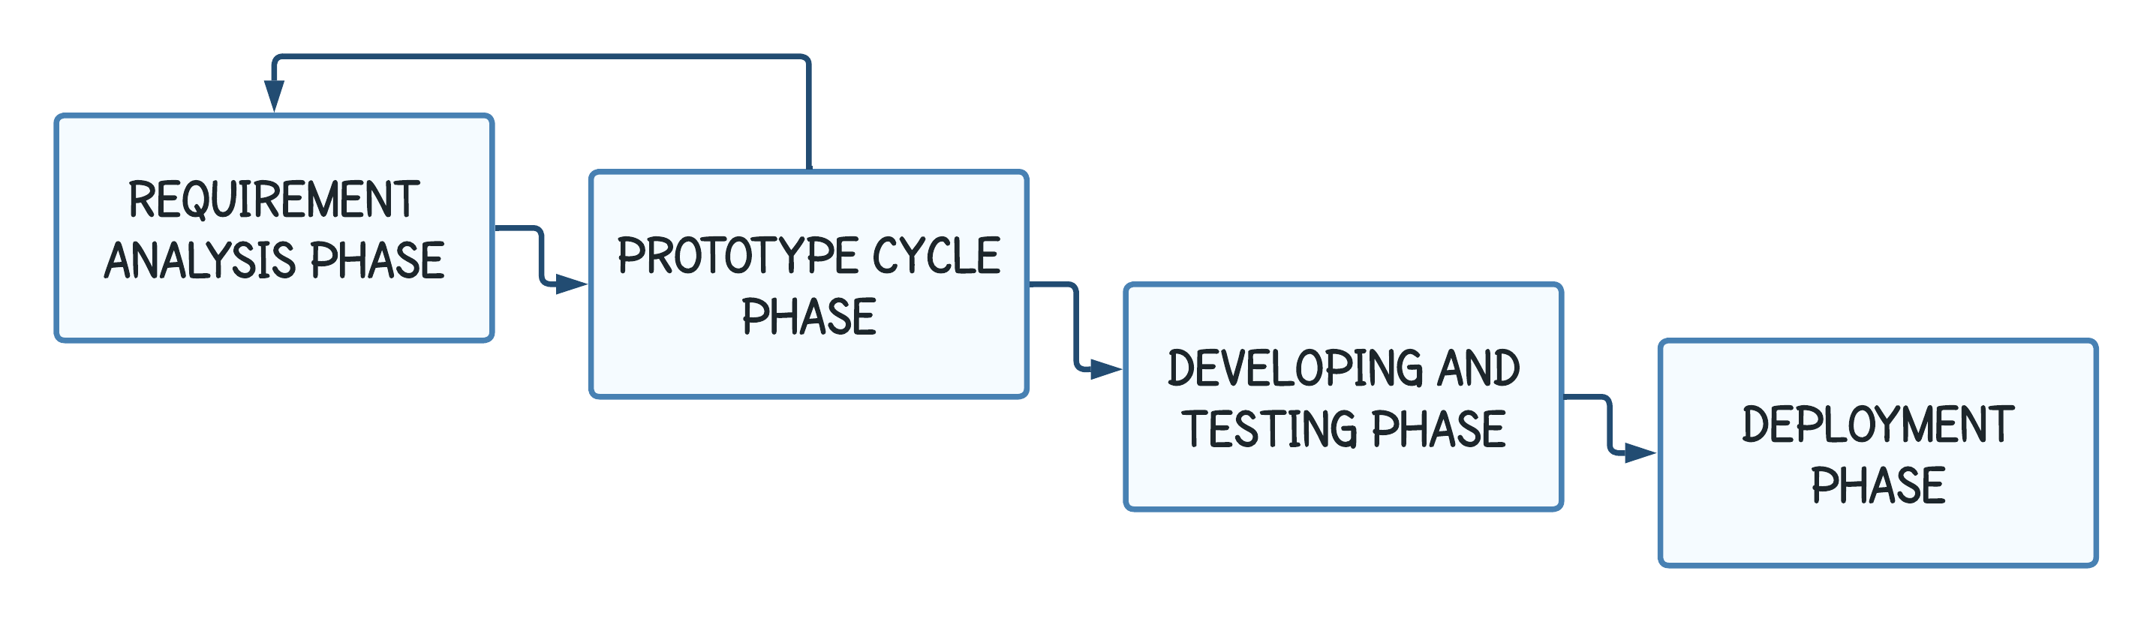

Figure . Research Framework

**Requirements Analysis phase**

During the Requirements Analysis phase, the developers sent a formal request letter to the registrar to obtain a digital copy of the CVSU CCAT Campus Checklist, which includes information about the courses offered at the university and the subjects available in each course. Subsequently, the developers received an email containing the requested checklist. *(See the Appendix Figure 1 for screenshot of email with the attached checklist of programs offered in the University and See the Appendix Figure 2 to 5 for BSCS and BSInfoTech subject offerings)* To gain a deeper understanding of the checklist and the faculty loading process, the developers conducted an online audio call interview with the scheduling committee of the Department of Computer Studies. After comprehending the manual scheduling process, the developers delved into an in-depth examination of related literature and thoroughly studied various existing systems. The purpose was to gather insights and identify key constraints. This phase laid the groundwork for subsequent stages and helped establish the essential parameters for the development of the system.

**Web-Based System Requirements**

In this phase, the developers described the software and hardware requirements for the web app, as well as the developmental tool used during development phase.

***Hardware***

In system development, the developers used an HP Laptop with the following specifications: 8 GB DDR4-3200 MHz RAM, AMD Ryzen 5 5500U with Radeon Graphics operating at a speed of 2100 megahertz, and 512 GB PCIe storage, running on a 64-bit Windows 11 operating system.

***Software***

The developers considered the following software requirements for the development of the Automated Timetable Scheduling System (ATS).

**Front-end:**

* + - **HTML**–stands for Hypertext Markup Language and it was used to structure the web page of the system and it also used to organize the contents of the webpage.
    - **CSS** – stands for Cascading Style Sheet, it is one of the core technologies of web development. It is used for the design of web pages such as fonts, layouts, colors, shapes and it also used for responsive web pages to different device.
    - **Bootstrap 5** – it is a free and open-source front-end development CSS framework. It was used to provide responsive web design.
    - **JavaScript** - it is a scripting language that are used to create an interactive or dynamic website.
    - **JQuery –** It was used in system development to enhance the functionality and interactivity of the web application. It provided features and utilities for tasks such as DOM manipulation, event handling, AJAX requests, and animations, making it easier to implement dynamic and responsive elements in the system.

**Back-end:**

* **PHP -** is a widely-used server-side scripting language specifically designed for web development. It is embedded within HTML code and executed on the server to generate dynamic web pages. PHP offers a wide range of functionalities and is popular for building dynamic websites, web applications, and handling server-side tasks. It can interact with databases, handle form data, and generate dynamic content. PHP is known for its simplicity, flexibility, and strong community support, making it a popular choice for web development.
* **MySQL** – is a relational database management system that used for storing or handling data using Structure Query Language.
* **XAMPP** – It is a software package that provides a local development environment for building and testing web applications. It stands for "Cross-Platform, Apache, MySQL. XAMPP is a bundled software solution that includes several components necessary for web development, such as the Apache web server, MySQL database server, PHP programming language
* **TCPDF** - TCPDF is a PHP library used for generating PDF documents. It stands for "TCPDF - PHP class for PDF". TCPDF provides various functions and methods to create PDF files dynamically, allowing developers to generate PDFs from scratch or based on templates.

***Developmental Tools***

During the development of the Automated Timetable Scheduling System (ATS), the developers utilized a variety of developmental tools that serve multiple purposes, including storage management, facilitating meetings, creating UI designs, generating diagrams, and for editing picture and logos.

* **Google Drive -** Google Drive is a file storage, it is used to store research paper, images, diagrams, UI Design and Wireframes
* **One Drive** – It is a cloud storage that allow you to edit and synchronize file.
* **Microsoft Teams –** it is used to communicate with one another and schedule a meeting twice a week to report the progress of their task.
* **Figma –** is an online collaboration tool used for creating digital products. It is used to design user interface of the system.
* **Lucid Chart** – is a diagramming tool web application, it is used for creating diagrams (e.g., flowcharts, Site map).
* **Visual Studio Code –** is a code editor and its supports different programming language like Python.
* **Adobe Photoshop CS6** – is photo editing software, it is used for the design and image of the website.
* **GitHub -** GitHub is a web-based platform that serves as a version control repository for developers. It provides a centralized location where developers can store, manage, and collaborate on their code projects. The platform uses Git, a distributed version control system, to track changes to files and facilitate collaboration among team members.

**Prototype Cycle Phase**

During the Prototype Cycle Phase, the developers utilized the collected information to create a wireframe prototype using Figma. After designing the prototype, the developers presented it to their technical critic for feedback and refinement before proceeding to the development phase. The prototype was refined based on the critic's input until it reached a stage where it was deemed ready for development. In addition, the developers utilized the gathered information and the final prototype to design various research diagrams, including System Flowcharts, Use Case Diagrams, Database Scheme, and Entity Relationship Diagram (ERD). *(See Appendix Figure 7 to 12 for system flowcharts, See Appendix Figure 13 for use case diagram and See Appendix Figures 14 and 15 for Database Scheme and ERD).*

These diagrams were created to visually represent and illustrate the system's functionalities, interactions, and data relationships.

**Developing and Testing Phase**

During the Development and Testing Phase, the developers utilized all the gathered information, the final prototype, and the diagrams to develop Automated Timetable Scheduling System (ATS). These resources served as valuable references and guides throughout the development process, ensuring that the web-based system was implemented in accordance with the defined functionalities, user requirements, and system architecture.

**Implementation of the Backtracking Algorithm in the System**

The developers utilized a backtracking algorithm to assign unique and conflict-free class schedules to each course. This algorithm facilitated a systematic exploration of potential assignments while efficiently backtracking and adjusting schedules when conflicts or duplications were encountered. By employing the backtracking algorithm, the developers ensured that every course was allocated a distinct and non-conflicting class schedule within the specified context. Please see figure 10 for flowchart of the backtracking algorithm implementation. Please refer to Figure 10 to view the flowchart depicting the implementation of the backtracking algorithm.

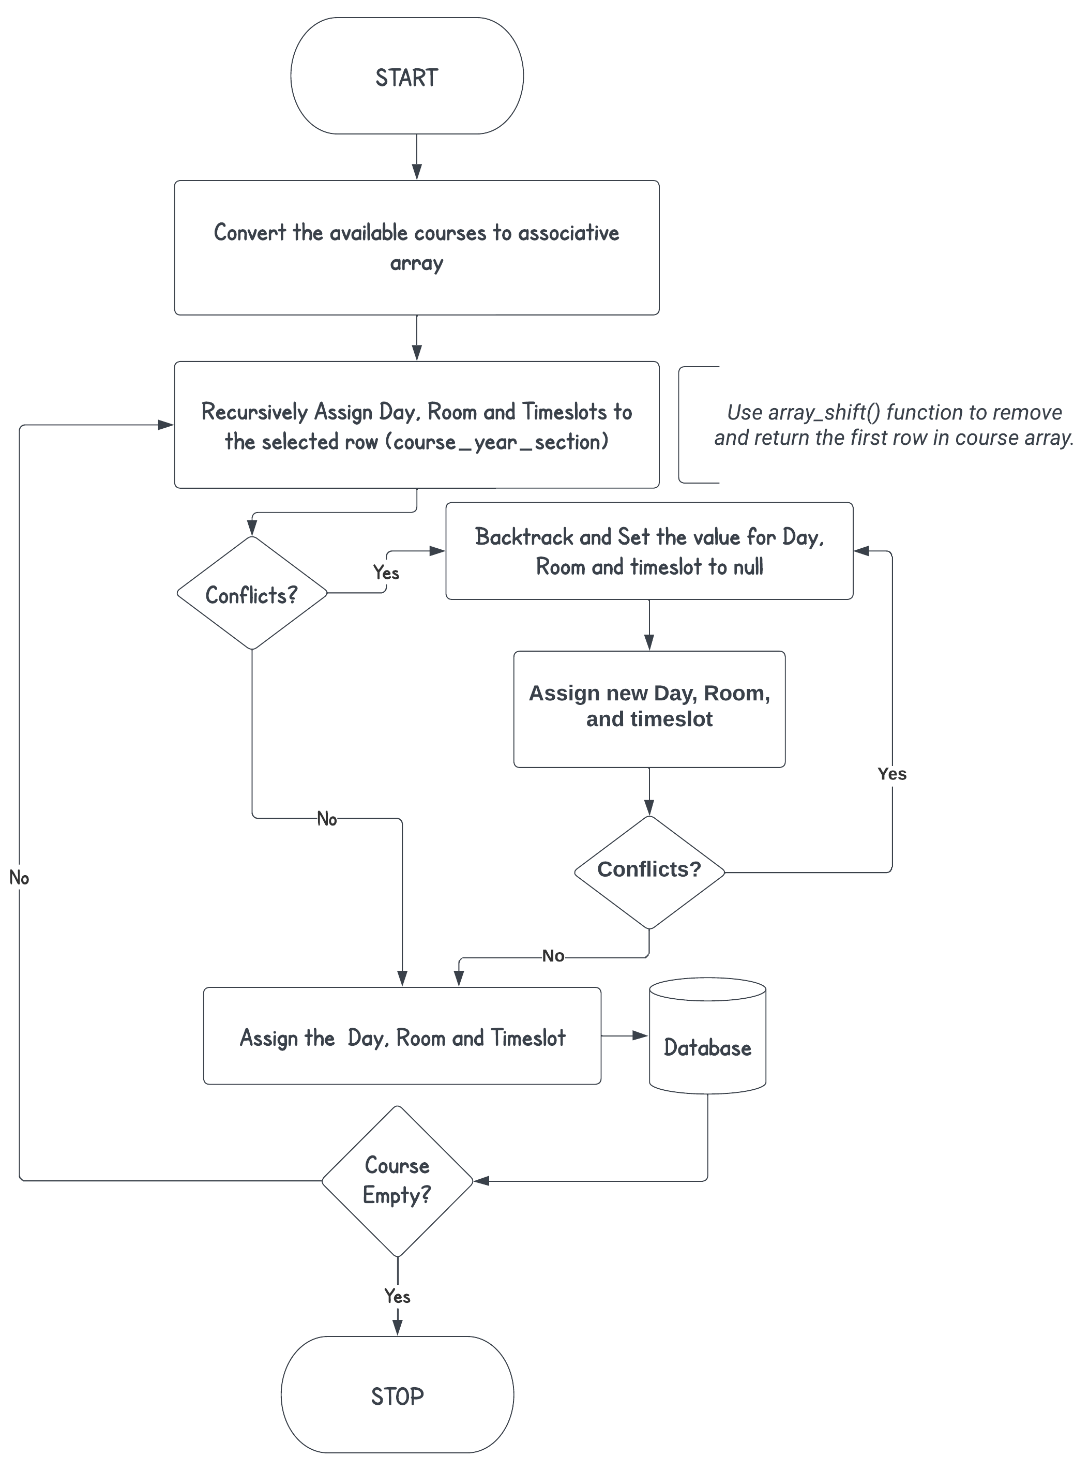

Figure . Backtracking Algorithm Implementation Flowchart

In Figure 10, the implementation of the backtracking algorithm in the web-based system is demonstrated. The developers followed a series of steps to implement the algorithm. They began by converting all available courses from the database into an associative array. Subsequently, the backtracking algorithm recursively assigned a unique timeslot to each selected course. Before inserting the assigned timeslots, a helper function was utilized to check for conflicts. In cases where overlaps occurred with other schedules, the algorithm backtracked, set the value to null, and attempted a different timeslot until a non-overlapping one was found. The algorithm continued this process recursively until all courses in the array were assigned a timeslot

## Principles of Operation

The developers developed an Automated Timetable Scheduling System for Cavite State University CCAT Campus, especially designed for the Department of Computer Studies. The scheduling committees or teachers had to register an account first to log in to web-based system. After successfully logging in, the user needed to add data for faculty loading to assign a subject to a specific teacher. After all the data was added to the faculty loading, the user needed to choose between Automated or Manual creation of the schedule. Then, the user had to wait approximately one to two minutes for automated generation. On the other hand, in the manual creation of the schedule, the user could assign specific days, timeslots, and rooms to the teachers listed in the faculty loading table. However, as of now, the manual generated schedule was not able to check if it conflicted with the automated schedules. Lastly, the web-based system had a specific view page for room, teacher, and course schedules. Each teacher, room, and course had separate tables displaying their respective schedules. The generated schedule can be converted in pdf format for printing purposes. *(See Appendix Figure 8 to 11 for the whole system flowchart).*

## Testing and Evaluation

**Testing**

During the testing phase, three categories were employed to thoroughly test the system. Realistic data, specifically the current faculty loading, was utilized for comprehensive testing of functionality, reliability, and performance *(See Appendix Figure 15 to 17)*. The developers utilized a Test Case Form to test system modules functionality, while Testing Conditions were implemented to ensure the reliability of system outputs. These categories collectively contributed to a robust testing process prior to system implementation.

1. **Test Case Form**

In the testing process, several key elements were used to document and track the test cases. These elements include:

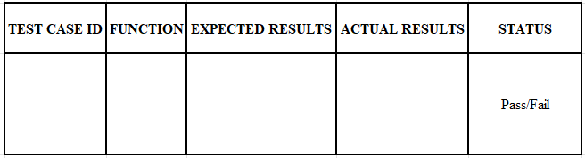

Figure . Test Case Form

* + - **Test Case ID:** This is a unique identification number assigned to each test case. It helps in identifying and organizing the individual test cases.
    - **Function:** This describes the primary objective or goal of the specific test case. It provides information about what aspect or functionality of the system is being tested.
    - **Expected Results:** These are the anticipated outcomes or results that are expected when the test case is executed. They serve as a benchmark for evaluating the actual results.
    - **Actual Results:** This refers to the real outcome or result obtained when the test case is executed. It provides information about what actually happened during the testing process.
    - **Status:** The status indicates the outcome of the testing. It determines whether the test case has passed or failed based on a comparison between the expected and actual results. This helps in tracking the progress of testing and identifying any issues or discrepancies.

These elements collectively assist in documenting, tracking, and evaluating the test cases, ensuring that the system's functionality and behavior are thoroughly assessed.

1. **Reliability**

The developers tested the reliability of generated class schedule with the specified testing conditions in table 1, aiming to verify the system's reliability and ensure conflict-free generated schedules.

Reliability, in this context, pertains to the system's ability to consistently generate accurate and conflict-free class schedules in a dependable manner. The developers conducted 10 manual tests to evaluate the reliability of the generated class schedules based on testing conditions shown in table 1. During these tests, they meticulously reviewed the schedules for teachers, courses, and rooms, comparing them to identify any conflicts or issues that may have arisen *(See Appendix Figure 18 to 20).* This thorough examination allowed them to ensure that the generated schedules were reliable and free from conflicts.

Table . Testing Conditions

|  |  |
| --- | --- |
| **TESTING CONDITION** | **REMARK** |
| 1. Teachers, Students and Rooms must have a conflict-free generated schedules. | Passed/Failed |
| 1. The timeslot duration must align with the subject hours. | Passed/Failed |
| 1. The generated output should be free of conflicts. | Passed/Failed |
| 1. The Manual added schedule should not overlap with the existing schedules. | Passed/Failed |
| 1. The room type should be corresponded to the subject type. | Passed/Failed |

1. **Functionality**

Functionality refers to the specific capabilities and features of the modules within an automated scheduling system (ATS). Testing the functionality of each module involves assessing whether it performs its intended tasks and operations effectively within the context of the scheduling system.

Table . Compilation of functions requiring testing

|  |  |  |  |  |
| --- | --- | --- | --- | --- |
| **TEST CASE ID** | **FUNCTION** | **EXPECTED RESULT** | **ACTUAL RESULT** | **STATUS** |
| T-001 | Test the login module | The system must not allow to login the unregistered user, |  | Pass/Fail |
| T-002 | Test the register module | If the user registers a new account with a same email, The system must not allow the registration of the account, |  | Pass/Fail |
| T-003 | Test the CRUD functionality for Semester | Users should be able to create, view, update, and delete semesters. |  | Pass/Fail |

Table 2. Continued

|  |  |  |  |  |
| --- | --- | --- | --- | --- |
| **TEST CASE ID** | **FUNCTION** | **EXPECTED RESULT** | **ACTUAL RESULT** | **STATUS** |
| T-004 | Test the CRUD functionality for Day | Users should be able to create, view, update, and delete Day. |  | Pass/Fail |
| T-005 | Test the CRUD functionality for Teacher | Users should be able to create, view, update, and delete teacher. |  | Pass/Fail |
| T-006 | Test the CRUD functionality for Course | Users should be able to create, view, update, and delete course. |  | Pass/Fail |
| T-007 | Test the CRUD functionality for Section | Users should be able to create, view, update, and delete section. |  | Pass/Fail |
| T-008 | Test the CRUD functionality for Subject | Users should be able to create, view, update, and delete subject. |  | Pass/Fail |
| T-009 | Test the CRUD functionality for Room | Users should be able to create, view, update, and delete room. |  | Pass/Fail |
| T-010 | Test faculty loading module | The same teacher should not have a same assigned subject with same sections. |  | Pass/Fail |

In order to test the functionality of the modules described in table 2, the developers conducted alpha testing and employed the test case presented in figure 11 to test the module listed below.

* User Authentication Module
* Faculty Loading Module

**Evaluation**

After successfully completing the testing phase, where all the system modules met all the criteria and the generated class schedules passed all testing conditions, the developers proceeded to evaluate their system using a modified ISO-IEC 25101 software evaluation instrument. This evaluation provided a comprehensive assessment of the system's performance, allowing the developers to validate the effectiveness of their system and identify any areas for improvement.

The evaluation form was evaluated by 40 respondents, including 10 IT Experts and 30 End-Users, who utilized two different evaluation forms, enabling a comprehensive assessment of the system from both technical and user experience viewpoints. *(See Appendix Figures 21 to 22).*

Among the respondents, the IT Experts consisted of 10 teachers who possessed expertise in the relevant technology and had a deep understanding of the system's functionalities and requirements. On the other hand, the End-Users comprised 30 students, specifically those pursuing Bachelor of Science in Computer Science (BSCS) and Information Technology (IT) degrees from Cavite State University CCAT Campus. These students, being the primary users of the system, provided valuable insights and feedback based on their firsthand experience and perspective. The inclusion of both IT Experts and End-Users ensured a comprehensive evaluation process, encompassing technical expertise and user-centric viewpoints.

## Data Analysis

The developers computed the evaluation results by getting the total of each criterion then divided it by the total evaluators and interpret the total score using the table below:

Table . Descriptive Interpretation of total score

|  |  |
| --- | --- |
| **SCORE** | **INTERPRETATION** |
| 4.51 -5.00 | Excellent |
| 3.51 - 4.50 | Very Satisfactory |
| 2.51 - 2.50 | Satisfactory |
| 1.51 - 2.50 | Unsatisfactory |
| 1.00 - 1.50 | Needs Improvement |

# RESULTS AND DISCUSSION

In this chapter, the findings and discussions of the study are presented. The chapter encompasses The Web App Design, Outcomes of the testing and evaluation offering a comprehensive analysis and interpretation of the data collected

## Web-Based System Design

Automated Timetable Scheduling System is a web application that generates class schedules without conflicts. It encompasses crucial functionalities such as CRUD operations for managing data required for schedule generation, faculty loading to assign subjects, and schedule generation for teachers, students, and rooms. Furthermore, the system allows for manual updates to the schedules. The developers use PHP as their programming language to employs a dependable backtracking algorithm to ensure conflict-free scheduling.

Figure 12 shows the register page, where user can register account to login in the web-based system. The user needs to add unique email, name and password.

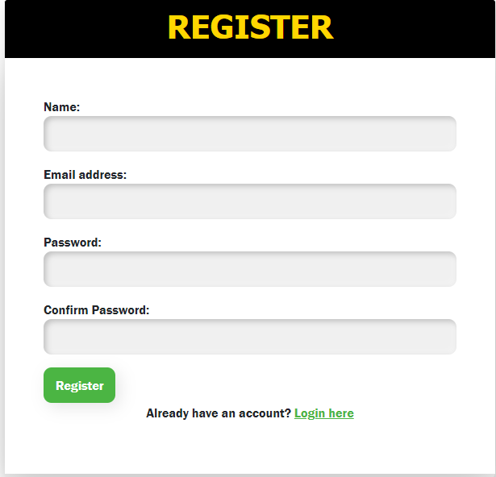

Figure . Register Page

Figure 13 shows the login page where the user needs to input the data, they used in registration page.

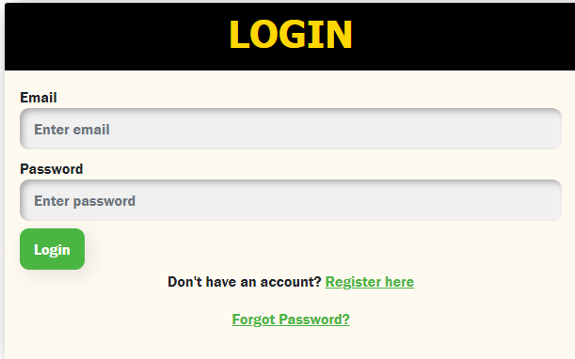

Figure . Log in Page

Figure 14 shows that the user already logged in and redirected to the dashboard that display the frequency of all data in the web-based system.

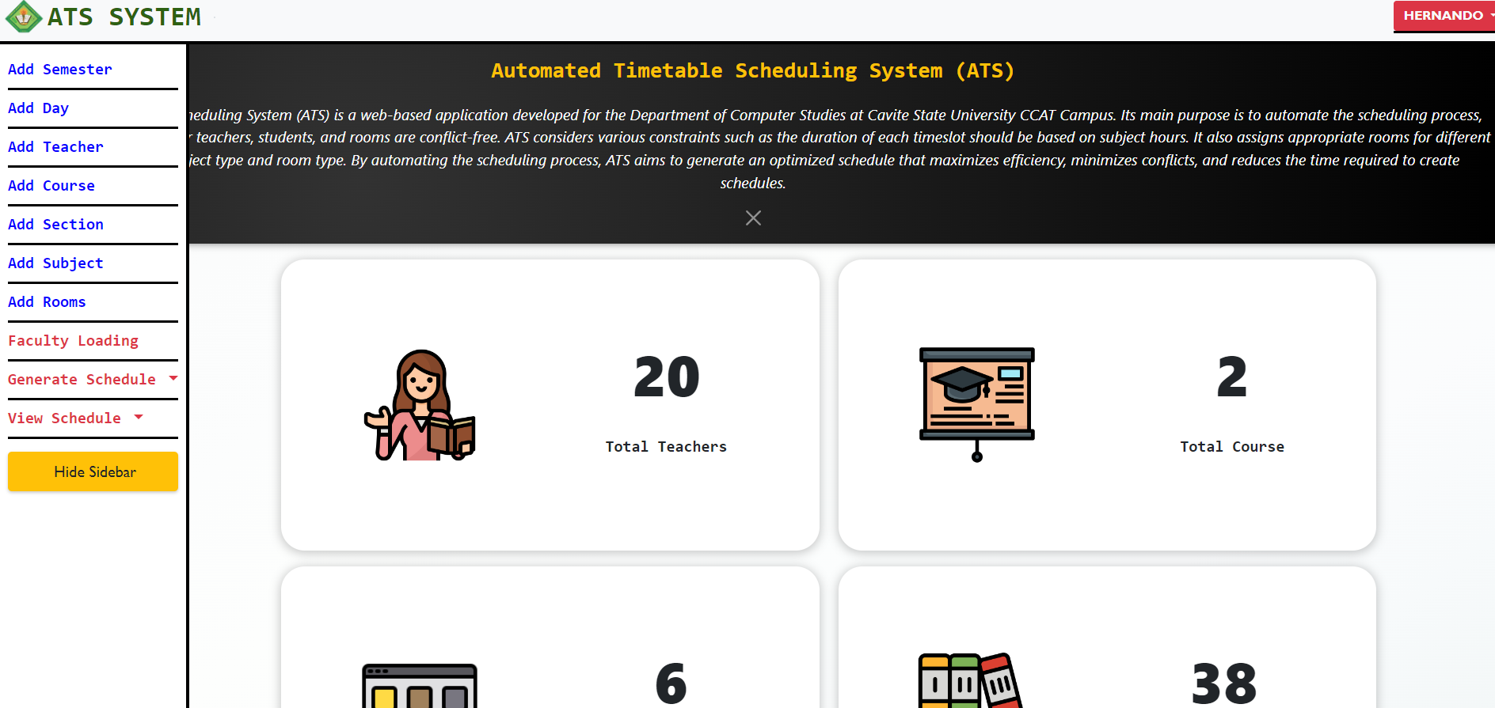

Figure . Admin Dashboard

Figure 15 shows the list of semesters, the user can add another semester by clicking the add semester button and the current semester can be updated and deleted.

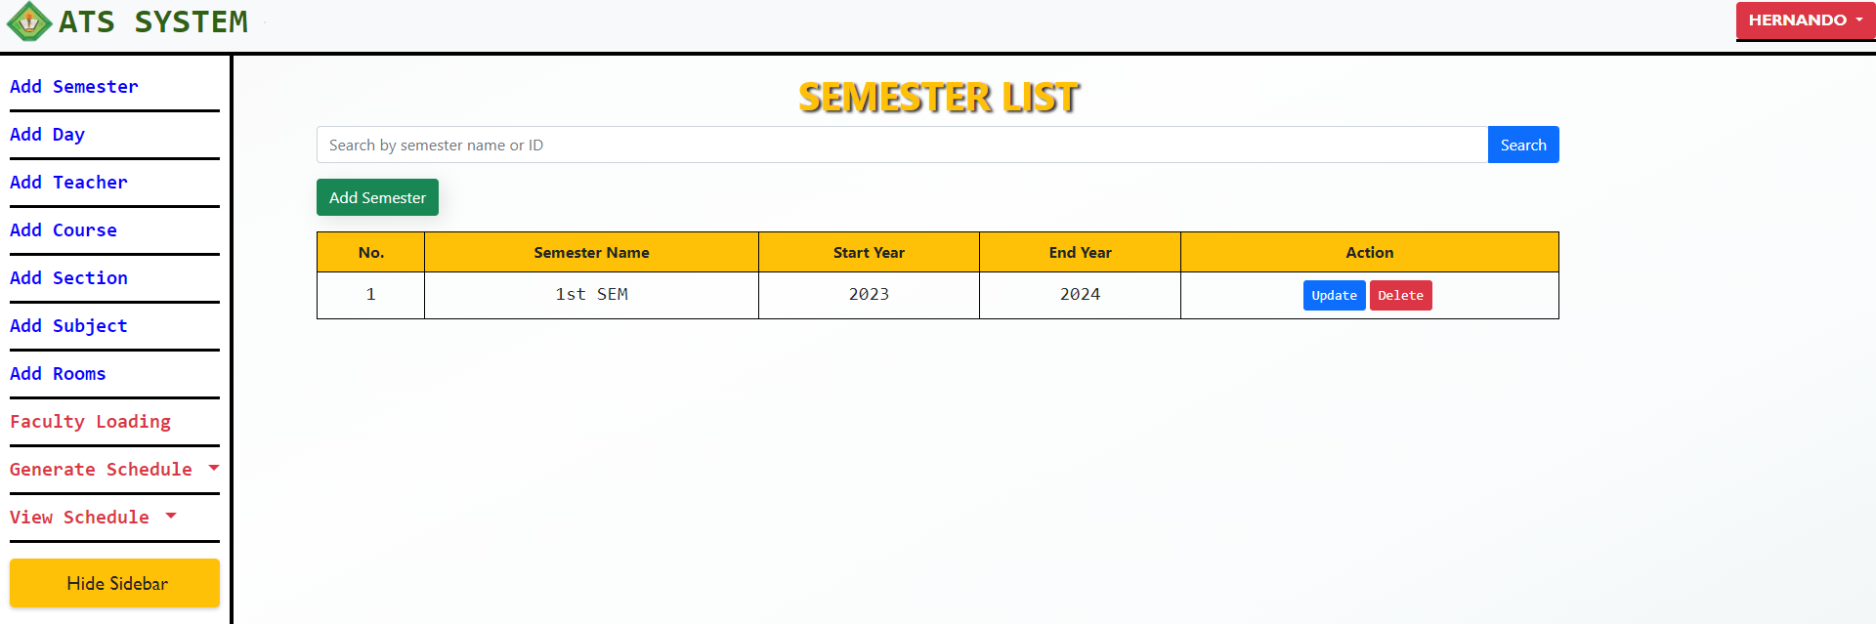

Figure . Semester List

Figure 16 shows the add semester page where user need to input semester id, semester name, start year and end year and then click the create button to save it to the database.

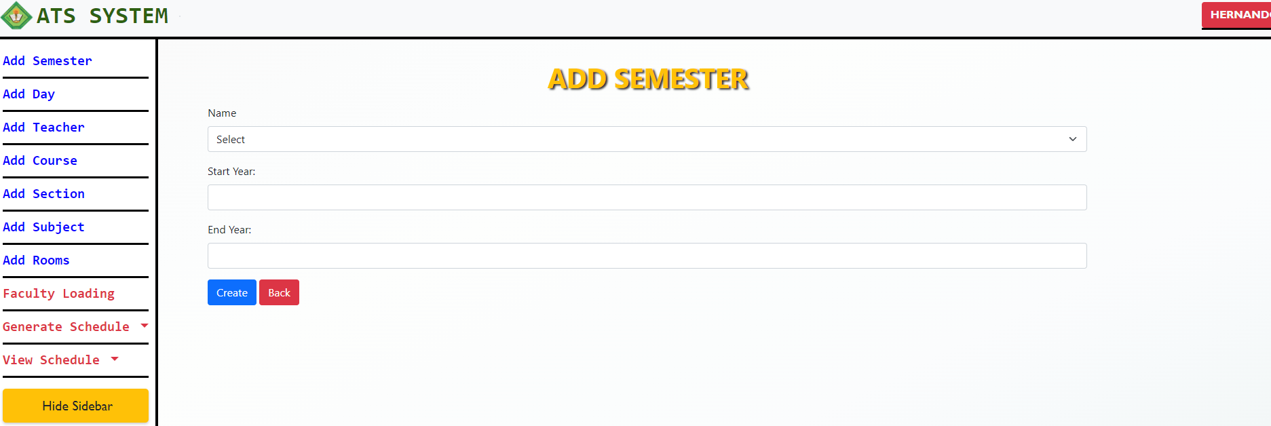

Figure . Adding Semester Page

Figure 17 shows the day list page where the user can see the available days for the current’s semester, the user can add, update and delete data.

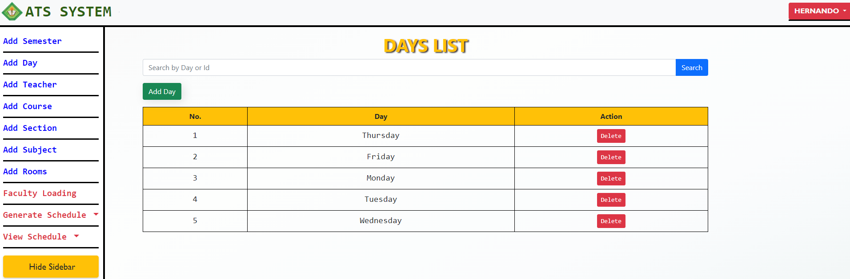

Figure . Day List

Figure 18 shows the page for adding new day, the user needs to select a day between Monday to Friday but if the day is already existing the system will not allow to add the day.

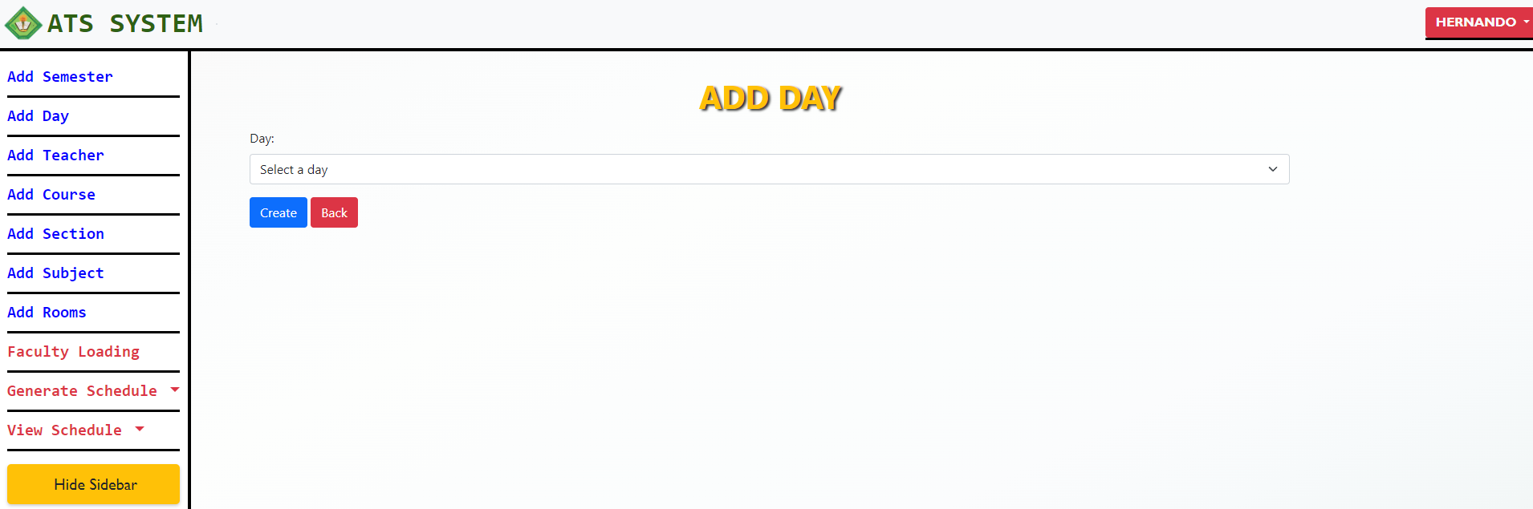

Figure . Adding Day Page

Figure 19 shows the list of available teachers for faculty loading. The user can add, update and delete teachers’ data but if the teacher is already existing in the list the system will not allow to add new teacher.

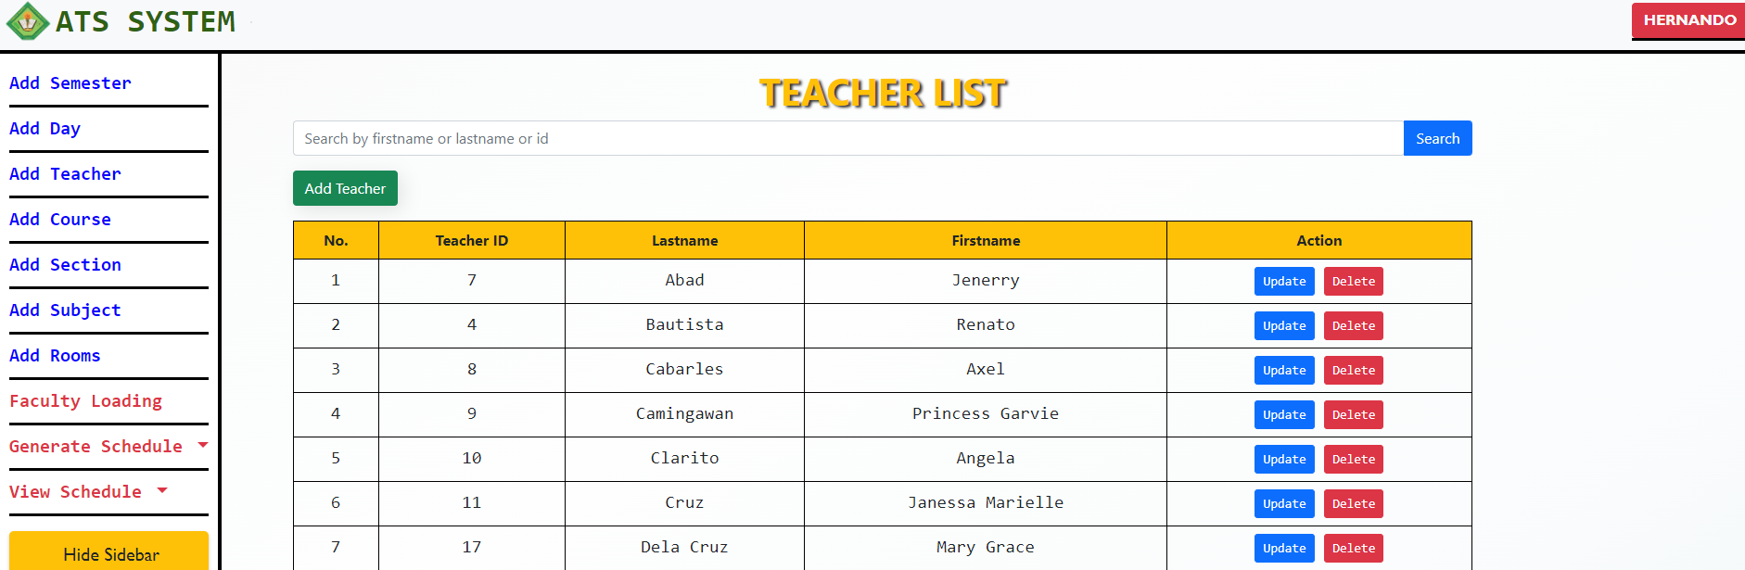

Figure . Teacher List

Figure 20 shows the page for adding new teacher, the user needs to input a unique teacher id and the teacher’s name but if the teacher id is already existing the system will not allow the insertion of new teacher.

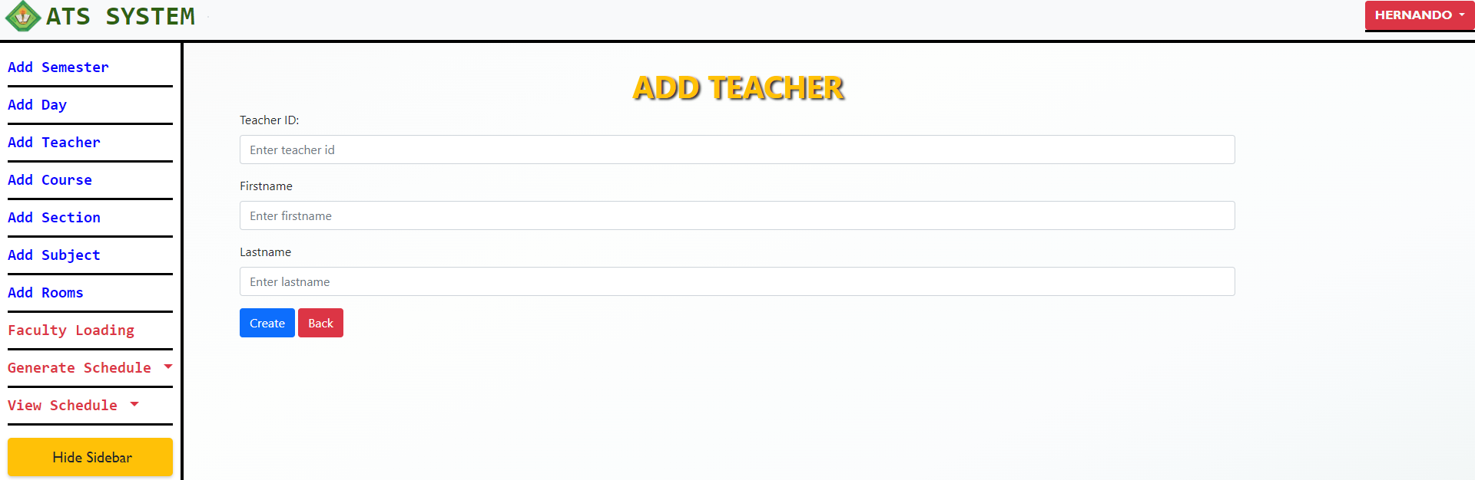

Figure . Adding Teacher Page

Figure 21 shows the list of available courses for the semester. The user can add new course to the list or update and delete the existing courses.

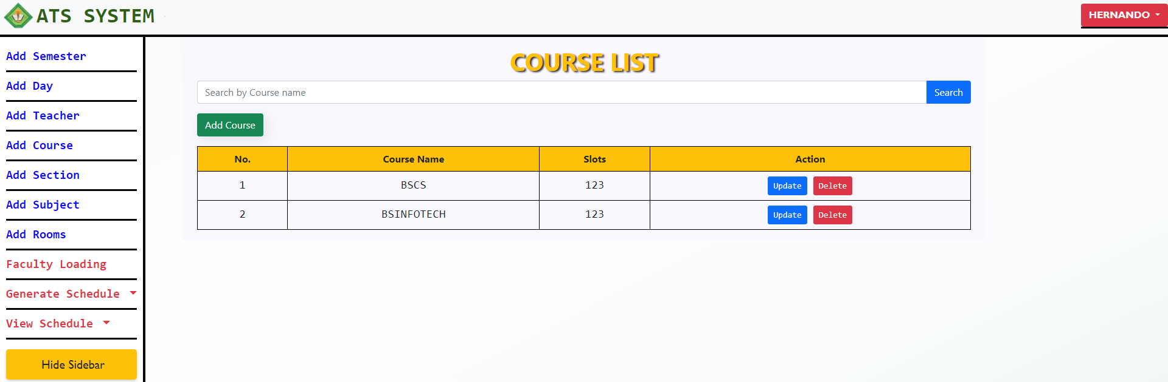

Figure . Course List

Figure 22 shows the page for adding courses, the user needs to add course name, slots and a unique id but if the course id is existing it will block by the system.

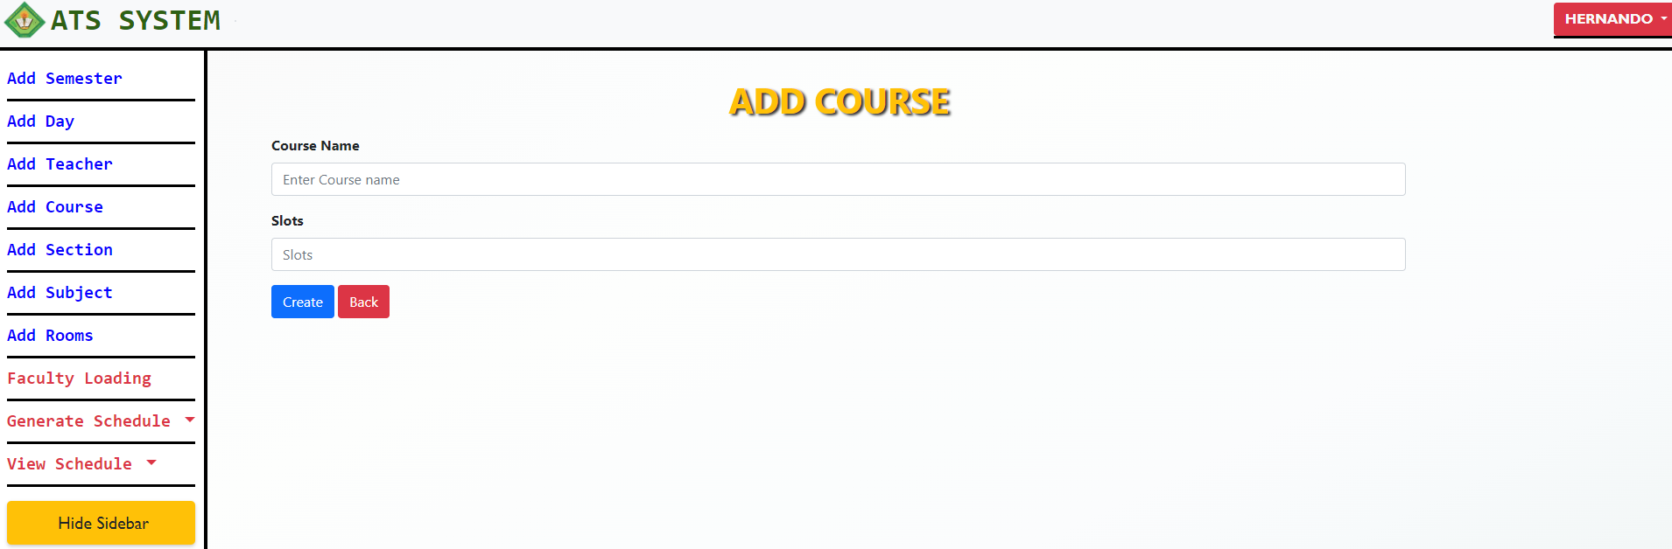

Figure . Adding Course Page

Figure 23 shows the list of available sections for the semester. The user can add new section to the list or update and delete the existing sections.

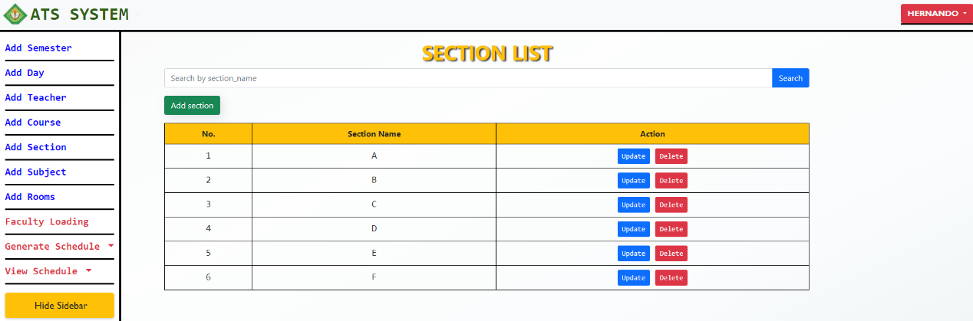

Figure . Section List

Figure 24 shows the page for adding sections, the user needs to add section name and a unique id but if the section id is existing the system will prompt section already exist.

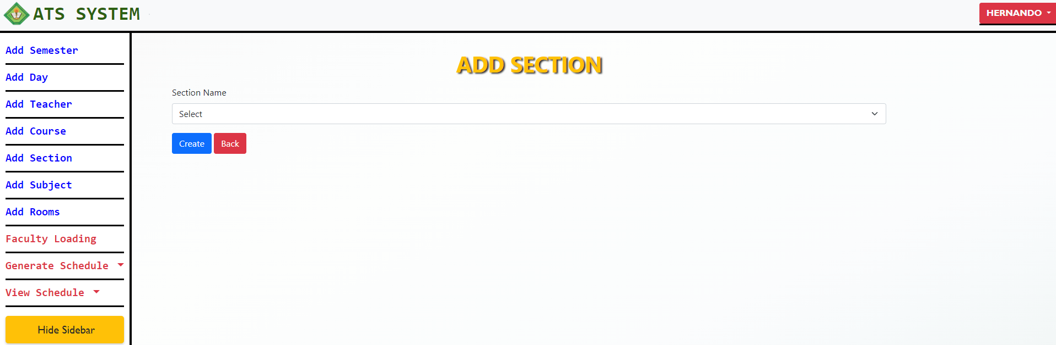

Figure . Adding Section Page

Figure 25 shows the list of available subjects for the semester. The user can add new subjects to the list or update and delete the existing subjects.

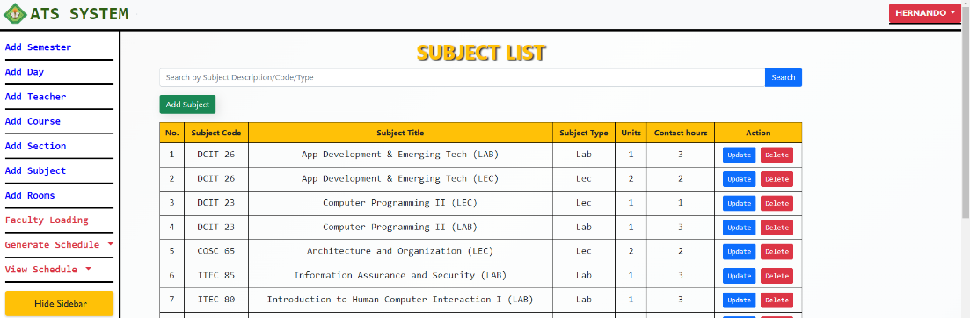

Figure . Subject List

Figure 26 shows the page for adding subject, the user needs to add subject name, subject title, subject type, units and subject hours but if the subject is existing the system will prompt subject already exist.

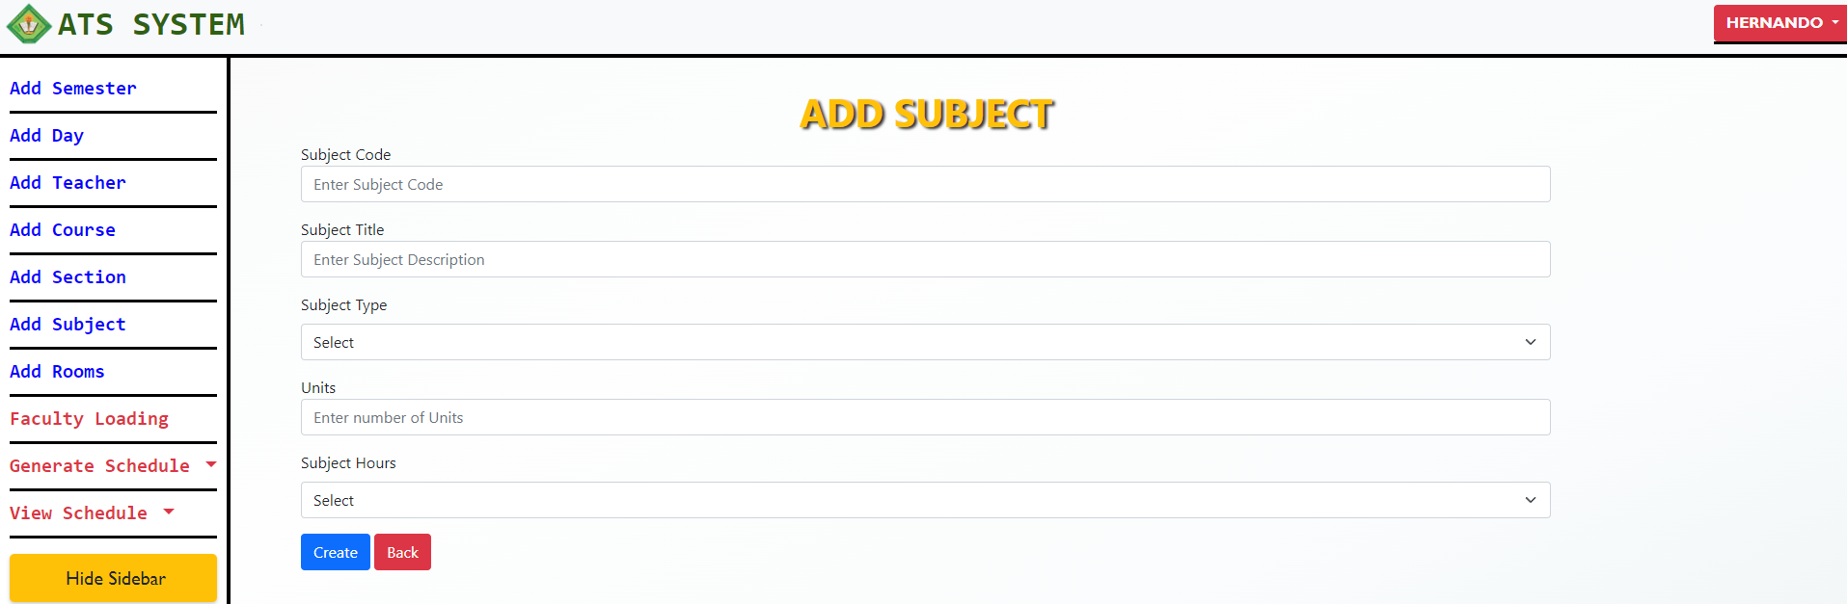

Figure . Adding Subject Page

Figure 27 shows the list of available room for the semester. The user can add new rooms to the list or update and delete the existing rooms.

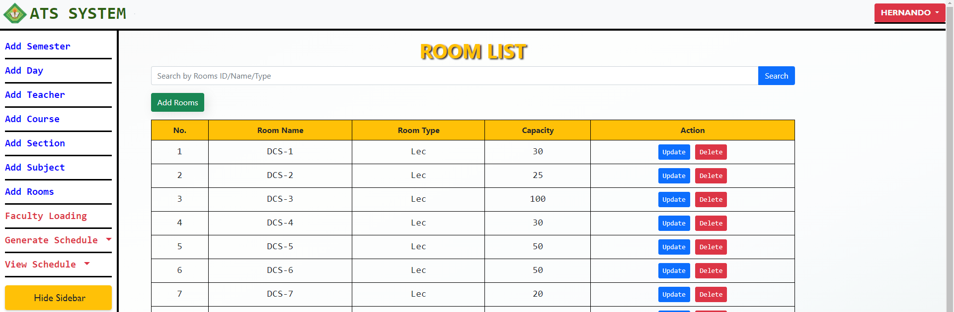

Figure . Room List

Figure 28 shows the page for adding rooms, the user needs to add room name, room type and capacity but if the room is existing the system will prompt room already exist.

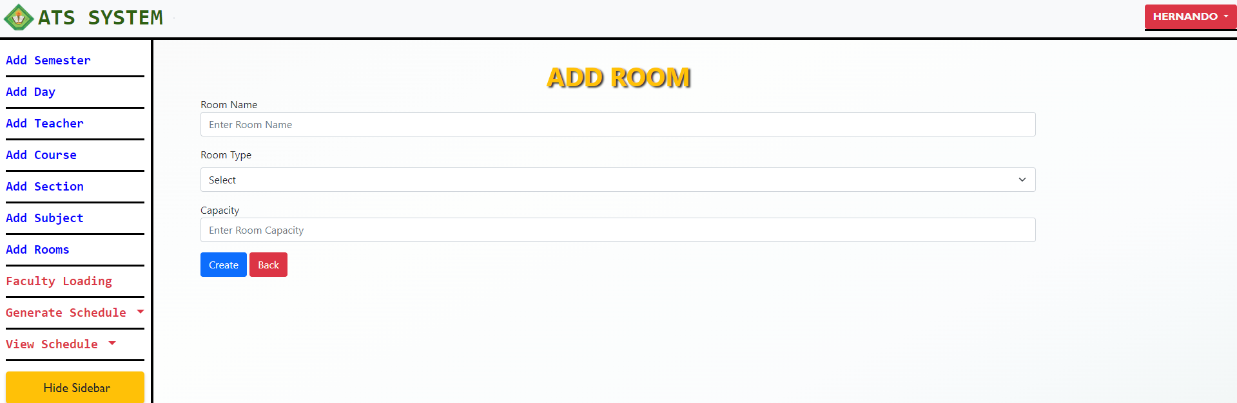

Figure . Adding Room Page

Figure 29 shows the list of assigned subject to the teacher in the faculty loading page. The user can add assign new subject or update and delete the existing data.

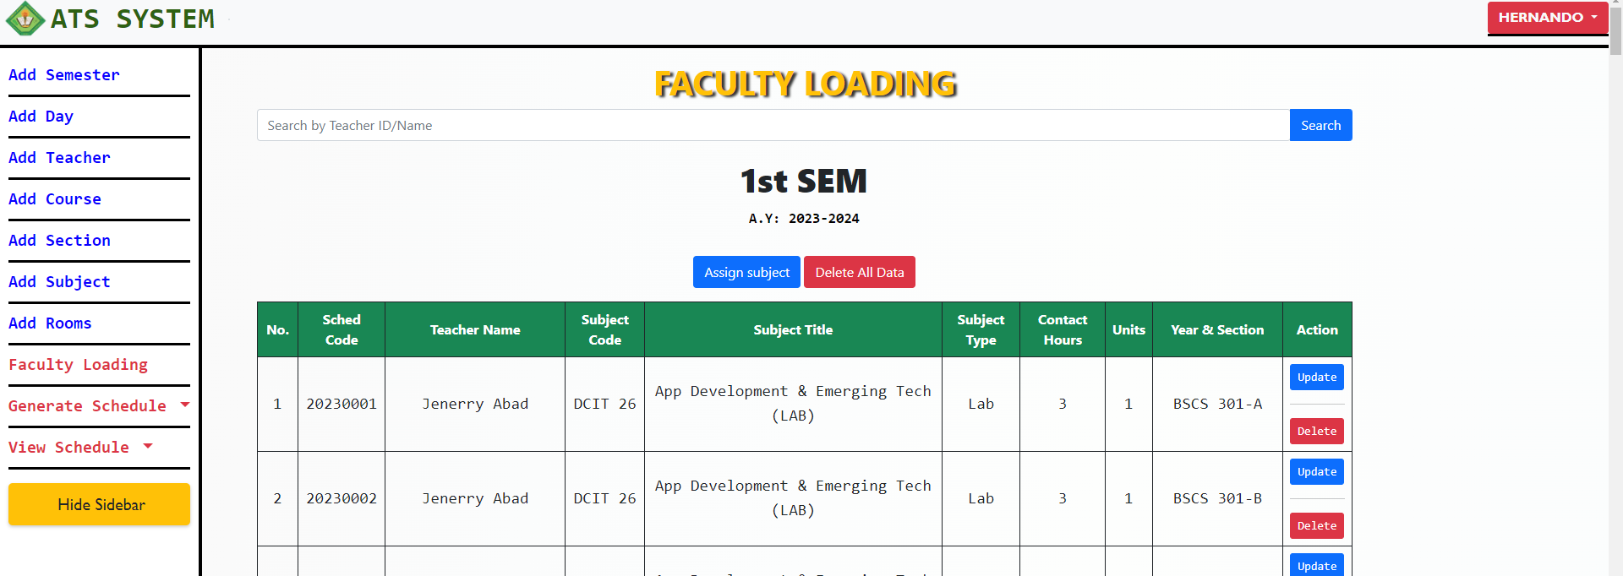

Figure . Faculty Loading List

Figure 30 shows the page for assigning a subject to a teacher. If the selected subject was already assigned the system will not allow the user to assign that subject.

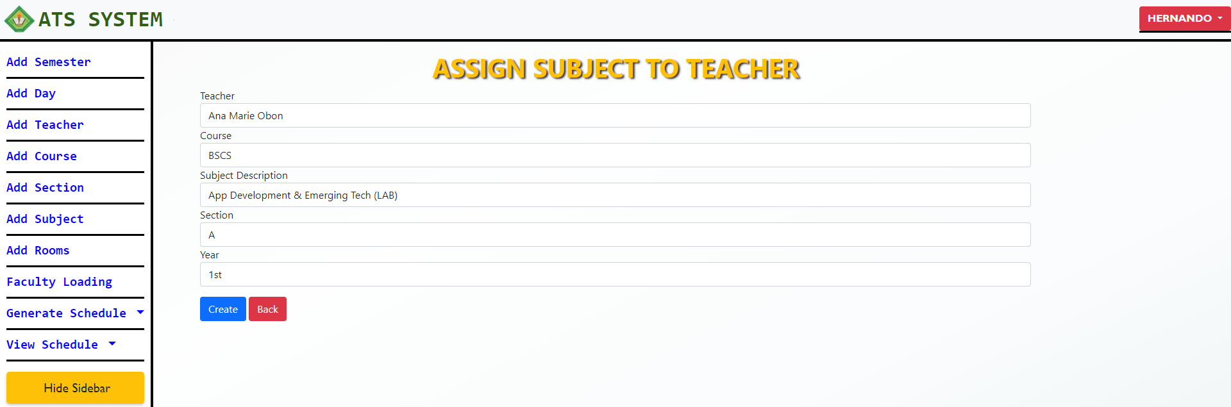

Figure . Adding Faculty Loading Page

Figure 31 shows the page for the automated generation page, where the user will click the generate button and wait approximate one to five minutes to generate the schedules.

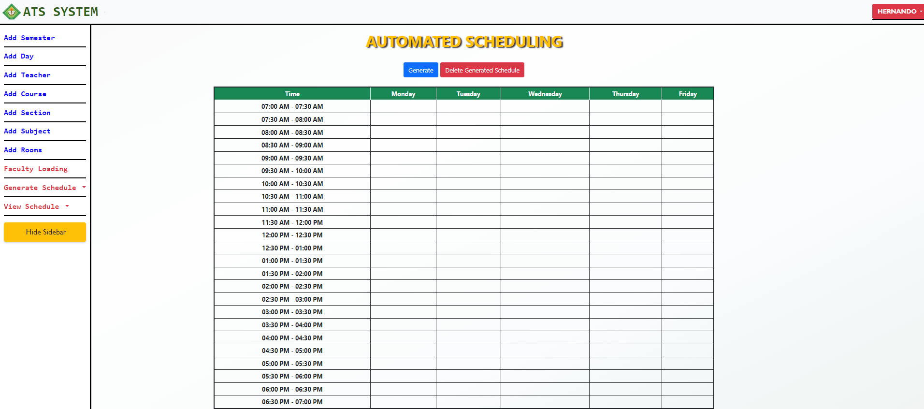

Figure . Automated Timetable Page

Figure 32 shows the generated schedules, the user can regenerate the schedules by clicking the regenerate button and user can also delete the generated schedules using delete button.

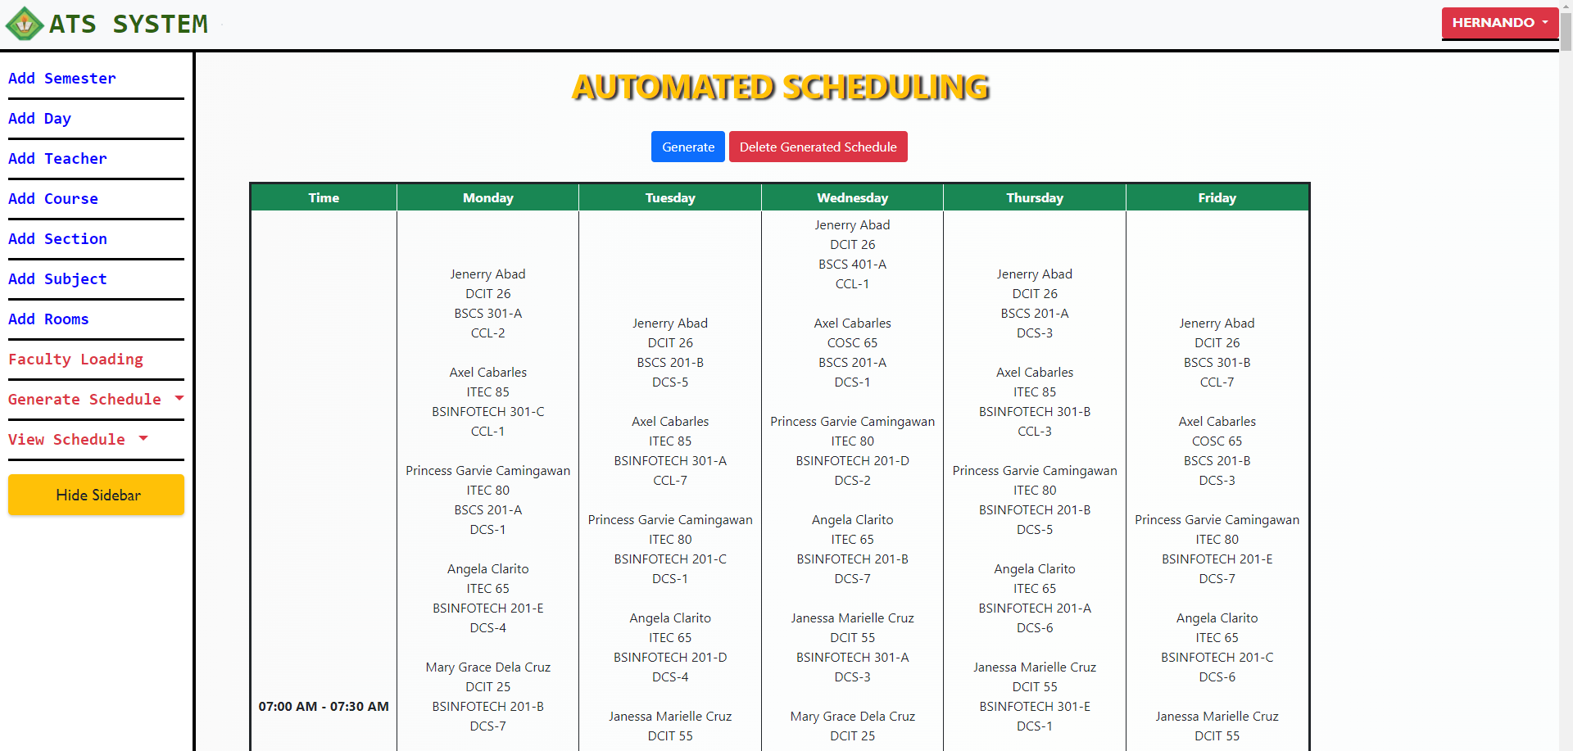

Figure . Automated Timetable Page with Generated Schedule

Figure 33 shows the page for adding a manual schedule to the generated schedules. The user must manually check if the teacher, subject, course, year and section, day, start time and end time is not overlap with the generated schedules. If the user will add timeslot that was already assigned the system will not allow the schedule to be added to the generated schedules.

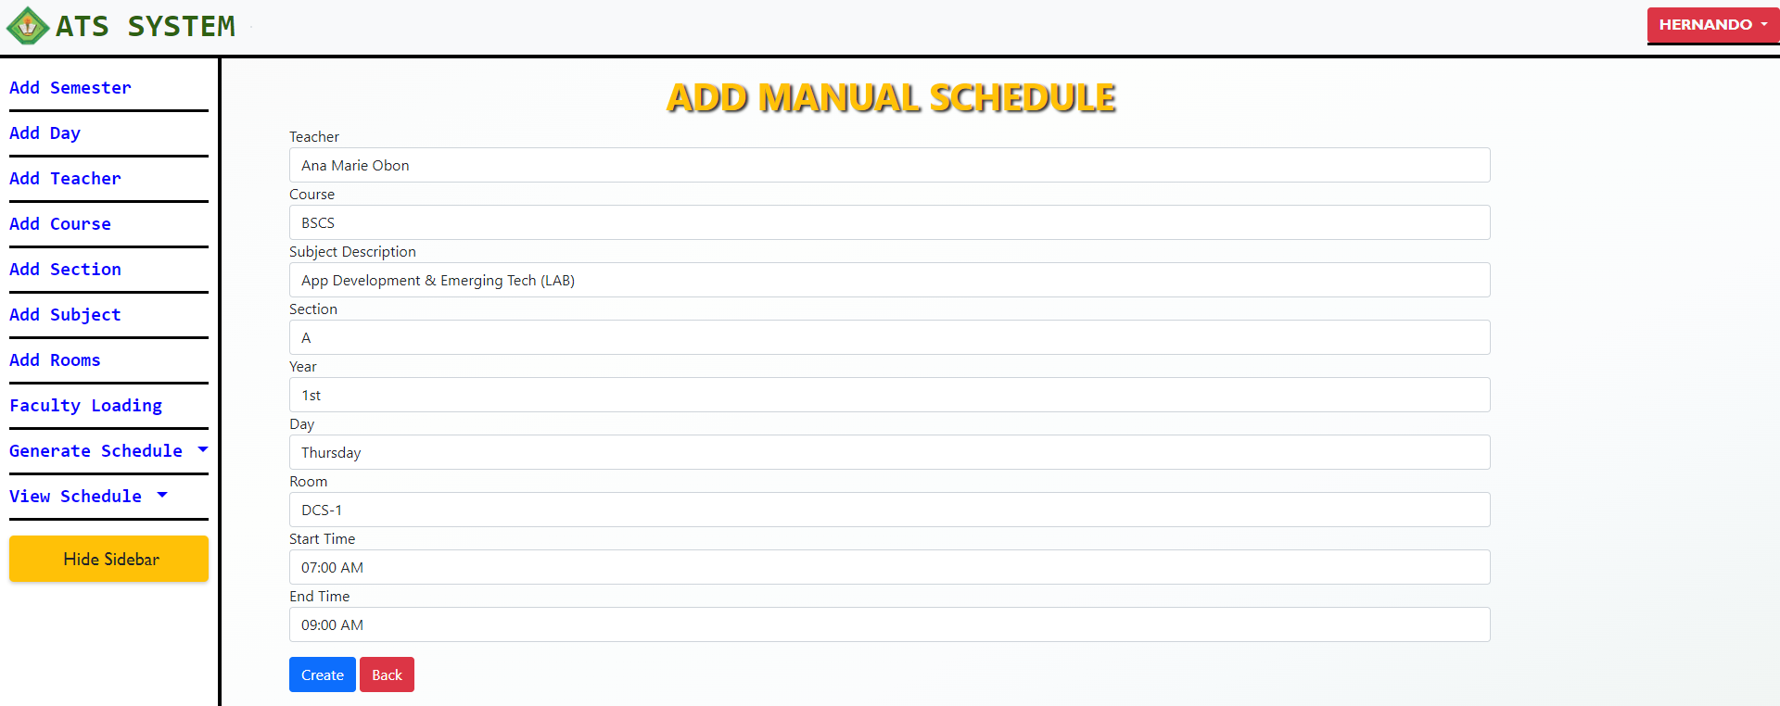

Figure . Adding of Manual Schedule

Figure 34 shows the generated room schedule, the user can see the separated schedules for room in table format.

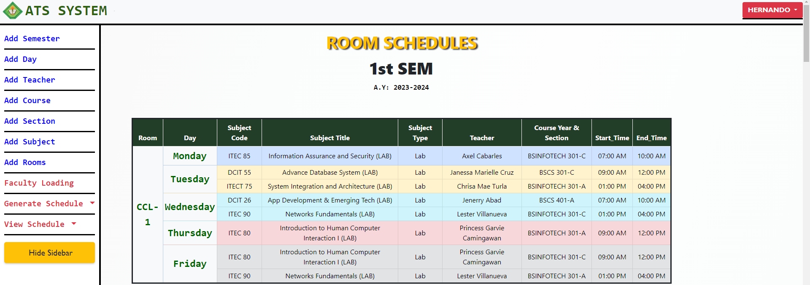

Figure . Generated Room Schedules

Figure 35 shows the pdf format of the generated schedule, the user needs to click the CTR+P for printing the pdf generated schedules.

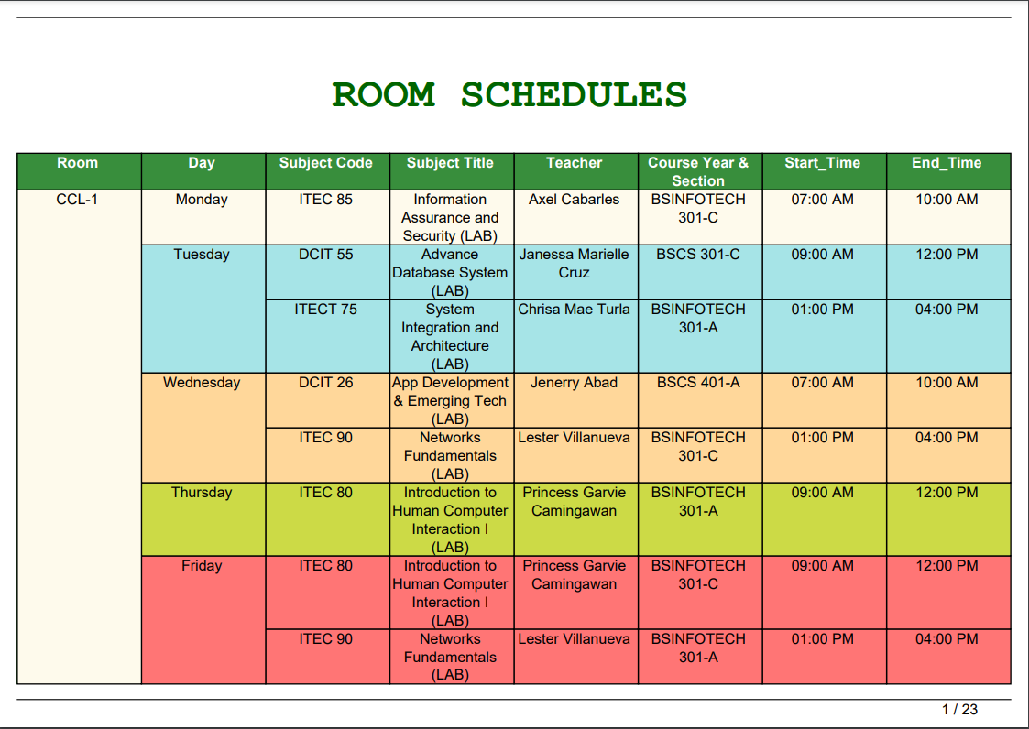

Figure . PDF Schedule for Room

Figure 36 shows the generated teacher schedules in separate tables. The user can convert the generated schedule in pdf format by clicking CTRL + P.

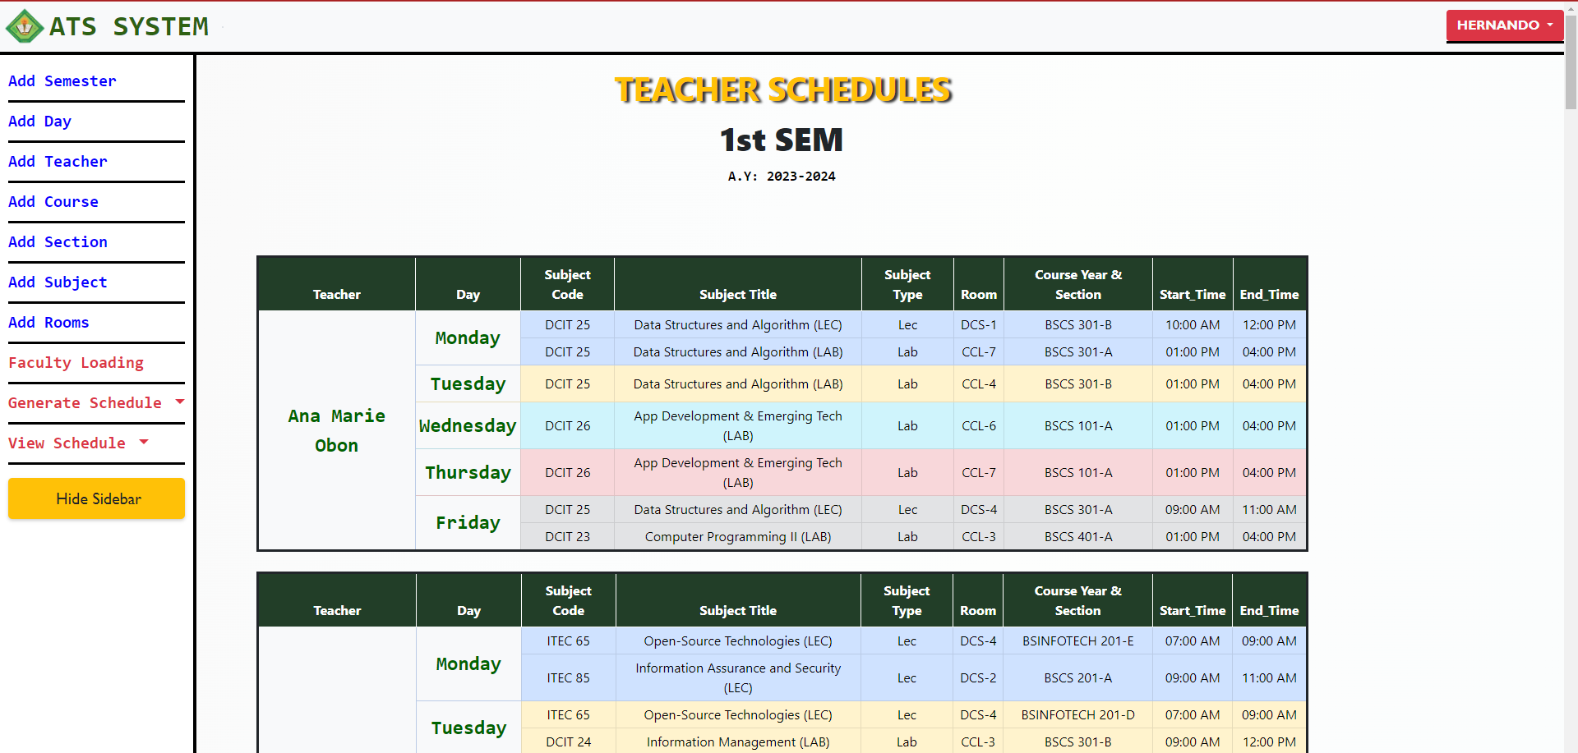

Figure . Generated Teachers Schedule

Figure 37 shows the pdf format of the generated schedules for teachers. The user can print the generated pdf schedules.

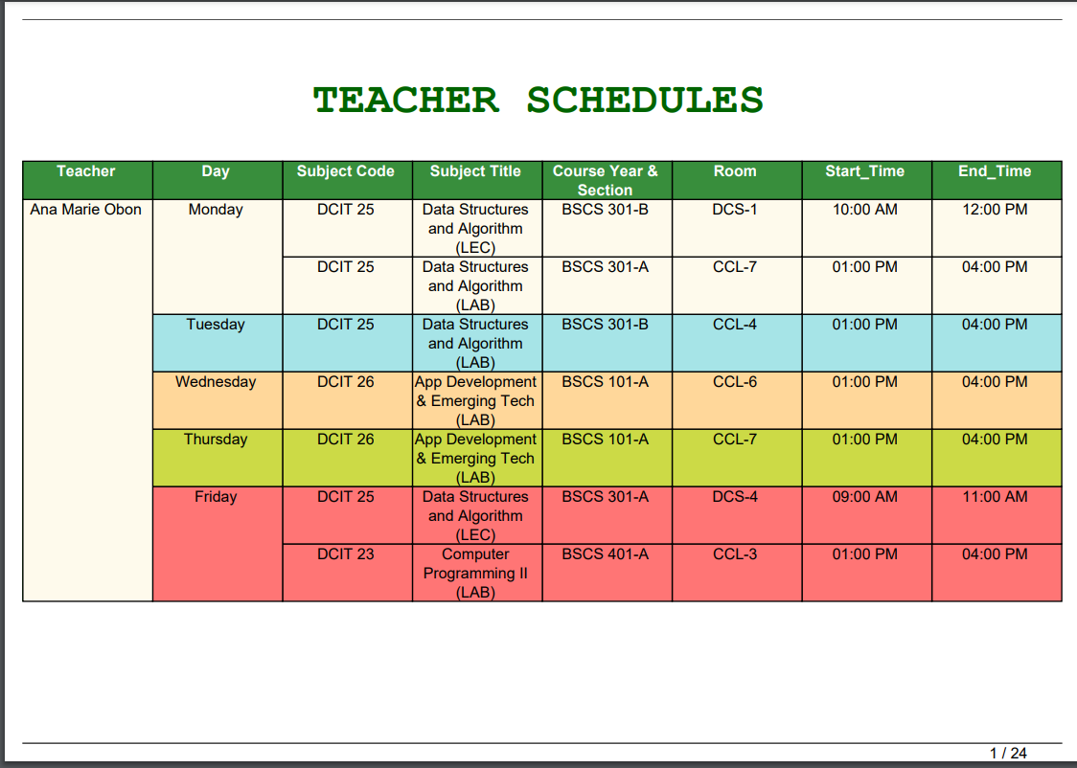

Figure . PDF Teachers Schedule

Figure 38 shows the course generated schedules in a separate table. The user can also convert it into pdf format.

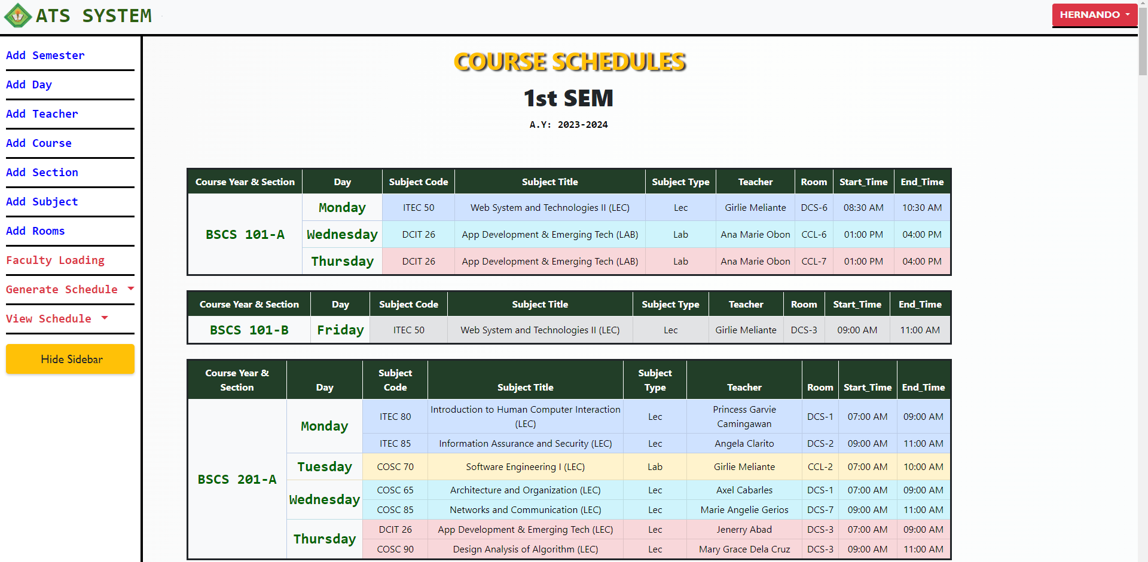

Figure . Generated Course Schedule

Figure 39 shows the converted PDF format of course generated schedules. It was used for printing purposes.

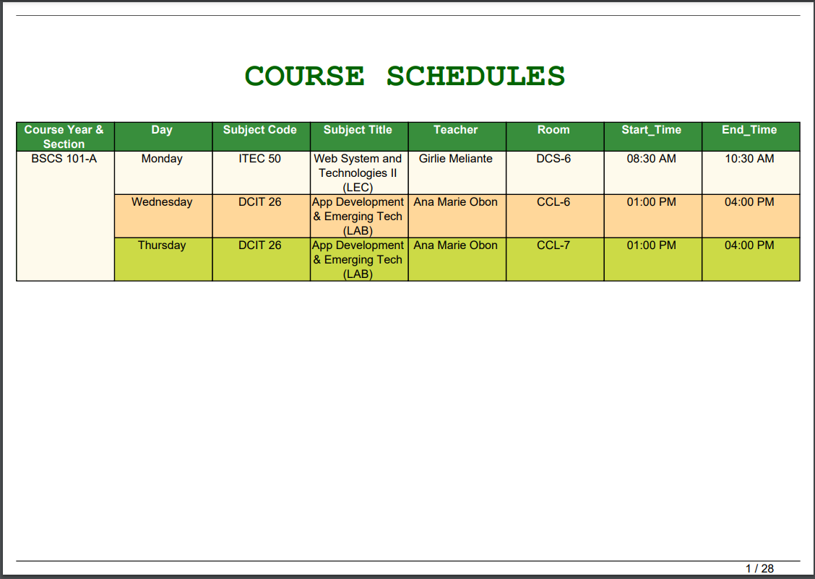Figure . PDF Schedule for Course

## Testing Results

In this section, the testing results for both the reliability of the generated schedules and the functionality of the system modules are presented and discussed. These results provide insights into the dependability and consistency of the generated schedules as well as the effectiveness of the individual system modules in performing their intended tasks.

**Reliability**

The developers performed tests to verify the reliability of the generated class schedules, ensuring that criteria such as conflict-free schedules for teachers, rooms, and courses were met. These tests were conducted based on specific testing conditions

Developers performed 10 tests for each testing condition to thoroughly evaluate the reliability of the generated class schedules. This iterative testing approach was undertaken to ensure that the schedules consistently adhered to the specified criteria. The developers test the reliability of generated schedules based on the testing conditions (See Appendix Table 2). Table 4 summarizes the test results for the reliability assessment.

Table . Summary of Testing Results for Reliability

|  |  |
| --- | --- |
| **TESTING CONDITION** | **REMARK** |
| 1. Teachers, Students and Rooms must have a conflict-free generated schedules. | Passed |
| 1. The timeslot duration must align with the subject hours. | Passed |
| 1. The generated output should be free of conflicts. | Passed |
| 1. The Manual added schedule should not overlap with the existing schedules. | Passed |
| 1. The room type should be corresponded to the subject type. | Passed |

***Functionality***

To ensure the functionality of each module, the system incorporates essential security measures and features, including unique email restriction, account blocking for failed login attempts, and password reset functionality. Additionally, it provides CRUD functionality for efficient data management, while enforcing restrictions on duplicate entries to uphold data integrity as shown in Table 5. These measures collectively contribute to the overall effectiveness and reliability of the system. *(See Appendix Tables 3 to 4 for specific detailed test case for each module).*

Table . Summary of Testing Results for Functionality

|  |  |  |  |  |
| --- | --- | --- | --- | --- |
| **TEST CASE ID** | **FUNCTION** | **EXPECTED RESULT** | **ACTUAL RESULT** | **STATUS** |
| T-001 | Test the login module | Web-based system should block unregistered users and it should not allow new user to register same email address. | Unregistered users were denied access by web-based system, and the registration process for the same email address was restricted. | Passed |
| T-002 | Test Faculty Loading Module | CRUD Functionality and Duplicate Data Restriction | CRUD functionality is functioning effectively, ensuring that duplicate data is prevented and users are unable to enter redundant information. | Passed |

## Evaluation Results

The system's performance was assessed using the modified ISO-IEC 25010. evaluation criteria, encompassing functional suitability, performance efficiency, usability, security, maintainability, and portability. A total of 40 individuals participated in the evaluation process, including 10 IT experts and 30 end-users.

***Narrative Discussion of the Performance Evaluation of the System based on IT Experts***

Table 6 reflects the assessment of the IT expert respondents in the functional sustainability of the system when it comes to Functional Completeness, Functional Correctness, Functional Appropriateness. The indicator was rated as follows; Functional Completeness received, 4.10; Functional Correctness, 4.30 and Functional Appropriateness, 4.50. The mean of 4.30 indicates that the system is functioned well, provides correct results with precision and facilitates the accomplishment of the tasks and objectives.

Table . Perception of IT Experts in the functional suitability of the system

|  |  |  |
| --- | --- | --- |
| CHARACTERISTICS | AVERAGE SCORE | DESCRIPTIVE INTERPRETATION |
| 1. Functional Completeness | 4.10 | Satisfactory |
| 1. Functional Correctness | 4.30 | Very Satisfactory |
| 1. Functional Appropriateness | 4.50 | Excellent |
| Average Mean | 4.30 | Very Satisfactory |

Table 7 reflects the assessment of the IT expert respondents in the performance efficiency of the system when it comes to Time Behavior, resource utilization, capacity. The indicator was rated as follows; Time behavior received, 4.50; Resource Utilization, 4.60 and Capacity, 4.60. The mean of 4.56 indicates that the system performed well as it met the specified requirements of the system.

Table . Perception of IT Experts in the Performance Efficiency of the system

|  |  |  |
| --- | --- | --- |
| CHARACTERISTICS | AVERAGE SCORE | DESCRIPTIVE INTERPRETATION |
| 1. Time behavior | 4.50 | Excellent |
| 1. Resource utilization | 4.60 | Excellent |
| 1. Capacity | 4.60 | Excellent |
| Average Mean | 4.56 | Excellent |

Table 8 reflects the assessment of the IT Expert respondents in the Appropriateness Recognizability, Learnability, Operability, User Error Protection and User Interface Aesthetics of the system. Appropriateness Recognizability received, 4.50, Learnability received 4.50, Operability received 4.50, User Error Protection received 4.40 User Interface Aesthetics received 3.80 and Accessibility received 4.40. This result indicates that the system is Very Satisfactory in exchanging information and make use of information.

Table . Perception of IT Experts in the Usability of the system

|  |  |  |
| --- | --- | --- |
| CHARACTERISTICS | AVERAGE SCORE | DESCRIPTIVE INTERPRETATION |
| 1. Appropriateness Recognizability | 4.50 | Excellent |
| 1. Learnability | 4.50 | Excellent |
| 1. Operability | 4.50 | Excellent |
| 1. User Error Protection | 4.40 | Satisfactory |
| 1. User Interface Aesthetics | 3.80 | Very Satisfactory |
| 1. Accessibility | 4.40 | Very Satisfactory |
| Average Mean | 4.35 | Very Satisfactory |

Table 9 reflects the assessment of the IT Expert respondents in the security of the system when it comes confidentiality and integrity, The indicator was rated as follows, confidentiality received, 4.20; and integrity received, 3.90. The mean of 4.05 indicates very satisfactory, and the system can provide strong security for the user.

Table . Perception of IT Experts in the Security of the system

|  |  |  |
| --- | --- | --- |
| CHARACTERISTICS | AVERAGE SCORE | DESCRIPTIVE INTERPRETATION |
| 1. Confidentiality | 4.20 | Very Satisfactory |
| 1. Integrity | 3.90 | Satisfactory |
| Average Mean | 4.05 | Very Satisfactory |

Table 10 shows system maintainability evaluation results with ratings for each indicator: modularity 4.30, reusability 4.40, analyzability 4.20, modifiability 4.30, and testability 4.00. The mean average of 4.24 indicates high user satisfaction and ease of modification and maintenance.

Table . Perception of IT Experts in the Maintainability of the system

|  |  |  |
| --- | --- | --- |
| CHARACTERISTICS | AVERAGE SCORE | DESCRIPTIVE INTERPRETATION |
| 1. Modularity | 4.30 | Very Satisfactory |
| 1. Reusability | 4.40 | Very Satisfactory |
| 1. Analyzability | 4.20 | Very Satisfactory |
| 1. Modifiability | 4.30 | Very Satisfactory |
| 1. Testability | 4.00 | Very Satisfactory |
| Average Mean | 4.24 | Very Satisfactory |

Table 11 reflects the assessment of the IT Expert respondents in the portability of the system when it comes Adaptability. The indicator was rated as follows, Adaptability received, 3.60. The mean of 3.60 indicates satisfactory, and the system can provide enough portability for the user.

Table . Perception of IT Experts in the Portability of the system

|  |  |  |
| --- | --- | --- |
| CHARACTERISTICS | AVERAGE SCORE | DESCRIPTIVE INTERPRETATION |
| 1. Adaptability | 3.60 | Satisfactory |
| Average Mean | 3.60 | Satisfactory |

The summary of assessments provided by the IT Experts is presented in Table 12 showcasing the ratings for various aspects. Functional Suitability achieved a score of 4.16, Performance Efficiency received 4.56, Usability obtained 4.35, Security received 4.05, Maintainability achieved 4.24, and lastly, the portability of the system received a rating of 3.60. The average mean of these scores is 4.16, indicating a Very Satisfactory performance overall. *(See Appendix Figures 23 to 26 for detailed evaluation form of IT Experts).*

Table . Summary of Evaluation Results for IT Experts

|  |  |  |
| --- | --- | --- |
| CHARACTERISTICS | AVERAGE SCORE | DESCRIPTIVE INTERPRETATION |
| 1. Functional Suitability | 4.16 | Very Satisfactory |
| 1. Performance Efficiency | 4.56 | Very Satisfactory |
| 1. Usability | 4.35 | Very Satisfactory |
| 1. Security | 4.05 | Very Satisfactory |
| 1. Maintainability | 4.24 | Very Satisfactory |
| 1. Portability | 3.60 | Satisfactory |
| Average Mean | 4.16 | Very Satisfactory |

***Narrative Discussion of the Performance Evaluation of the System based on End Users***

The evaluation of the system involved 30 participants, comprising students from Department of Computer Studies. These respondents assessed the system's usability, effectiveness, efficiency, satisfaction, and coverage of relevant contexts.

Table 13 reflects the assessment of the end user respondents in the usability of the system when it comes to appropriateness recognizability, learnability, operability, user error protection, user interface aesthetics. The indicator was rated as follows; appropriateness recognizability received, 4.70; learnability, 4.60; operability, 4.70; user error protection, 4.40; and User Interface Aesthetics, 4.50. The mean of 4.58 indicates that the system is significantly user-friendly.

Table . Perception of End-users in the Usability of the system

|  |  |  |
| --- | --- | --- |
| CHARACTERISTICS | AVERAGE SCORE | DESCRIPTIVE INTERPRETATION |
| 1. Appropriateness Recognizability | 4.70 | Excellent |
| 1. Learnability | 4.60 | Excellent |
| 1. Operability | 4.70 | Excellent |
| 1. User Error Protection | 4.40 | Very Satisfactory |
| 1. User Interface Aesthetics | 4.50 | Very Satisfactory |
| Average Mean | 4.58 | Excellent |

Table 14 reflects the assessment of the end user respondents in terms of effectiveness of the system. The indicator was rated as follows; Effectiveness, 4.80. This result indicates that the system is significantly effective in terms of achieving specified goals when used in specified contexts.

Table . Perception of End-users in the Effectiveness of the system

|  |  |  |
| --- | --- | --- |
| CHARACTERISTICS | AVERAGE SCORE | DESCRIPTIVE INTERPRETATION |
| 1. Effectiveness | 4.80 | Excellent |
| Average Mean | 4.80 | Excellent |

Table 15 reflects the assessment of the end user respondents in terms of the efficiency of the system. The indicator was rated as follows; Efficiency, 4.70. This result suggests that the system demonstrates a commendable level of efficiency by effectively utilizing resources to assist users in achieving their objectives accurately and comprehensively.

Table . Perception of End-users in the Efficiency of the system

|  |  |  |
| --- | --- | --- |
| CHARACTERISTICS | AVERAGE SCORE | DESCRIPTIVE INTERPRETATION |
| 1. Efficiency | 4.70 | Very Satisfactory |
| Average Mean | 4.70 | Very Satisfactory |

Table 16 reflects the assessment of the end user respondents in terms of user satisfaction of the system. The indicator was rated as follows; Usefulness, 4.80; Trust, 4.70; Pleasure, 4.60, and Comfort, 4.70. The mean of 4.70 indicates that the system is relevantly satisfied the user in terms of trust, pleasure, comfort, and usefulness.

Table . Perception of End-users in the Satisfaction of the system

|  |  |  |
| --- | --- | --- |
| CHARACTERISTICS | AVERAGE SCORE | DESCRIPTIVE INTERPRETATION |
| 1. Usefulness | 4.80 | Excellent |
| 1. Trust | 4.70 | Excellent |
| 1. Pleasure | 4.60 | Excellent |
| 1. Comfort | 4.70 | Excellent |
| Average Mean | 4.70 | Excellent |

Table 17 reflects the assessment of the end user respondents in terms of context coverage of the system. The indicator was rated as follows; Content Completeness, 4.70; and Flexibility, 4.80. The mean of 4.75 indicates that the system is significantly complete and flexible in order for the users to achieve specified goals effectively, efficiently, and satisfactorily through different complexity.

Table . Perception of End-users in the Context Coverage of the system

|  |  |  |
| --- | --- | --- |
| CHARACTERISTICS | AVERAGE SCORE | DESCRIPTIVE INTERPRETATION |
| 1. Content Completeness | 4.70 | Excellent |
| 1. Flexibility | 4.80 | Excellent |
| Average Mean | 4.75 | Excellent |

Based on the feedback from end-users table 18 shows that the system has received exceptional evaluations in terms of usability, effectiveness, efficiency, satisfaction, and context coverage. The average mean score of 4.70 reflects the system's remarkable performance across these dimensions, highlighting its ability to meet the needs and expectations of the users. The positive ratings signify that the system is user-friendly, efficient, and effective in achieving its intended purposes, ultimately resulting in high user satisfaction *(See Appendix Tables 26 to 28 for end-user detailed evaluation form).*

Table . Summary of Evaluation results for End-user

|  |  |  |
| --- | --- | --- |
| CHARACTERISTICS | AVERAGE SCORE | DESCRIPTIVE INTERPRETATION |
| 1. Usability | 4.58 | Excellent |
| 1. Effectiveness | 4.80 | Excellent |
| 1. Efficiency | 4.70 | Excellent |
| 1. Satisfaction | 4.70 | Excellent |
| 1. Context Coverage | 4.75 | Excellent |
| Average Mean | 4.70 | Excellent |

# SUMMARY, CONCLUSIONS AND RECOMMENDATION

## Summary

The research project entitled "Automated Timetable Scheduling System using Backtracking Algorithm" was conducted from May 2022 to May 2023. The objectives of the study were as follows: 1) document and analyze the existing process of scheduling classes, 2) design and develop a web application that automate the generation of class schedules. 3) test the reliability of generated schedules based on testing conditions and the functionality of system modules. b) Evaluate the system using modified ISO-IEC 25010. During the study, the developers adopted the Rapid Application Development (RAD) methodology, which involved four phases: Requirement Analysis Phase, Prototype Cycle Phase, Developing and Testing Phase, and Deployment Phase.

During the Requirement analysis phase, the developers collected and analyzed information about the existing scheduling process, as well as studied related articles, books, studies, and systems to identify the criteria for assigning timeslots and rooms. Once the requirements and necessary data were gathered, the developers created flow charts and prototypes (or wireframes) for the proposed system. Subsequently, the prototype was transformed into a functioning system, which underwent refinements whenever errors or bugs were identified.

## Conclusion

The following conclusion were made based on the results of the study:

* The developers were able to develop a dynamic web-based system to automates the generation of schedules using backtracking algorithm.
* The developers were able to document and analyzed the current scheduling process at Cavite State University CCAT Campus and used it for designing the prototype or wireframes.
* The developers were able to test the reliability of generated outputs based on the testing conditions. The generated output passed all the testing condition which means that the generated schedules were free of conflict. The developers were also able to test the functionality of each system modules using the test cased provided in the manuscript.
* The developers were able to use the modified ISO-IEC 25101 for evaluation. Collectively, these evaluation results highlight the exceptional performance and characteristics of our developed system, demonstrating its effectiveness, efficiency, usability, security, maintainability, and contextual coverage. The positive ratings from both IT experts and end users affirm its high quality and ability to meet user requirements, making it a highly satisfactory and excellent system overall.

## Recommendation

Based on the results the following recommendation was made:

1. Printing Specific Schedules: Allow users to easily print specific schedules directly from the system.
2. User and Teacher Management: Introduce a user management system that enables administrators to add and manage user accounts. Additionally, provide teachers with access to view schedules online.
3. Loading Screen Animation: Add a loading screen so the user knows what is happening during generation of schedules.

# REFERENCES

Abhik Mitra (2020), Intelligent Timetable Generator using Genetic Algorithm. <http://abhik.pythonanywhere.com/>

Al-Jarrah, M. A., Al-Sawalqah, A. A., & Al-Hamdan, S. F. (2017). Developing a course timetable system for academic departments using genetic algorithm https://www.researchgate.net/profile/Sami-Hamdan-4/publication/313487752_Developing_A_Course_Timetable_System_for_Academic_Departments_Using_Genetic_Algorithm/links/

Ben Moreland, (2015), Hard and Soft timetabling constraints. <https://educationspaceconsultancy.com/hard-and-soft-timetabling-constraints-not-only-a-working-timetable-but-a-great-timetable/>

Edmund Kieran Burke, Sanja Petrovic (2002), Recent research   directions in automated timetabling <https://doi.org/10.1016/S0377-2217(02)00069-3>

Gamale, Jeralyn M., Anuta, Edward C., Sayson, Zina D. (2011), Automated Scheduling System Capstone Project. <https://capstoneguide.com/automated-class-scheduling-system-capstone-project-document/>

John Benedict C. Legaspi, Roman M. De Angel, Ace C. Lagman, John Heland Jasper C. Ortega (n.d), Web based Course Scheduling System using Greedy Algorithm. <https://ijssst.info/Vol-20/No-S2/paper14.pdf>

Loic Ngou (2019), Timetable Generator using Genetic Algoritmh. https://Timetable Generator

“Neon Projects” (2015), Automated College Timetable Generator. <https://nevonprojects.com/automated-college-timetable-generator/>

Manoj Kumar, Mohammad Husian, Naveen Upreti & Deepti Gupta (2010), Genetic Algorithm: Review and Application. https://deliverypdf.ssrn.com/delivery.php

Paymon Khamooshi (2019), The Benefits of using a web-based application. <https://www.geeks.ltd.uk/insights/the-benefits-of-using-web-based-applications>

Soni Upadhyay (2023), Introdcution Backtracking algorithm <https://www.simplilearn.com/>

“Stanford University (2017), Recursive Backtracking and Optimization. https://web.stanford.edu/class/cs106b-8/lectures/backtracking optimization/Lecture13.pdf

Subhan Datta (2022), Backtracking Algorithms. https://www.baeldung.com/cs/backtracking-algorithms

Zina Houhamdi, Belkacem Athamena, Rani Abuzaineddin, Mohammad Muhairat (2019), A Multi-Agent System for Course Timetable Generation. <https://www.researchgate.net/publication/331995150_A_multi-agent_system_for_course_timetable_generation>

# APPENDICES

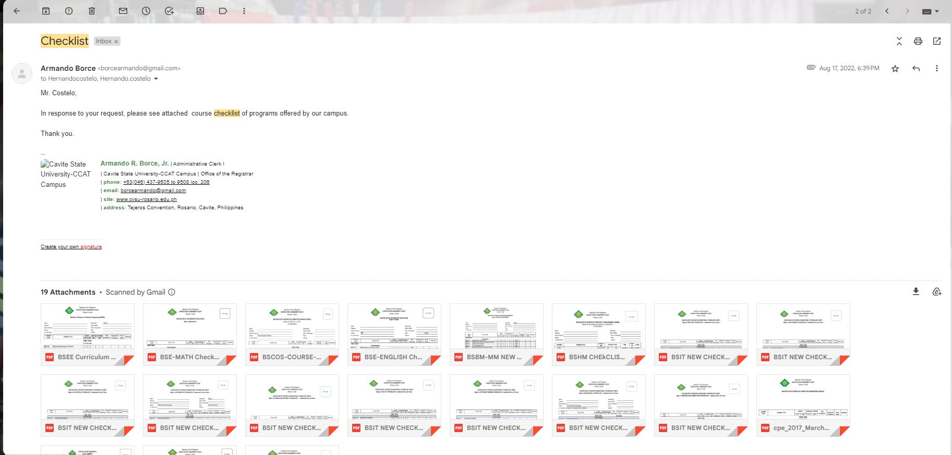

Appendix Figure . Email with attached checklist

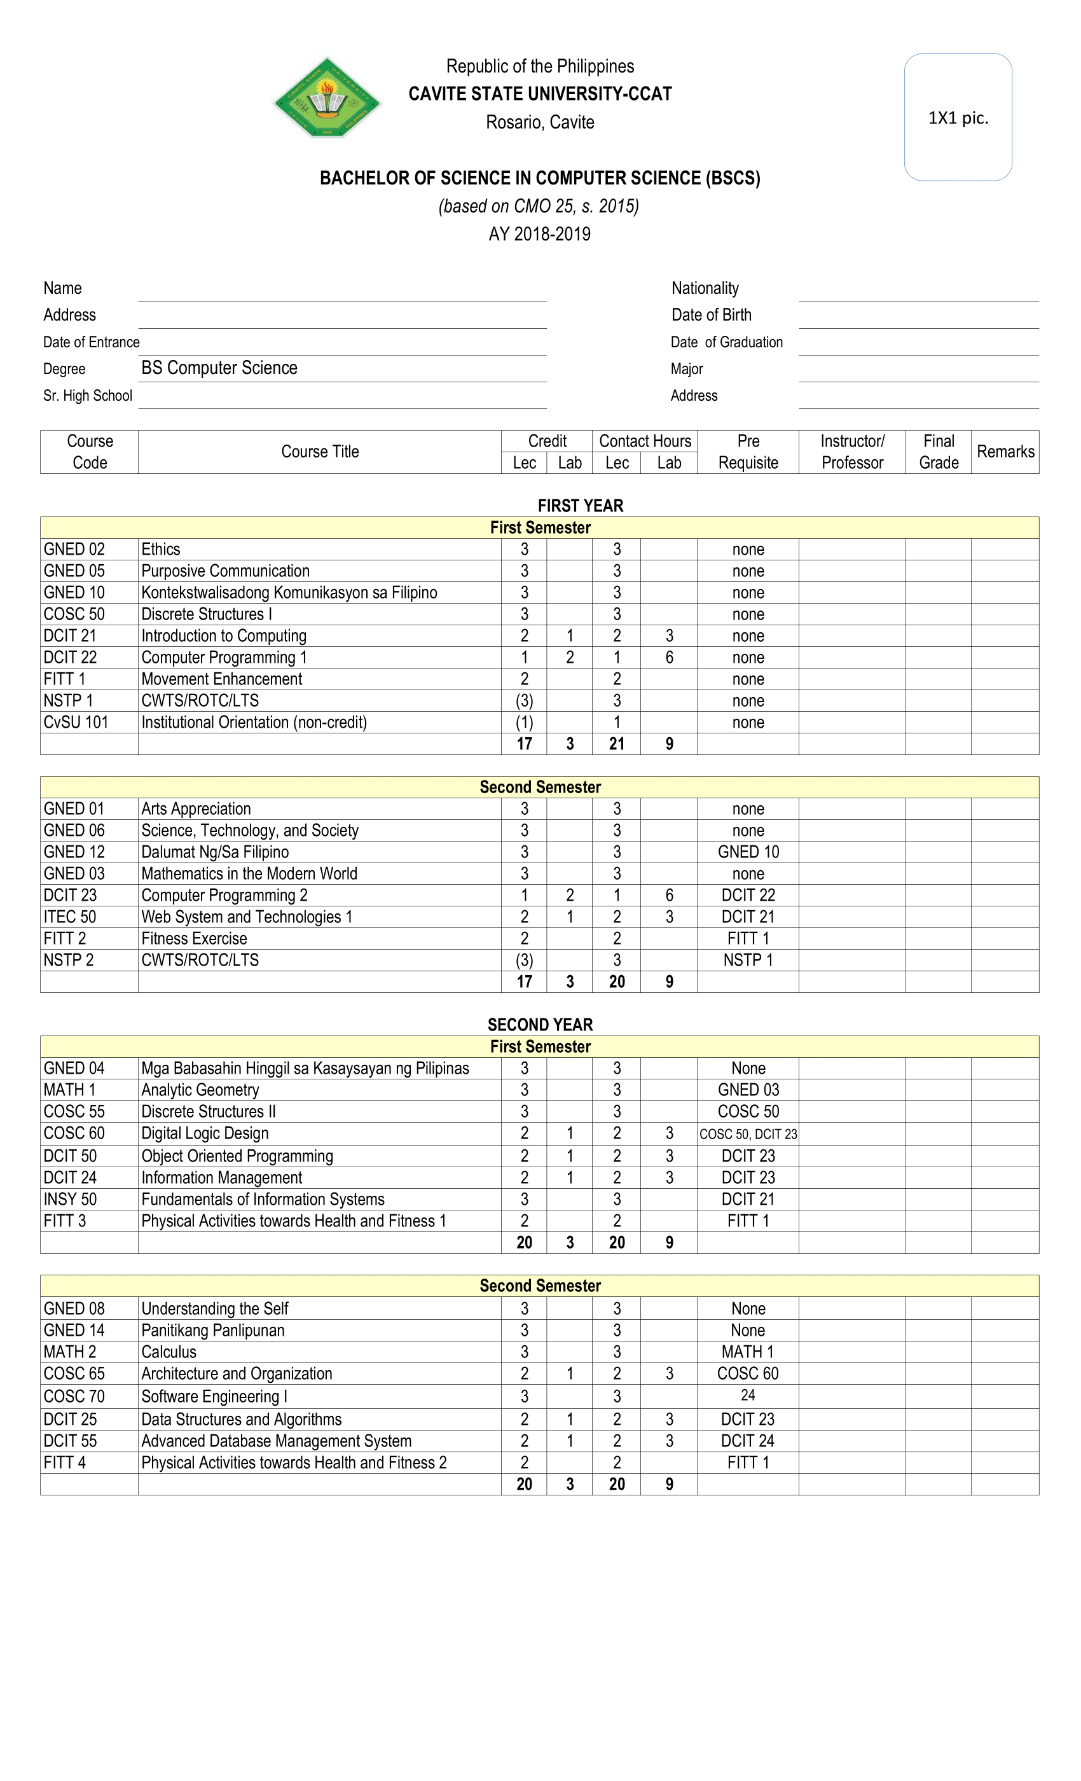

Appendix Figure . Subject Offerings (BSCS)

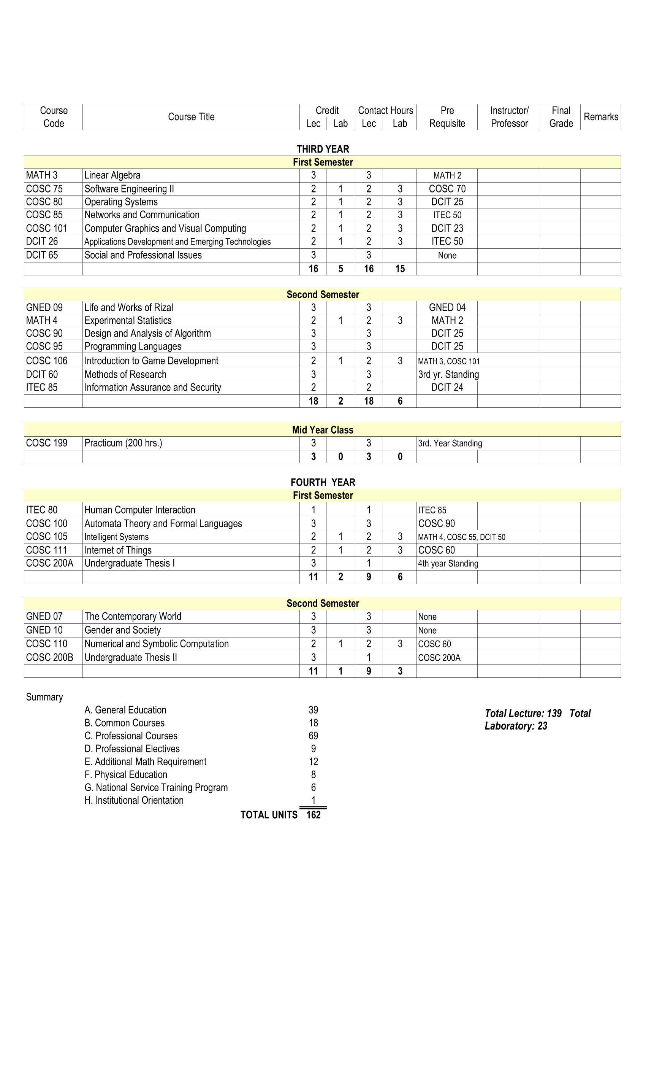

Appendix Figure . Subject Offerings (BSCS) 2

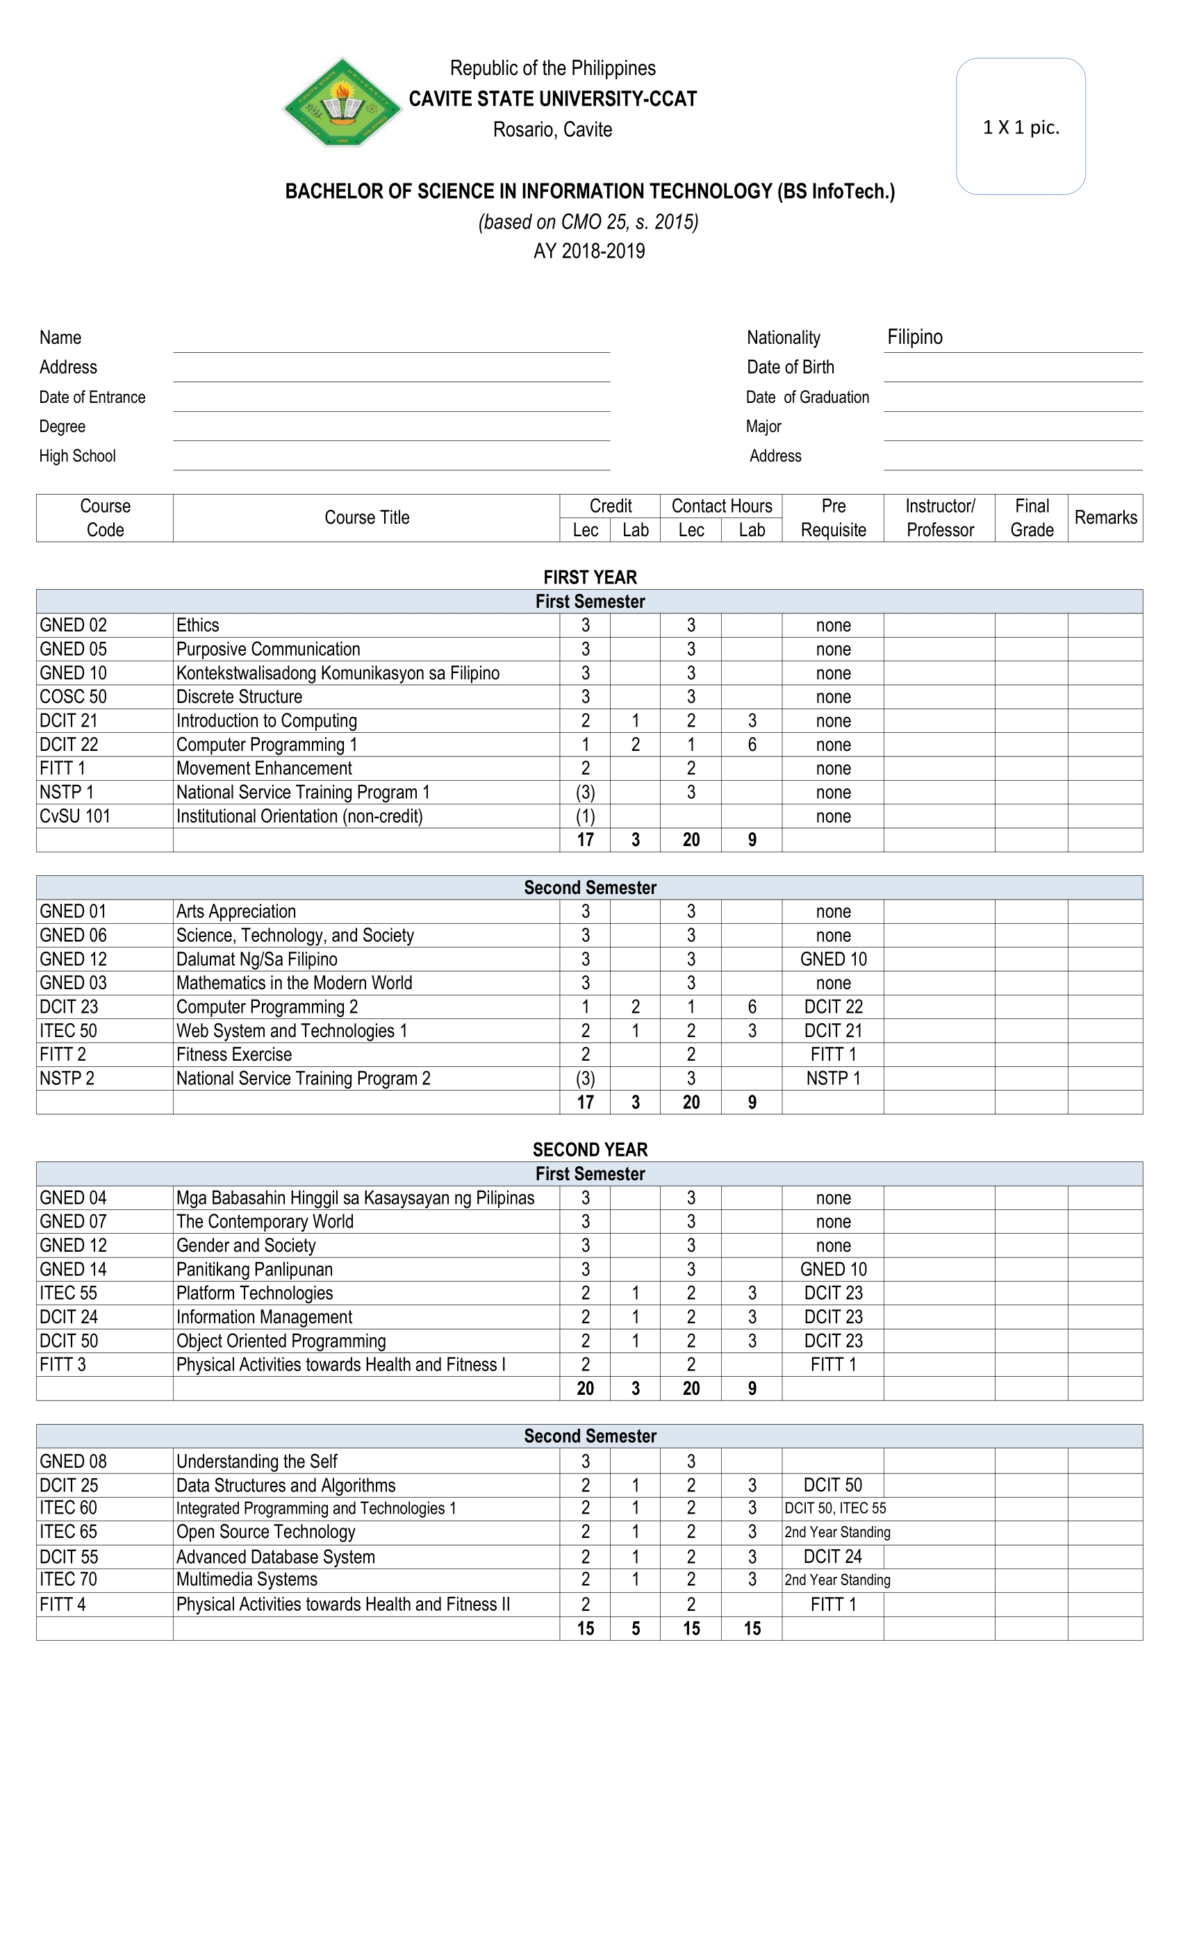

Appendix Figure . Subject Offerings (BSInfoTech)

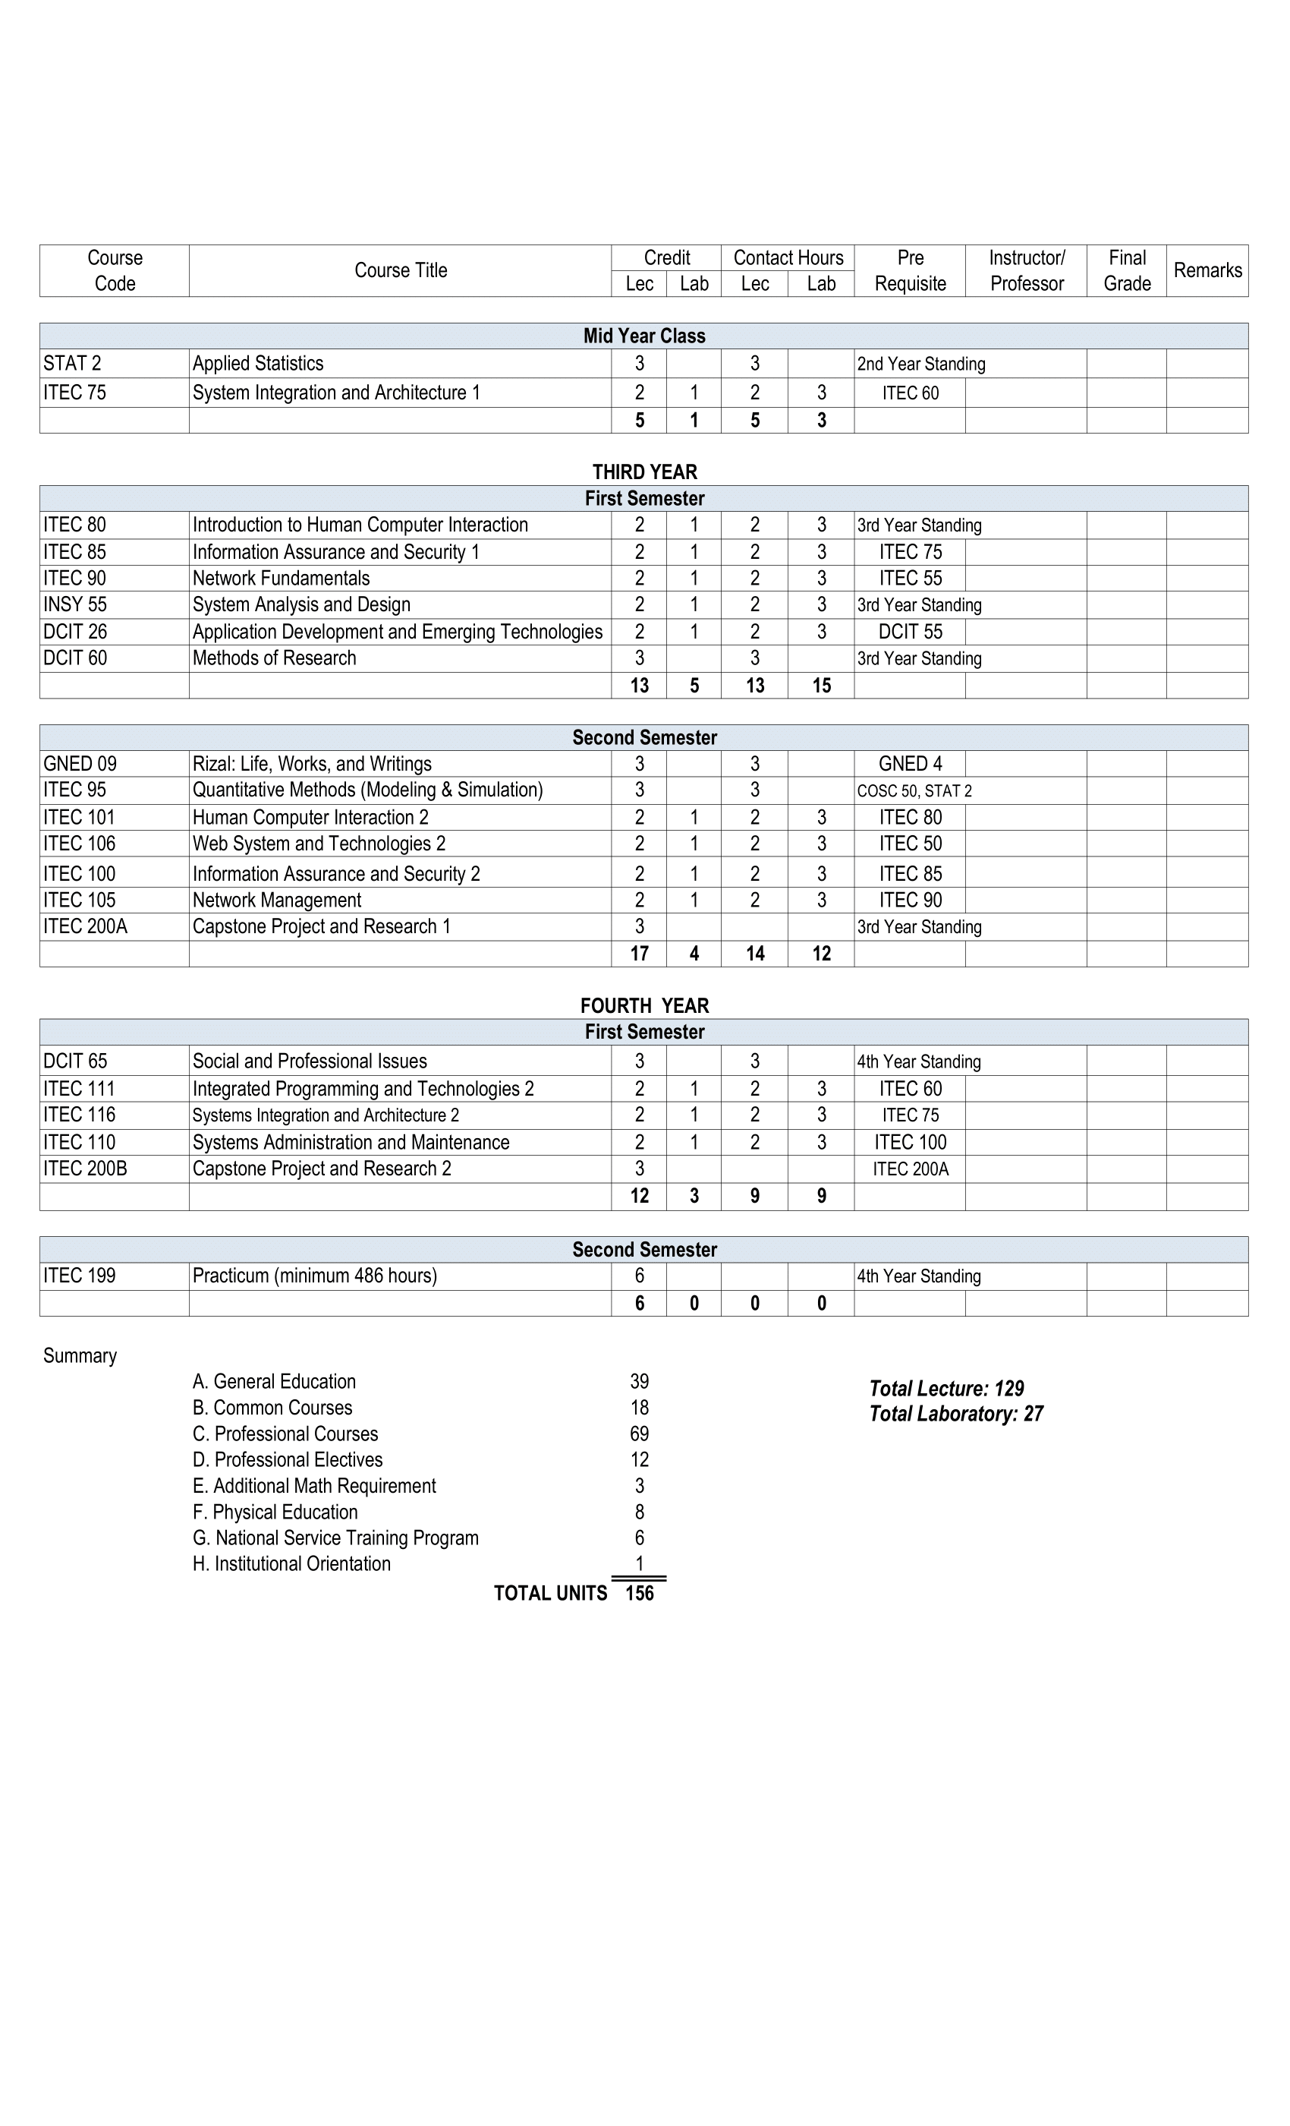

Appendix Figure . Subject Offerings (BSInfoTech) 2

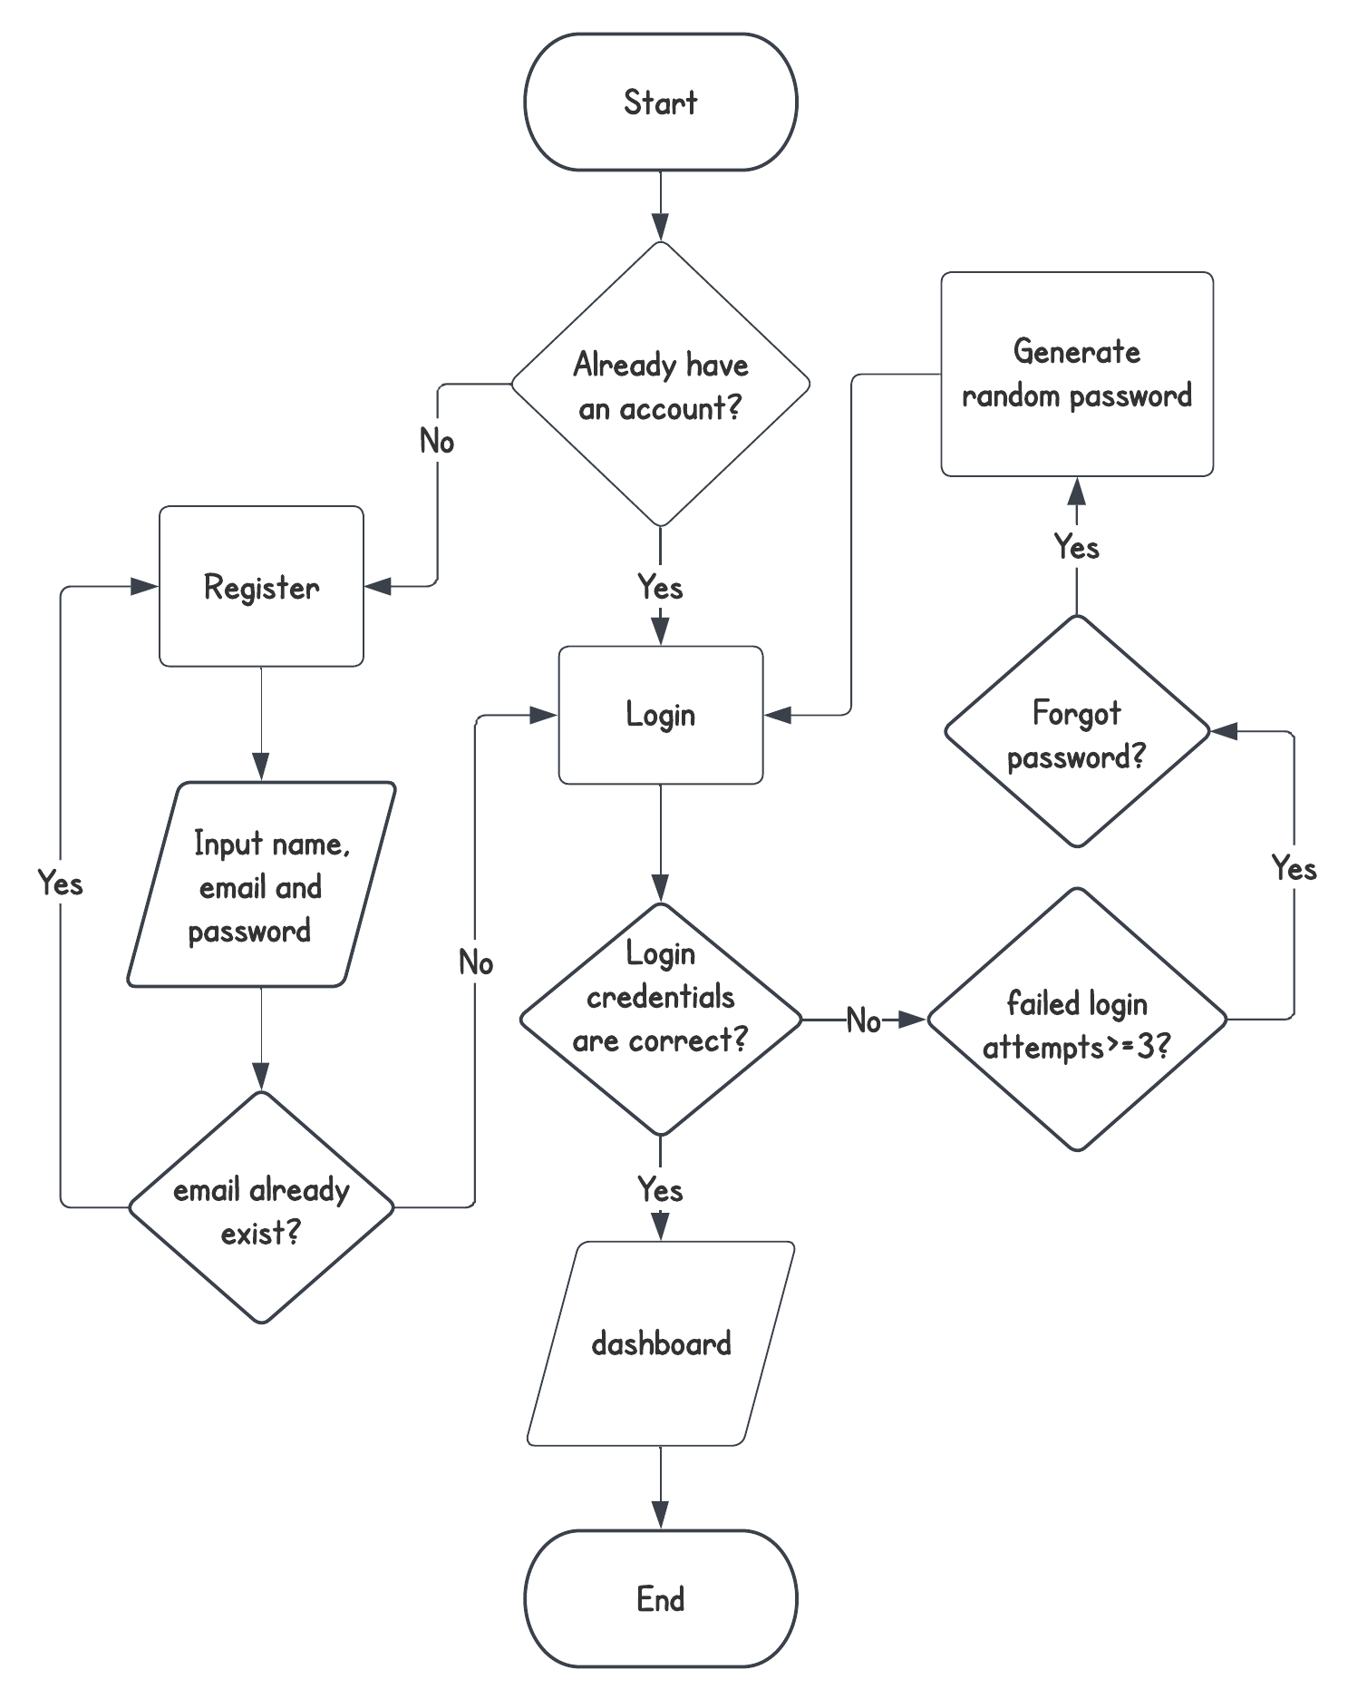

Appendix Figure . Login Flowchart

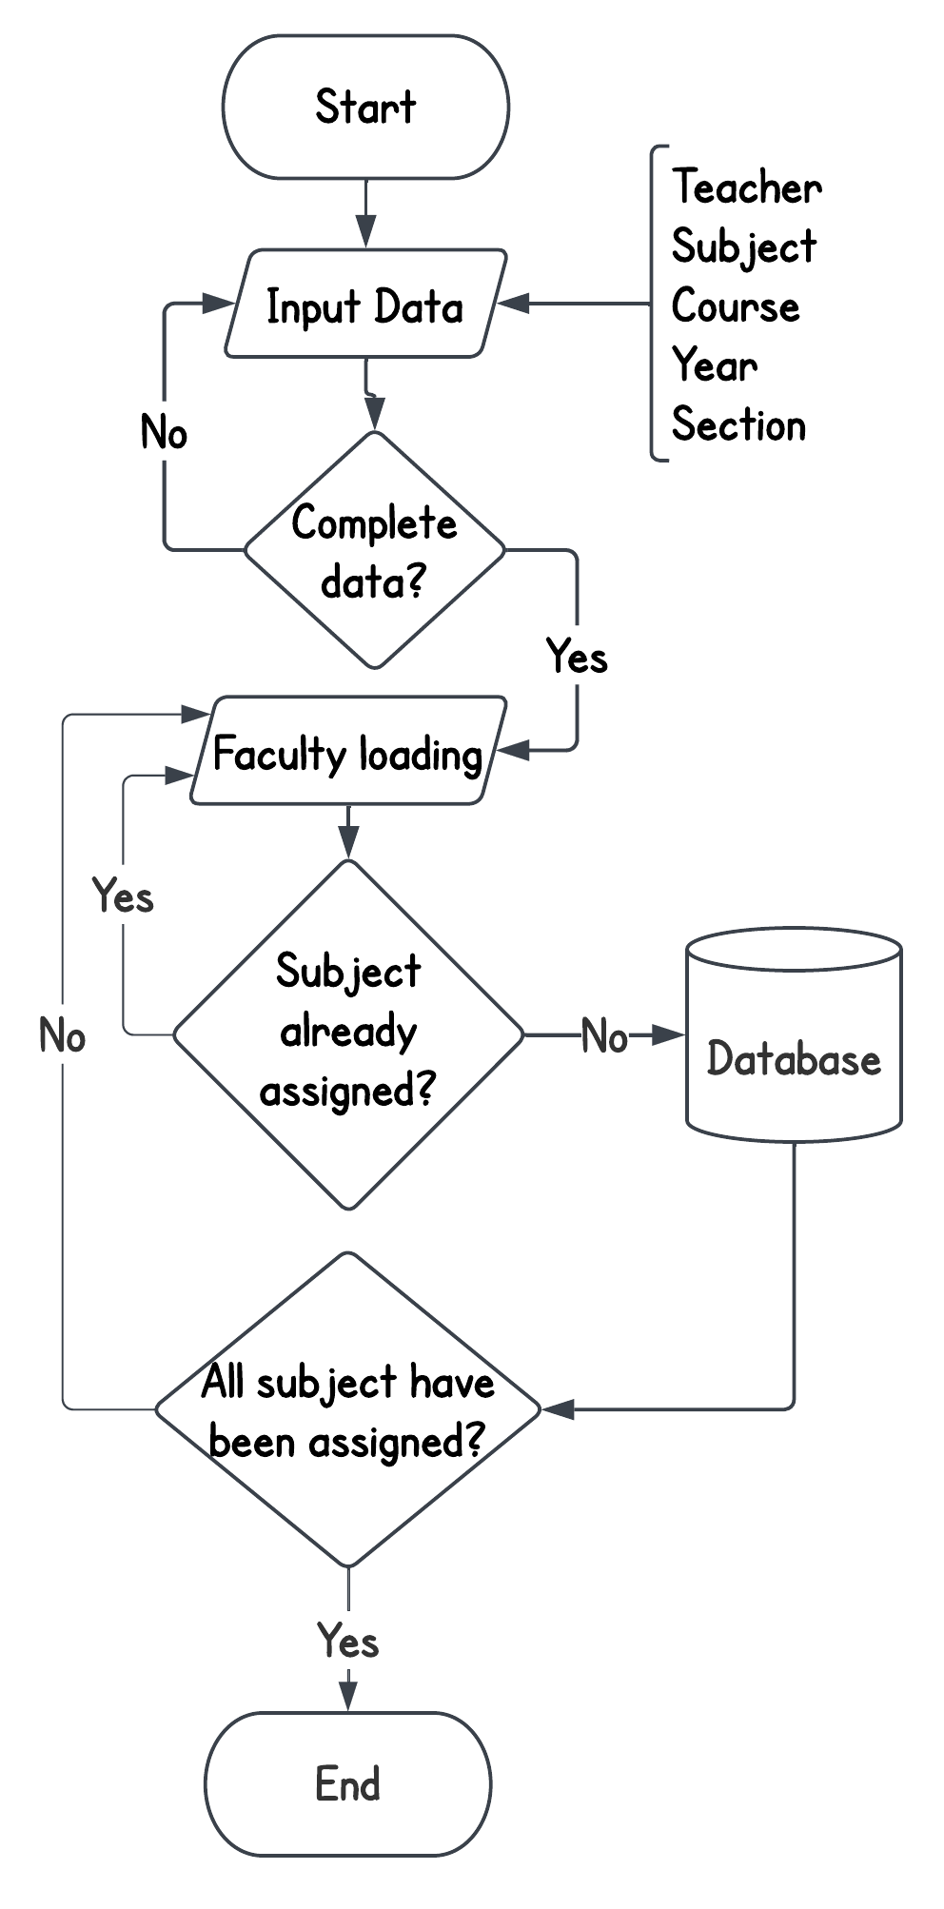

Appendix Figure . Faculty loading Flowchart

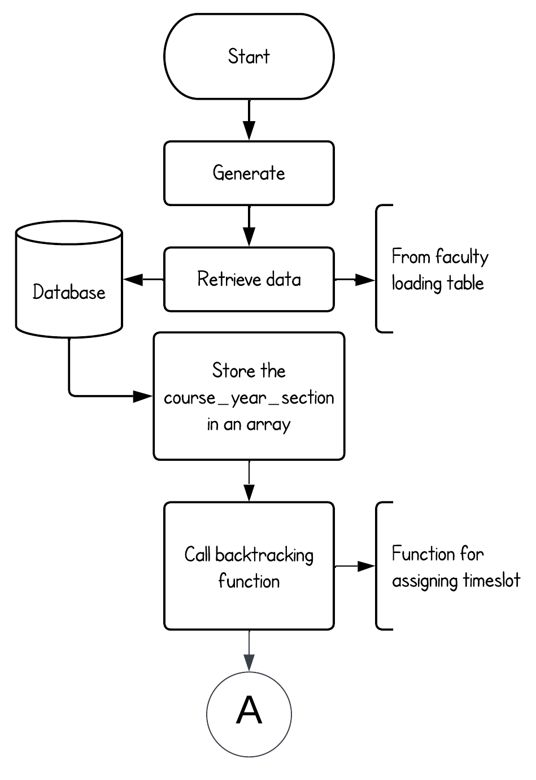

Appendix Figure . Automated Scheduling Flowchart

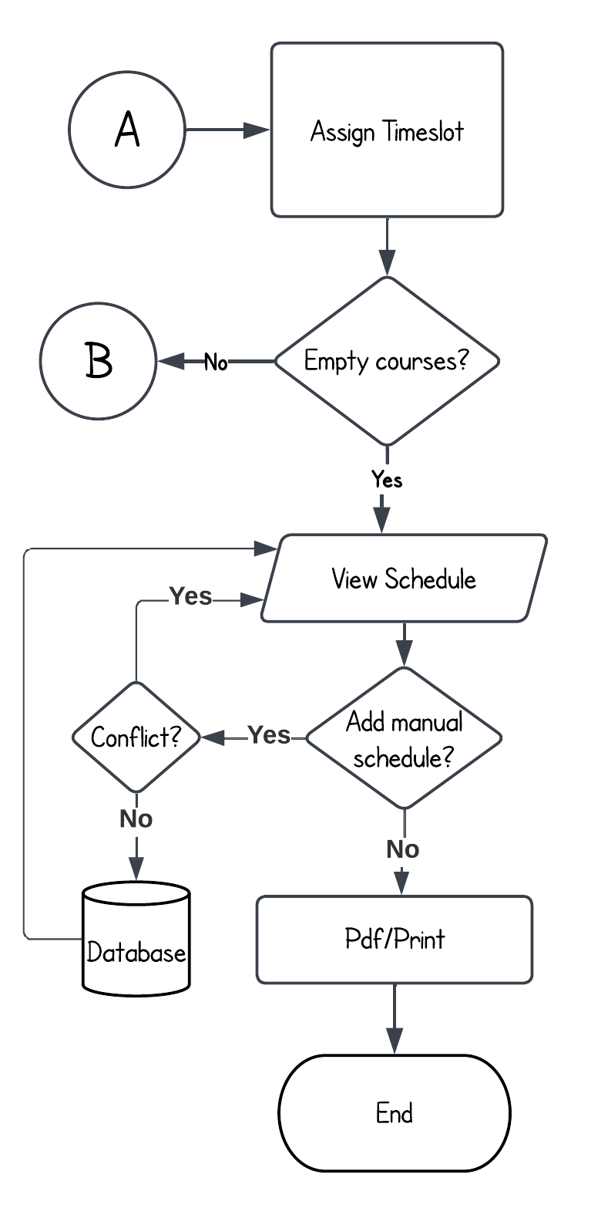

Appendix Figure . Automated Scheduling Flowchart Pt.2

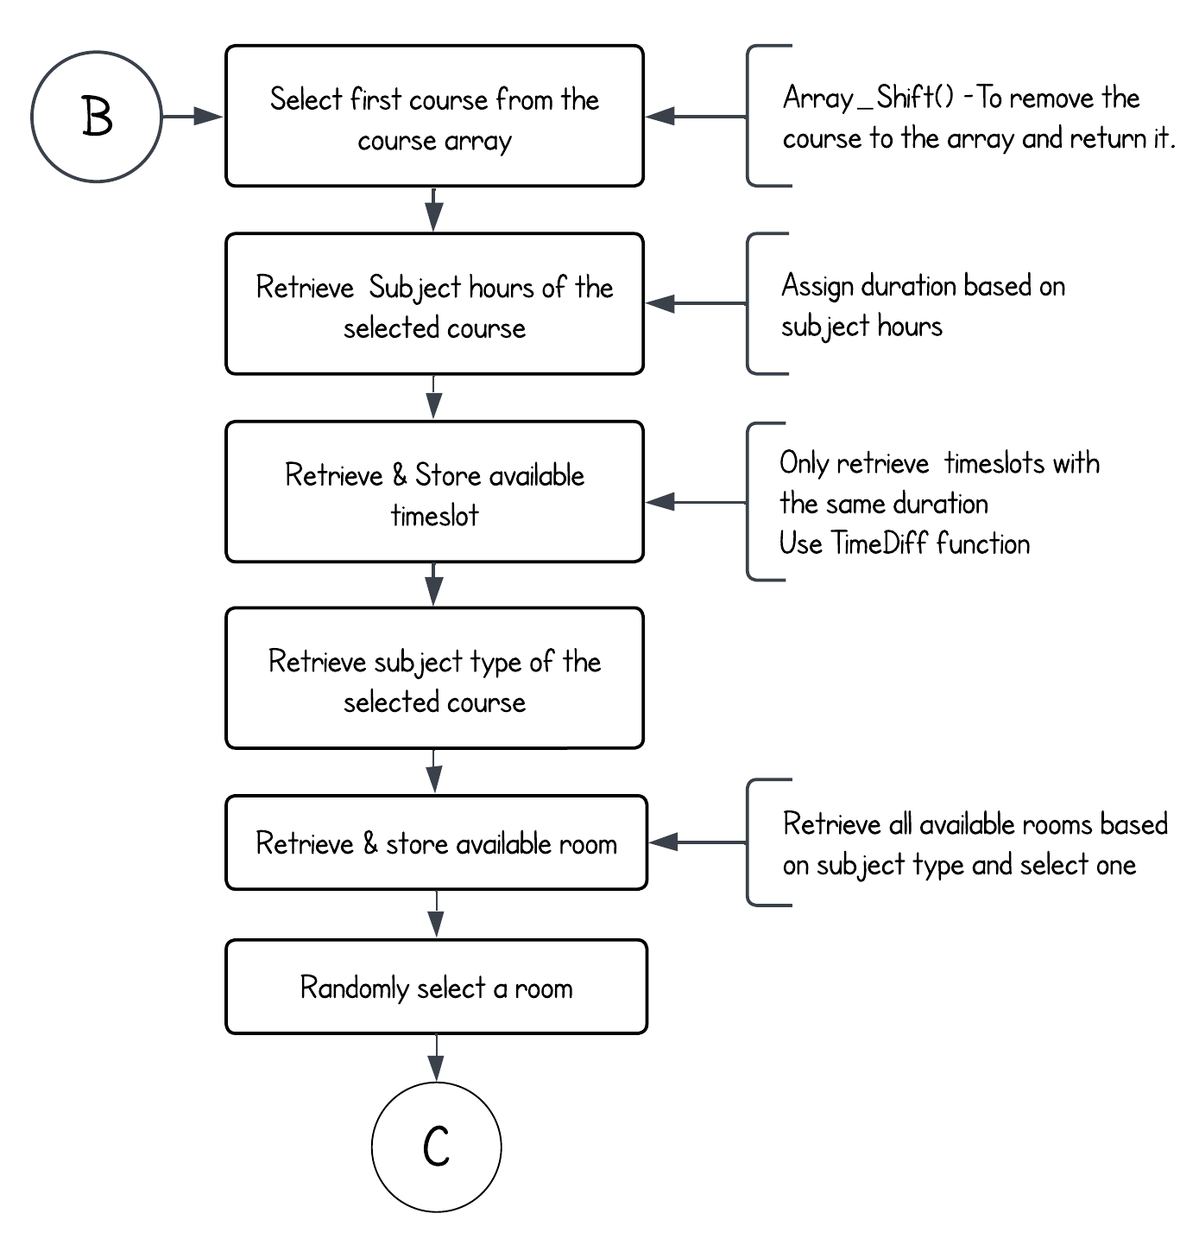

Appendix Figure . Automated Scheduling Flowchart Pt.3

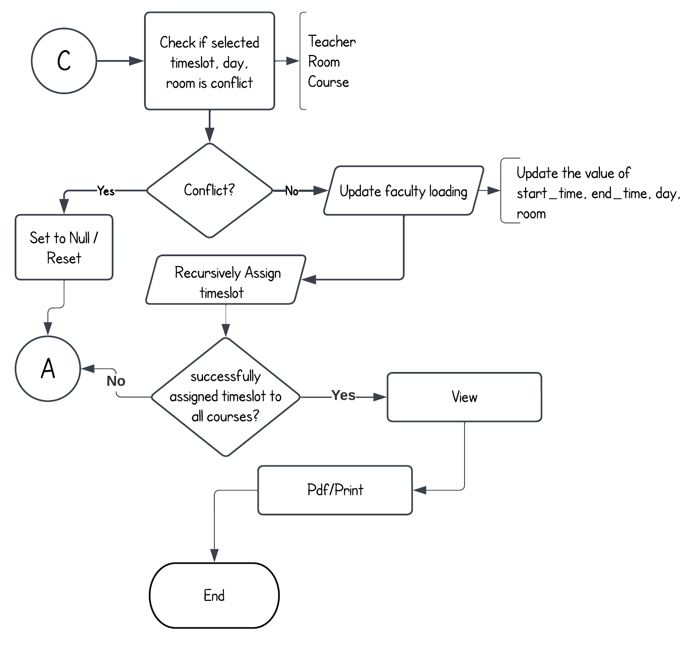

Appendix Figure . Automated Scheduling Flowchart Pt.4

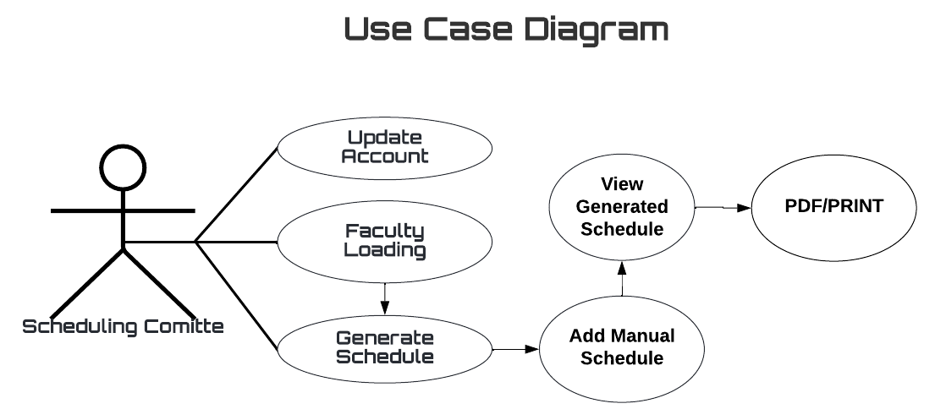

Appendix Figure . Use Case Diagram

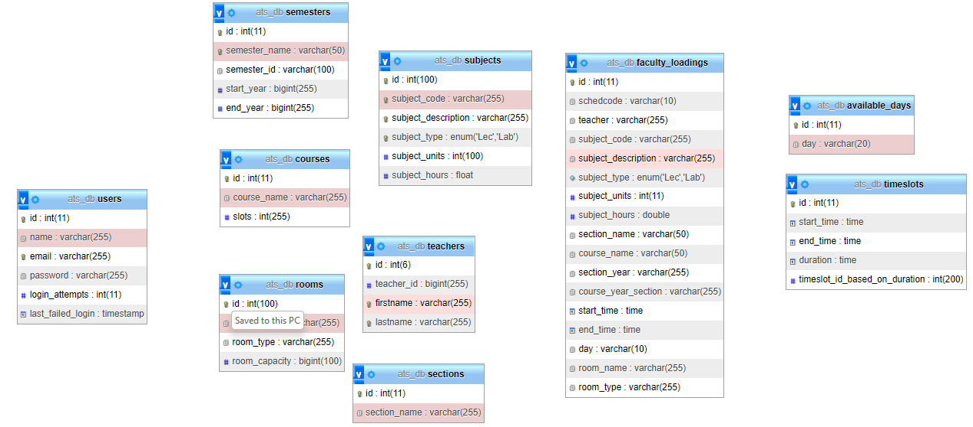

Appendix Figure 14. ATS Database Scheme

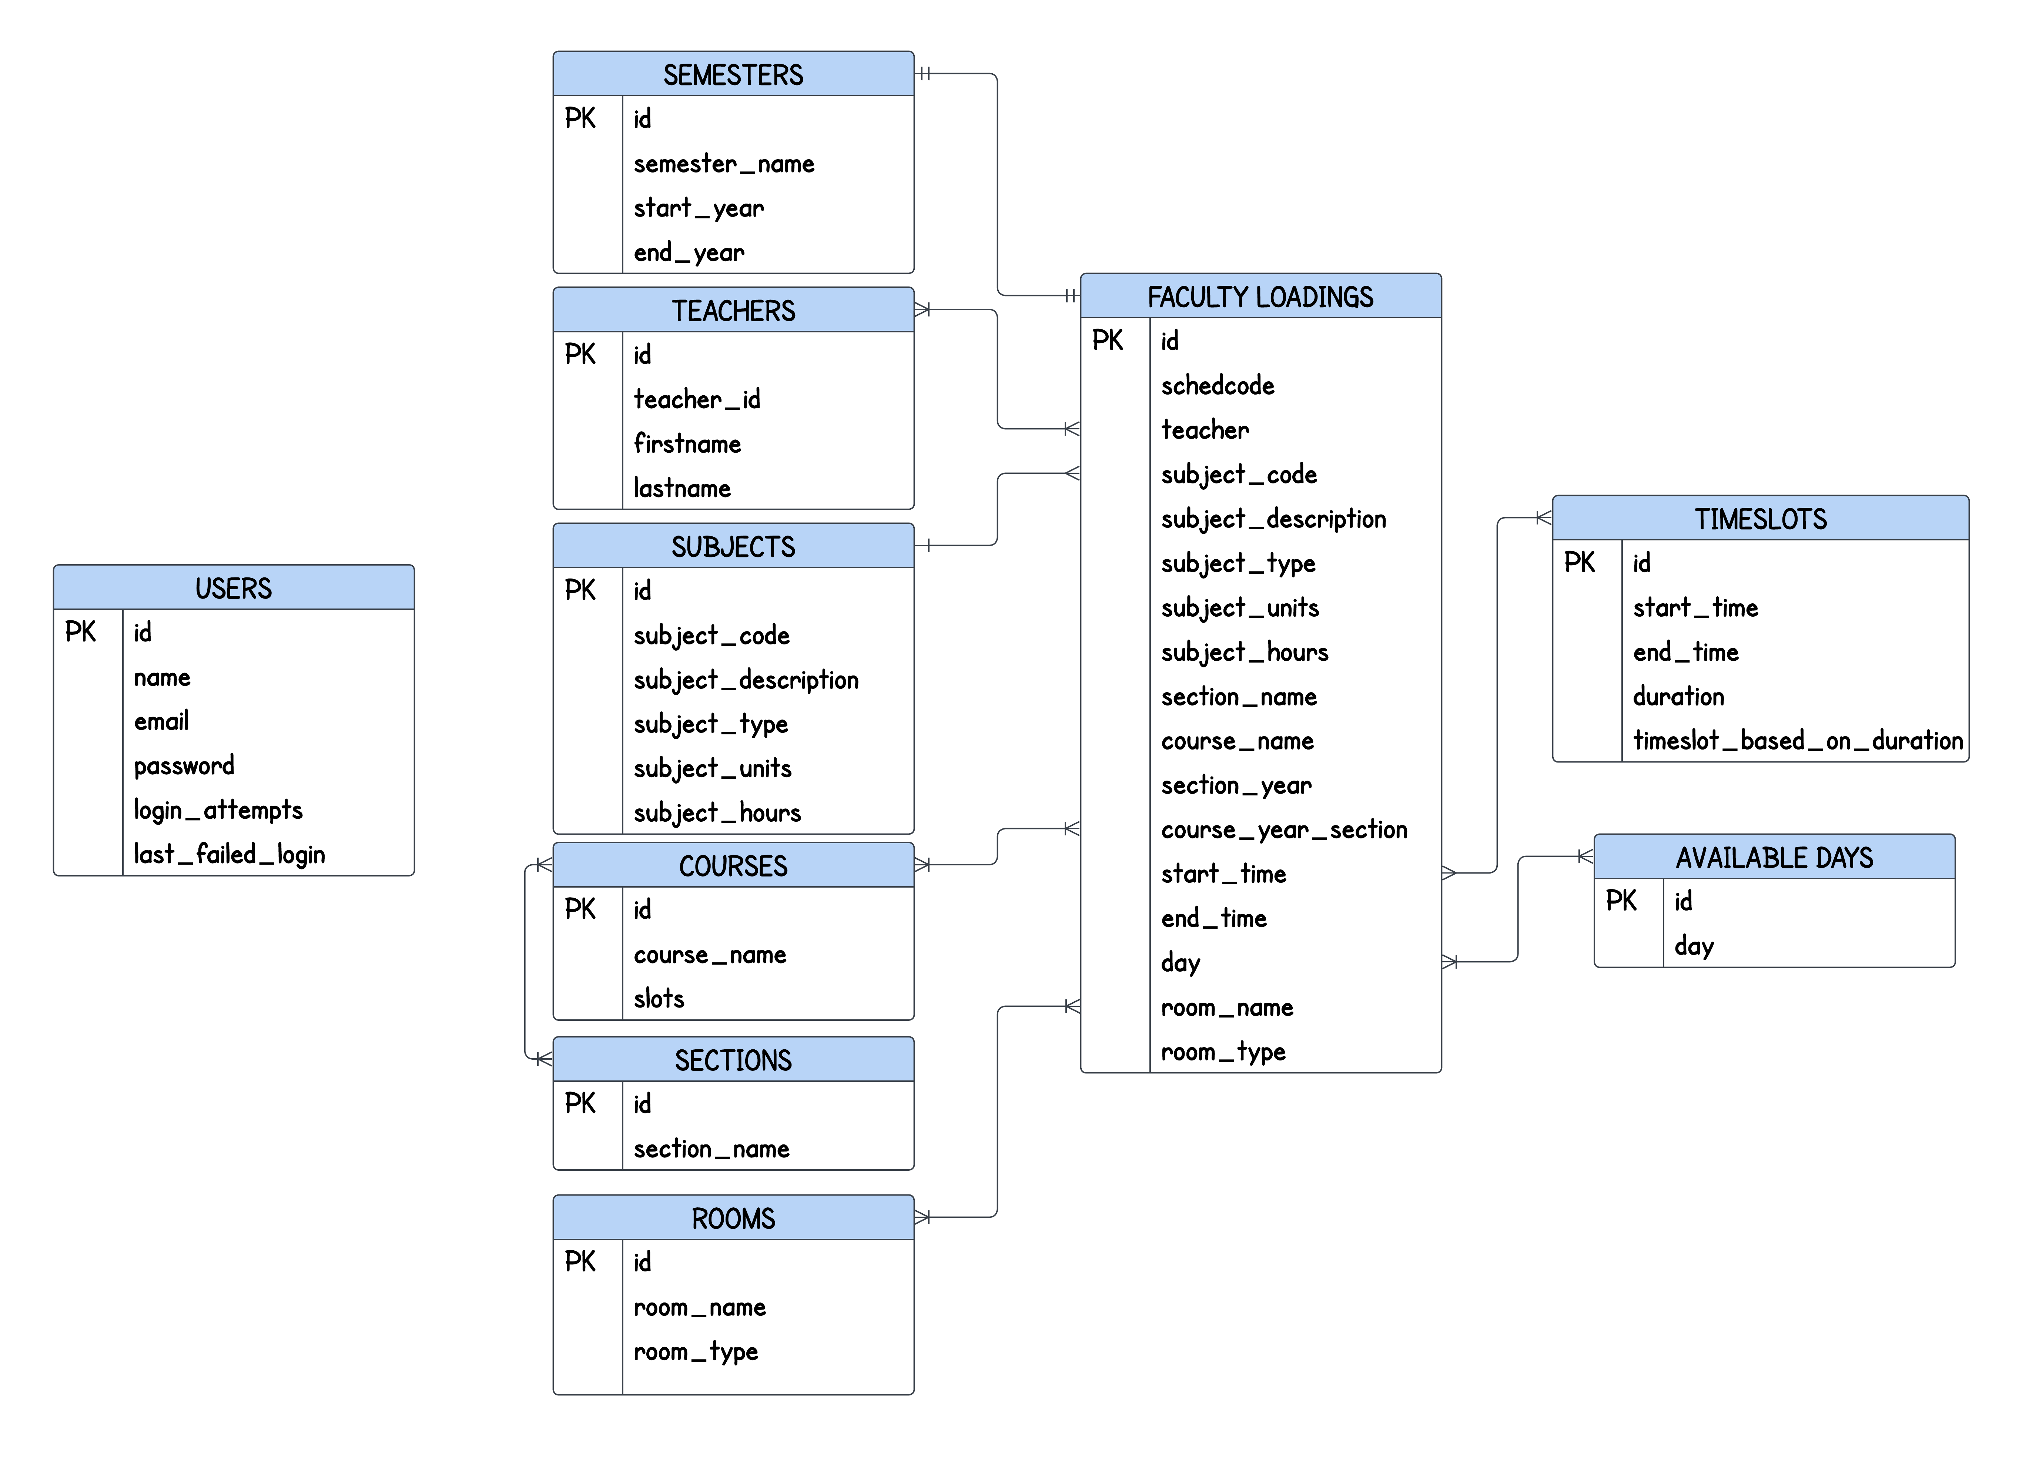

Appendix Figure . ATS Entity Relationship Diagram

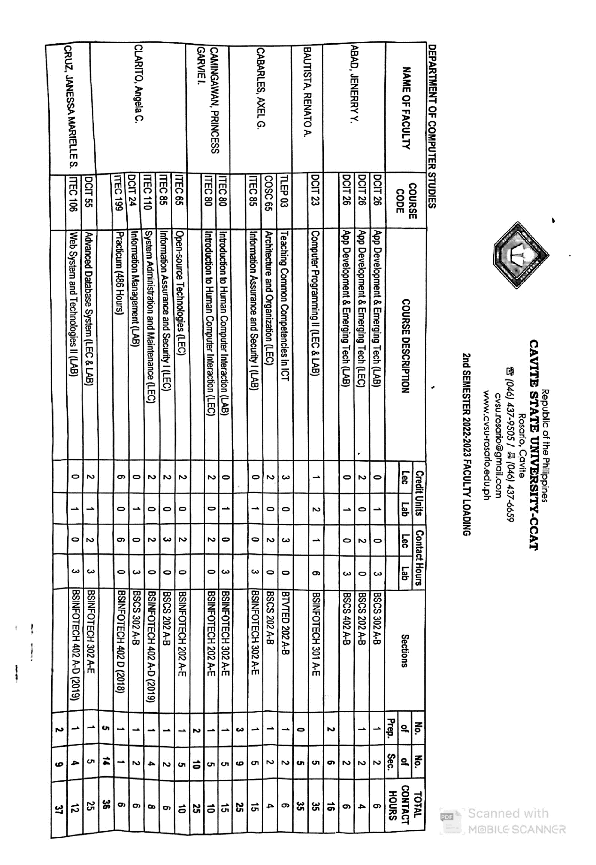

Appendix Figure . Faculty Loading Test Data pt.1

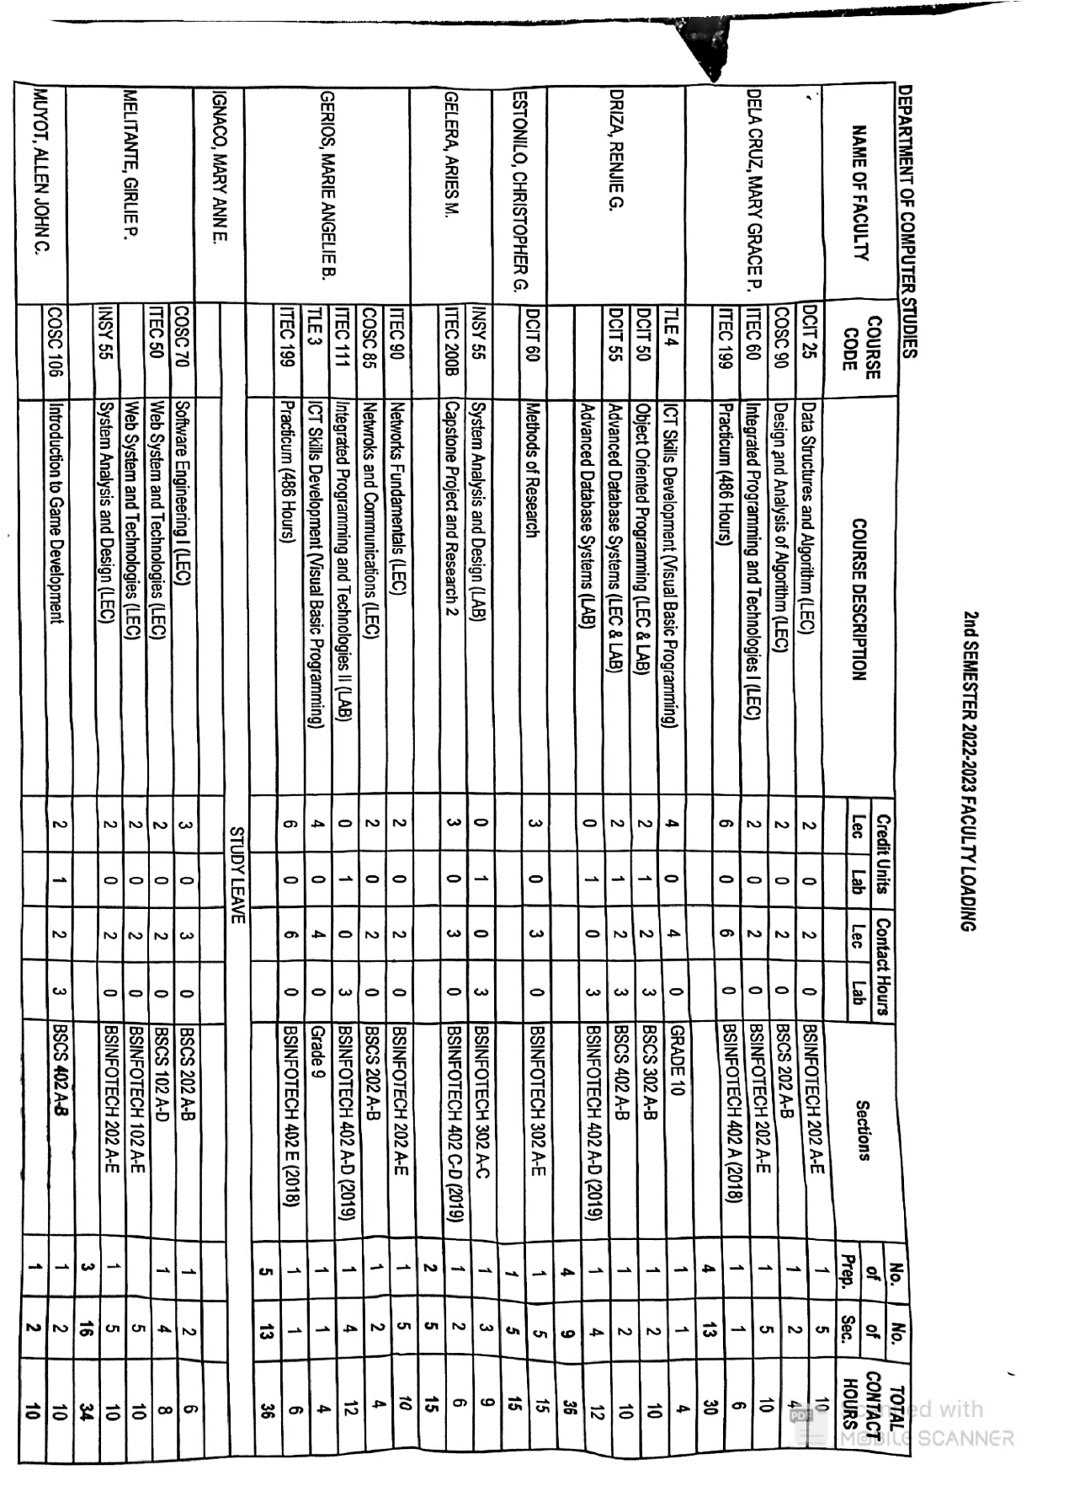

Appendix Figure . Faculty Loading Test Data pt.2

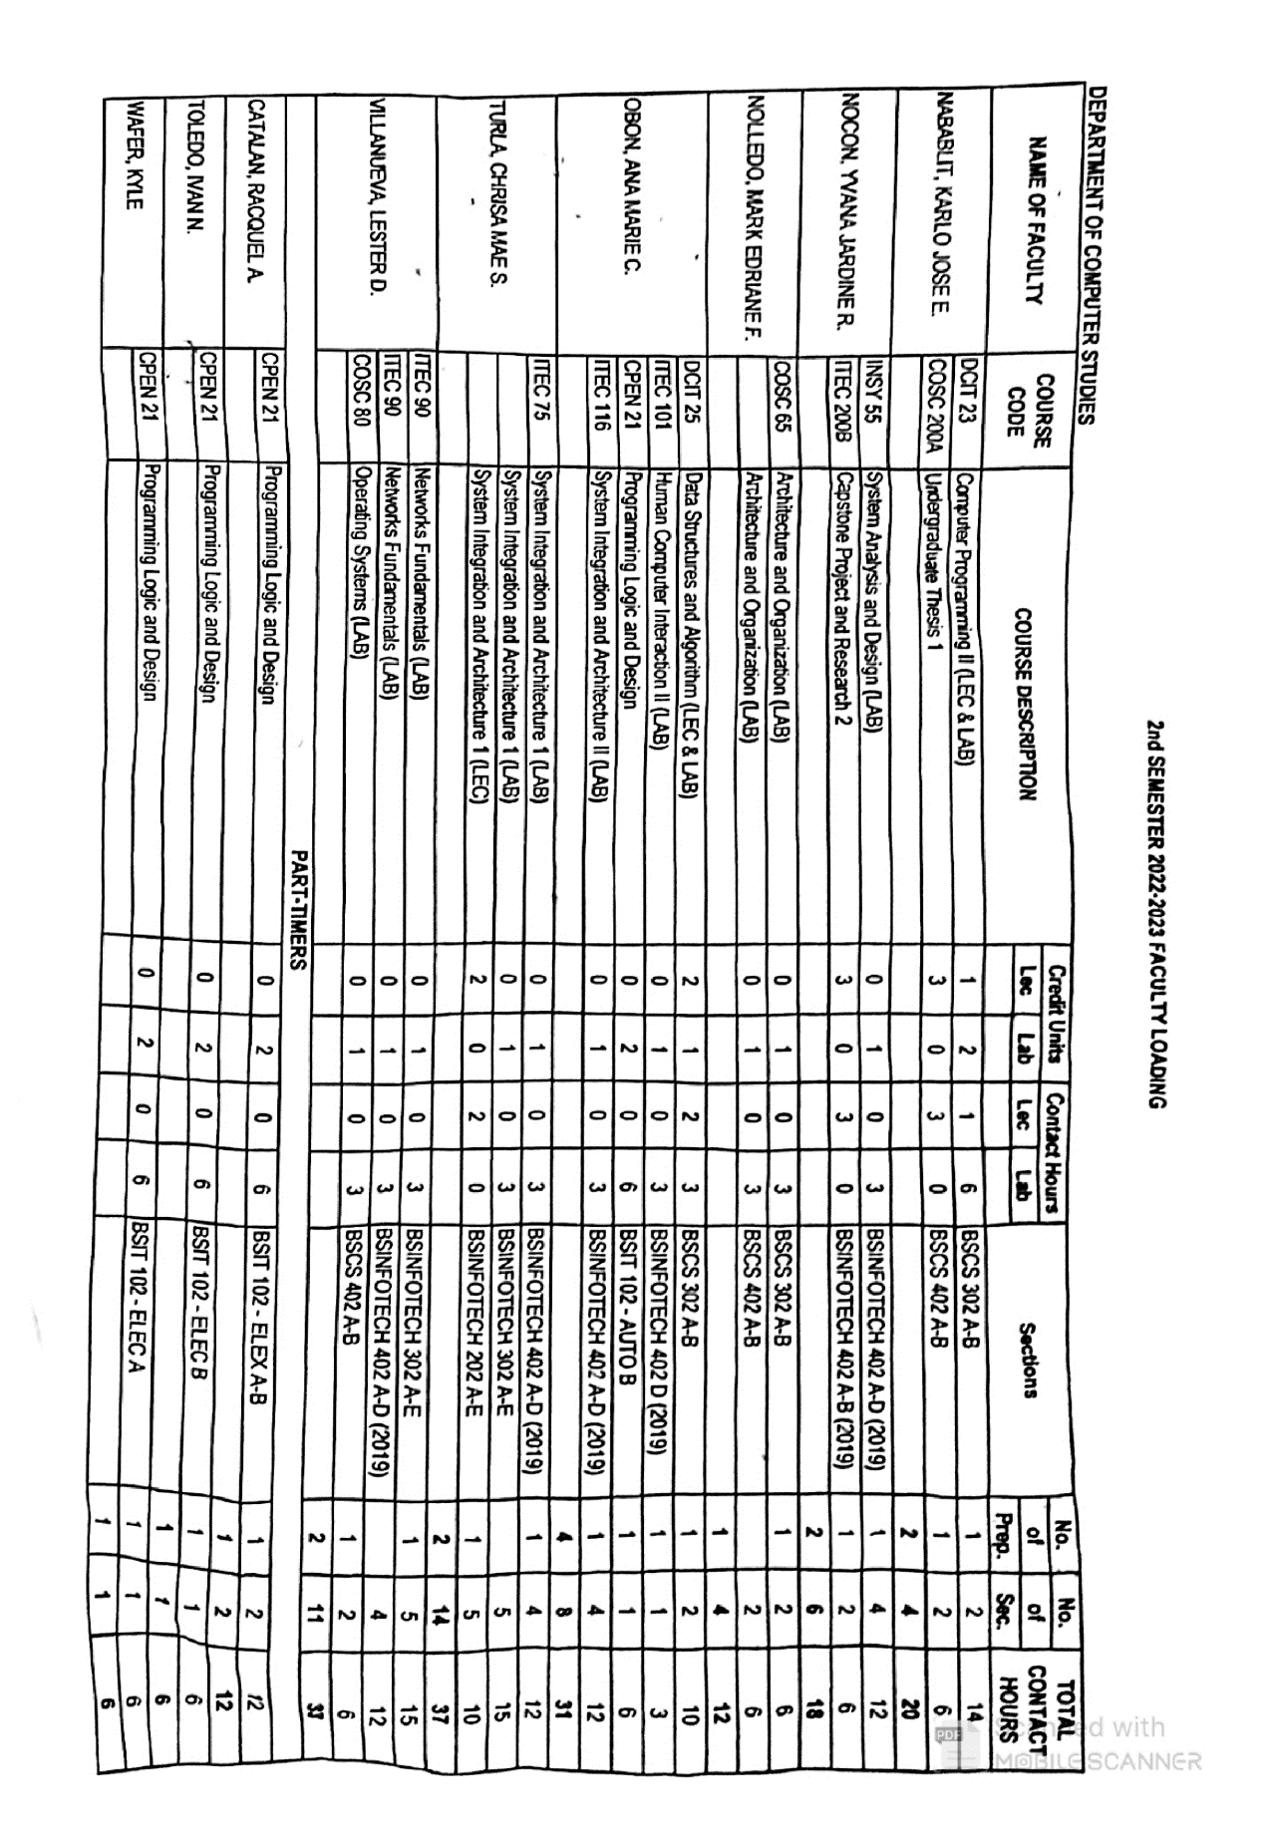

Appendix Figure .. Faculty Loading Test Data pt.3

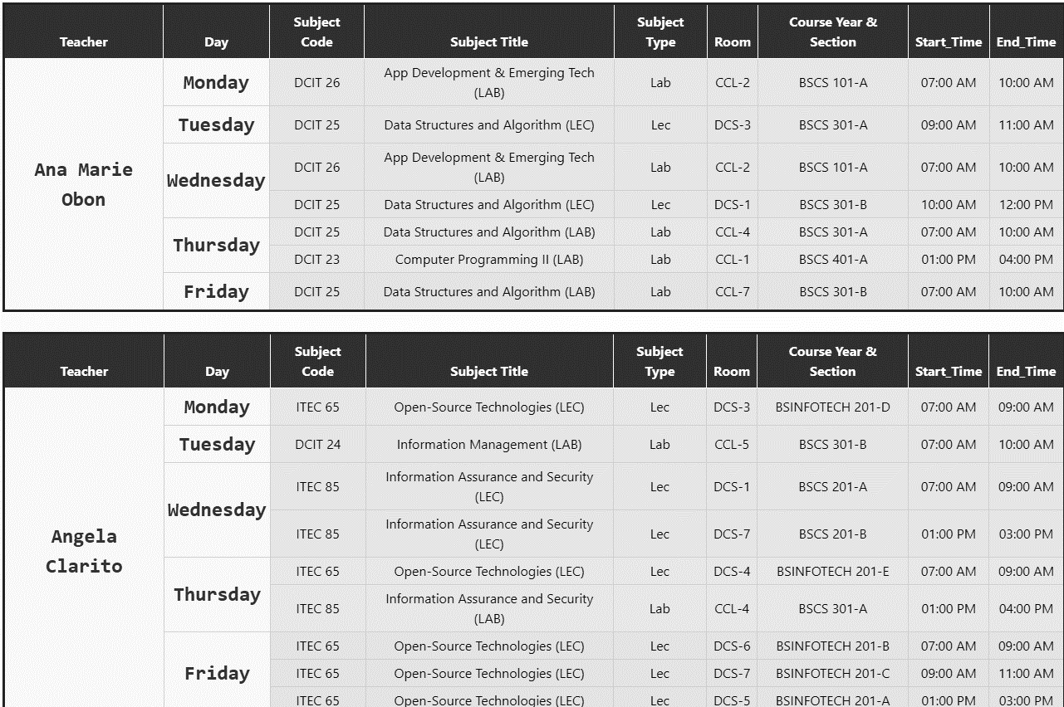

Appendix Figure . Generated Schedule for Teacher

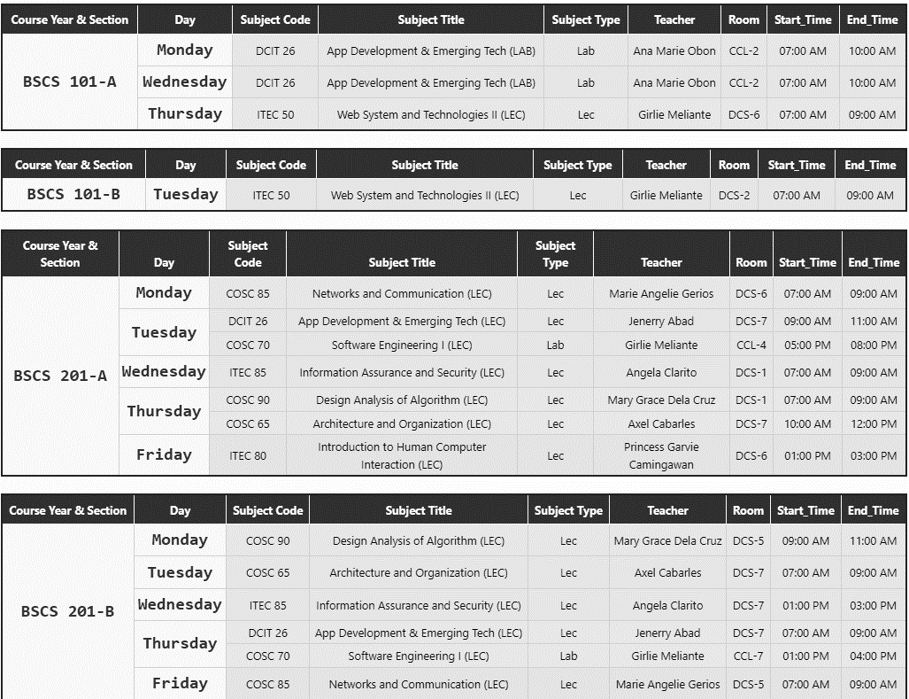

Appendix Figure . Generated Schedule for Course

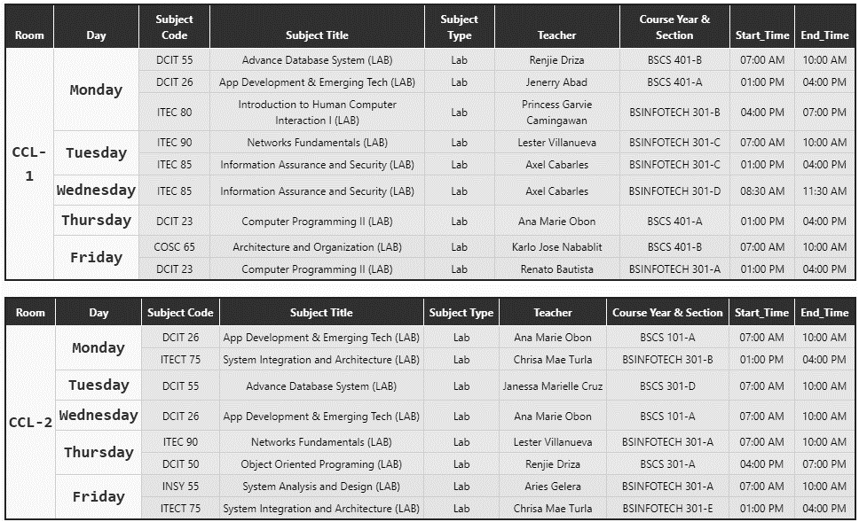

Appendix Figure . Generated Schedule for Rooms

|  |  |  |  |  |  |  |  |  |  |
| --- | --- | --- | --- | --- | --- | --- | --- | --- | --- |
| **ID** | **TASK** | **2022-2023** | | | | | | | |
| **MAY** | **JUNE** | **JULY** | **AUG.** | **SEPT.** | **OCT.** | **NOV.** | **DEC.** |
| **1** | **Requirements Analysis and Design phase** |  | | |  |  |  |  |  |
| **2** | **Prototype Cycle Phase** |  |  |  |  |  |  |  |  |
| **3** | **Developing and Testing Phase** |  |  |  |  | | | | |
| **4** | **Deployment Phase** |  |  |  |  |  |  |  |  |

Appendix Table . Gantt Chart

|  |  |
| --- | --- |
| **TESTING CONDITION** | **REMARK** |
| 1. Teachers, Students and Rooms must have a conflict-free generated schedules. | Passed |
| 1. The timeslot duration must align with the subject hours. | Passed |
| 1. The generated output should be free of conflicts. | Passed |
| 1. The Manual added schedule should not overlap with the existing schedules. | Passed |
| 1. The room type should be corresponded to the subject type. | Passed |

Appendix Table . Test Table for Reliability

|  |  |  |  |  |
| --- | --- | --- | --- | --- |
| **TEST CASE ID** | **FUNCTION** | **EXPECTED RESULT** | **ACTUAL RESULT** | **STATUS** |
| T-001 | Test the login module | The system must not allow to login the unregistered user, | Unregistered login was blocked the system. | PASSED |
| T-002 | Test the register module | If the user registers a new account with a same email, The system must not allow the registration of the account, | Same email used in registration process was blocked by the system. | PASSED |

Appendix Table . Test Case for Login Module

|  |  |  |  |  |
| --- | --- | --- | --- | --- |
| **TEST CASE ID** | **FUNCTION** | **EXPECTED RESULT** | **ACTUAL RESULT** | **STATUS** |
| T-003 | Test the CRUD functionality for Semester | Users should be able to create, view, update, and delete semesters. | Users have successfully handled semester management, including creation, viewing, updating, and deletion. | PASSED |
| T-004 | Test the CRUD functionality for Day | Users should be able to create, view, update, and delete Day. | Users have effectively performed day management tasks, which encompassed creating, viewing, updating, and deleting operations. | PASSED |
| T-005 | Test the CRUD functionality for Teacher | Users should be able to create, view, update, and delete teacher. | Users have successfully managed teachers’ details including creation, viewing, updating, and deletion. | PASSED |
| T-006 | Test the CRUD functionality for Course | Users should be able to create, view, update, and delete course. | Users have successfully handled course management, including creation, viewing, updating, and deletion. | PASSED |
| T-007 | Test the CRUD functionality for Section | Users should be able to create, view, update, and delete section. | Users have successfully handled section management, including creation, viewing, updating, and deletion. | PASSED |
| T-008 | Test the CRUD functionality for Subject | Users should be able to create, view, update, and delete subject. | Users have successfully handled subject management, including creation, viewing, updating, and deletion. | PASSED |
| T-009 | Test the CRUD functionality for Room | Users should be able to create, view, update, and delete room. | Users efficiently managed room operations, covering creation, viewing, updating, and deletion. | PASSED |
| T-010 | Test faculty loading module | The same teacher should not have a same assigned subject with same sections. | The system prompts a message “The subject was already assigned with the same teacher!” | PASSED |

Appendix Table . Test Case for Faculty Loading

# OTHER APPENDICES

## Definition of terms

The following definitions were established for the following terms, aligning their meanings with how they were specifically utilized in the research.

***ATS*** stands for “Automated Timetable Scheduling System”.

***Backtracking Algorithm*** used to automate the schedules. The backtracking algorithm is a technique used to systematically search for solutions to a problem by incrementally building a solution and then undoing or "backtracking" when a dead-end was reached. This algorithm was used to recursively generate timeslots, rooms, days to a course.

***Backtrack*** when automating the schedules and conflicts occurs, the algorithm goes back to the previous state to explore other possibilities to find timeslots without conflicts and this is known as backtracking.

***Constraints*** are the conditions or rules that must be satisfied by a valid solution. they help prune the search space and guide the backtracking process.

***Course Timetabling*** is the assigning of class schedules to a specific course including teachers, rooms, timeslot, and subjects.

***Recursive Backtracking*** is the type of backtracking algorithm used by the developers to automated the assigning of timeslots to different courses.

***Solution space*** represents all the potential solution or potential valid schedules that are free of conflicts.

***TCPDF*** stands for "The PHP PDF Creation Library," which is a robust tool used for converting tables into PDF format. Its purpose in ATS SYSTEM was to enable the printing of the generated schedules in a visually pleasing and easily shareable format.

**APPENDIX A**

**ROUTING SLIP**

**APPENDIX B**

**CERTIFICATE OF ENGLISH CRITIC**

**APPENDIX C**

**LETTER OF REQUEST FOR ORAL OUTLINE REVIEW**

**APPENDIX D**

**LETTER OF REQUEST FOR FINAL DEFENSE**

**APPENDIX E**

**LETTER OF REQUEST FOR ADVISER AND TECHNICAL CRITIC**

**APPENDIX F**

**EVALUATION FORM FOR END-USER**

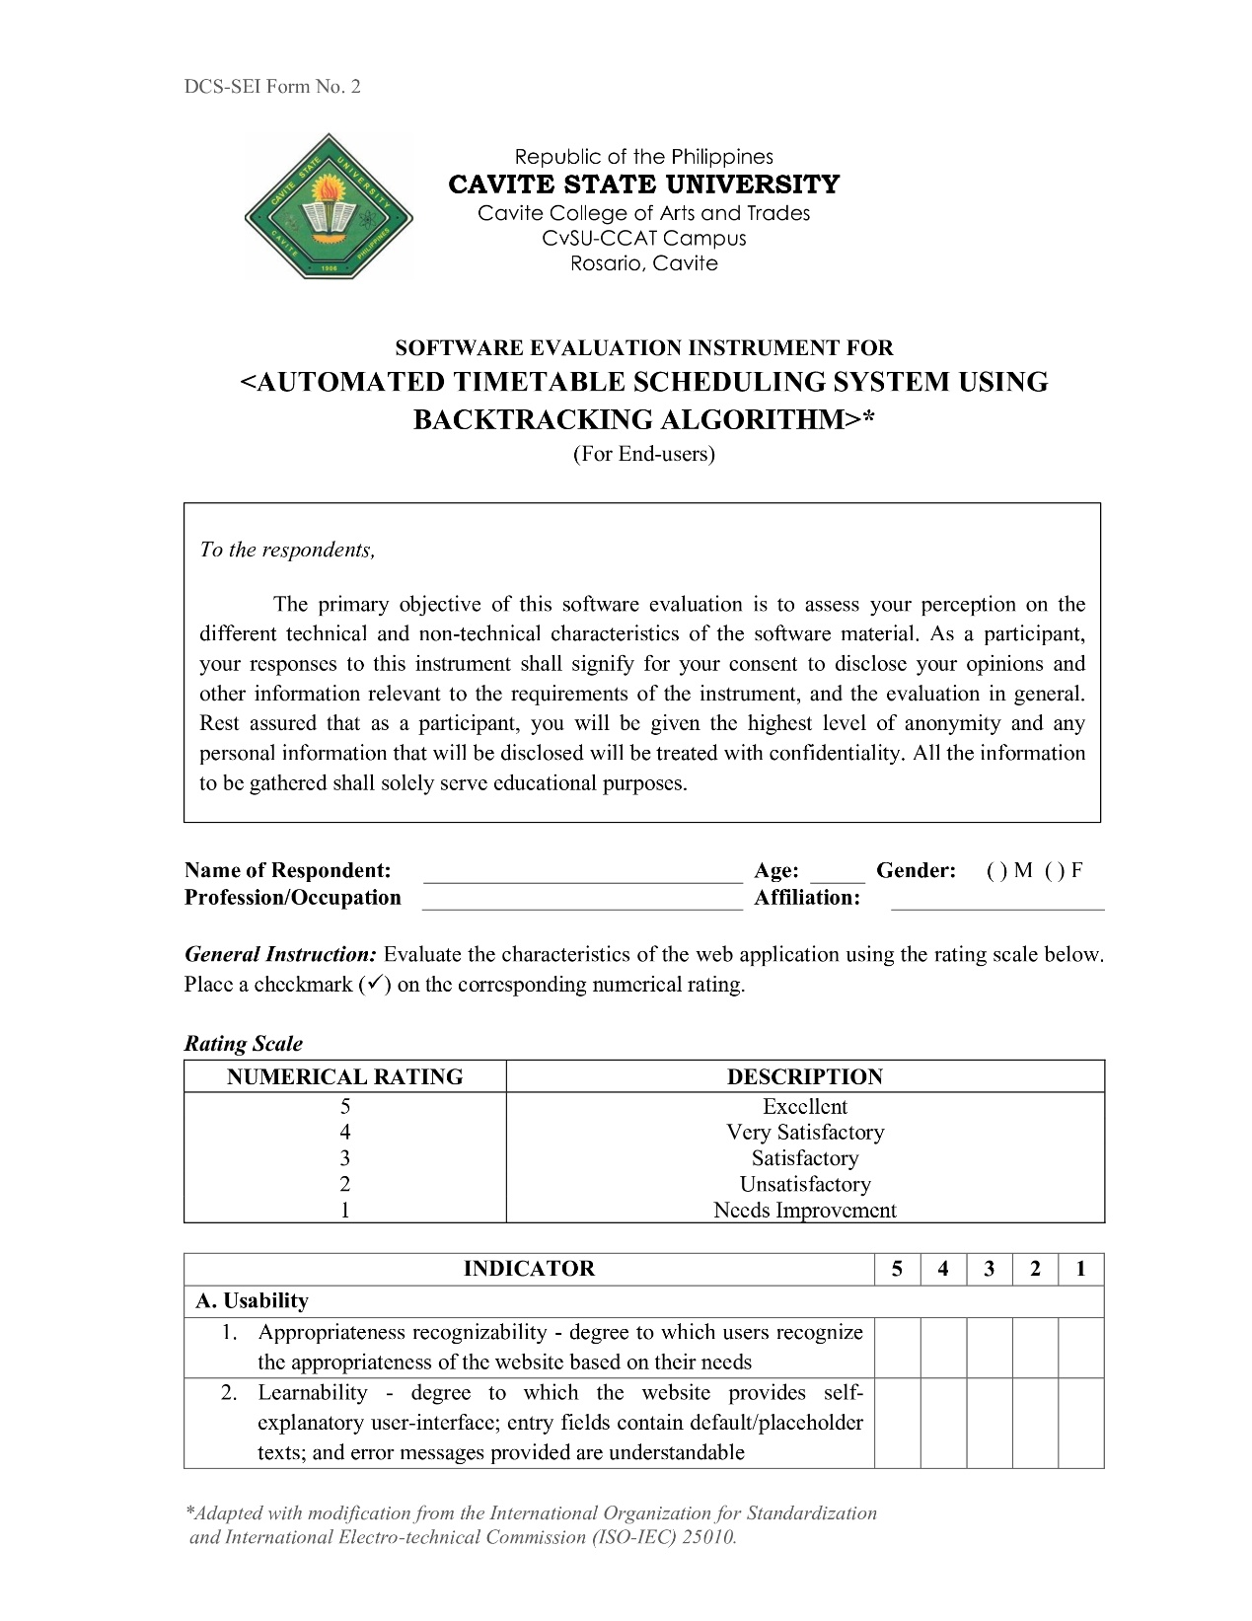

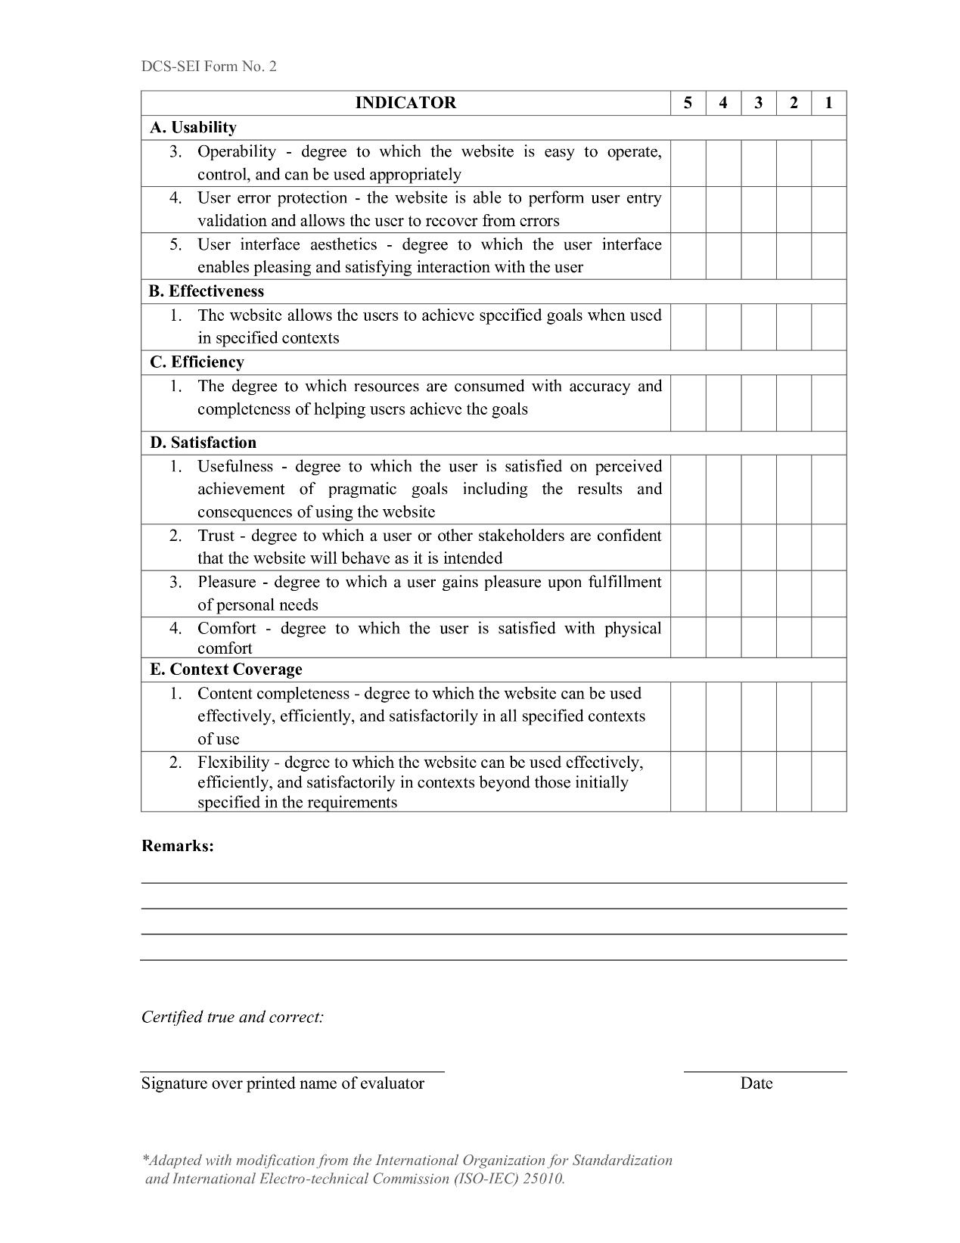

**APPENDIX G**

**EVALUATION FORM FOR WEB-DEVELOPERS**

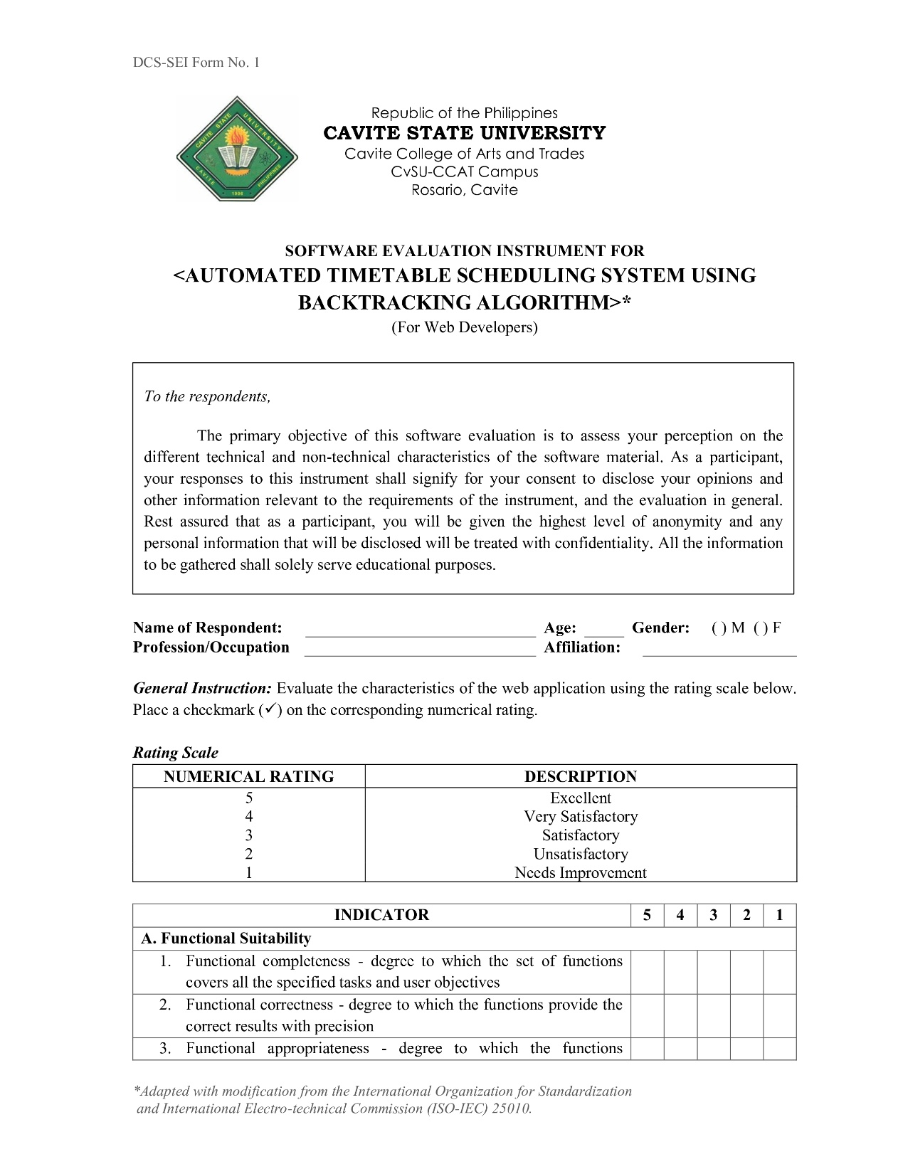

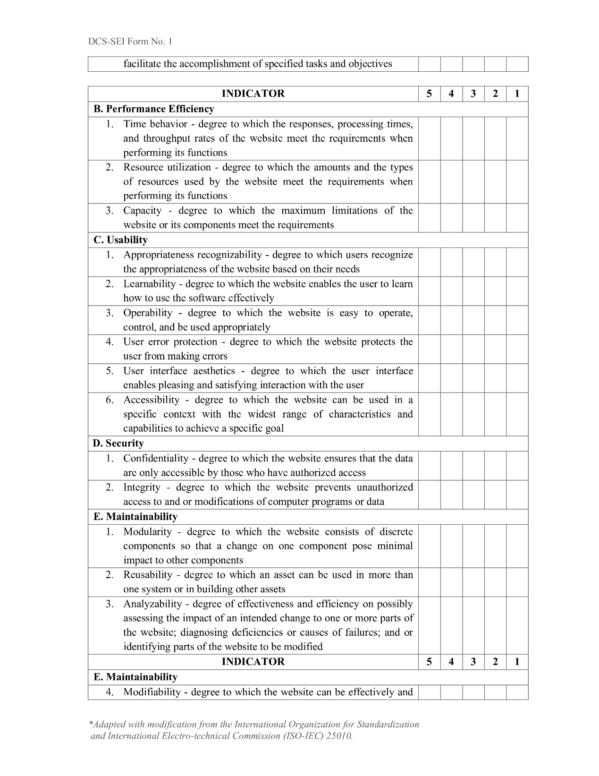

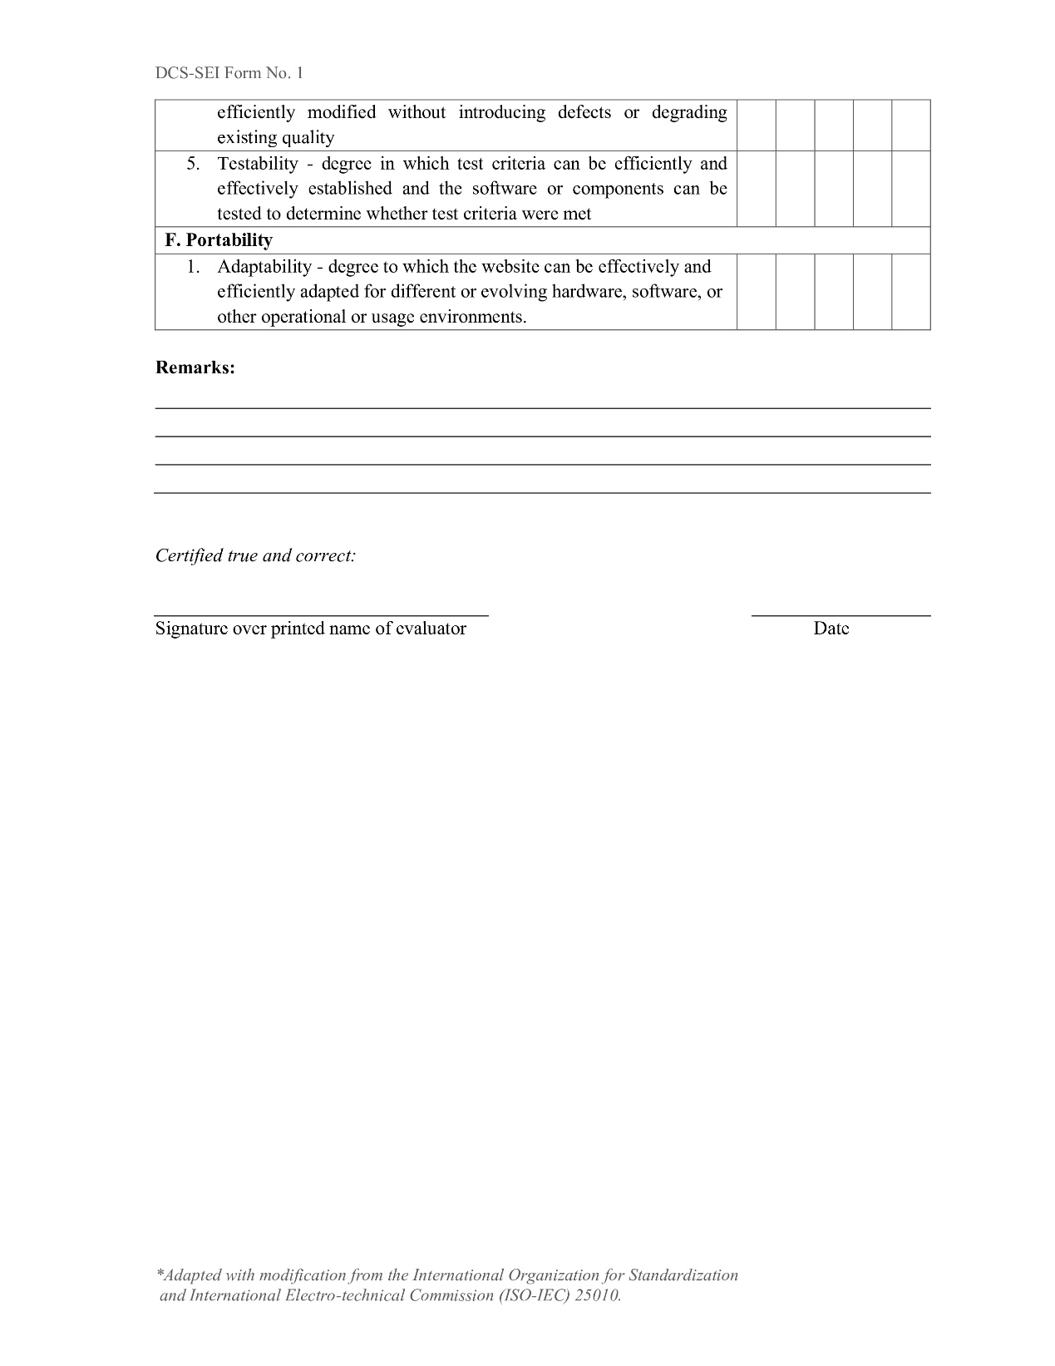

**APPENDIX H**

**SAMPLE ACCOMPLISHED EVALUATION TOOL**

**FOR END-USER**

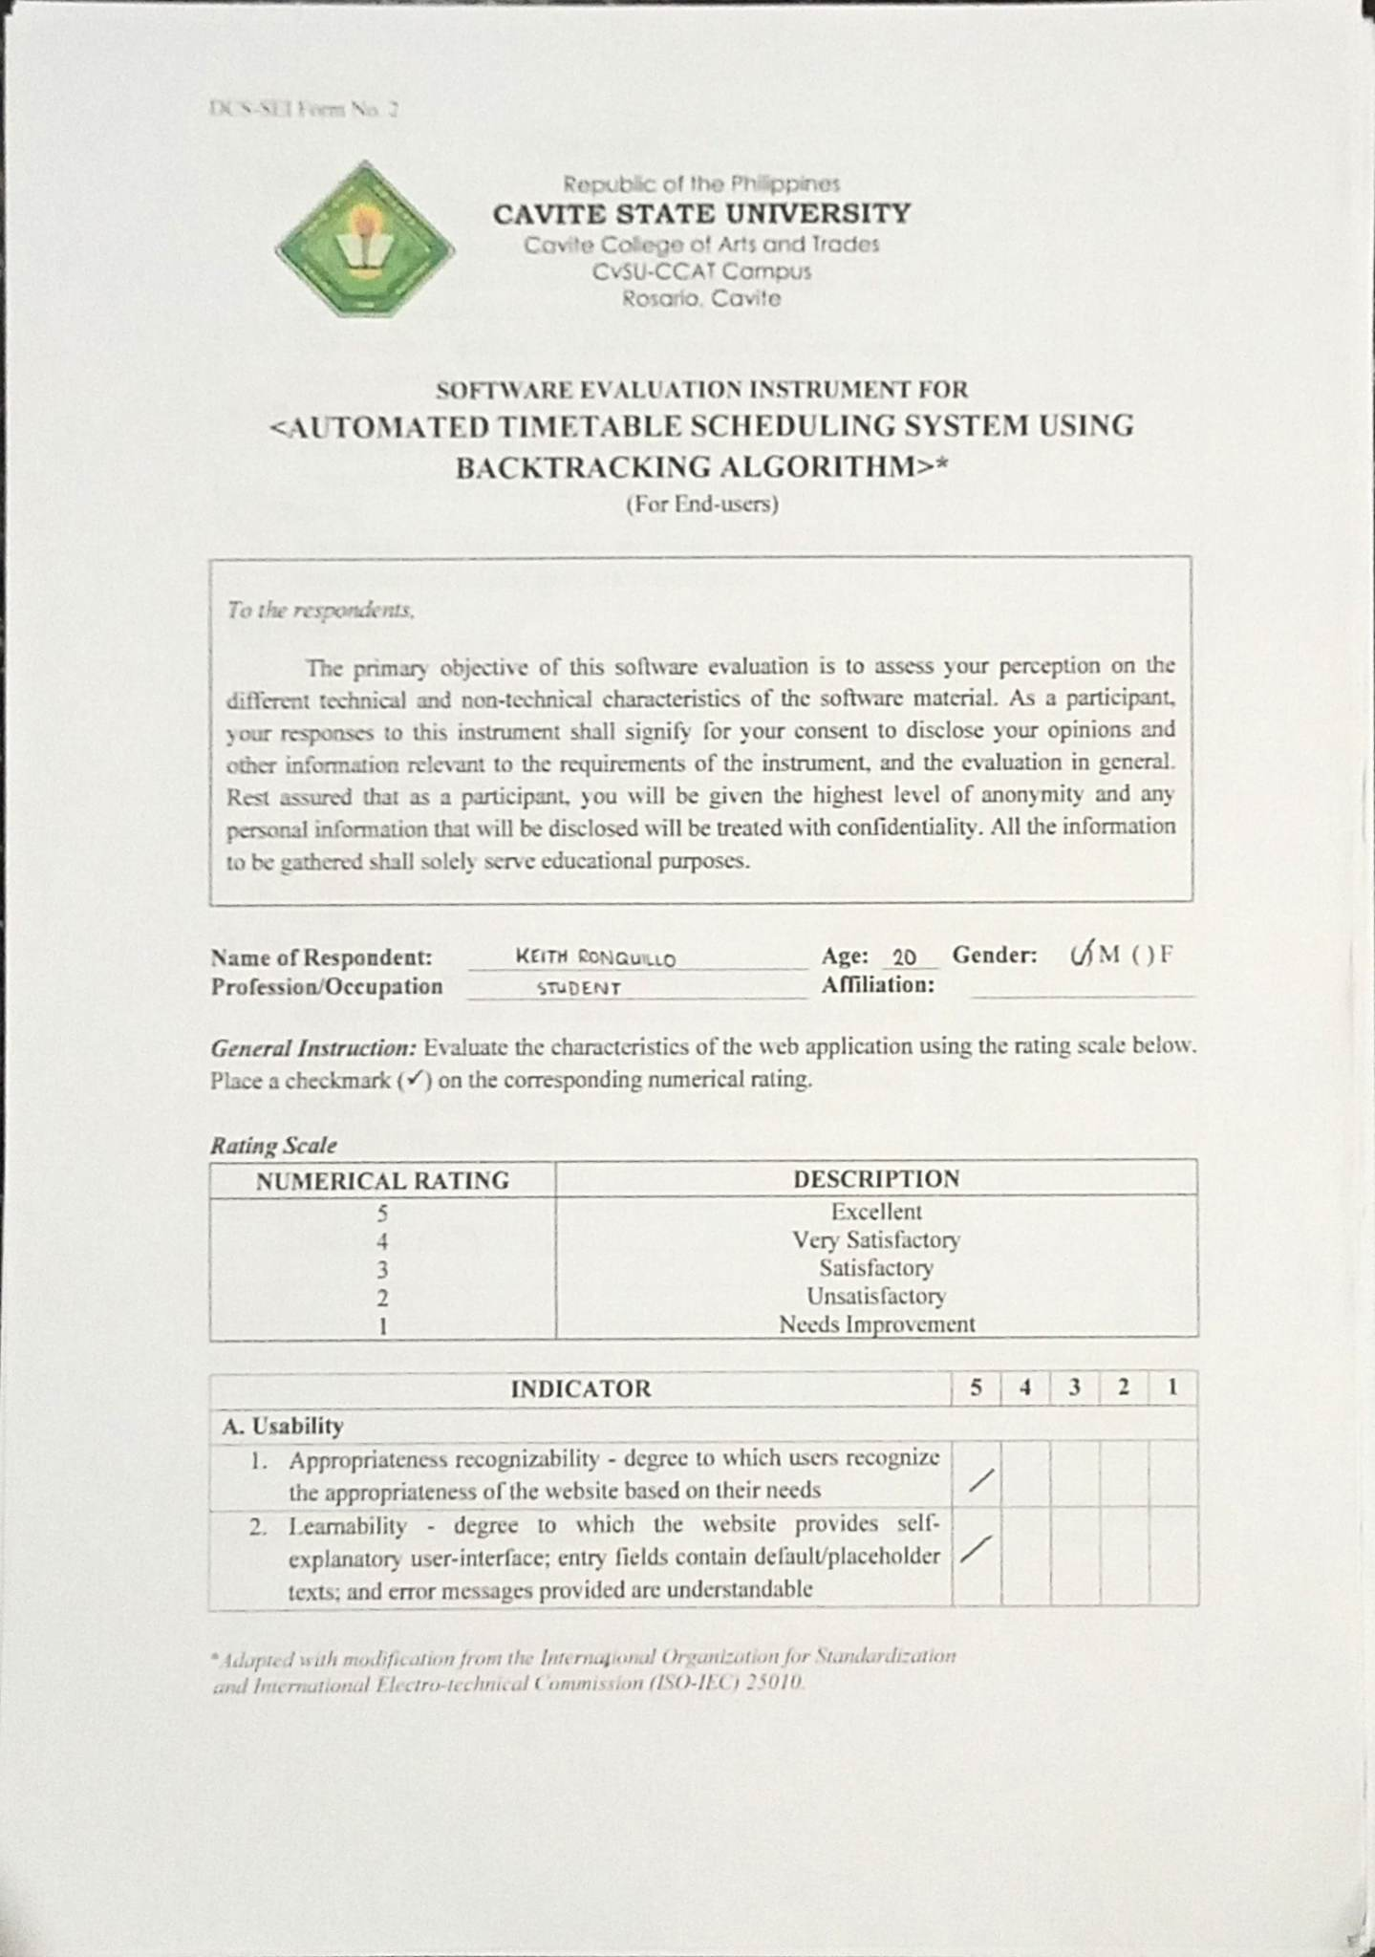

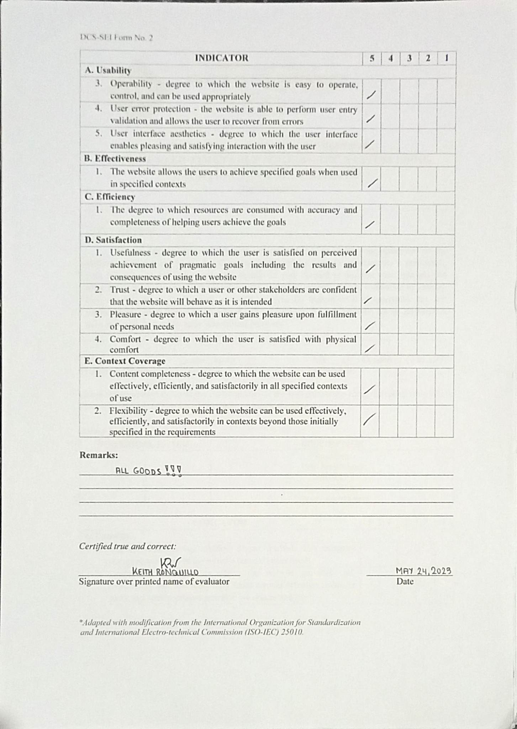

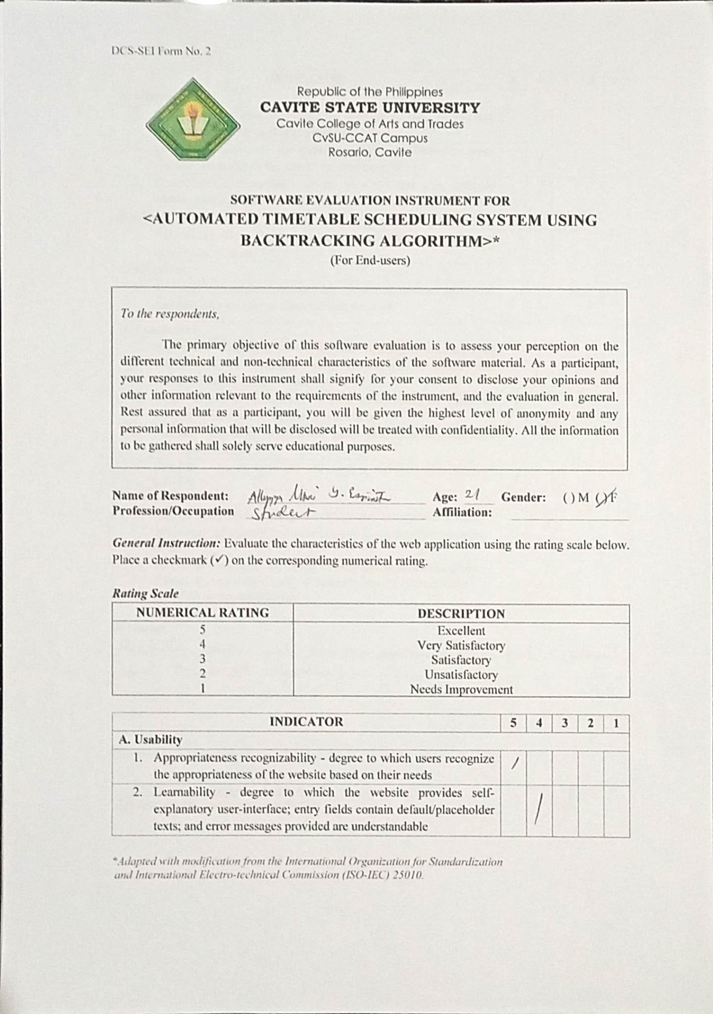

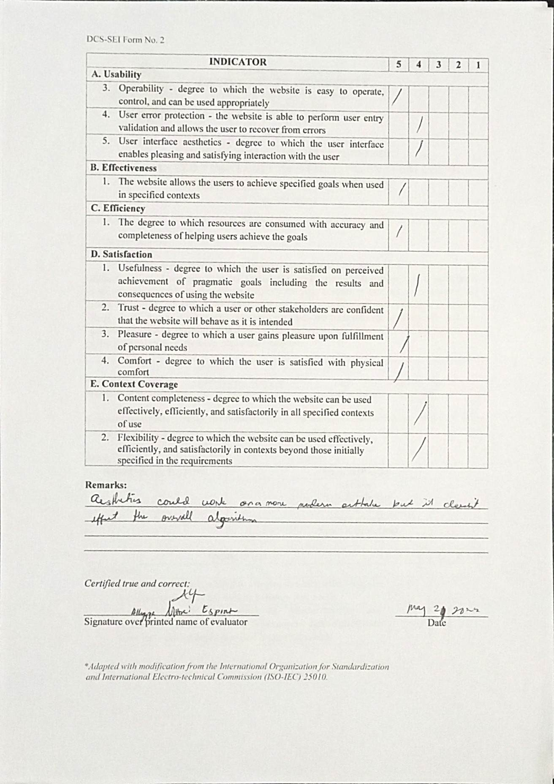

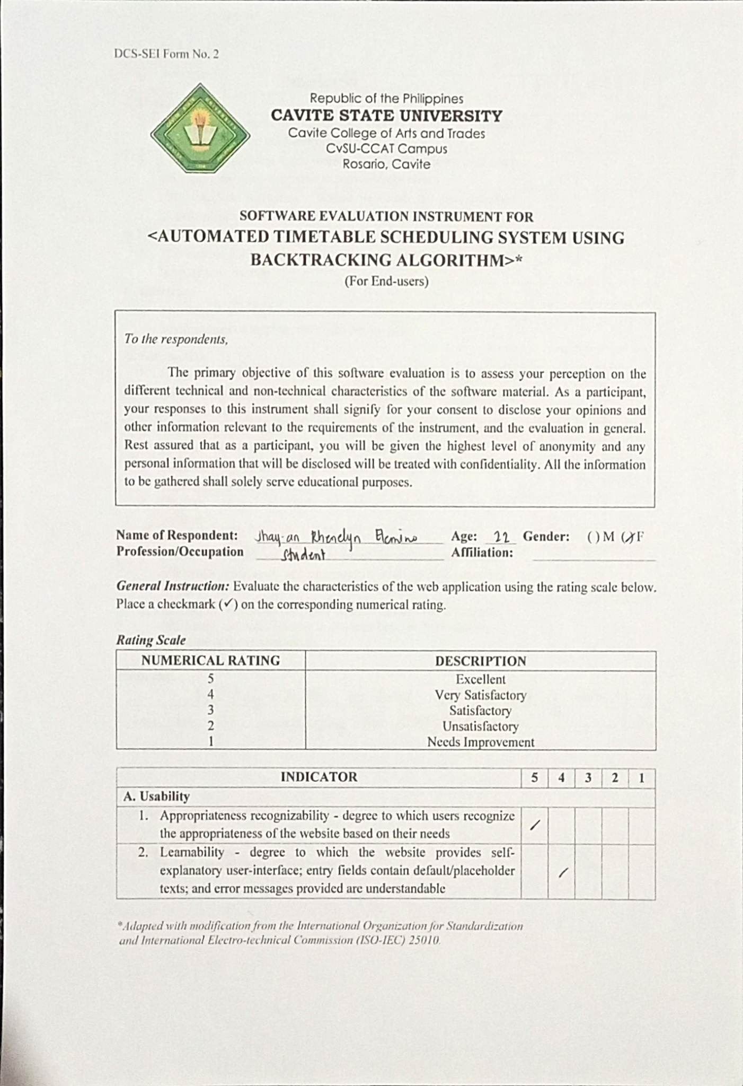

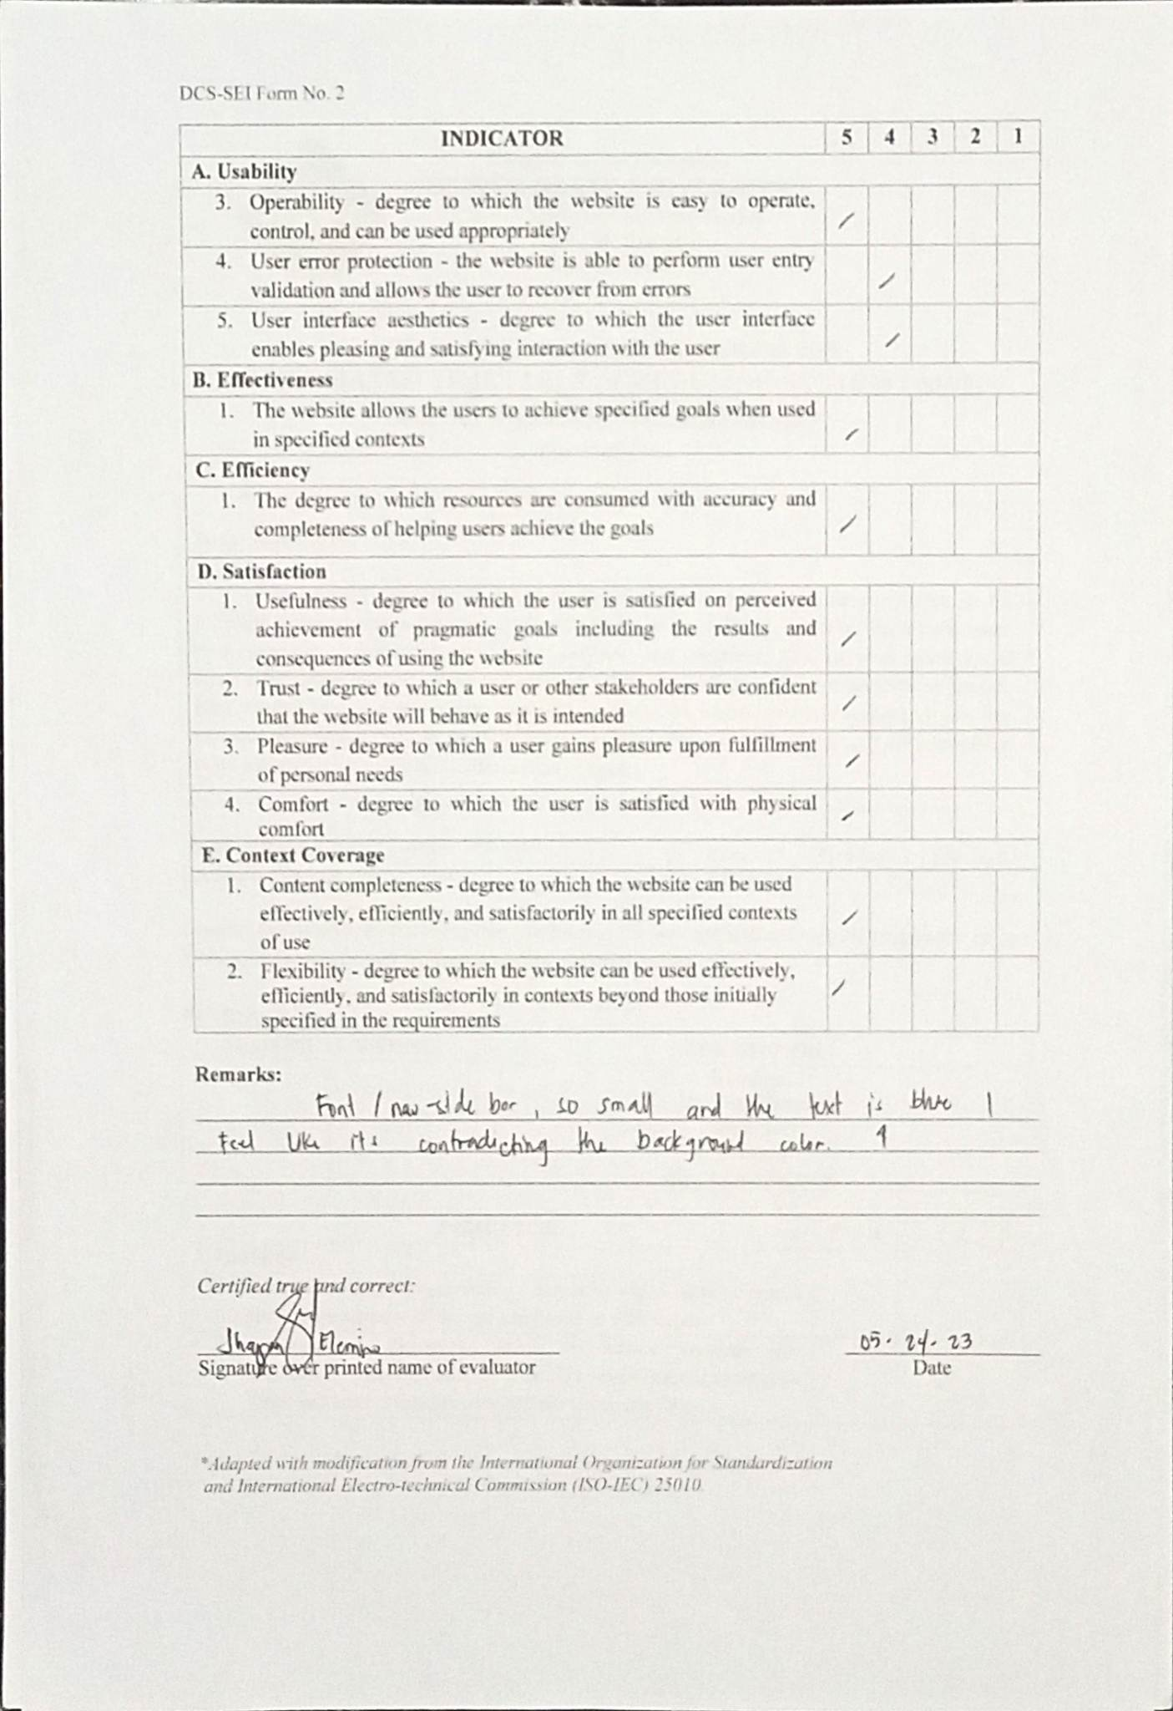

**APPENDIX I**

**SAMPLE ACCOMPLISHED EVALUATION TOOL**

**FOR IT EXPERTS**

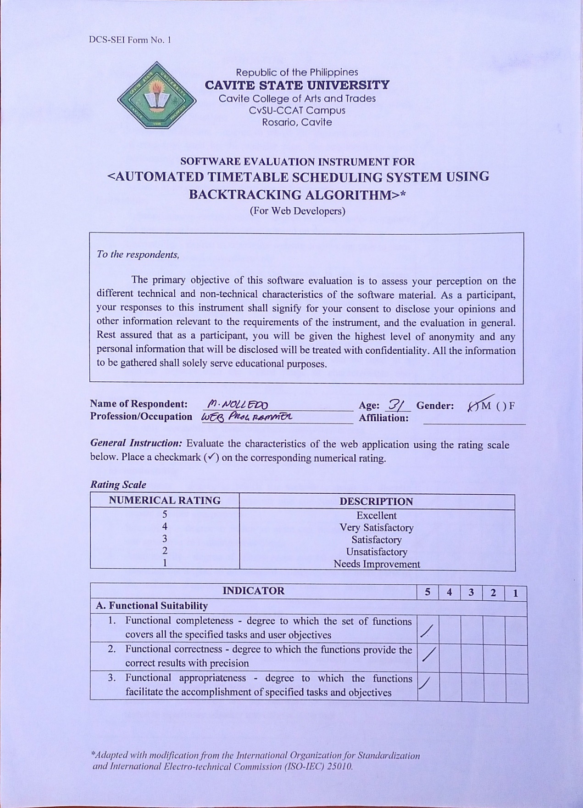

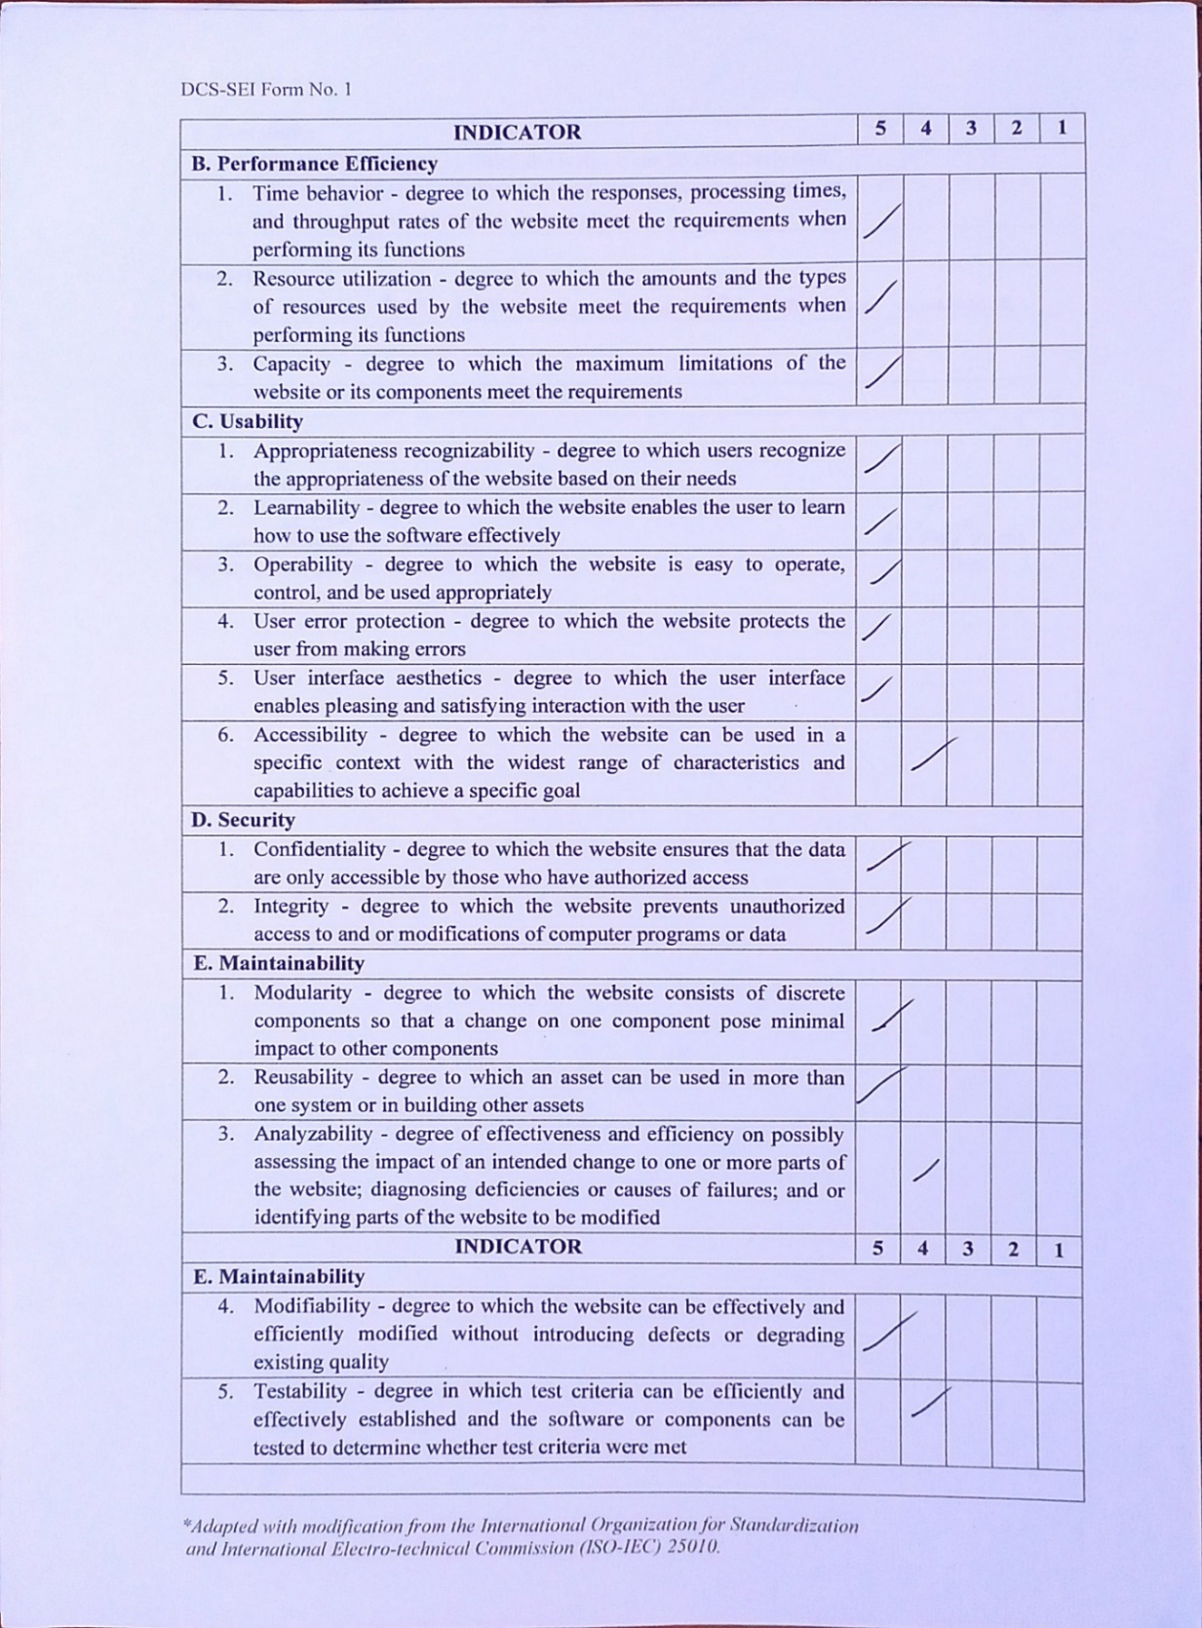

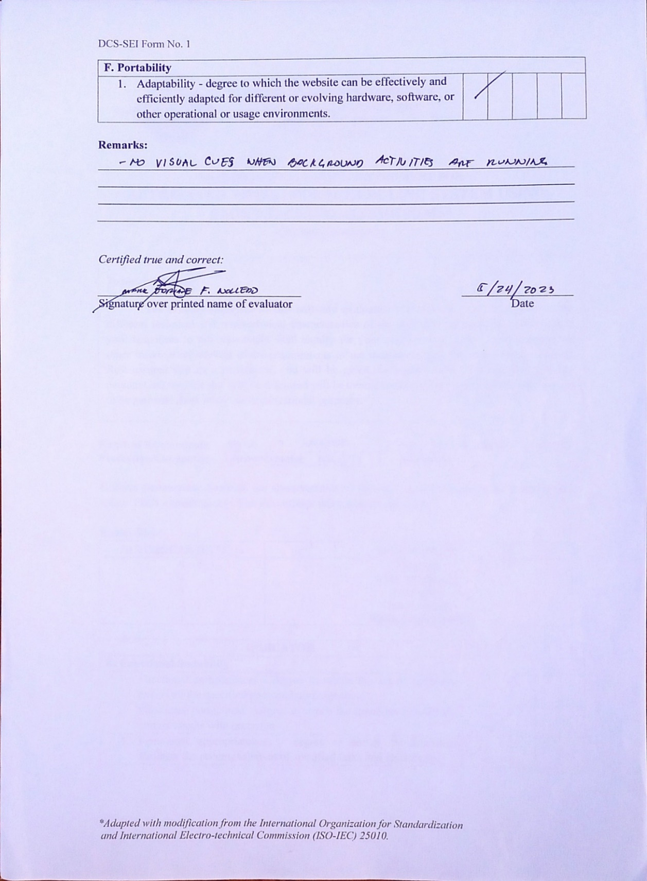

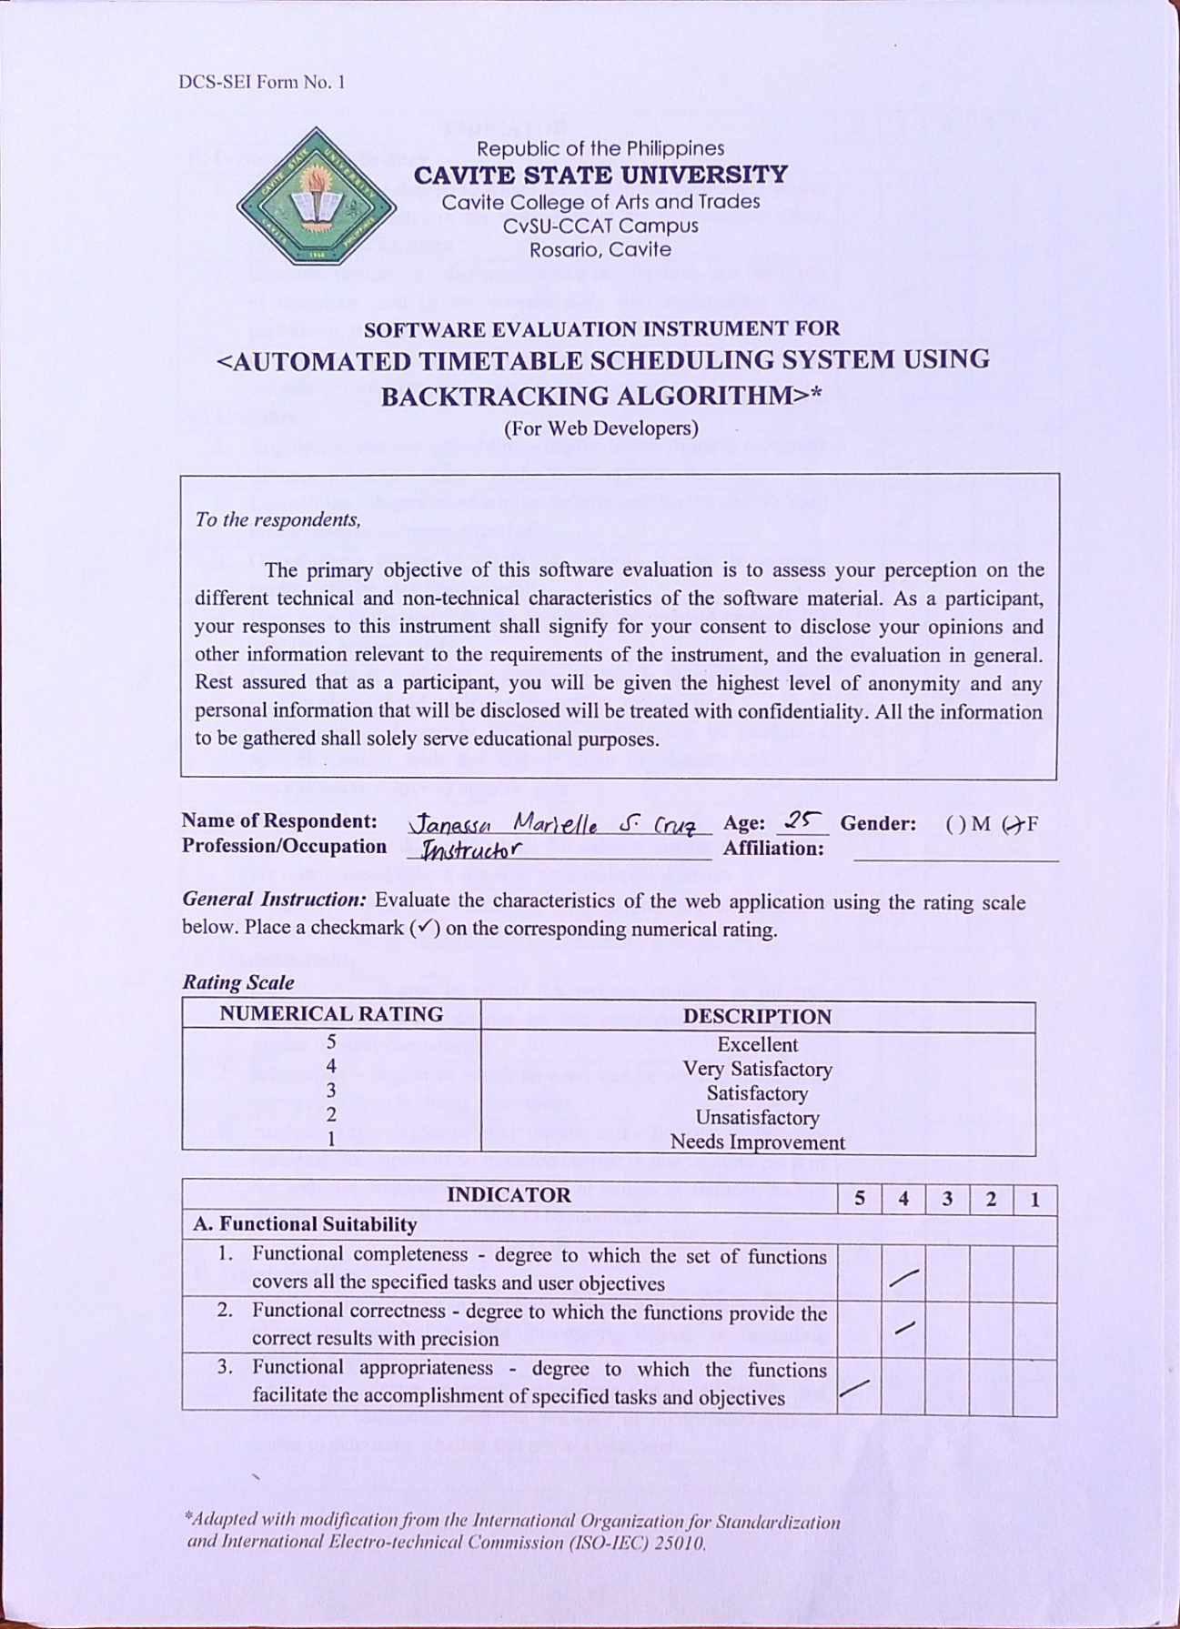

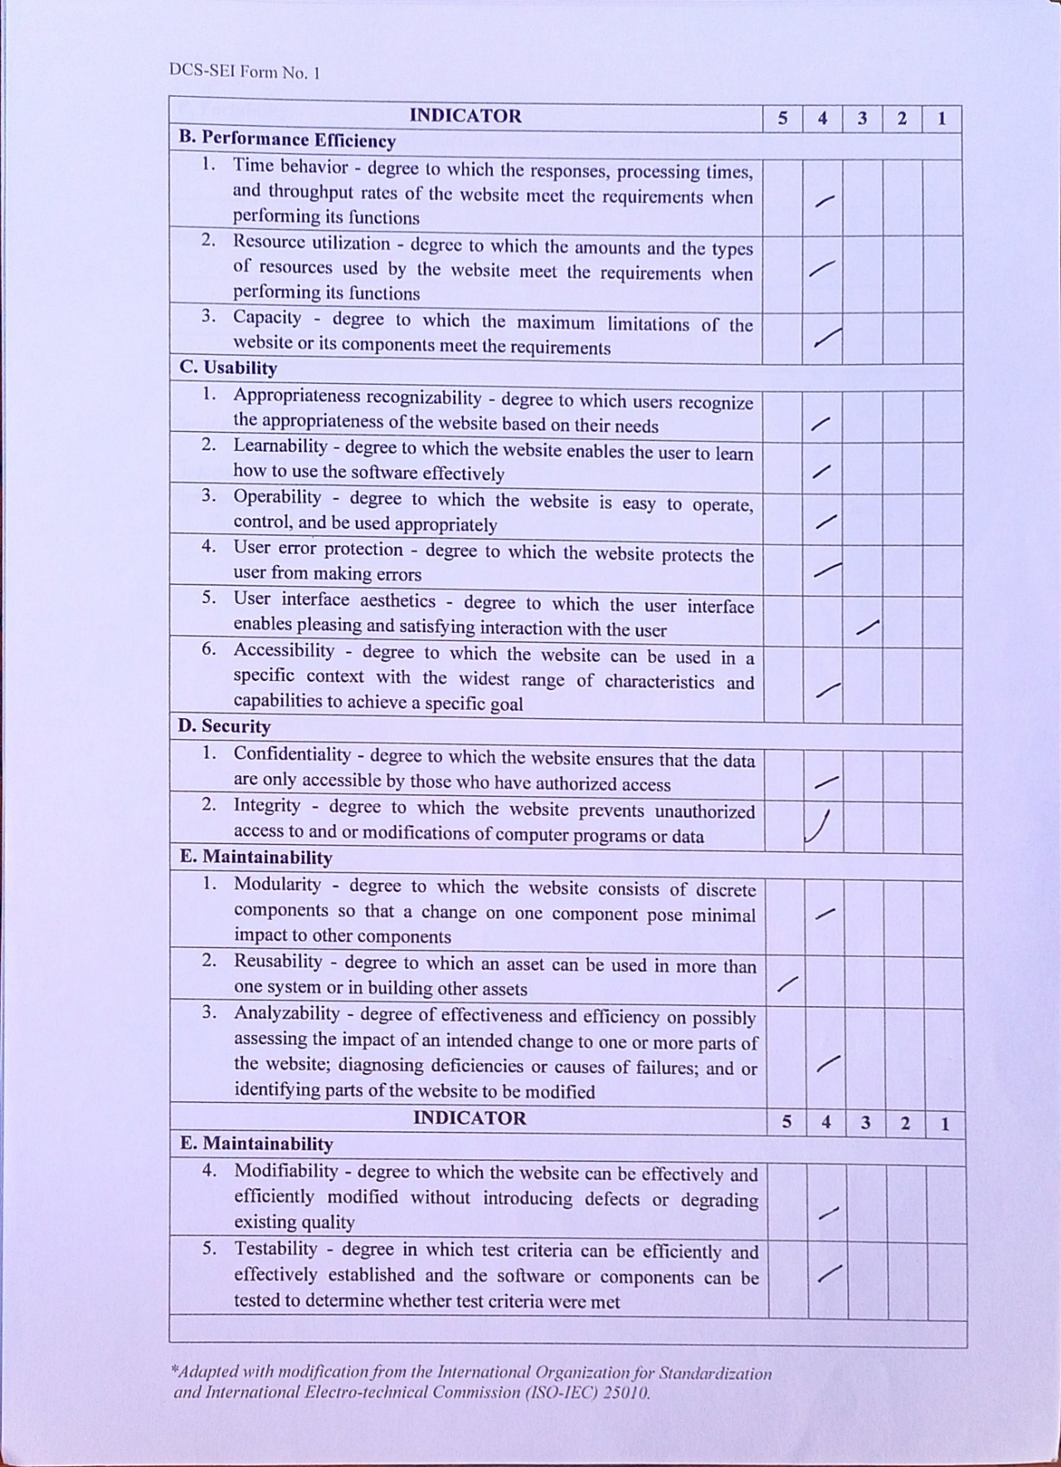

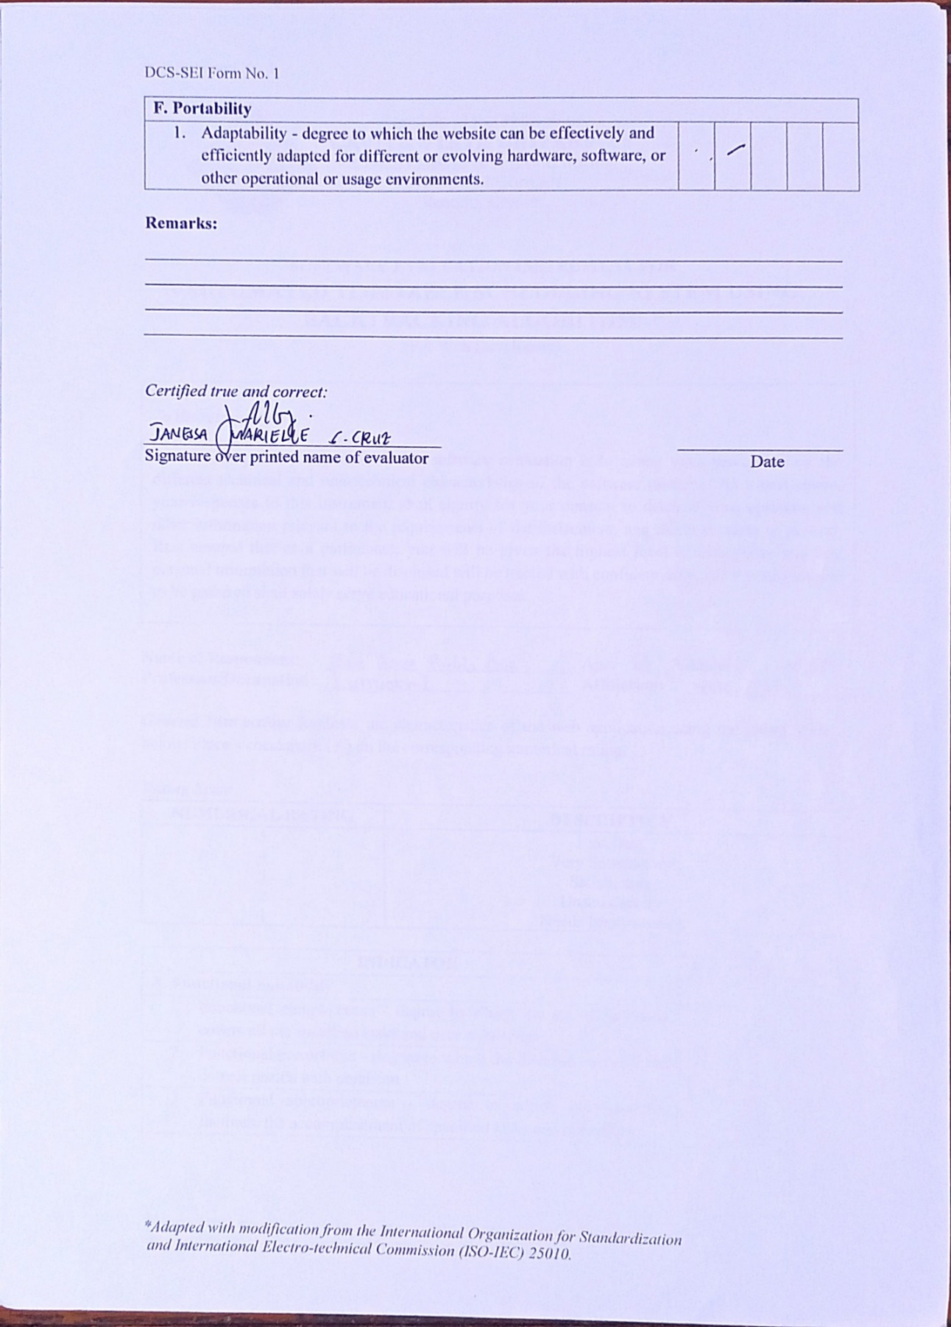

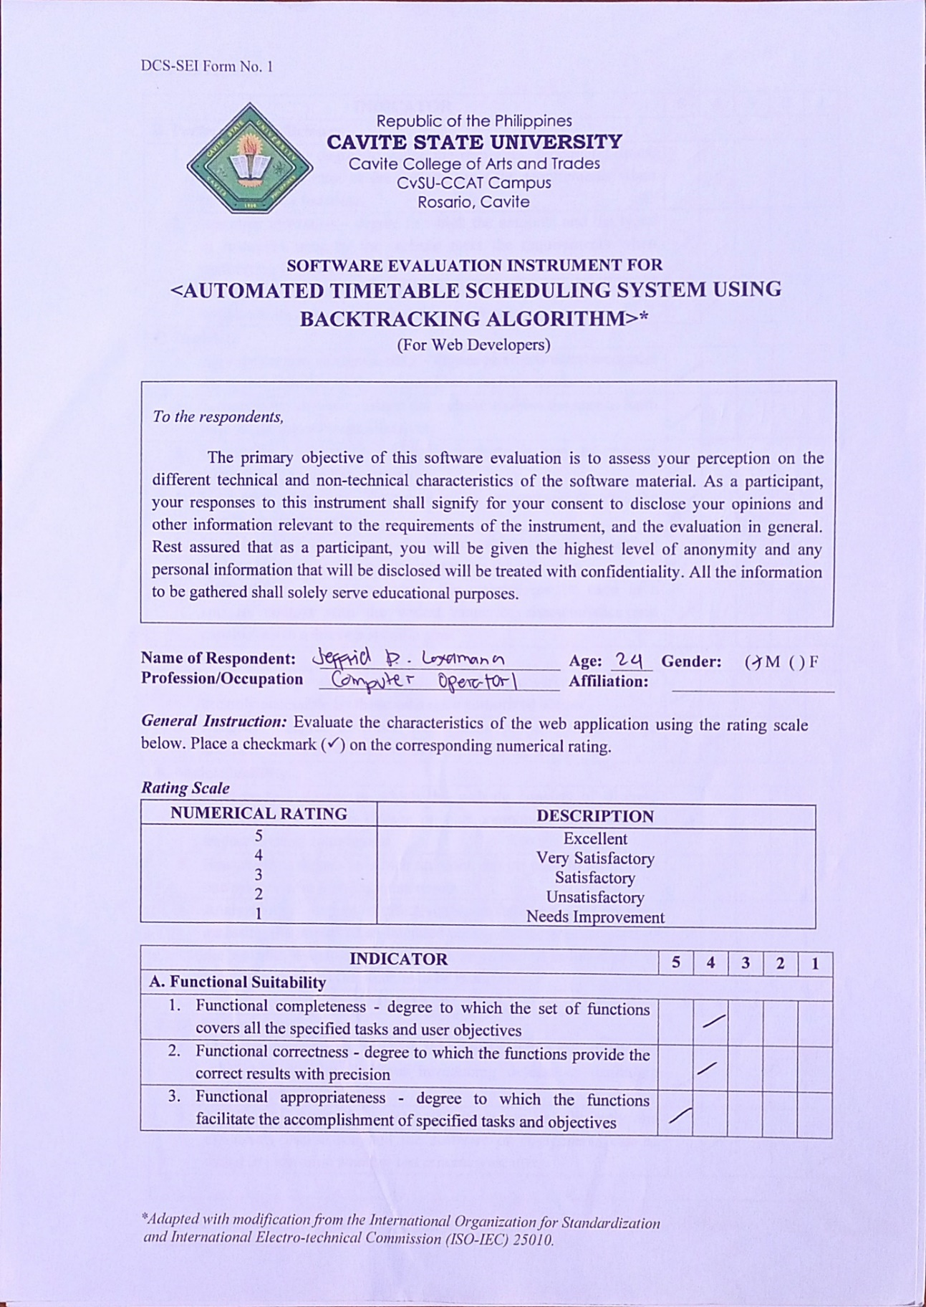

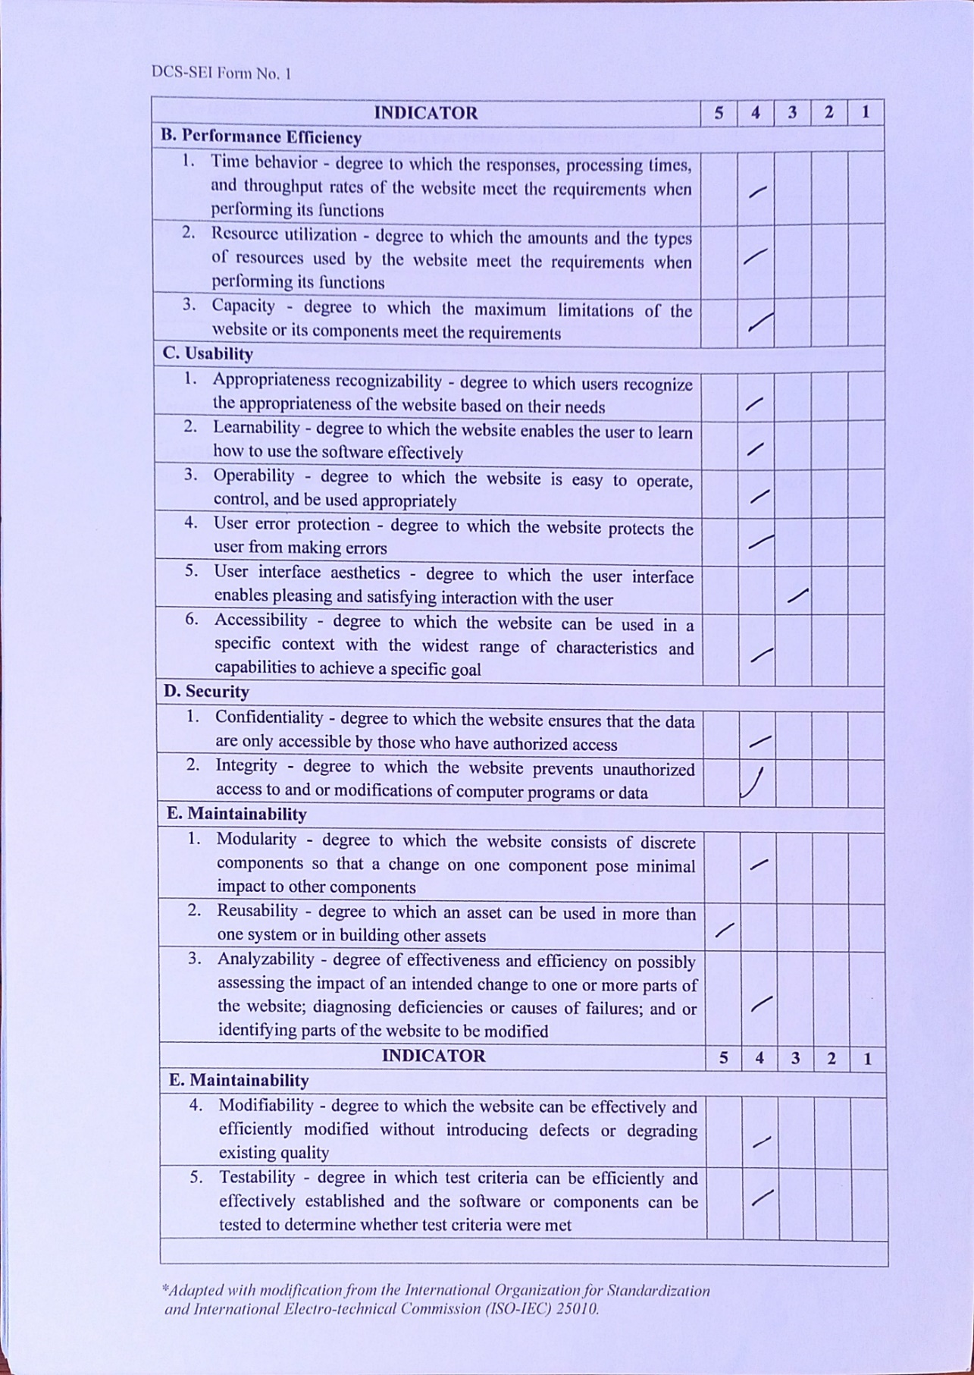

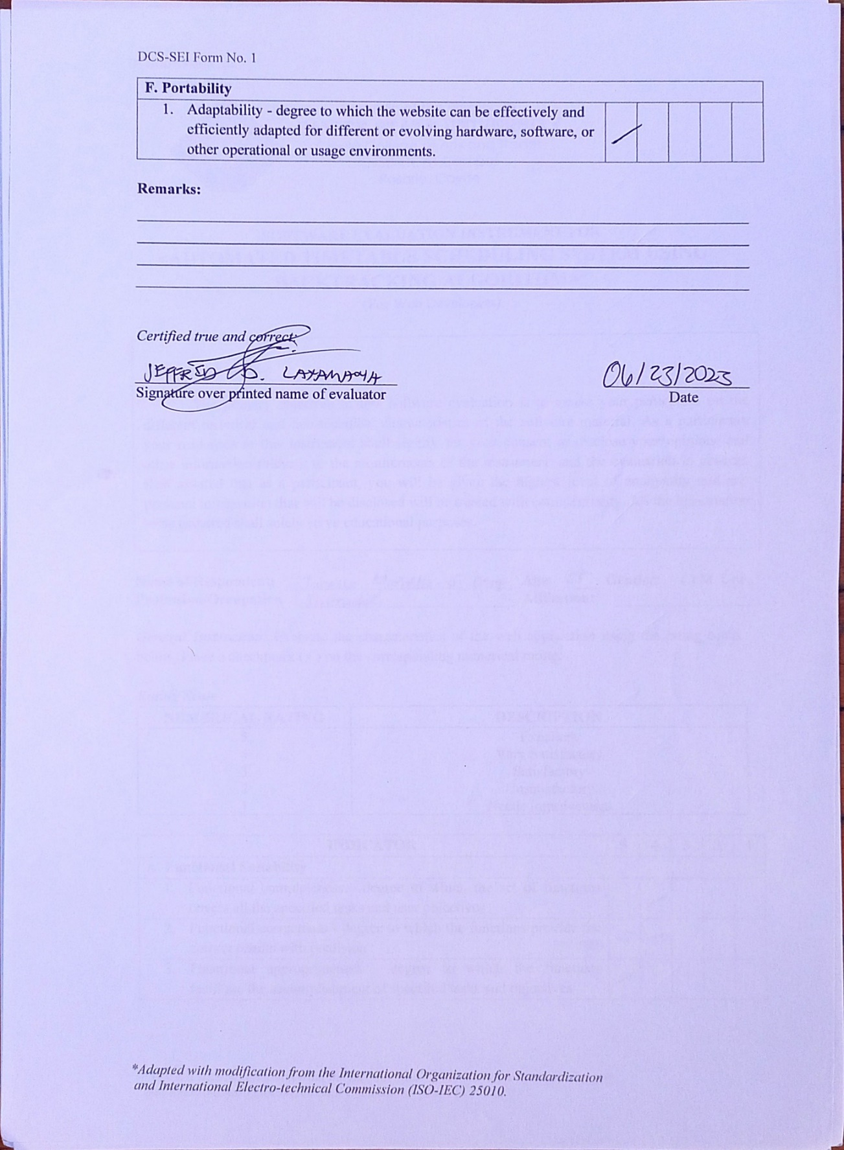

**APPENDIX J**

**USERS MANUAL**

**Introduction**

The Automated Timetable Scheduling System is a web-based application designed to generate conflict-free class schedules automatically.

This user manual provides step-by-step instructions on how to effectively utilize the web-based system.

**System Requirements**

*Hardware*

To ensure optimal performance while using the web-based system, it is recommended to meet the following system requirements:

* A minimum of 8 GB RAM.
* An AMD Ryzen 5 processor or a higher specification CPU.
* An operating system of either 64-bit Windows 11 or Windows 10.

Meeting these system requirements will help ensure smooth operation and a satisfactory user experience while using the web-based system.

*Software*

For optimal performance and offline access to the web-based system, it is important to meet the following system requirements:

* Browser: Use either Google Chrome or Microsoft Edge as your preferred web browser. These browsers are recommended for compatibility and optimal performance with the web-based system.
* XAMPP: Install XAMPP version 3.3.0 or the latest available version. XAMPP is a software package that provides a local server environment for hosting web applications on your computer. It allows you to access and run the web-based system offline, providing a convenient way to work without an internet connection.

By ensuring you have the specified browser and XAMPP installed, you can experience optimal performance and utilize the web-based system even when offline.

**The Web-based System**

The web-based system is called “ATS or Automated Timetable Scheduling System” that can generate an automated class schedules for teachers, students and rooms.

To utilize the web-based system offline, please follow these steps:

1. Install XAMPP: Download and install XAMPP from the official website. Follow the installation instructions provided.
2. Extract ATS-SYSTEM PHP files: Once XAMPP is installed, locate the htdocs folder within the XAMPP installation directory. Extract the PHP files of the web-based system into this folder. Ensure that the file structure is maintained.
3. Start XAMPP: Launch the XAMPP control panel and start the Apache web server. This will enable you to access the web-based system locally on your computer.
4. Access the web-based system: Open your preferred browser, such as Google Chrome or Microsoft Edge. In the address bar, type "http://localhost/ats-system/login.php" and hit Enter. This will take you to the login page of the web-based system.
5. Login and use the system: Enter your credentials (if applicable) on the login page or Register an account using your email.

**Getting Started**

After successful installation of xampp and extracting php files you can now use the web-based system. First you need to login your registered credential or register new account on the web-based system login module as shown below. 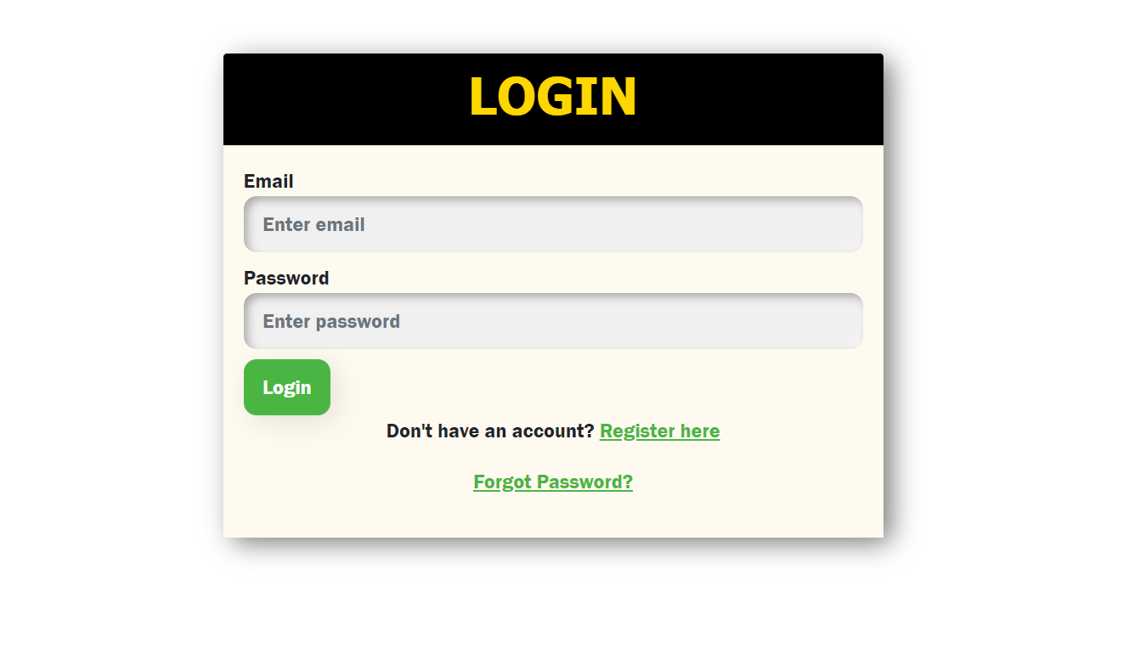

After successful login you will proceed to the dashboard as shown below:

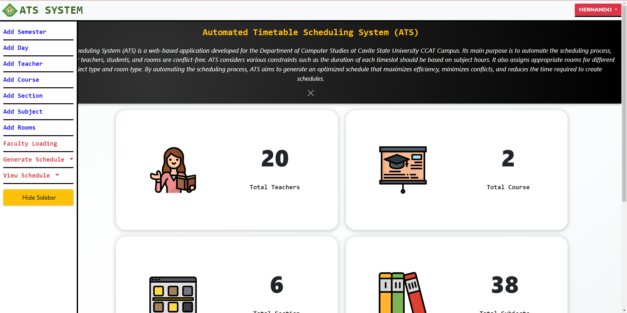

The dashboard of the web-based system features a sidebar menu with three main modules:

1. **Data Adding Module**

This module allows you to add and manage various data needed for the generation of class schedule. The following data section are shown and explained below.

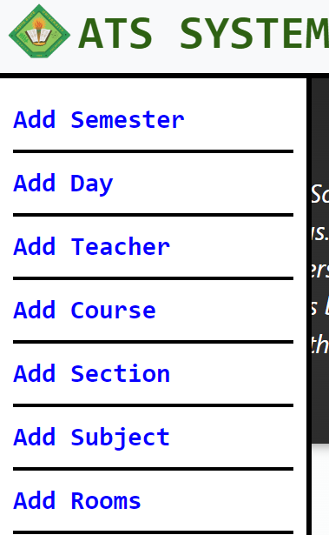

* Semester: Add or manage semesters.
* Day: Add or manage the days of the week.
* Teacher: Add or manage teacher information
* Course: Add or manage different courses
* Section: Add or manage sections.
* Subject: Add or manage individual subjects within courses.
* Rooms: Add or manage classroom information

After clicking one on the sidebar menu for example you clicked the Add Teacher menu you will redirect to the adding of teacher page as shown below.In that page you can search for specific teacher, add, update and delete teacher information.

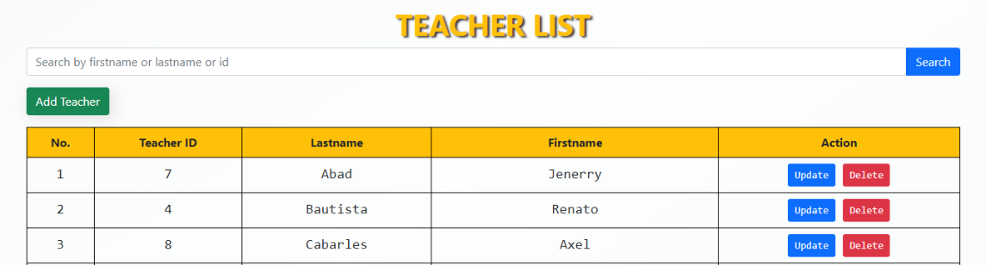

1. **Faculty Loading Module**

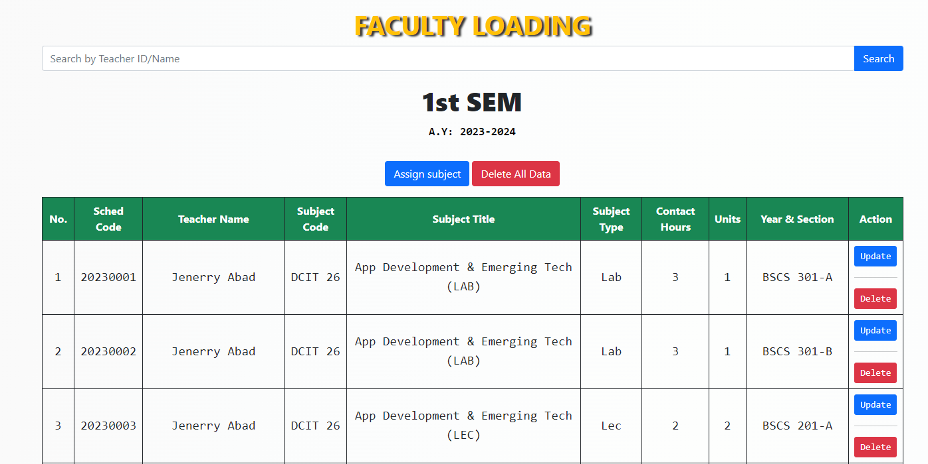

This module is designed to handle the faculty loading process. It likely includes features such as assigning teachers to specific courses or subjects, managing their workload

1. **Generate Module**

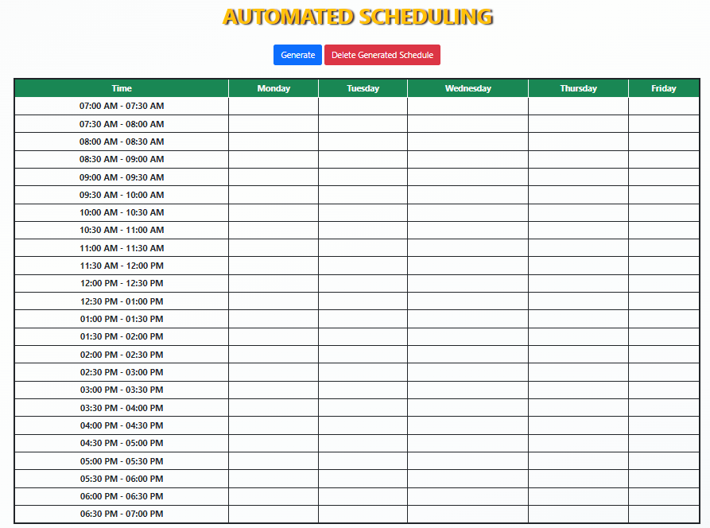

After adding all the data needed you can now proceed to the generate module. This module is responsible for generating the class schedule based on the provided data. It utilizes the information from faculty loading module and use backtracking algorithm to automatically generate a conflict-free class schedule. To generate schedule you just need to click the generate button and wait for approximately one to three minutes and the class schedule will be generated.

1. **View Module**

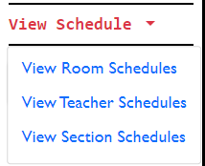

View module allows you to view the generated schedule separately in tables. You can view class schedule for teacher, students and room respectively and convert it in pdf format for printing purposes.

After the generation process can now view your generated schedule just click the view schedule menu and choose what schedule you want to see for example you clicked the teacher schedule you will redirect to the web page shown in the image below.

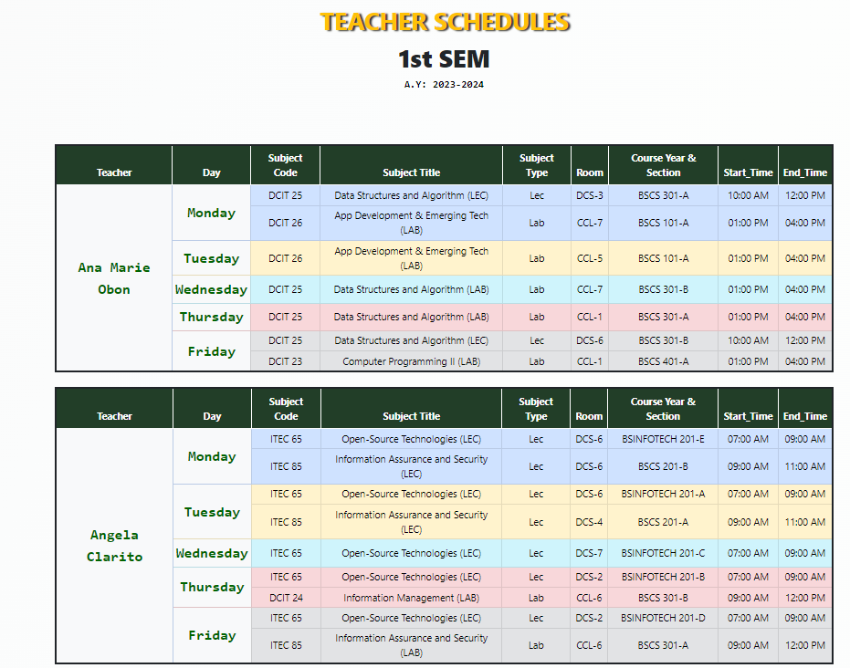

If you are finish viewing your schedules you can convert it in PDF Format just typle CTRL + P and it will be converted to PDF format as shown below.

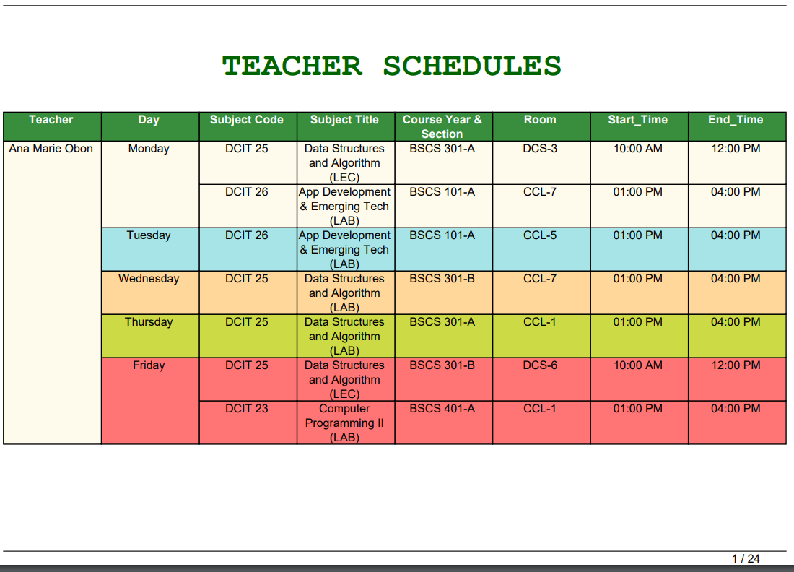

Lastly, if the generated schedules are in PDF format you can now print it just click CTRL + P again and it will be printed using your printer.

**APPENDIX K**

**SOURCE CODE**

CSS FILES

DASHBOARD.CSS

.logo {

  width: 150px;

  height: 150px;

}

.dashboard {

  margin-top: 20px;

  padding: 100px;

  border-radius: 30px;

  box-shadow: 0px 2px 12px 2px rgba(0, 0, 0, 0.2);

  display: flex;

  justify-content: space-between;

  align-items: center;

  background-color:rgb(255, 255, 255);

}

.metric {

  text-align: center;

}

.metric .value {

  font-size: 1rem;

  font-weight: bold;

  margin-bottom: 20px;

}

.metric .label {

  font-size: 20px;

  font-family: consolas;

  font-weight: bold;

  background-color: rgb(255, 255, 255);

}

INDEX.CSS

.navbar-brand img {

  max-width: 3em;

  height: auto;

}

.navbar-nav {

  display: flex;

  flex-wrap: wrap;

  font-size: 20px;

  font-family: "Gill Sans", "Gill Sans MT", Calibri, "Trebuchet MS", sans-serif;

}

.navbar {

  height: 65px;

  border-bottom: 4px solid #000000;

}

.sidebar {

  position: fixed;

  top: 64px;

  bottom: 0;

  left: 0;

  overflow-x: hidden;

  transition: 0.5s;

  padding: 10px;

  border-right: 4px solid #000000;

  background-color: rgb(255, 255, 255);

}

.nav-item {

  border-bottom: 3px solid #000000;

  margin: 0;

  text-align: left;

}

.nav-link {

  font-weight: bold;

  font-family: Consolas, monospace;

  color: rgb(8, 0, 255) !important;

  background-color:rgb(255, 255, 255);

}

.navbar-brand-label {

  color: #050505;

  font-size: 25px;

  font-family: Arial, sans-serif;

  font-weight: bold;

}

.navbar-brand {

  display: flex;

  align-items: center;

}

.hover-color:hover {

  background-color: rgb(186, 186, 186); /* Change the color to your desired hover color */

}

.btn-success {

  background-color: #4bb543;

  border: none;

  border-radius: 10px;

  box-shadow: 5px 5px 20px rgba(0, 0, 0, 0.1);

  padding: 10px 15px;

}

LOGIN.CSS

    body {

        background-repeat: repeat;

        background-position: center;

    }

    .text-shadow {

      text-shadow: 2px 2px 4px rgba(3, 0, 2, 0.1);

    }

PHP FILES

automated_schedule.php

    <?php

    include 'database_connection.php';

    include 'index.php';

// Check the number of rows in the rooms table, course table, and available_days table

$sql = "SELECT COUNT(*) AS room_count FROM rooms";

$result = mysqli_query($conn, $sql);

$row = mysqli_fetch_assoc($result);

$roomCount = $row['room_count'];

$sql = "SELECT COUNT(*) AS courses_count FROM courses";

$result = mysqli_query($conn, $sql);

$row = mysqli_fetch_assoc($result);

$courses_count = $row['courses_count'];

$sql = "SELECT COUNT(*) AS day_count FROM available_days";

$result = mysqli_query($conn, $sql);

$row = mysqli_fetch_assoc($result);

$day_count = $row['day_count'];

if ($roomCount < 10 || $courses_count <= 1 || $day_count < 4) {

    if ($courses_count <= 1) {

        echo '<script>alert("Required number of courses is 2");</script>';

        echo "<script>window.location.href = 'course_list.php';</script>";

    } elseif ($day_count < 4) {

        echo '<script>alert("Required number of days is 4");</script>';

        echo "<script>window.location.href = 'dashboard.php';</script>";

    } else {

        echo '<script>alert("[Required Course = 2|\n|Required Rooms = 10]\n[Required Days = 4]");</script>';

        echo "<script>window.location.href = 'dashboard.php';</script>";

    }

} else {

    // Function to check if a teacher is available at the given day and time

    function isTeacherAvailable($teacher, $day, $start_time, $end_time)

    {

        global $conn;

        $sql = "SELECT * FROM faculty_loadings WHERE teacher = '$teacher' AND day = '$day' AND (start_time < '$end_time' AND end_time > '$start_time')";

        $result = mysqli_query($conn, $sql);

        return mysqli_num_rows($result) == 0;

    }

    // Function to check if a room is available at the given day and time

    function isRoomAvailable($room_name, $day, $start_time, $end_time)

    {

        global $conn;

        $sql = "SELECT * FROM faculty_loadings WHERE room_name = '$room_name' AND day = '$day' AND (start_time < '$end_time' AND end_time > '$start_time')";

        $result = mysqli_query($conn, $sql);

        return mysqli_num_rows($result) == 0;

    }

    // Function to check if there is a conflict in course_year_section

    function isCourseYearSectionConflict($course_year_section, $day, $start_time, $end_time)

    {

        global $conn;

        $sql = "SELECT * FROM faculty_loadings WHERE course_year_section = '$course_year_section' AND day = '$day' AND (start_time < '$end_time' AND end_time > '$start_time')";

        $result = mysqli_query($conn, $sql);

        return mysqli_num_rows($result) > 0;

    }

    // Function to assign timeslots to courses using backtracking

    function assignTimeslots($courses)

    {

        global $conn;

        // Base case: If all courses have been assigned timeslots, return true

        if (empty($courses)) {

            return true;

        }

        // Select the first course from the list and remove it from the array

        $course = array_shift($courses);

        $subjectHours = $course['subject_hours'];

        // Retrieve a timeslot with the corresponding duration

        $duration = '';

        if ($subjectHours == 1) {

            $duration = "01:00:00";

        } elseif ($subjectHours == 1.5) {

            $duration = "01:30:00";

        } elseif ($subjectHours == 2) {

            $duration = "02:00:00";

        } elseif ($subjectHours == 3) {

            $duration = "03:00:00";

        }

        // Retrieve available timeslots with the same duration

        $timeslot_sql = "SELECT * FROM timeslots WHERE TIMEDIFF(end_time, start_time) = '$duration'";

        $timeslot_result = mysqli_query($conn, $timeslot_sql);

        // Check for SQL query error

        if (!$timeslot_result) {

            die('Error retrieving timeslots: ' . mysqli_error($conn));

        }

        while ($timeslot_row = mysqli_fetch_assoc($timeslot_result)) {

            // Retrieve the subject type of the course

            $subject_type = $course['subject_type'];

            // Retrieve an available room with the same room type and subject type

            $room_sql = "SELECT room_name FROM rooms WHERE room_type = '$subject_type' ORDER BY RAND()";

            $room_result = mysqli_query($conn, $room_sql);

            // Check for SQL query error

            if (!$room_result) {

                die('Error retrieving rooms: ' . mysqli_error($conn));

            }

            // Loop through each available room

            while ($room_row = mysqli_fetch_assoc($room_result)) {

                $room_name = $room_row['room_name'];

                // Randomly select a day from available_days

                $day_sql = "SELECT day FROM available_days ORDER BY RAND()";

                $day_result = mysqli_query($conn, $day_sql);

                // Check for SQL query error

                if (!$day_result) {

                    die('Error retrieving days: ' . mysqli_error($conn));

                }

                // Loop through each available day

                while ($day_row = mysqli_fetch_assoc($day_result)) {

                    $day = $day_row['day'];

                    // Check if the teacher, room, and course year section are available at the selected day and timeslot

                    if (isTeacherAvailable($course['teacher'], $day, $timeslot_row['start_time'], $timeslot_row['end_time']) &&

                        isRoomAvailable($room_name, $day, $timeslot_row['start_time'], $timeslot_row['end_time']) &&

                        !isCourseYearSectionConflict($course['course_year_section'], $day, $timeslot_row['start_time'], $timeslot_row['end_time'])) {

                        // Assign the timeslot, day, room name, and room type to the course

                        $update_sql = "UPDATE faculty_loadings SET start_time = '{$timeslot_row['start_time']}', end_time = '{$timeslot_row['end_time']}', day = '$day', room_name = '$room_name' WHERE id = {$course['id']}";

                        mysqli_query($conn, $update_sql);

                        // Recursively assign timeslots to the remaining courses

                        $success = assignTimeslots($courses);

                        // If a valid assignment is found for all courses, return true

                        if ($success) {

                            //echo '<script>alert("Generated successfully!");</script>'; PROMPT AFTER SUCCESSFUL LOGIN

                            return true;

                        }

                        // If the assignment was not successful, backtrack by resetting the timeslot, day, room name, and room type

                        $update_sql = "UPDATE faculty_loadings SET start_time = NULL, end_time = NULL, day = NULL, room_name = NULL WHERE id = {$course['id']}";

                        mysqli_query($conn, $update_sql);

                    }

                }

            }

        }

        // If no valid assignment is found, return false

        return false;

    }

    // Check if the faculty_loadings table is empty

    $sql = "SELECT COUNT(*) AS count FROM faculty_loadings";

    $result = mysqli_query($conn, $sql);

    $row = mysqli_fetch_assoc($result);

    $count = $row['count'];

    // SQL query to select data from the table where start_time is empty

    $sql_start_time = "SELECT * FROM faculty_loadings WHERE start_time IS NULL";

    $result_start_time = mysqli_query($conn, $sql_start_time);

    $button_disabled = "";

    if ($count == 0) {

        // The faculty_loadings table is empty

        $button_disabled = "disabled";

        $button_text = "Generate";

    } elseif ($result_start_time->num_rows > 0) {

        // The start_time column is empty for some rows

        while ($row = mysqli_fetch_assoc($result_start_time)) {

            // Process each row of data

            $columnValue = $row["start_time"];

            // Retrieve the updated value from the database

            $select_sql = "SELECT start_time FROM faculty_loadings WHERE id = " . $row["id"];

            $result_updated_start_time = mysqli_query($conn, $select_sql);

            $updated_start_time = mysqli_fetch_assoc($result_updated_start_time)["start_time"];

            // Check if the start_time value is not null

            if ($updated_start_time !== null) {

                // Additional processing or output

                $button_text = "Regenerate";

            } else {

                $button_text = "Generate";

            }

        }

    } else {

        // The start_time column is not empty for any rows

        $button_text = "Regenerate";

    }

    // Check if the button was clicked

    if (isset($_POST['assign_timeslots'])) {

        // Retrieve the data from the faculty_loading table

        $sql = "SELECT * FROM faculty_loadings";

        $result = mysqli_query($conn, $sql);

        // Check for SQL query error

        if ($result) {

            // Store the courses in an array

            $courses = array();

            while ($row = mysqli_fetch_assoc($result)) {

                $courses[] = $row;

            }

            // Call the backtrack function to assign timeslots to the courses

            $success = assignTimeslots($courses);

            if ($success) {

                echo '<script type="text/javascript">';

                echo ' alert("Schedule is Generated Successfully without conflicts!");';

                echo '</script>';

            } else {

                echo '<script type="text/javascript">';

                echo ' alert("Unable to assign timeslots without conflicts.");';

                echo '</script>';

            }

        } else {

            die('Error retrieving faculty_loadings data: ' . mysqli_error($conn));

        }

    }

    // Check if the faculty_loading table is not empty

    if ($count > 0) {

        // Display the timetable

        echo '

        <!DOCTYPE html>

        <html>

        <head>

            <title>Faculty Loading System</title>

            <link rel="stylesheet" href="https://cdnjs.cloudflare.com/ajax/libs/bootstrap/5.0.2/css/bootstrap.min.css">

        <style>

        .table-bordered {

            border:.2rem solid;

            text-align:center;

            vertical-align:middle;

        }

        @media print {

            body {

                visibility: hidden;

            .print-page {

                visibility: visible;

                width: 210mm;

                height: 297mm;

                margin: 0 auto;

                padding: 20mm;

                box-sizing: border-box;

                page-break-after: always;

            }

        }

    </style>

    </head>

    <body>

    <div class="container print-page ">

    <h1 style="  text-shadow: 4px 2px 3px rgba(0, .5, 0, .80);" class="fw-bolder text-center text-warning mt-3 text-outline">AUTOMATED SCHEDULING</H1>

    <div class="containe-fluid text-center "><form method="post">

    <button type="submit" name="assign_timeslots" id="buttonGenerate" class="btn btn-primary mt-4" ' . $button_disabled . '>' . $button_text . '</button>

    <button type="button" class=" mt-4 btn btn-danger" id="truncate">Delete Generated Schedule</button>

    </form></div>

    <table class="table mt-4 print-table table-bordered table table-hover table-sm">

        <thead class="thead-dark bg-success text-light fw-bolder text-light">

        <tr>

            <th>Time</th>'; // Empty cell for spacing

        // Loop through the days (Monday to Friday)

        $days = array('Monday', 'Tuesday', 'Wednesday', 'Thursday','Friday');

        foreach ($days as $day) {

            echo "<th>{$day}</th>";

        }

        echo '</tr>

                </thead>

                <tbody style="font-size:1rem;">';

        // Loop through the time slots MODIFY THIS IF YOU WANT TO ADD TIME RANGE

        $start_time = strtotime('07:00:00');

        $end_time = strtotime('19:00:00');

        while ($start_time < $end_time) {

            $end_time_formatted = date('h:i A', strtotime('+30 minutes', $start_time));

            echo "<tr>";

            echo "<th>" . date('h:i A', $start_time) . " - " . $end_time_formatted . "</th>";

            // Loop through the days (Monday to Friday)

            foreach ($days as $day) {

                echo '<td>';

                // Retrieve the data from the faculty_loading table for the current day and time interval

                $sql = "SELECT * FROM faculty_loadings WHERE day = '$day' AND start_time <= '" . date('H:i:s', $start_time) . "' AND end_time > '" . date('H:i:s', $start_time) . "'";

                $result = mysqli_query($conn, $sql);

                // Check for SQL query error

                if ($result) {

                    $combined_data = '';

                    while ($row = mysqli_fetch_assoc($result)) {

                        $combined_data .= '<div class="text-center">' . $row['teacher'] . '<br>' . $row['subject_code'] . '<br>' . $row['course_year_section'] . '<br>' . $row['room_name'] . '<br><br></div>';

                    }

                    echo $combined_data;

                } else {

                    die('Error retrieving faculty_loadings data: ' . mysqli_error($conn));

                }

                echo '</td>';

            }

            echo '</tr>';

            $start_time = strtotime('+30 minutes', $start_time);

        }

        echo '</tbody>

            </table>

    <div>

        </body>

        </html>';

    } else {

        echo "<script>alert('No data available!\\nPlease add data to the faculty_loadings table.');</script>";

        echo "<script>window.location.href = 'faculty_loading_list.php';</script>";

    }

    }

    ?>

    <!-- DELETE SCHED AJAX -->

    <script>

        $(document).ready(function () {

            $('#truncate').click(function () {

                if (confirm("Are you sure you want to delete the generated schedule?")) {

                    $.ajax({

                        url: "delete_generated_sched.php", // the PHP script that truncates the table

                        success: function (response) {

                            alert(response); // show the response message from the PHP script

                            location.reload(); // reload the page

                        }

                    });

                }

            });

        });

    </script>

    <script>

    $(document).ready(function () {

    $('#buttonGenerate').click(function () {

        if (confirm("Are you sure you want to generate the schedule?")) {

        $.ajax({

            url: "automated_schedule.php",

            success: function () {

                alert("Please wait for approximately 1 to 3 minutes while the schedule is being generated.");

            location.reload();

            },

            error: function (xhr, status, error) {

            alert("An error occurred while generating the schedule. Please try again later.");

            console.log(xhr.responseText);

            }

        });

        }

    });

    });

    </script>

course_create.php

<?php

//include the db connection php file.

include 'database_connection.php';

include 'index.php';

// Check if user is not logged in

if (!isset($_SESSION['user_id'])) {

    header("Location: login.php");

    exit;

}

// Inserting data for courses table

if (isset($_POST['submit'])) {

    $course_name = mysqli_real_escape_string($conn,$_POST['course_name']);

    $slots = mysqli_real_escape_string ($conn,$_POST['slots']);

    // Check if data already exists in the database

    $sql = "SELECT * FROM courses WHERE course_name = '$course_name'";

    $result = mysqli_query($conn, $sql);

    if (mysqli_num_rows($result) > 0) {

        // Data already exists in the database, display an error message

        echo '<script type="text/javascript">';

        echo ' alert("Course already exists!")';

        echo '</script>';

    } else {

        // Data does not exist in the database, insert the data into the table

        $sql = "INSERT INTO courses (course_name, slots) VALUES ('$course_name', '$slots')";

        if (mysqli_query($conn, $sql)) {

            echo '<script type="text/javascript">';

            echo ' alert("New record added successfully!");';

            echo ' window.location.href = "course_list.php";';

            echo '</script>';

            exit; // Make sure to exit after the redirect

        } else {

            echo "Error: " . $sql . "<br>" . mysqli_error($conn);

        }

    }

}

?>

<!doctype html>

<html lang="en">

<head>

    <!-- Required meta tags -->

    <meta charset="utf-8">

    <meta name="viewport" content="width=device-width, initial-scale=1">

    <!-- CDN Bootstrap CSS -->

    <link href="https://cdn.jsdelivr.net/npm/bootstrap@5.0.2/dist/css/bootstrap.min.css" rel="stylesheet"

        integrity="sha384-EVSTQN3/azprG1Anm3QDgpJLIm9Nao0Yz1ztcQTwFspd3yD65VohhpuuCOmLASjC" crossorigin="anonymous">

    <!--External CSS-->

    <link rel="stylesheet" href="css/dashboard.css">

    <!-- CDN Bootstrap JS -->

    <script src="https://cdn.jsdelivr.net/npm/bootstrap@5.0.2/dist/js/bootstrap.bundle.min.js"

        integrity="sha384-xm/1MSCs2sDx6kLZ6Qm84zE4U6mSWJXa3gfn+Or05YnSdrgHxOmkjIVtwZgMk50D" crossorigin="anonymous">

    </script>

    <!-- CDN jquery -->

    <script src="https://code.jquery.com/jquery-3.6.0.min.js"></script>

    <link rel="stylesheet" href="https://cdn.jsdelivr.net/npm/bootstrap@5.1.3/dist/css/bootstrap.min.css"

        integrity="sha384-PoX9L+uPbsAVCv+jcUscle6Udq7VrypQT8Uv7zsLAbB6C9fV0pG8yBlxkdgsHOD+" crossorigin="anonymous">

    <script src="https://cdn.jsdelivr.net/npm/bootstrap@5.1.3/dist/js/bootstrap.bundle.min.js"

        integrity="sha384-8t+gWy0JhGjbOxbtu2QzKACoVrAJRz/iBRymx1Ht/W1hXxrFL05t8PChqoo3sLsP" crossorigin="anonymous">

    </script>

</head>

<body>

    <title>Add Course</title>

    <div class="container mt-3" >

        <h1 style="  text-shadow: 3px 2px 3px rgba(0, .5, 0, .80)" class="fw-bolder text-center text-warning mt-3 text-outline">ADD COURSE</H1>

        <form method="post" class="fw-bolder">

            <div class="mb-3 mt-3">

                <label for="course_name" class="form-label">Course Name</label>

                <input type="text" class="form-control" id="course_name" placeholder="Enter Course name"

                    name="course_name" required>

            </div>

            <div class="mb-3">

                <label for="slots" class="form-label">Slots</label>

                <input type="number" class="form-control" id="slots" placeholder="Slots"

                    name="slots" required>

            </div>

            <button type="submit" class="btn btn-primary" name="submit">Create</button>

            <a href="course_list.php" class="btn btn-danger" name="back">Back</a>

        </form>

    </div>

</body>

</html>

course_list.php

<?php

include 'database_connection.php';

include 'index.php';

// Delete course if delete_id is set in the URL parameters

if (isset($_GET['delete_id'])) {

    $id = $_GET['delete_id'];

    $sql = "DELETE FROM courses WHERE id='$id'";

    if ($conn->query($sql) === TRUE) {

        echo "<script>alert('Course deleted successfully');</script>";

        echo "<script>window.location.href = 'course_list.php';</script>";

    } else {

        echo "Error deleting record: " . $conn->$error;

    }

}

// Execute search query if search form is submitted

if (isset($_POST['search'])) {

    $search_term = $_POST['search'];

    $query = "SELECT * FROM courses WHERE course_name LIKE '%$search_term%'";

    $result = $conn->query($query);

} else {

    $query = "SELECT * FROM courses";

    $result = $conn->query($query);

}

?>

<!doctype html>

<html lang="en">

<head>

    <!-- Required meta tags -->

    <meta charset="utf-8">

    <meta name="viewport" content="width=device-width, initial-scale=1">

    <!-- CDN Bootstrap CSS -->

    <link href="https://cdn.jsdelivr.net/npm/bootstrap@5.0.2/dist/css/bootstrap.min.css" rel="stylesheet"

        integrity="sha384-EVSTQN3/azprG1Anm3QDgpJLIm9Nao0Yz1ztcQTwFspd3yD65VohhpuuCOmLASjC" crossorigin="anonymous">

    <!--External CSS-->

    <link rel="stylesheet" href="css/courses.css">

    <!-- CDN Bootstrap JS -->

    <script src="https://cdn.jsdelivr.net/npm/bootstrap@5.0.2/dist/js/bootstrap.bundle.min.js"

        integrity="sha384-xm/1MSCs2sDx6kLZ6Qm84zE4U6mSWJXa3gfn+Or05YnSdrgHxOmkjIVtwZgMk50D" crossorigin="anonymous">

    </script>

    <!-- CDN jquery -->

    <script src="https://code.jquery.com/jquery-3.6.0.min.js"></script>

    <link rel="stylesheet" href="https://cdn.jsdelivr.net/npm/bootstrap@5.1.3/dist/css/bootstrap.min.css"

        integrity="sha384-PoX9L+uPbsAVCv+jcUscle6Udq7VrypQT8Uv7zsLAbB6C9fV0pG8yBlxkdgsHOD+" crossorigin="anonymous">

    <script src="https://cdn.jsdelivr.net/npm/bootstrap@5.1.3/dist/js/bootstrap.bundle.min.js"

        integrity="sha384-8t+gWy0JhGjbOxbtu2QzKACoVrAJRz/iBRymx1Ht/W1hXxrFL05t8PChqoo3sLsP" crossorigin="anonymous">

    </script>

</head>

<body>

    <div class="container" style="background-color:#FAF8FF">

        <div class="container">

        <h1 style="text-shadow: 3px 2px 3px rgba(0, .5, 0, .80)" class="fw-bolder text-center text-warning mt-3 text-outline">COURSE LIST</H1>

            <form method="POST">

                <div class="input-group mb-3">

                    <input type="text" class="form-control rounded" placeholder="Search by Course name"

                        name="search">

                    <button type="submit" class="btn btn-primary">Search</button>

                </div>

                <a href="course_create.php" class="btn btn-success mb-3"><i class='fas fa-user-plus'></i> Add Course</a>

            </form>

            <table class="table table-bordered table-hover text-center" style="border:1px solid black">

                 <thead class="bg-warning">

                    <tr>

                        <th>No.</th>

                        <th>Course Name</th>

                        <th>Slots</th>

                        <th>Action</th>

                    </tr>

                </thead>

                <tbody style="font-size:1.2rem;font-family:monospace">

                    <?php

                    if ($result->num_rows > 0) {

                        // output data of each row

                        $i = 1;

                        while ($row = $result->fetch_assoc()) {

                            echo "<tr>";

                            echo "<td>" . $i . "</td>";

                            echo "<td>" . $row["course_name"] . "</td>";

                            echo "<td>" . $row["slots"] . "</td>";

                            echo "<td>";

                            echo "<a href='course_update.php?id=" . $row["id"] . "' class='btn btn-primary btn-sm'>Update<i class='fas fa-edit'></i></a>&nbsp";

                            echo "<a href='" . $_SERVER['PHP_SELF'] . "?delete_id=" . $row["id"] . "' class='btn btn-danger btn-sm' onclick=\"return confirm('Are you sure you want to delete this teacher?')\">Delete<i class='fas fa-trash'></i></a>";

                            echo "</td>";

                            echo "</tr>";

                            $i++;

                        }

                    } else {

                        echo "<tr><td colspan='5'>No courses found</td></tr>";

                    }

                    ?>

                </tbody>

            </table>

        </div>

    </div>

</body>

</html>

course_update.php

<?php

// include the database connection file

include 'database_connection.php';

include 'index.php';

// Fetching data from the database

if (isset($_GET['id'])) {

    $id = mysqli_real_escape_string($conn, $_GET['id']);

    $sql = "SELECT * FROM courses WHERE id ='$id'";

    $result = mysqli_query($conn, $sql);

    if ($result && mysqli_num_rows($result) > 0) {

        $row = mysqli_fetch_assoc($result);

    } else {

        // If there was an error in the query, display an error message and exit

        echo "Error: " . $sql . "<br>" . mysqli_error($conn);

        exit();

    }

}

// Updating data in the database

if (isset($_POST['update'])) {

    // First, retrieve the data from the form and sanitize it

    $id = mysqli_real_escape_string($conn, $_POST['id']);

    $course_name = mysqli_real_escape_string($conn, $_POST['course_name']);

    $slots = mysqli_real_escape_string($conn, $_POST['slots']);

    // Then, check if the Course name, start date and end date already exists in the database

    $sql = "SELECT * FROM courses WHERE course_name='$course_name'";

    $result = mysqli_query($conn, $sql);

    if (mysqli_num_rows($result) > 0) {

        // If the Course with the same name, start date and end date already exists, display an error message

        echo '<script type="text/javascript">';

        echo ' alert("Course name already exists!")';

        echo '</script>';

    } else {

        // If the Course with the same name, start date and end date does not exist, update the data in the database

        $sql = "UPDATE courses SET course_name='$course_name', slots ='$slots' WHERE id='$id'";

        if (mysqli_query($conn, $sql)) {

            // Data updated successfully, display an alert message and redirect to Course_list.php

            echo '<script type="text/javascript">';

            echo ' alert("Record updated successfully!");';

            echo ' window.location.href = "course_list.php";';

            echo '</script>';

            exit; // Make sure to exit after the redirect

        } else {

            echo "Error updating record: " . mysqli_error($conn);

        }

    }

}

?>

<!doctype html>

<html lang="en">

    <head>

        <!-- Required meta tags -->

        <meta charset="utf-8">

        <meta name="viewport" content="width=device-width, initial-scale=1">

        <!-- CDN Bootstrap CSS -->

        <link href="https://cdn.jsdelivr.net/npm/bootstrap@5.0.2/dist/css/bootstrap.min.css" rel="stylesheet"

            integrity="sha384-EVSTQN3/azprG1Anm3QDgpJLIm9Nao0Yz1ztcQTwFspd3yD65VohhpuuCOmLASjC" crossorigin="anonymous">

        <!--External CSS-->

        <link rel="stylesheet" href="css/course.css">

        <!-- CDN Bootstrap JS -->

        <script src="https://cdn.jsdelivr.net/npm/bootstrap@5.0.2/dist/js/bootstrap.bundle.min.js"

            integrity="sha384-xm/1MSCs2sDx6kLZ6Qm84zE4U6mSWJXa3gfn+Or05YnSdrgHxOmkjIVtwZgMk50D" crossorigin="anonymous">

            </script>

        <!-- CDN jquery -->

        <script src="https://code.jquery.com/jquery-3.6.0.min.js"></script>

        <link rel="stylesheet" href="https://cdn.jsdelivr.net/npm/bootstrap@5.1.3/dist/css/bootstrap.min.css"

            integrity="sha384-PoX9L+uPbsAVCv+jcUscle6Udq7VrypQT8Uv7zsLAbB6C9fV0pG8yBlxkdgsHOD+" crossorigin="anonymous">

        <script src="https://cdn.jsdelivr.net/npm/bootstrap@5.1.3/dist/js/bootstrap.bundle.min.js"

            integrity="sha384-8t+gWy0JhGjbOxbtu2QzKACoVrAJRz/iBRymx1Ht/W1hXxrFL05t8PChqoo3sLsP" crossorigin="anonymous">

            </script>

    </head>

<body>

    <div class="container mt-3">

    <h1 style="  text-shadow: 3px 2px 3px rgba(0, .5, 0, .80)" class="fw-bolder text-center text-warning mt-3 text-outline">UPDATE COURSE DETAILS</H1>

        <!-- Display the data of the selected Course in the form fields -->

        <form method="POST" action="">

            <input type="hidden" name="id" value="<?php echo $row['id']; ?>">

            <div class="mb-3">

                <label for="course_name" class="form-label">Course Name</label>

                <input type="text" class="form-control" id="course_name" name="course_name"

                    value="<?php echo $row['course_name']; ?>">

            </div>

            <div class="mb-3">

                <label for="slots" class="form-label">Course Slots</label>

                <input type="number" class="form-control" id="slots" name="slots"

                    value="<?php echo $row['slots']; ?>">

            </div>

                <button type="submit" name="update" class="btn btn-primary">Update</button>

                <a href="course_list.php" class="btn btn-danger">Back</a>

        </form>

    </div>

</body>

</html>

dashboard.php

<?php

include 'database_connection.php';

include 'index.php';

// Check if user is not logged in

if (!isset($_SESSION['user_id'])) {

    header("Location: login.php");

    exit;

}

?>

<!doctype html>

<html lang="en">

<head>

    <!-- Required meta tags -->

    <meta charset="utf-8">

    <meta name="viewport" content="width=device-width, initial-scale=1">

    <!-- CDN Bootstrap CSS -->

    <link href="https://cdn.jsdelivr.net/npm/bootstrap@5.0.2/dist/css/bootstrap.min.css" rel="stylesheet"

        integrity="sha384-EVSTQN3/azprG1Anm3QDgpJLIm9Nao0Yz1ztcQTwFspd3yD65VohhpuuCOmLASjC" crossorigin="anonymous">

    <!--External CSS-->

    <link rel="stylesheet" href="css/dashboard.css">

    <!-- CDN Bootstrap JS -->

    <script src="https://cdn.jsdelivr.net/npm/bootstrap@5.0.2/dist/js/bootstrap.bundle.min.js"

        integrity="sha384-xm/1MSCs2sDx6kLZ6Qm84zE4U6mSWJXa3gfn+Or05YnSdrgHxOmkjIVtwZgMk50D" crossorigin="anonymous">

        </script>

    <!-- CDN jquery -->

    <script src="https://code.jquery.com/jquery-3.6.0.min.js"></script>

    <link rel="stylesheet" href="https://cdn.jsdelivr.net/npm/bootstrap@5.1.3/dist/css/bootstrap.min.css"

        integrity="sha384-PoX9L+uPbsAVCv+jcUscle6Udq7VrypQT8Uv7zsLAbB6C9fV0pG8yBlxkdgsHOD+" crossorigin="anonymous">

    <script src="https://cdn.jsdelivr.net/npm/bootstrap@5.1.3/dist/js/bootstrap.bundle.min.js"

        integrity="sha384-8t+gWy0JhGjbOxbtu2QzKACoVrAJRz/iBRymx1Ht/W1hXxrFL05t8PChqoo3sLsP" crossorigin="anonymous">

        </script>

    <title>Dashboard Page</title>

</head>

<!-- System Description-->

<div id="description_system"

    style="box-shadow: 0 0 10px rgba(0, 0, 0, 0.5);background: radial-gradient(circle at 24.1% 68.8%, rgb(50, 50, 50) 0%, rgb(0, 0, 0) 99.4%);;font-size:1.2rem;"

    class="container-fluid p-3 text-center">

    <?php

    $user_id = $_SESSION['user_id'];

    $sql = "SELECT * FROM users WHERE id='$user_id'";

    $result = mysqli_query($conn, $sql);

    $user_data = mysqli_fetch_assoc($result);

    $user_name = $user_data['name'];

    echo "<h3 style='font-family:monospace;' class='fw-bolder text-warning'>Automated Timetable Scheduling System (ATS)</h3>";

    ?>

    <div class="mt-4">

        <ul class="list-unstyled text-white ">

            <em>

                Automated Timetable Scheduling System (ATS) is a web-based application developed for the Department

                of Computer Studies at Cavite State University CCAT Campus. Its main purpose is to automate the

                scheduling process, ensuring that schedules for teachers, students, and rooms are conflict-free. ATS

                considers various constraints such as the duration of each timeslot should be based on subject hours. It

                also assigns appropriate rooms for different subjects based on subject type and room type. By automating

                the scheduling process, ATS aims to generate an optimized schedule that maximizes efficiency, minimizes

                conflicts, and reduces the time required to create schedules.

            </em>

        </ul>

    </div>

    <button type="button" id="button_close" class="btn-close btn-close-white" data-bs-dismiss="alert"

        aria-label="Close"></button>

</div>

<div class="container-fluid">

    <div class="row justify-content-center" style="margin-right:0px;margin-left:190px;">

        <!-- TEACHER DASHBOARD -->

        <div class="col-5">

            <div class="dashboard hover-color">

                <?php

                $query = "SELECT COUNT(*) AS total_teachers FROM teachers";

                $result = mysqli_query($conn, $query);

                if ($result) {

                    $row = mysqli_fetch_assoc($result);

                    $total_teachers = $row['total_teachers'];

                } else {

                    $total_teachers = "N/A";

                }

                ?>

                <img class="logo" src="logos/teacher.png" alt="ATS">

                <div class="metric rounded-circle">

                    <div class="value">

                        <?php echo '<div class="display-2 fw-bolder text-dark">' . $total_teachers . '</div>'; // Replace display-1 with the desired size class.?>

                    </div>

                    <div class="card-body ">

                        <div class="label text-dark">Total Teachers</div>

                    </div>

                </div>

            </div>

        </div>

        <!--  COURSE DASHBOARD-->

        <div class="col-5">

            <div class="dashboard hover-color">

                <?php

                $query = "SELECT COUNT(*) AS total_course FROM courses";

                $result = mysqli_query($conn, $query);

                if ($result) {

                    $row = mysqli_fetch_assoc($result);

                    $total_course = $row['total_course'];

                } else {

                    $total_course = "N/A";

                }

                ?>

                <img class="logo" src="logos/course.png" alt="ATS">

                <div class="metric rounded-circle">

                    <div class="value">

                        <?php echo '<div class="display-2 fw-bolder text-dark">' . $total_course . '</div>'; // Replace display-1 with the desired size class.?>

                    </div>

                    <div class="card-body">

                        <div class="label text-dark">Total Course</div>

                    </div>

                </div>

            </div>

        </div>

        <!--  SECTION DASHBOARD-->

        <div class="col-5">

            <div class="dashboard hover-color">

                <?php

                $query = "SELECT COUNT(*) AS total_section FROM sections";

                $result = mysqli_query($conn, $query);

                if ($result) {

                    $row = mysqli_fetch_assoc($result);

                    $total_section = $row['total_section'];

                } else {

                    $total_section = "N/A";

                }

                ?>

                <img class="logo" src="logos/section.png" alt="ATS">

                <div class="metric rounded-circle">

                    <div class="value">

                        <?php echo '<div class="display-2 fw-bolder text-dark">' . $total_section . '</div>'; // Replace display-1 with the desired size class.?>

                    </div>

                    <div class="card-body">

                        <div class="label text-dark">Total Section</div>

                    </div>

                </div>

            </div>

        </div>

        <!--  SUBJECT DASHBOARD-->

        <div class="col-5">

            <div class="dashboard hover-color">

                <?php

                $query = "SELECT COUNT(*) AS total_subject FROM subjects";

                $result = mysqli_query($conn, $query);

                if ($result) {

                    $row = mysqli_fetch_assoc($result);

                    $total_subject = $row['total_subject'];

                } else {

                    $total_subject = "N/A";

                }

                ?>

                <img class="logo" src="logos/subjects.png" alt="ATS">

                <div class="metric rounded-circle">

                    <div class="value">

                        <?php echo '<div class="display-2 fw-bolder text-dark">' . $total_subject . '</div>'; // Replace display-1 with the desired size class.?>

                    </div>

                    <div class="card-body">

                        <div class="label text-dark">Total Subjects</div>

                    </div>

                </div>

            </div>

        </div>

        <!--  Rooms DASHBOARD-->

        <div class="col-5">

            <div class="dashboard hover-color">

                <?php

                $query = "SELECT COUNT(*) AS total_rooms FROM rooms";

                $result = mysqli_query($conn, $query);

                if ($result) {

                    $row = mysqli_fetch_assoc($result);

                    $total_rooms = $row['total_rooms'];

                } else {

                    $total_rooms = "N/A";

                }

                ?>

                <img class="logo" src="logos/rooms.png" alt="ATS">

                <div class="metric rounded-circle">

                    <div class="value">

                        <?php echo '<div class="display-2 fw-bolder text-dark">' . $total_rooms . '</div>'; // Replace display-1 with the desired size class.?>

                    </div>

                    <div class="card-body">

                        <div class="label text-dark">Total Rooms</div>

                    </div>

                </div>

            </div>

        </div>

        <!--  randomize DASHBOARD-->

        <div class="col-5">

            <div class="dashboard hover-color">

                <?php

                $query = "SELECT COUNT(start_time) AS total_sched FROM faculty_loadings WHERE start_time IS NOT NULL";

                $result = mysqli_query($conn, $query);

                if ($result) {

                    $row = mysqli_fetch_assoc($result);

                    $total_sched = $row['total_sched'];

                } else {

                    $total_sched = "N/A";

                }

                ?>

                <img class="logo" src="logos/sched.png" alt="ATS">

                <div class="metric rounded-circle">

                    <div class="value">

                        <?php echo '<div class="display-2 fw-bolder text-dark">' . $total_sched . '</div>'; // Replace display-1 with the desired size class.?>

                    </div>

                    <div class="card-body">

                        <div class="label text-dark">Total Generated Schedules</div>

                    </div>

                </div>

            </div>

        </div>

    </div>

</div>

</div>

<script>

    $(document).ready(function () {

        $(".btn-close").click(function () {

            $("#description_system").hide();

        });

    });

</script>

</body>

</html>

database_connection.php

<?php

$servername = "localhost";

$username = "root";

$password = "";

$dbname = "ats_db";

// Create connection

$conn = new mysqli($servername, $username, $password, $dbname);

// Check connection

if ($conn->connect_error) {

    die("Connection failed: " . $conn->connect_error);

}

?>

days_create.php

<?php

//include the db connection php file.

include 'database_connection.php';

include 'index.php';

// Check if user is not logged in

if (!isset($_SESSION['user_id'])) {

    header("Location: login.php");

    exit;

}

// Inserting data for courses table

if (isset($_POST['submit'])) {

    $course_name = mysqli_real_escape_string($conn,$_POST['day']);

    // Check if data already exists in the database

    $day = mysqli_real_escape_string($conn, $_POST['day']);

    $sql = "SELECT * FROM available_days WHERE day ='$day'";

    $result = mysqli_query($conn, $sql);

    if (mysqli_num_rows($result) > 0) {

        // Data already exists in the database, display an error message

        echo '<script type="text/javascript">';

        echo ' alert("Day already exists!")';

        echo '</script>';

    } else {

        // Data does not exist in the database, insert the data into the table

        $sql = "INSERT INTO available_days (day) VALUES ('$day')";

        if (mysqli_query($conn, $sql)) {

            echo '<script type="text/javascript">';

            echo ' alert("New day has been added successfully!");';

            echo ' window.location.href = "days_list.php";';

            echo '</script>';

            exit; // Make sure to exit after the redirect

        } else {

            echo "Error: " . $sql . "<br>" . mysqli_error($conn);

        }

    }

}

?>

<!doctype html>

<html lang="en">

<head>

    <!-- Required meta tags -->

    <meta charset="utf-8">

    <meta name="viewport" content="width=device-width, initial-scale=1">

    <!-- CDN Bootstrap CSS -->

    <link href="https://cdn.jsdelivr.net/npm/bootstrap@5.0.2/dist/css/bootstrap.min.css" rel="stylesheet"

        integrity="sha384-EVSTQN3/azprG1Anm3QDgpJLIm9Nao0Yz1ztcQTwFspd3yD65VohhpuuCOmLASjC" crossorigin="anonymous">

    <!--External CSS-->

    <link rel="stylesheet" href="css/dashboard.css">

    <!-- CDN Bootstrap JS -->

    <script src="https://cdn.jsdelivr.net/npm/bootstrap@5.0.2/dist/js/bootstrap.bundle.min.js"

        integrity="sha384-xm/1MSCs2sDx6kLZ6Qm84zE4U6mSWJXa3gfn+Or05YnSdrgHxOmkjIVtwZgMk50D" crossorigin="anonymous">

    </script>

    <!-- CDN jquery -->

    <script src="https://code.jquery.com/jquery-3.6.0.min.js"></script>

    <link rel="stylesheet" href="https://cdn.jsdelivr.net/npm/bootstrap@5.1.3/dist/css/bootstrap.min.css"

        integrity="sha384-PoX9L+uPbsAVCv+jcUscle6Udq7VrypQT8Uv7zsLAbB6C9fV0pG8yBlxkdgsHOD+" crossorigin="anonymous">

    <script src="https://cdn.jsdelivr.net/npm/bootstrap@5.1.3/dist/js/bootstrap.bundle.min.js"

        integrity="sha384-8t+gWy0JhGjbOxbtu2QzKACoVrAJRz/iBRymx1Ht/W1hXxrFL05t8PChqoo3sLsP" crossorigin="anonymous">

    </script>

</head>

<body>

    <title>Add Day</title>

    <div class="container mt-3">

    <h1 style="  text-shadow: 3px 2px 3px rgba(0, .5, 0, .80)" class="fw-bolder text-center text-warning mt-3 text-outline">ADD DAY</H1>

        <form method="post">

        <div class="form-group mt-3">

            <label for="day" class="form-label">Day:</label>

            <select class="form-select" name="day" id="day" required>

                <option value="">Select a day</option>

                <option value="Monday">Monday</option>

                <option value="Tuesday">Tuesday</option>

                <option value="Wednesday">Wednesday</option>

                <option value="Thursday">Thursday</option>

                <option value="Friday">Friday</option>

            </select>

        </div>

            <button type="submit" class="btn btn-primary mt-3" name="submit">Create</button>

            <a href="course_list.php" class="btn btn-danger mt-3" name="back">Back</a>

        </form>

    </div>

</body>

</html>

days_list.php

<?php

include 'database_connection.php';

include 'index.php';

// Delete course if delete_id is set in the URL parameters

if (isset($_GET['delete_id'])) {

    $id = $_GET['delete_id'];

    $sql = "DELETE FROM available_days WHERE id='$id'";

    if ($conn->query($sql) === TRUE) {

        echo "<script>alert('Day deleted successfully');</script>";

        echo "<script>window.location.href = 'days_list.php';</script>";

    } else {

        echo "Error deleting record: " . $conn->$error;

    }

}

// Execute search query if search form is submitted

if (isset($_POST['search'])) {

    $search_term = $_POST['search'];

    $query = "SELECT * FROM available_days WHERE day LIKE '%$search_term%' OR id LIKE '%$search_term%'";

    $result = $conn->query($query);

} else {

    $query = "SELECT * FROM available_days";

    $result = $conn->query($query);

}

?>

<!doctype html>

<html lang="en">

<head>

    <!-- Required meta tags -->

    <meta charset="utf-8">

    <meta name="viewport" content="width=device-width, initial-scale=1">

    <!-- CDN Bootstrap CSS -->

    <link href="https://cdn.jsdelivr.net/npm/bootstrap@5.0.2/dist/css/bootstrap.min.css" rel="stylesheet"

        integrity="sha384-EVSTQN3/azprG1Anm3QDgpJLIm9Nao0Yz1ztcQTwFspd3yD65VohhpuuCOmLASjC" crossorigin="anonymous">

    <!--External CSS-->

    <link rel="stylesheet" href="css/courses.css">

    <!-- CDN Bootstrap JS -->

    <script src="https://cdn.jsdelivr.net/npm/bootstrap@5.0.2/dist/js/bootstrap.bundle.min.js"

        integrity="sha384-xm/1MSCs2sDx6kLZ6Qm84zE4U6mSWJXa3gfn+Or05YnSdrgHxOmkjIVtwZgMk50D" crossorigin="anonymous">

    </script>

    <!-- CDN jquery -->

    <script src="https://code.jquery.com/jquery-3.6.0.min.js"></script>

    <link rel="stylesheet" href="https://cdn.jsdelivr.net/npm/bootstrap@5.1.3/dist/css/bootstrap.min.css"

        integrity="sha384-PoX9L+uPbsAVCv+jcUscle6Udq7VrypQT8Uv7zsLAbB6C9fV0pG8yBlxkdgsHOD+" crossorigin="anonymous">

    <script src="https://cdn.jsdelivr.net/npm/bootstrap@5.1.3/dist/js/bootstrap.bundle.min.js"

        integrity="sha384-8t+gWy0JhGjbOxbtu2QzKACoVrAJRz/iBRymx1Ht/W1hXxrFL05t8PChqoo3sLsP" crossorigin="anonymous">

    </script>

</head>

<body>

    <div class="container">

        <div class="container">

        <h1 style="  text-shadow: 3px 2px 3px rgba(0, .5, 0, .80)" class="fw-bolder text-center text-warning mt-3 text-outline">DAYS LIST</H1>

            <form method="POST">

                <div class="input-group mb-3">

                    <input type="text" class="form-control rounded" placeholder="Search by Day or Id" name="search">

                    <button type="submit" class="btn btn-primary">Search</button>

                </div>

            </form>

            <a href="days_create.php" class="btn btn-success mb-3"><i class='fas fa-user-plus'></i> Add Day</a>

            <table class="table table-bordered table-hover text-center" style="border:1px solid black">

                <thead class="bg-warning">

                    <tr>

                        <th>No.</th>

                        <th>Day</th>

                        <th>Action</th>

                    </tr>

                </thead>

                <tbody style="font-size:1.2rem;font-family:monospace">

                    <?php

                    if ($result->num_rows > 0) {

                        // output data of each row

                        $i = 1;

                        while ($row = $result->fetch_assoc()) {

                            echo "<tr>";

                            echo "<td>" . $i . "</td>";

                            echo "<td>" . $row["day"] . "</td>";

                            echo "<td>";

                            echo "<a href='" . $_SERVER['PHP_SELF'] . "?delete_id=" . $row["id"] . "' class='btn btn-danger btn-sm' onclick=\"return confirm('Are you sure you want to delete this day?')\">Delete<i class='fas fa-trash'></i></a>";

                            echo "</td>";

                            echo "</tr>";

                            $i++;

                        }

                    } else {

                        echo "<tr><td colspan='5'>No day found</td></tr>";

                    }

                    ?>

                </tbody>

            </table>

        </div>

    </div>

</body>

</html>

delete_generated_sched.php

<?php

include 'database_connection.php';

    $query = "UPDATE faculty_loadings SET

                room_name = NULL,

                room_type = NULL,

                start_time = NULL,

                end_time = NULL,

                day = NULL";

    echo"deleted successfully!";

    mysqli_query($conn, $query);

?>

faculty_loading_list.php

<?php

include 'database_connection.php';

include 'index.php';

// Delete section if delete_id is set in the URL parameters

if (isset($_GET['delete_id'])) {

    $id = $_GET['delete_id'];

    $sql = "DELETE FROM faculty_loadings WHERE id='$id'";

    if ($conn->query($sql) === TRUE) {

        echo "<script>alert('Data deleted successfully');</script>";

        echo "<script>window.location.href = 'faculty_loading_list.php';</script>";

    } else {

        echo "Error deleting record: " . $conn->$error;

    }

}

// Update section if update_id is set in the URL parameters

if (isset($_GET['update_id'])) {

    $id = $_GET['update_id'];

    $query = "SELECT * FROM faculty_loadings WHERE id='$id'";

    $result = $conn->query($query);

    if ($result->num_rows > 0) {

        $row = $result->fetch_assoc();

    }

}

// Execute search query if search form is submitted

if (isset($_POST['search'])) {

    $search_term = $_POST['search'];

    $query = "SELECT * FROM faculty_loadings WHERE teacher LIKE '%$search_term%' OR section_name LIKE '%$search_term%' OR course_name LIKE '%$search_term%' OR subject_description LIKE '%$search_term%'";

} else {

    $query = "SELECT fl.id, fl.sched_code, fl.teacher_name, s.subject_code, fl.subject_units, fl.subject_hours, fl.subject_description, fl.subject_type, fl.contact_hours, fl.course_name, fl.section_name, fl.section_year

    FROM faculty_loadings fl

    JOIN subjects s ON fl.subject_description = s.subject_description

    JOIN subjects sd ON sd.subject_type = s.subject_type

    ORDER BY fl.course_year_section ASC";

    $result = $conn->query($query);

}

// Update record if update form is submitted

if (isset($_POST['update'])) {

    $id = $_POST['id'];

    $teacher = $_POST['teacher'];

    $subject_description = $_POST['subject_description'];

    $subject_units = $_POST['subject_units'];

    $subject_hours = $_POST['subject_hours'];

    $course_name = $_POST['course_name'];

    $section_name = $_POST['section_name'];

    $section_year = $_POST['section_year'];

    $sql = "UPDATE faculty_loadings SET teacher='$teacher', subject_description='$subject_description', subject_units='$subject_units', subject_hours='$subject_hours', course_name='$course_name', section_name='$section_name', section_year='$section_year' WHERE id='$id'";

    if ($conn->query($sql) === TRUE) {

        echo "<script>alert('Record updated successfully');</script>";

        echo "<script>window.location.href = 'faculty_loading_list.php';</script>";

    } else {

        echo "Error updating record: " . $conn->$error;

    }

}

?>

<!doctype html>

<html lang="en">

<head>

    <!-- Required meta tags -->

    <meta charset="utf-8">

    <meta name="viewport" content="width=device-width, initial-scale=1">

    <!-- CDN Bootstrap CSS -->

    <link href="https://cdn.jsdelivr.net/npm/bootstrap@5.0.2/dist/css/bootstrap.min.css" rel="stylesheet"

        integrity="sha384-EVSTQN3/azprG1Anm3QDgpJLIm9Nao0Yz1ztcQTwFspd3yD65VohhpuuCOmLASjC" crossorigin="anonymous">

    <!--External CSS-->

    <link rel="stylesheet" href="css/faculty_loadings.css">

    <!-- CDN Bootstrap JS -->

    <script src="https://cdn.jsdelivr.net/npm/bootstrap@5.0.2/dist/js/bootstrap.bundle.min.js"

        integrity="sha384-xm/1MSCs2sDx6kLZ6Qm84zE4U6mSWJXa3gfn+Or05YnSdrgHxOmkjIVtwZgMk50D" crossorigin="anonymous">

        </script>

    <!-- CDN jquery -->

    <script src="https://code.jquery.com/jquery-3.6.0.min.js"></script>

    <link rel="stylesheet" href="https://cdn.jsdelivr.net/npm/bootstrap@5.1.3/dist/css/bootstrap.min.css"

        integrity="sha384-PoX9L+uPbsAVCv+jcUscle6Udq7VrypQT8Uv7zsLAbB6C9fV0pG8yBlxkdgsHOD+" crossorigin="anonymous">

    <script src="https://cdn.jsdelivr.net/npm/bootstrap@5.1.3/dist/js/bootstrap.bundle.min.js"

        integrity="sha384-8t+gWy0JhGjbOxbtu2QzKACoVrAJRz/iBRymx1Ht/W1hXxrFL05t8PChqoo3sLsP" crossorigin="anonymous">

        </script>

</head>

<body>

    <div class="container">

        <h1 style="text-shadow: 4px 2px 3px rgba(0, .5, 0, .80);"

            class="fw-bolder text-center text-warning mt-3 text-outline">FACULTY LOADING</H1>

        <form method="POST">

            <div class="input-group mb-3">

                <input type="text" class="form-control rounded" placeholder="Search by Teacher ID/Name" name="search">

                <button type="submit" class="btn btn-primary">Search</button>

            </div>

        </form>

        <div class="containe-fluid text-center ">

            <div class="container fw-bolder" style="padding: 5px;">

                <?php // SEMESTER DISPLAY

                $sql = "SELECT * FROM semesters";

                $result = mysqli_query($conn, $sql);

                // Check if the query was successful

                if ($result) {

                    // Fetch the semester name

                    $row = mysqli_fetch_assoc($result);

                    $semester_name = $row['semester_name'];

                    $start_year = $row['start_year'];

                    $end_year = $row['end_year'];

                    // Display the schedule

                    echo '<h1 class= "fw-bolder" style="color:dark; margin-top: 0; margin-bottom: 10px;font-family:">' . $semester_name . '</h1>';

                    echo '<p style="margin: 0;color:black;font-family:monospace; font-size: 17px; margin-bottom: 10px;">A.Y: ' . $start_year . '-' . $end_year . '</p>';

                } else {

                    // Handle the case when the query fails

                    echo' Add semester!';

                    echo 'Error fetching     semester name: ' . mysqli_error($connection);

                }

                ?>

            </div>

            <a href="faculty_loading.php" style="text-align:center" class="btn btn-primary mb-3 mt-3"><i

                    class='fas fa-user-plus'></i>Assign subject</a>

            <button type="button" class="btn btn-danger mb-3 text-center mt-3" id="truncate-btn">Delete All

                Data</button>

        </div>

        <table class="table table-bordered border-dark table-hover">

            <thead class="bg-success text-white text-center" style=" vertical-align:middle;">

                <tr>

                    <th>No.</th>

                    <th>Sched Code</th>

                    <th>Teacher Name</th>

                    <th>Subject Code</th>

                    <th>Subject Title</th>

                    <th>Subject Type</th>

                    <th>Contact Hours</th>

                    <th>Units</th>

                    <th>Year & Section</th>

                    <th>Action</th>

                </tr>

            </thead>

            <tbody style="font-size:1.2rem;font-family:monospace">

                <?php

                // Execute search query if search form is submitted

                if (isset($_POST['search'])) {

                    $search_term = $_POST['search'];

                    $query = "SELECT * FROM faculty_loadings WHERE teacher LIKE '%$search_term%' OR section_name LIKE '%$search_term%' OR course_name LIKE '%$search_term%'";

                    $result = $conn->query($query);

                    if (!$result) {

                        die("Error executing search query: " . $conn->$error);

                    }

                } else {

                    $query = "SELECT * FROM faculty_loadings";

                    $result = $conn->query($query);

                    if (!$result) {

                        die("Error executing query: " . $conn->$error);

                    }

                }

                ?>

                <?php

                if ($result->num_rows > 0) {

                    // output data of each row

                    $i = 1;

                    while ($row = $result->fetch_assoc()) {

                        // Loop through data and combine year and section columns

                        $section_year = $row["section_year"];

                        $section_name = $row["section_name"];

                        $course_name = $row["course_name"];

                        if ($semester_name == "1st SEM"){

                            if ($section_year == "1st" ) {

                                $course_year_section = $course_name . " 101-" . $section_name;

                            } elseif ($section_year == "2nd") {

                                $course_year_section = $course_name . " 201-" . $section_name;

                            } elseif ($section_year == "3rd") {

                                $course_year_section = $course_name . " 301-" . $section_name;

                            } elseif ($section_year == "4th") {

                                $course_year_section = $course_name . " 401-" . $section_name;

                            } else {

                                $course_year_section = $course_name . $section_year . $section_name;

                            }

                        }else{

                            if ($section_year == "1st" ) {

                                $course_year_section = $course_name . " 102-" . $section_name;

                            } elseif ($section_year == "2nd") {

                                $course_year_section = $course_name . " 202-" . $section_name;

                            } elseif ($section_year == "3rd") {

                                $course_year_section = $course_name . " 302-" . $section_name;

                            } elseif ($section_year == "4th") {

                                $course_year_section = $course_name . " 402-" . $section_name;

                            } else {

                                $course_year_section = $course_name . $section_year . $section_name;

                            }

                        }

                        // Update row in database with combined value

                        $id = $row["id"];

                        $sql = "UPDATE faculty_loadings SET course_year_section = '$course_year_section' WHERE id = '$id'";

                        $result2 = $conn->query($sql);

                        echo "<tr class='text-center' style='vertical-align:middle;'>";

                        echo "<td>" . $i . "</td>";

                        echo "<td>" . $row["schedcode"] . "</td>";

                        echo "<td>" . $row["teacher"] . "</td>";

                        echo "<td>" . $row["subject_code"] . "</td>";

                        echo "<td>" . $row["subject_description"] . "</td>";

                        echo "<td>" . $row["subject_type"] . "</td>";

                        echo "<td>" . $row["subject_hours"] . "</td>";

                        echo "<td>" . $row["subject_units"] . "</td>";

                        echo "<td>" . $course_year_section . "</td>";

                        echo "<td>";

                        echo "<a href='faculty_loading_update.php?id=" . $row["id"] . "' class='btn btn-primary btn-sm'>Update<i class='fas fa-edit'></i></a><hr>";

                        echo "<a href='" . $_SERVER['PHP_SELF'] . "?delete_id=" . $row["id"] . "' class='btn btn-danger btn-sm' onclick=\"return confirm('Are you sure you want to delete this subject?')\">Delete<i class='fas fa-trash'></i></a>";

                        echo "</td>";

                        echo "</tr>";

                        $i++;

                    }

                } else {

                    echo "<tr><td colspan='5'>No faculty_loadings found</td></tr>";

                }

                ?>

            </tbody>

        </table>

    </div>

    <script>

        $(document).ready(function () {

            $('#truncate-btn').click(function () {

                if (confirm("Are you sure you want to truncate the table?")) {

                    $.ajax({

                        url: "truncate_table_faculty_loadings.php", // the PHP script ghat truncates the table

                        success: function (response) {

                            alert(response); // show the response message from the PHP script

                        }

                    });

                }

            });

        });

    </script>

</body>

</html>

faculty_loading_update.php

<?php

include 'database_connection.php';

include 'index.php';

$error = '';

if (isset($_POST['submit'])) {

    $id = $_POST['id'];

    $teacher = $_POST['teacher'];

    $subjectDescription = $_POST['subject_description'];

    $courseName = $_POST['course_name'];

    $sectionName = $_POST['section_name'];

    $sectionYear = $_POST['section_year'];

    if (!empty($emptyFields)) {

        $error = 'Please fill in all required fields.';

    } else {

        $stmt = $conn->prepare("SELECT subject_units, subject_type, subject_hours, subject_code FROM subjects WHERE subject_description = ?");

        $stmt->bind_param("s", $subjectDescription);

        $stmt->execute();

        $result = $stmt->get_result();

        if ($result->num_rows > 0) {

            $row = $result->fetch_assoc();

            $subjectUnits = $row['subject_units'];

            $subjectType = $row['subject_type'];

            $subjectHours = $row['subject_hours'];

            $subjectCode = $row['subject_code'];

        } else {

            $subjectUnits = "";

            $subjectType = "";

            $subjectHours = "";

            $subjectCode = "";

        }

        $stmt = $conn->prepare("SELECT * FROM faculty_loadings WHERE teacher=? AND subject_code=? AND subject_description=? AND course_name=? AND section_name=? AND section_year=?");

        $stmt->bind_param("ssssss", $teacher, $subjectCode, $subjectDescription, $courseName, $sectionName, $sectionYear);

        $stmt->execute();

        $result = $stmt->get_result();

        if ($result->num_rows > 0) {

            while ($row = $result->fetch_assoc()) {

                if ($row['id'] != $id) {

                    $error = "Data already exist!.";

                    break;

                } else {

                    echo "<script>alert('Data is already up to date.');</script>";

                    echo "<script>window.location.href = 'faculty_loading.php';</script>";

                    exit();

                }

            }

        } else {

            $stmt = $conn->prepare("UPDATE faculty_loadings SET teacher=?, subject_description=?, subject_code=?, subject_hours=?, subject_type=?, subject_units=?, course_name=?, section_name=?, section_year=? WHERE id=?");

            $stmt->bind_param("sssssssssi", $teacher, $subjectDescription, $subjectCode, $subjectHours, $subjectType, $subjectUnits, $courseName, $sectionName, $sectionYear, $id);

            try {

                $stmt->execute();

                echo "<script>alert('Data updated successfully');</script>";

                echo "<script>window.location.href = 'faculty_loading_list.php';</script>";

                exit();

            } catch (Exception $e) {

                $error = 'Error: ' . $e->getMessage();

            }

        }

    }

    if (!empty($error)) {

        echo "<script>alert('".$error."');</script>";

                echo "<script>window.location.href = 'faculty_loading_list.php';</script>";

                exit();

    }

} else {

    $id = $_GET['id'];

    $stmt = $conn->prepare("SELECT * FROM faculty_loadings WHERE id=?");

    $stmt->bind_param("i", $id);

    $stmt->execute();

    $result = $stmt->get_result();

    if ($result->num_rows > 0) {

        $row = $result->fetch_assoc();

        $teacher = $row['teacher'];

        $subjectDescription = $row['subject_description'];

        $courseName = $row['course_name'];

        $sectionName = $row['section_name'];

        $sectionYear = $row['section_year'];

    } else {

        $error = 'Invalid data.';

    }

}

?>

<!DOCTYPE html>

<html>

<head>

    <title>Edit Faculty Loading</title>

    <!-- Include Bootstrap CSS -->

    <link rel="stylesheet" href="https://cdnjs.cloudflare.com/ajax/libs/bootstrap/5.0.2/css/bootstrap.min.css">

</head>

<body>

    <div class="container">

        <head>

            <h1 style="  text-shadow: 3px 2px 3px rgba(0, .5, 0, .80)"

                class="fw-bolder text-center text-warning mt-3 text-outline">UPDATE FACULTY LOADING DETAILS</H1>

            <?php

            // Show error message if there is any

            if (!empty($error)) {

                echo '<div class="alert alert-danger" role="alert">' . $error . '</div>';

            }

            ?>

            <form method="POST" action="<?php echo $_SERVER['PHP_SELF']; ?>">

                <input type="hidden" name="id" value="<?php echo $id; ?>">

                <div class="mb-3">

                    <label for="teacher" class="form-label">Teacher</label>

                    <input type="text" class="form-control" id="teacher" name="teacher" value="<?php echo $teacher; ?>">

                </div>

                <div class="mb-3">

                    <label for="subject_description" class="form-label">Subject Title:</label>

                    <select name="subject_description" id="subject_description" class="form-select" required>

                        <option value="" disabled selected>Select subject description</option>

                        <?php

                        $stmt = $conn->prepare("SELECT subject_description FROM subjects");

                        $stmt->execute();

                        $result = $stmt->get_result();

                        while ($row = $result->fetch_assoc()) {

                            if ($row['subject_description'] == $subjectDescription) {

                                echo "<option value='" . $row['subject_description'] . "' selected>" . $row['subject_description'] . "</option>";

                            } else {

                                echo "<option value='" . $row['subject_description'] . "'>" . $row['subject_description'] . "</option>";

                            }

                        }

                        ?>

                    </select>

                </div>

                <div class="mb-3">

                    <label for="course_name" class="form-label">Course Name:</label>

                    <select class="form-select" id="course_name" name="course_name">

                        <?php

                        $stmt = $conn->prepare("SELECT course_name FROM courses");

                        $stmt->execute();

                        $result = $stmt->get_result();

                        while ($row = $result->fetch_assoc()) {

                            $selected = ($row['course_name'] == $sectionName) ? "selected" : "";

                            echo '<option value="' . $row['course_name'] . '"' . $selected . '>' . $row['course_name'] . '</option>';

                        }

                        ?>

                    </select>

                </div>

                <div class="mb-3">

                    <label for="section-name" class="form-label">Section Name:</label>

                    <select class="form-select" id="section-name" name="section_name">

                        <?php

                        $stmt = $conn->prepare("SELECT section_name FROM sections");

                        $stmt->execute();

                        $result = $stmt->get_result();

                        while ($row = $result->fetch_assoc()) {

                            $selected = ($row['section_name'] == $sectionName) ? "selected" : "";

                            echo '<option value="' . $row['section_name'] . '"' . $selected . '>' . $row['section_name'] . '</option>';

                        }

                        ?>

                    </select>

                </div>

                <div class="mb-3">

                    <label for="section-year" class="form-label">Section Year:</label>

                    <select class="form-select" id="section-year" name="section_year">

                        <?php

                        $years = array("1st", "2nd", "3rd", "4th");

                        foreach ($years as $year) {

                            $selected = ($year == $sectionYear) ? "selected" : "";

                            echo '<option value="' . $year . '"' . $selected . '>' . $year . '</option>';

                        }

                        ?>

                    </select>

                </div>

                <button type="submit" name="submit" class="btn btn-success">Update</button>

                <a href="faculty_loading_list.php" class="btn btn-danger">Cancel</a>

            </form>

            <!-- Include Bootstrap JS -->

            <script src="https://cdnjs.cloudflare.com/ajax/libs/bootstrap/5.0.2/js/bootstrap.bundle.min.js"></script>

</body>

</html>

faculty_loading.php

<?php

include 'database_connection.php';

include 'index.php';

// Check the number of rows in the rooms table, course table

$sql = "SELECT COUNT(*) AS semester_count FROM semesters";

$result = mysqli_query($conn, $sql);

$row = mysqli_fetch_assoc($result);

$semester_count = $row['semester_count'];

$sql = "SELECT COUNT(*) AS subject_count FROM subjects";

$result = mysqli_query($conn, $sql);

$row = mysqli_fetch_assoc($result);

$subject_count = $row['subject_count'];

$sql = "SELECT COUNT(*) AS courses_count FROM courses";

$result = mysqli_query($conn, $sql);

$row = mysqli_fetch_assoc($result);

$courses_count = $row['courses_count'];

$sql = "SELECT COUNT(*) AS section_count FROM sections";

$result = mysqli_query($conn, $sql);

$row = mysqli_fetch_assoc($result);

$section_count = $row['section_count'];

$sql = "SELECT COUNT(*) AS teacher_count FROM teachers";

$result = mysqli_query($conn, $sql);

$row = mysqli_fetch_assoc($result);

$teacher_count = $row['teacher_count'];

if ($teacher_count <=0 || $courses_count <=0 || $section_count <=0 || $subject_count <=0 || $semester_count <1) {

    echo '<script>alert("Please make sure that you inserted data on the following table:\n 1. Semester 2. Teacher\n 3. Course \n 4. Section \n 5. Subject");</script>';

    echo "<script>window.location.href = 'course_list.php';</script>";

} else {

$error = '';

function check_teacher_load($teacher_id) {

    global $conn;

    $query = "SELECT COUNT(*) as count FROM faculty_loadings WHERE teacher=?";

    $stmt = $conn->prepare($query);

    $stmt->bind_param("s", $teacher_id);

    $stmt->execute();

    $result = $stmt->get_result();

    if (!$result) {

        throw new Exception("Query failed: " . $conn->error);

    }

    $row = $result->fetch_assoc();

    $count = $row['count'];

    return $count;

}

if (isset($_POST['submit'])) {

    $teacher = $_POST['teacher'];

    $subjectDescription = $_POST['subject_description'];

    $courseName = $_POST['course_name'];

    $sectionName = $_POST['section_name'];

    $sectionYear = $_POST['section_year'];

    // Validate form fields (PDO)

    if (empty($teacher) || empty($subjectDescription) || empty($courseName) || empty($sectionName) || empty($sectionYear)) {

        $error = 'Please fill in all required fields.';

    } else {

        // Check teacher load>5 not inserting data anymore

        $teacher_load = check_teacher_load($teacher);

        if ($teacher_load >= 30) {

            $error = 'Teacher has already been assigned 30 subjects.';

            echo "<script>alert('$error');</script>";

        } else {

            // Get the subject units from the database

            $stmt = $conn->prepare("SELECT subject_units, subject_type, subject_hours, subject_code FROM subjects WHERE subject_description = ?");

            $stmt->bind_param("s", $subjectDescription);

            $stmt->execute();

            $result = $stmt->get_result();

            if ($result->num_rows > 0) {

                $row = $result->fetch_assoc();

                $subjectUnits = $row['subject_units'];

                $subjectType = $row['subject_type'];

                $subjectHours = $row['subject_hours'];

                $subjectCode = $row['subject_code'];

            } else {

                $subjectUnits = "";

                $subjectType = "";

                $subjectHours = "";

                $subjectCode = "";

            }

            // Check if the data already exists in the faculty_loading table

            $stmt = $conn->prepare("SELECT * FROM faculty_loadings WHERE teacher=? AND subject_description=? AND course_name=? AND section_name=? AND section_year=?");

            $stmt->bind_param("sssss", $teacher, $subjectDescription, $courseName, $sectionName, $sectionYear);

            $stmt->execute();

            $result = $stmt->get_result();

            if ($result->num_rows > 0) {

                // Data already exists, do nothing

                echo "<script>alert('The subject was already assigned with the same teacher!');</script>";

            } else {

                // Check if the subject and course_year_section combination already exists

                $stmt = $conn->prepare("SELECT * FROM faculty_loadings WHERE subject_description=? AND course_name=? AND section_name=? AND section_year=?");

                $stmt->bind_param("ssss", $subjectDescription, $courseName, $sectionName, $sectionYear);

                $stmt->execute();

                $result = $stmt->get_result();

                if ($result->num_rows > 0) {

                    // Subject and course_year_section combination already exists, do not assign

                    echo "<script>alert('The subject and course section are already assigned!');</script>";

                } else {

                    // Data does not exist, insert the data into the faculty_loading table

                    $stmt = $conn->prepare("INSERT INTO faculty_loadings (teacher, subject_description, subject_code, subject_hours, subject_type, subject_units, course_name, section_name, section_year) VALUES (?, ?, ?, ?, ?, ?, ?, ?, ?)");

                    $stmt->bind_param("sssssssss", $teacher, $subjectDescription, $subjectCode, $subjectHours, $subjectType, $subjectUnits, $courseName, $sectionName, $sectionYear);

                    try {

                        $stmt->execute();

                        echo "<script>alert('Data added successfully');</script>";

                        echo "<script>window.location.href = 'faculty_loading_list.php';</script>";

                    } catch(Exception $e) {

                        $error = "Error adding data: " . $e->getMessage();

                    }

                }

            }

        }

    }

}

}

?>

<!doctype html>

<html lang="en">

<head>

    <!-- Required meta tags -->

    <meta charset="utf-8">

    <meta name="viewport" content="width=device-width, initial-scale=1">

    <!-- CDN Bootstrap CSS -->

    <link href="https://cdn.jsdelivr.net/npm/bootstrap@5.0.2/dist/css/bootstrap.min.css" rel="stylesheet"

        integrity="sha384-EVSTQN3/azprG1Anm3QDgpJLIm9Nao0Yz1ztcQTwFspd3yD65VohhpuuCOmLASjC" crossorigin="anonymous">

    <!--External CSS-->

    <link rel="stylesheet" href="css/index.css">

    <!-- CDN Bootstrap JS -->

    <script src="https://cdn.jsdelivr.net/npm/bootstrap@5.0.2/dist/js/bootstrap.bundle.min.js"

        integrity="sha384-xm/1MSCs2sDx6kLZ6Qm84zE4U6mSWJXa3gfn+Or05YnSdrgHxOmkjIVtwZgMk50D" crossorigin="anonymous">

        </script>

    <!-- CDN jquery -->

    <script src="https://code.jquery.com/jquery-3.6.0.min.js"></script>

    <link rel="stylesheet" href="https://cdn.jsdelivr.net/npm/bootstrap@5.1.3/dist/css/bootstrap.min.css"

        integrity="sha384-PoX9L+uPbsAVCv+jcUscle6Udq7VrypQT8Uv7zsLAbB6C9fV0pG8yBlxkdgsHOD+" crossorigin="anonymous">

    <script src="https://cdn.jsdelivr.net/npm/bootstrap@5.1.3/dist/js/bootstrap.bundle.min.js"

        integrity="sha384-8t+gWy0JhGjbOxbtu2QzKACoVrAJRz/iBRymx1Ht/W1hXxrFL05t8PChqoo3sLsP" crossorigin="anonymous">

        </script>

    <title>ATS-SYSTEM</title>

</head>

<form method="POST">

    <div class="container mt-3">

    <h1 style="  text-shadow: 3px 2px 3px rgba(0, .5, 0, .80)" class="fw-bolder text-center text-warning mt-3 text-outline">ASSIGN SUBJECT TO TEACHER</H1>

        <!-- Dropdown for selecting a teacher -->

        <div class="form-group">

            <label for="teacher">Teacher</label>

            <select class="form-control" id="teacher" name="teacher">

                <?php

                $sql = "SELECT * FROM teachers ORDER BY firstname ASC";

                $result = $conn->query($sql);

                if ($result->num_rows > 0) {

                    while ($row = $result->fetch_assoc()) {

                        echo '<option value="' . $row['firstname'] . ' ' . $row['lastname'] . '"' . $selected . '>' . $row['firstname'] . ' ' . $row['lastname'] . '</option>';

                    }

                }

                ?>

            </select>

        </div>

        <!-- Dropdown for selecting a course -->

        <div class="form-group">

            <label for="course_name">Course</label>

            <select class="form-control" id="course_name" name="course_name">

                <?php

                $sql = "SELECT * FROM courses";

                $result = $conn->query($sql);

                if ($result->num_rows > 0) {

                    while ($row = $result->fetch_assoc()) {

                        echo '<option value="' . $row["course_name"] . '">' . $row["course_name"] . '</option>';

                    }

                }

                ?>

            </select>

        </div>

        <!-- Form for selecting a subject -->

        <div class="form-group">

            <label for="subject_description">Subject Description</label>

            <select class="form-control" id="subject_description" name="subject_description">

                <?php

                $sql = "SELECT * FROM subjects";

                $result = $conn->query($sql);

                if ($result->num_rows > 0) {

                    while ($row = $result->fetch_assoc()) {

                        echo '<option value="' . $row["subject_description"] . '">' . $row["subject_description"] . '</option>';

                    }

                }

                ?>

            </select>

        </div>

        <!-- Dropdown for selecting a section -->

        <div class="form-group">

            <label for="section_name">Section</label>

            <select class="form-control" id="section_name" name="section_name">

                <?php

                $sql = "SELECT * FROM sections";

                $result = $conn->query($sql);

                if ($result->num_rows > 0) {

                    while ($row = $result->fetch_assoc()) {

                        echo '<option value="' . $row["section_name"] . '">' . $row["section_name"] . '</option>';

                    }

                }

                ?>

            </select>

        </div>

        <!-- Dropdown for selecting a section year -->

        <div class="form-group">

            <label for="section_year">Year</label>

            <select class="form-control" id="section_year" name="section_year">

                <?php

                $year_choices = ['1st', '2nd', '3rd', '4th'];

                foreach ($year_choices as $year) {

                    echo '<option value="' . $year . '">' . $year . '</option>';

                }

                ?>

            </select>

        </div>

        <div class="mt-3">

        <button type="submit" class="btn btn-primary" name="submit">Create</button>

        <a href="faculty_loading_list.php" class="btn btn-danger" name="back">Back</a>

        </div>

    </div>

</form>

</body>

</html>

forgot_password.php

<?php

session_start();

include 'database_connection.php';

if (isset($_SESSION['user_id'])) {

    header("Location: dashboard.php");

    exit;

}

if (isset($_POST['reset_password'])) {

    $email = $_POST['email'];

    // Generate a new password

    $newPassword = generateRandomPassword();

    // Update the password in the database

    $connection = mysqli_connect("localhost", "root", "", "ats_db");

    $query = "UPDATE users SET password='$newPassword' WHERE email='$email'";

    mysqli_query($connection, $query);

    // Show the new password to the user

    $_SESSION['success'] = "Your new password is: $newPassword";

    header("Location: login.php");

    exit;

}

// Function to generate a random password

function generateRandomPassword($length = 8) {

    $characters = 'abcdefghijklmnopqrstuvwxyzABCDEFGHIJKLMNOPQRSTUVWXYZ0123456789';

    $password = '';

    $charactersLength = strlen($characters);

    for ($i = 0; $i < $length; $i++) {

        $password .= $characters[rand(0, $charactersLength - 1)];

    }

    return $password;

}

?>

<!DOCTYPE html>

<html>

<head>

    <meta charset="utf-8">

    <meta name="viewport" content="width=device-width, initial-scale=1, shrink-to-fit=no">

    <title>Forgot Password</title>

    <!-- Bootstrap CSS -->

    <link href="https://cdn.jsdelivr.net/npm/bootstrap@5.0.2/dist/css/bootstrap.min.css" rel="stylesheet">

</head>

<style>

        .container {

            padding: 40px;

        }

        .card {

            background-color: #f0f0f0;

            border: none;

            border-radius: 10px;

            box-shadow: 5px 5px 20px rgba(0, 0, 0, 0.2);

        }

        .card-header {

            background-color:black;

            border: none;

        }

        .card-body {

            background-color:floralwhite;

        }

        .form-control {

            background-color: #f0f0f0;

            border: none;

            border-radius: 10px;

            box-shadow: inset 3px 3px 7px rgba(0, 0, 0, 0.3), inset -3px -3px 7px rgba(255, 255, 255, 0.3);

            padding: 10px 15px;

        }

        .btn-success {

            background-color: #4bb543;

            border: none;

            border-radius: 10px;

            box-shadow: 5px 5px 20px rgba(0, 0, 0, 0.1);

            padding: 10px 15px;

        }

        .btn-success:hover {

            background-color: #3e923f;

        }

        a {

            color: #4bb543;

        }

    </style>

<body>

    <div class="container mt-5">

        <div class="row justify-content-center">

            <div class="col-md-6">

                <div class="card">

                    <div class="card-header text-center">

                        <h1 style="color:gold;font-family:tahoma;font-weight:bold">FORGOT PASSWORD</h1>

                    </div>

                    <div class="card-body shadow-lg p-5 mb-2 bg-gray">

                        <?php

                        if (isset($_SESSION['error'])) {

                            echo '<div class="alert alert-danger">' . $_SESSION['error'] . '</div>';

                            unset($_SESSION['error']);

                        }

                        if (isset($_SESSION['success'])) {

                            echo '<div class="alert alert-success">' . $_SESSION['success'] . '</div>';

                            unset($_SESSION['success']);

                        }

                        ?>

                        <form style="font-family:'Franklin Gothic Medium', 'Arial Narrow', Arial, sans-serif" method="POST">

                            <div class="form-group mb-3">

                                <label for="email">Email</label>

                                <input type="email" class="form-control" name="email" placeholder="Enter email" required>

                            </div>

                            <div class="form-group mb-3">

                                <button type="submit" name="reset_password" class="btn btn-success">Reset Password</button>

                                <p class="text-center"><a href="login.php">Back to Login</a></p>

                            </div>

                        </form>

                    </div>

                </div>

            </div>

        </div>

    </div>

</body>

</html>

Index.php

<?php

include 'database_connection.php';

session_start();

// Check if the user is logged in

// Check if user is not logged in

if (!isset($_SESSION['user_id'])) {

    header("Location: login.php");

    exit;

}

// Logout function

if (isset($_POST['logout'])) {

    session_destroy();

    header("Location: login.php");

    exit;

}

?>

<!doctype html>

<html lang="en">

<head>

    <link rel="icon" type="image/x-icon" href="logos/CVSU_LOGO.png">

    <!-- Required meta tags -->

    <meta charset="utf-8">

    <meta name="viewport" content="width=device-width, initial-scale=1">

    <!-- CDN Bootstrap CSS -->

    <link href="https://cdn.jsdelivr.net/npm/bootstrap@5.0.2/dist/css/bootstrap.min.css" rel="stylesheet"

        integrity="sha384-EVSTQN3/azprG1Anm3QDgpJLIm9Nao0Yz1ztcQTwFspd3yD65VohhpuuCOmLASjC" crossorigin="anonymous">

    <!--External CSS-->

    <link rel="stylesheet" href="css/index.css">

    <!-- CDN Bootstrap JS -->

    <script src="https://cdnjs.cloudflare.com/ajax/libs/bootstrap/5.0.2/js/bootstrap.bundle.min.js"></script>

    <!-- CDN jquery -->

    <script src="https://code.jquery.com/jquery-3.6.0.min.js"></script>

    <link rel="stylesheet" href="https://cdn.jsdelivr.net/npm/bootstrap@5.1.3/dist/css/bootstrap.min.css"

        integrity="sha384-PoX9L+uPbsAVCv+jcUscle6Udq7VrypQT8Uv7zsLAbB6C9fV0pG8yBlxkdgsHOD+" crossorigin="anonymous">

    <title>ATS-SYSTEM</title>

    <style>

        .hidden {

            display: none;

        }

    </style>

</head>

<body style="background-color: #d5fefd; background-image: linear-gradient(to left top, #f0f2ee, #f1f5f3, #f3f7f7, #f7fafb, #fbfcfd, #fbfdfd, #fcfdfd, #fdfefd, #fcfdfd, #fbfcfc, #fafafa, #f9f9f9);"

    class="d-flex flex-column min-vh-100" ;>

    <!--Nested Nav Bar -->

    <!-- RESPONSIVE NAV BAR STARTS HERE -->

    <nav class="navbar navbar-expand bg-light sticky-top">

        <a class="navbar-brand" href="dashboard.php">

            <div class="d-flex align-items-center">

            <img src="logos/CVSU_LOGO.png" alt="Logo" id="logo" class="sidebar-toggle-image">

                </div>

                <span class="navbar-brand-label"

                        style="color: #2e6113; font-family: Consolas, monospace; font-size: 2.2rem;">ATS SYSTEM</span>

            </div>

        </a>

        <div class=" bg-gray text-warning border ms-12  fw-bolder ">

            <?php

            if (isset($_SESSION['user_id'])) {

                // Fetch the user data from the database

                $user_id = $_SESSION['user_id'];

                $sql = "SELECT * FROM users WHERE id='$user_id'";

                $result = mysqli_query($conn, $sql);

                $user_data = mysqli_fetch_assoc($result);

                // Display the user name

                $user_name = $user_data['name'];

                $welcome_message = "Welcome, $user_name!";

                if (!isset($_SESSION['welcome_alert_shown'])) {

                    echo "<script>alert('$welcome_message');</script>";

                    $_SESSION['welcome_alert_shown'] = true;

                }

            }

            ?>

        </div>

        <div class="navbar-nav ms-auto">

            <li class="nav-item dropdown">

                <div class="dropdown">

                    <button class="fw-bolder btn btn-danger  text-center text-light dropdown-toggle" type="button"

                        id="userDropdown" data-bs-toggle="dropdown" aria-expanded="false">

                        <?php echo $user_data['name']; ?>

                    </button>

                    <ul class="dropdown-menu dropdown-menu-dark" aria-labelledby="userDropdown">

                        <li><a class="dropdown-item" href="update.php">Update Account</a></li>

                        <li>

                            <hr class="dropdown-divider">

                        </li>

                        <li>

                            <form method="post">

                                <button type="submit" name="logout" class="dropdown-item">Logout</button>

                            </form>

                        </li>

                    </ul>

                </div>

        </div>

    </nav>

    <div class="container-fluid wrapper">

        <div class="d-flex content">

            <div class="sidebar">

                <!-- Your sidebar content here -->

                <ul class="navbar-nav">

                    <li class="nav-item">

                        <a class="nav-link hover-color" href="semester_list.php">Add Semester</a>

                    </li>

                    <li class="nav-item">

                        <a class="nav-link hover-color" href="days_list.php">Add Day</a>

                    </li>

                    <li class="nav-item">

                        <a class="nav-link hover-color" href="teacher_list.php">Add Teacher</a>

                    </li>

                    <li class="nav-item">

                        <a class="nav-link hover-color" href="course_list.php">Add Course</a>

                    </li>

                    <li class="nav-item">

                        <a class="nav-link hover-color" href="section_list.php">Add Section</a>

                    </li>

                    <li class="nav-item">

                        <a class="nav-link hover-color" href="subject_list.php">Add Subject</a>

                    </li>

                    <li class="nav-item">

                        <a class="nav-link hover-color" href="room_list.php">Add Rooms</a>

                    </li>

                    <li class="nav-item">

                        <a class="nav-link hover-color text-danger" href="faculty_loading_list.php">Faculty Loading</a>

                    </li>

                    <li class="nav-item dropdown">

                        <a class="nav-link hover-color dropdown-toggle text-danger" href="#" id="scheduleDropdown" role="button"

                            data-bs-toggle="dropdown" aria-expanded="false">

                            Generate Schedule

                        </a>

                        <ul class="dropdown-menu " aria-labelledby="scheduleDropdown">

                            <a class="nav-link hover-color text-primary  fw-bolder text-center h5"

                                href="automated_schedule.php">Automated</a>

                    </li>

                    <hr class="dropdown-divider">

                    </li>

                    <a class="nav-link hover-color text-primary fw-bolder text-center h5" href="TEST.php">Manual</a>

                </ul>

                </li>

                <li class="nav-item dropdown">

                    <a class="nav-link hover-color dropdown-toggle text-danger" href="#" id="scheduleDropdown" role="button"

                        data-bs-toggle="dropdown" aria-expanded="false">

                        View Schedule

                    </a>

                    <ul class="dropdown-menu" aria-labelledby="scheduleDropdown">

                        <li><a class="dropdown-item text-primary h5" href="view_room_schedule.php">View Room Schedules</a>

                        </li>

                        <li><a class="dropdown-item hover-color text-primary h5" href="view_teacher_schedule.php">View Teacher

                                Schedules </a>

                        <li><a class="dropdown-item hover-color text-primary h5" href="view_section_schedule.php">View Section

                                Schedules </a></li>

                </li>

                </ul>

                </li>

                <button id="hideSidebar" class="sidebar-toggle btn-warning text-dark text-center mt-3"

                    style="padding: 10px 20px; border-radius: 5px; border: none; cursor: pointer; transition: background-color 0.3s; box-shadow: 0 2px 4px rgba(0, 0, 0, 0.2);">

                    <i class="fas fa-bars" style="margin-right: 5px;"></i> Hide Sidebar

                </button>

            </div>

        </div>

    </div>

    <script>

        $(document).ready(function () {

            $('.sidebar').show(); // Show the sidebar by default

            // Hide the sidebar with a slide animation when the "Hide Sidebar" button is clicked

            $('#hideSidebar').click(function () {

                $('.sidebar').slideUp(900); // Set the desired animation duration (e.g., 500ms)

            });

  });

    </script>

<script>

  $(document).ready(function () {

            $('.sidebar').show(); // Show the sidebar by default

    // Show the sidebar when hovering over the logo

    $('#logo').hover(function () {

      $('.sidebar').slideDown(900);

    });

  });

</script>

</body>

</html>

login.php

<!DOCTYPE html>

<html>

<head>

    <meta charset="utf-8">

    <meta name="viewport" content="width=device-width, initial-scale=1, shrink-to-fit=no">

    <!-- CDN Bootstrap CSS -->

    <link href="https://cdn.jsdelivr.net/npm/bootstrap@5.0.2/dist/css/bootstrap.min.css" rel="stylesheet"

        integrity="sha384-EVSTQN3/azprG1Anm3QDgpJLIm9Nao0Yz1ztcQTwFspd3yD65VohhpuuCOmLASjC" crossorigin="anonymous">

    <!-- CDN Bootstrap JS -->

    <script src="https://cdn.jsdelivr.net/npm/bootstrap@5.0.2/dist/js/bootstrap.bundle.min.js"

        integrity="sha384-xm/1MSCs2sDx6kLZ6Qm84zE4U6mSWJXa3gfn+Or05YnSdrgHxOmkjIVtwZgMk50D" crossorigin="anonymous"></script>

    <!-- CDN jquery -->

    <script src="https://code.jquery.com/jquery-3.6.0.min.js"></script>

    <link rel="stylesheet" href="https://cdn.jsdelivr.net/npm/bootstrap@5.1.3/dist/css/bootstrap.min.css"

        integrity="sha384-PoX9L+uPbsAVCv+jcUscle6Udq7VrypQT8Uv7zsLAbB6C9fV0pG8yBlxkdgsHOD+" crossorigin="anonymous">

    <title>Login Page</title>

    <!-- Bootstrap CSS -->

    <link href="https://cdn.jsdelivr.net/npm/bootstrap@5.0.2/dist/css/bootstrap.min.css" rel="stylesheet"

        integrity="sha384-EVSTQN3/azprG1Anm3QDgpJLIm9Nao0Yz1ztcQTwFspd3yD65VohhpuuCOmLASjC" crossorigin="anonymous">

    <link rel="stylesheet" href="css/login.css">

    <style>

        .container {

            padding: 40px;

        }

        .card {

            background-color: #f0f0f0;

            border: none;

            border-radius: 10px;

            box-shadow: 7px 5px 20px rgba(0, 0, 0, .5);

        }

        .card-header {

            background-color:black;

            border: none;

        }

        .card-body {

            background-color:floralwhite;

        }

        .form-control {

            background-color: #f0f0f0;

            border: none;

            border-radius: 10px;

            box-shadow: inset 3px 3px 7px rgba(0, 0, 0, .3), inset -3px -3px 7px rgba(255, 255, 255, 0.5);

            padding: 10px 15px;

        }

        .btn-success {

            background-color: #4bb543;

            border: none;

            border-radius: 10px;

            box-shadow: 5px 5px 20px rgba(0, 0, 0, 0.1);

            padding: 10px 15px;

        }

        .btn-success:hover {

            background-color: #3e923f;

        }

        a {

            color: #4bb543;

        }

    </style>

</head>

<body>

    <div class="container mt-5">

        <div class="row justify-content-center">

            <div class="col-md-6">

                <div class="card">

                    <div class="card-header text-center">

                        <h1 style="color:gold;font-family:tahoma;font-weight:bold">LOGIN</h1>

                    </div>

                    <div class="card-body">

                        <?php

                        session_start();

                        // Check if user is already logged in

                        if (isset($_SESSION['user_id'])) {

                            header("Location: dashboard.php");

                            exit;

                        }

                        // Check if form is submitted

                        if (isset($_POST['login'])) {

                            // Get user credentials

                            $email = $_POST['email'];

                            $password = $_POST['password'];

                            // Check user credentials in database

                            $connection = mysqli_connect("localhost", "root", "", "ats_db");

                            // Get the user's login_attempts and last_failed_login from the database

                            $query = "SELECT * FROM users WHERE email='$email'";

                            $result = mysqli_query($connection, $query);

                            $user = mysqli_fetch_assoc($result);

                            $loginAttempts = $user['login_attempts'];

                            $lastFailedLogin = $user['last_failed_login'];

                            // Check if the user is currently blocked

                            if ($loginAttempts >= 3 && time() - strtotime($lastFailedLogin) < 150) {

                                $secondsRemaining = 150 - (time() - strtotime($lastFailedLogin));

                                $minutesRemaining = ceil($secondsRemaining / 60);

                                // User is blocked, display error message with remaining time

                                $_SESSION['error'] = "You have exceeded the maximum login attempts. Please try again after $minutesRemaining minutes.";

                                header("Location: login.php");

                                exit;

                            }

                            $query = "SELECT * FROM users WHERE email='$email' AND password='$password'";

                            $result = mysqli_query($connection, $query);

                            if (mysqli_num_rows($result) == 1) {

                                // User is authenticated, reset login attempts and set session variables

                                $query = "UPDATE users SET login_attempts = 0, last_failed_login = NULL WHERE email='$email'";

                                mysqli_query($connection, $query);

                                $user = mysqli_fetch_assoc($result);

                                $_SESSION['user_id'] = $user['id'];

                                $_SESSION['username'] = $user['username'];

                                header("Location: dashboard.php");

                                exit;

                            } else {

                                // User is not authenticated, increment login attempts and update last failed login timestamp

                                $loginAttempts++;

                                $lastFailedLogin = date("Y-m-d H:i:s");

                                $query = "UPDATE users SET login_attempts = $loginAttempts, last_failed_login = '$lastFailedLogin' WHERE email='$email'";

                                mysqli_query($connection, $query);

                                // Check if the user has exceeded login attempts

                                if ($loginAttempts >= 3) {

                                    $_SESSION['error'] = "You have exceeded the maximum login attempts. Please try again after 5 minutes.";

                                } else {

                                    $_SESSION['error'] = "Incorrect email or password";

                                }

                                header("Location: login.php");

                                exit;

                            }

                        }

                        if (isset($_SESSION['error'])) {

                            echo '

                            <div class="alert alert-danger">' . $_SESSION['error'] . '</div>

                            ';

                            unset($_SESSION['error']);

                        }

                        if (isset($_SESSION['success'])) {

                            echo '

                            <div class="alert alert-success">' . $_SESSION['success'] . '</div>

                            ';

                            unset($_SESSION['success']);

                        }

                        ?>

                        <form style="font-family:'Franklin Gothic Medium', 'Arial Narrow', Arial, sans-serif"

                            method="POST">

                            <div class="form-group mb-2">

                                <label for="email">Email</label>

                                <input type="email" class="form-control" name="email" placeholder="Enter email" required>

                            </div>

                            <div class="form-group mb-2">

                                <label for="password">Password</label>

                                <input type="password" class="form-control" name="password" placeholder="Enter password"

                                    required>

                            </div>

                            <div class="form-group mb-3">

                                <button type="submit" name="login" class="btn btn-success">Login</button>

                                <p class="text-center">Don't have an account? <a href="register.php">Register here</a></p>

                                <p class="text-center"><a href="forgot_password.php">Forgot Password?</a></p>

                            </div>

                        </form>

                    </div>

                </div>

            </div>

        </div>

    </div>

</body>

</html>

manual_add_schedule.php

<?php

include 'database_connection.php';

include 'index.php';

// Function to check if a teacher is available at the given day and time

function isTeacherAvailable($teacher, $day, $start_time, $end_time)

{

    global $conn;

    $sql = "SELECT * FROM faculty_loadings WHERE teacher = ? AND day = ? AND (start_time < ? AND end_time > ?)";

    $stmt = $conn->prepare($sql);

    $stmt->bind_param("ssss", $teacher, $day, $end_time, $start_time);

    $stmt->execute();

    $result = $stmt->get_result();

    return mysqli_num_rows($result) == 0;

}

// Function to check if a room is available at the given day and time

function isRoomAvailable($room_name, $day, $start_time, $end_time)

{

    global $conn;

    $sql = "SELECT * FROM faculty_loadings WHERE room_name = ? AND day = ? AND (start_time < ? AND end_time > ?)";

    $stmt = $conn->prepare($sql);

    $stmt->bind_param("ssss", $room_name, $day, $end_time, $start_time);

    $stmt->execute();

    $result = $stmt->get_result();

    return mysqli_num_rows($result) == 0;

}

// Function to check if there is a conflict in course_year_section

function isCourseYearSectionConflict($course_year_section, $day, $start_time, $end_time)

{

    global $conn;

    $sql = "SELECT * FROM faculty_loadings WHERE course_year_section = ? AND day = ? AND (start_time < ? AND end_time > ?)";

    $stmt = $conn->prepare($sql);

    $stmt->bind_param("ssss", $course_year_section, $day, $end_time, $start_time);

    $stmt->execute();

    $result = $stmt->get_result();

    return mysqli_num_rows($result) > 0;

}

$error = '';

function check_teacher_load($teacher)

{

    global $conn;

    $query = "SELECT COUNT(*) as count FROM faculty_loadings WHERE teacher=?";

    $stmt = $conn->prepare($query);

    $stmt->bind_param("s", $teacher);

    $stmt->execute();

    $result = $stmt->get_result();

    if (!$result) {

        throw new Exception("Query failed: " . $conn->error);

    }

    $row = $result->fetch_assoc();

    $count = $row['count'];

    return $count;

}

if (isset($_POST['submit'])) {

    $teacher = mysqli_real_escape_string($conn, $_POST['teacher']);

    $subjectDescription = mysqli_real_escape_string($conn, $_POST['subject_description']);

    $courseName = mysqli_real_escape_string($conn, $_POST['course_name']);

    $sectionName = mysqli_real_escape_string($conn, $_POST['section_name']);

    $sectionYear = mysqli_real_escape_string($conn, $_POST['section_year']);

    $roomName = mysqli_real_escape_string($conn, $_POST['room_name']);

    $day = mysqli_real_escape_string($conn, $_POST['day']);

    $startTime = mysqli_real_escape_string($conn, $_POST['start_time']);

    $endTime = mysqli_real_escape_string($conn, $_POST['end_time']);

    $sql = "SELECT * FROM semesters";

    $result = mysqli_query($conn, $sql);

    $row = mysqli_fetch_assoc($result);

    $semester_name = $row['semester_name'];

    if ($semester_name == "1st SEM"){

        if ($sectionYear == "1st" ) {

            $course_year_section = $courseName . " 101-" . $sectionName;

        } elseif ($sectionYear == "2nd") {

            $course_year_section = $courseName . " 201-" . $sectionName;

        } elseif ($sectionYear == "3rd") {

            $course_year_section = $courseName . " 301-" . $sectionName;

        } elseif ($sectionYear == "4th") {

            $course_year_section = $courseName . " 401-" . $sectionName;

        } else {

            $course_year_section = $courseName . $section_year . $sectionName;

        }

    }else{

        if ($sectionYear == "1st" ) {

            $course_year_section = $courseName . " 102-" . $sectionName;

        } elseif ($sectionYear == "2nd") {

            $course_year_section = $courseName . " 202-" . $sectionName;

        } elseif ($sectionYear == "3rd") {

            $course_year_section = $courseName . " 302-" . $sectionName;

        } elseif ($sectionYear == "4th") {

            $course_year_section = $courseName . " 402-" . $sectionName;

        } else {

            $course_year_section = $courseName . $section_year . $sectionName;

        }

    }

    // Check if the teacher has reached the maximum load

    $teacherLoad = check_teacher_load($teacher);

    if ($teacherLoad >= 30) {

        $error = "Teacher has reached the maximum load.";

    } else {

        $stmt = $conn->prepare("SELECT subject_units, subject_type, subject_hours, subject_code FROM subjects WHERE subject_description = ?");

        $stmt->bind_param("s", $subjectDescription);

        $stmt->execute();

        $result = $stmt->get_result();

        if ($result->num_rows > 0) {

            $row = $result->fetch_assoc();

            $subjectUnits = $row['subject_units'];

            $subjectType = $row['subject_type'];

            $subjectHours = $row['subject_hours'];

            $subjectCode = $row['subject_code'];

        } else {

            $subjectUnits = "";

            $subjectType = "";

            $subjectHours = "";

            $subjectCode = "";

        }

    // Check if the timeslot is available for the teacher, room, and course year section

    $isTeacherAvailable = isTeacherAvailable($teacher, $day, $startTime, $endTime);

    $isRoomAvailable = isRoomAvailable($roomName, $day, $startTime, $endTime);

    $isCourseYearSectionConflict = isCourseYearSectionConflict("$courseName $sectionYear $sectionName", $day, $startTime, $endTime);

    if ($isTeacherAvailable && $isRoomAvailable && !$isCourseYearSectionConflict) {

        // Insert the schedule into the database

        $query = "INSERT INTO faculty_loadings (teacher,subject_description, subject_code, subject_hours, subject_type, subject_units, course_name, section_name, section_year, room_name, course_year_section, day, start_time, end_time) VALUES (?, ?, ?, ?, ?, ?, ?, ?, ?, ?, ?, ?, ?, ?)";

        $stmt = $conn->prepare($query);

        $stmt->bind_param("ssssssssssssss", $teacher,$subjectDescription,$subjectCode, $subjectHours, $subjectType, $subjectUnits, $courseName, $sectionName, $sectionYear, $roomName,$course_year_section,  $day, $startTime, $endTime);

        $stmt->execute();

        echo "<script>alert('Data Successfully added!');</script>";

        $stmt->close();

        echo "Schedule added successfully.";

    } else {

        $error  = "There is a schedule conflict. Check for the schedule of Teacher, Course Section and Room availability in view schedule page.";

        echo "<script>alert('".$error."');</script>";

        echo "<script>window.location.href = 'TEST.php';</script>";

    }

}

// Display the error message if there is any

if (!empty($error)) {

    echo $error;

}

}

?>

<!doctype html>

<html lang="en">

<head>

    <!-- Required meta tags -->

    <meta charset="utf-8">

    <meta name="viewport" content="width=device-width, initial-scale=1">

    <!-- CDN Bootstrap CSS -->

    <link href="https://cdn.jsdelivr.net/npm/bootstrap@5.0.2/dist/css/bootstrap.min.css" rel="stylesheet"

        integrity="sha384-EVSTQN3/azprG1Anm3QDgpJLIm9Nao0Yz1ztcQTwFspd3yD65VohhpuuCOmLASjC" crossorigin="anonymous">

    <!--External CSS-->

    <link rel="stylesheet" href="css/index.css">

    <!-- CDN Bootstrap JS -->

    <script src="https://cdn.jsdelivr.net/npm/bootstrap@5.0.2/dist/js/bootstrap.bundle.min.js"

        integrity="sha384-xm/1MSCs2sDx6kLZ6Qm84zE4U6mSWJXa3gfn+Or05YnSdrgHxOmkjIVtwZgMk50D" crossorigin="anonymous">

    </script>

    <!-- CDN jquery -->

    <script src="https://code.jquery.com/jquery-3.6.0.min.js"></script>

    <link rel="stylesheet" href="https://cdn.jsdelivr.net/npm/bootstrap@5.1.3/dist/css/bootstrap.min.css"

        integrity="sha384-PoX9L+uPbsAVCv+jcUscle6Udq7VrypQT8Uv7zsLAbB6C9fV0pG8yBlxkdgsHOD+" crossorigin="anonymous">

    <script src="https://cdn.jsdelivr.net/npm/bootstrap@5.1.3/dist/js/bootstrap.bundle.min.js"

        integrity="sha384-8t+gWy0JhGjbOxbtu2QzKACoVrAJRz/iBRymx1Ht/W1hXxrFL05t8PChqoo3sLsP" crossorigin="anonymous">

    </script>

    <title>ATS-SYSTEM</title>

</head>

<form method="POST">

    <div class="container mt-3">

        <h1 style="  text-shadow: 3px 2px 3px rgba(0, .5, 0, .80)"

            class="fw-bolder text-center text-warning mt-3 text-outline">ADD MANUAL SCHEDULE</H1>

        <!-- Dropdown for selecting a teacher -->

        <div class="form-group">

            <label for="teacher">Teacher</label>

            <select class="form-control" id="teacher" name="teacher">

                <?php

                $sql = "SELECT * FROM teachers ORDER by firstname ASC";

                $result = $conn->query($sql);

                if ($result->num_rows > 0) {

                    while ($row = $result->fetch_assoc()) {

                        echo '<option value="' . $row['firstname'] . ' ' . $row['lastname'] . '"' . $selected . '>' . $row['firstname'] . ' ' . $row['lastname'] . '</option>';

                    }

                }

                ?>

            </select>

        </div>

        <!-- Dropdown for selecting a course -->

        <div class="form-group">

            <label for="course_name">Course</label>

            <select class="form-control" id="course_name" name="course_name">

                <?php

                $sql = "SELECT * FROM courses";

                $result = $conn->query($sql);

                if ($result->num_rows > 0) {

                    while ($row = $result->fetch_assoc()) {

                        echo '<option value="' . $row["course_name"] . '">' . $row["course_name"] . '</option>';

                    }

                }

                ?>

            </select>

        </div>

      <!-- Form for selecting a subject -->

        <div class="form-group">

            <label for="subject_description">Subject Description</label>

            <select class="form-control" id="subject_description" name="subject_description">

                <?php

                $sql = "SELECT * FROM subjects";

                $result = $conn->query($sql);

                if ($result->num_rows > 0) {

                    while ($row = $result->fetch_assoc()) {

                        echo '<option value="' . $row["subject_description"] . '">' . $row["subject_description"] . '</option>';

                    }

                }

                ?>

            </select>

        </div>

        <!-- Dropdown for selecting a section -->

        <div class="form-group">

            <label for="section_name">Section</label>

            <select class="form-control" id="section_name" name="section_name">

                <?php

                $sql = "SELECT * FROM sections";

                $result = $conn->query($sql);

                if ($result->num_rows > 0) {

                    while ($row = $result->fetch_assoc()) {

                        echo '<option value="' . $row["section_name"] . '">' . $row["section_name"] . '</option>';

                    }

                }

                ?>

            </select>

        </div>

        <!-- Dropdown for selecting a section year -->

        <div class="form-group">

            <label for="section_year">Year</label>

            <select class="form-control" id="section_year" name="section_year">

                <?php

                $year_choices = ['1st', '2nd', '3rd', '4th'];

                foreach ($year_choices as $year) {

                    echo '<option value="' . $year . '">' . $year . '</option>';

                }

                ?>

            </select>

        </div>

        <div class="form-group">

            <label for="day">Day</label>

            <select class="form-control" id="day" name="day">

                <?php

                $sql = "SELECT * FROM available_days";

                $result = $conn->query($sql);

                if ($result->num_rows > 0) {

                    while ($row = $result->fetch_assoc()) {

                        echo '<option value="' . $row["day"] . '">' . $row["day"] . '</option>';

                    }

                }

                ?>

            </select>

        </div>

        <!-- Dropdown for selecting a room -->

        <div class="form-group">

            <label for="room_name">Room</label>

            <select class="form-control" id="room_name" name="room_name">

                <?php

                $sql = "SELECT * FROM rooms";

                $result = $conn->query($sql);

                if ($result->num_rows > 0) {

                    while ($row = $result->fetch_assoc()) {

                        echo '<option value="' . $row["room_name"] . '">' . $row["room_name"] . '</option>';

                    }

                }

                ?>

            </select>

        </div>

        <!-- Dropdown for selecting a start time -->

        <div class="form-group">

            <label for="start_time">Start Time</label>

            <select class="form-control" id="start_time" name="start_time">

                <?php

                $sql = "SELECT start_time FROM timeslots";

                $result = $conn->query($sql);

                if ($result->num_rows > 0) {

                    while ($row = $result->fetch_assoc()) {

                        $start_time = date("h:i A", strtotime($row["start_time"]));

                        echo '<option value="' . $row["start_time"] . '">' . $start_time . '</option>';

                    }

                }

                ?>

            </select>

        </div>

        <!-- Dropdown for selecting a start time -->

        <div class="form-group">

            <label for="end_time">End Time</label>

            <select class="form-control" id="end_time" name="end_time">

                <?php

                $sql = "SELECT end_time FROM timeslots";

                $result = $conn->query($sql);

                if ($result->num_rows > 0) {

                    while ($row = $result->fetch_assoc()) {

                        $end_time = date("h:i A", strtotime($row["end_time"]));

                        echo '<option value="' . $row["end_time"] . '">' . $end_time . '</option>';

                    }

                }

                ?>

            </select>

        </div>

        <div class="mt-3">

            <button type="submit" class="btn btn-primary" name="submit">Create</button>

            <a href="manual_schedule_list.php" class="btn btn-danger" name="back">Back</a>

        </div>

    </div>

</form>

</body>

</html>

register.php

<?php

include 'database_connection.php';

$message = '';

if (isset($_POST['register'])) {

    $name = $_POST['name'];

    $email = $_POST['email'];

    $password = $_POST['password'];

    $confirm_password = $_POST['confirm_password'];

    $check_query = "SELECT * FROM users WHERE email = '$email'";

    $check_result = mysqli_query($conn, $check_query);

    if (mysqli_num_rows($check_result) > 0) {

        $message = "This email is already in use.";

    } elseif ($password !== $confirm_password) {

        $message = "Passwords do not match!";

    } else {

        $query = "INSERT INTO users (name, email, password) VALUES ('$name', '$email', '$password')";

        if (mysqli_query($conn, $query)) {

            $_SESSION['message'] = "User created successfully!";

            header("location: login.php");

        } else {

            $message = "Error: " . mysqli_error($conn);

        }

    }

}

?>

<!doctype html>

<html lang="en">

<head>

    <!-- Required meta tags -->

    <meta charset="utf-8">

    <meta name="viewport" content="width=device-width, initial-scale=1">

    <!-- Bootstrap CSS -->

    <link href="https://cdn.jsdelivr.net/npm/bootstrap@5.0.2/dist/css/bootstrap.min.css" rel="stylesheet"

        integrity="sha384-EVSTQN3/azprG1Anm3QDgpJLIm9Nao0Yz1ztcQTwFspd3yD65VohhpuuCOmLASjC" crossorigin="anonymous">

    <title>Register</title>

</head>

<style>

        .container {

            padding: 40px;

        }

        .card {

            background-color: #f0f0f0;

            border: none;

            border-radius: 10px;

            box-shadow: 5px 5px 20px rgba(0, 0, 0, 0.2);

        }

        .card-header {

            background-color:black;

            border: none;

        }

        .card-body {

            background-color:floralwhite;

        }

        .form-control {

            background-color: #f0f0f0;

            border: none;

            border-radius: 10px;

            box-shadow: inset 3px 3px 7px rgba(0, 0, 0, .2), inset -3px -3px 7px rgba(255, 255, 255, 0.3);

            padding: 10px 15px;

        }

        .btn-success {

            background-color: #4bb543;

            border: none;

            border-radius: 10px;

            box-shadow: 5px 5px 20px rgba(0, 0, 0, 0.1);

            padding: 10px 15px;

        }

        .btn-success:hover {

            background-color: #3e923f;

        }

        a {

            color: #4bb543;

        }

    </style>

<body>

    <div class="container">

        <div class="row justify-content-center mt-5">

            <div class="col-md-6">

                <div class="card">

                    <div class="card-header size text-center">

                        <h1 style="color:gold;font-family:tahoma;font-weight:bold" ;>REGISTER</h1>

                    </div>

                    <div class="card-body shadow-lg p-5 mb-2 bg-white">

                        <?php if ($message != ''): ?>

                            <div class="alert alert-danger" role="alert">

                                <?= $message ?>

                            </div>

                        <?php endif; ?>

                        <form style="font-family:'Franklin Gothic Medium', 'Arial Narrow', Arial, sans-serif" ;

                            method="POST">

                            <div class="form-group mb-3">

                                <label for="name">Name:</label>

                                <input type="text" class="form-control" id="name" name="name" required>

                            </div>

                            <div class="form-group mb-3">

                                <label for="email">Email address:</label>

                                <input type="email" class="form-control" id="email" name="email" required>

                            </div>

                            <div class="form-group mb-3">

                                <label for="password">Password:</label>

                                <input type="password" class="form-control" id="password" name="password" required>

                            </div>

                            <div class="form-group mb-3">

                                <label for="confirm_password">Confirm Password:</label>

                                <input type="password" class="form-control" id="confirm_password"

                                    name="confirm_password" required>

                            </div>

                            <button type="submit" class="btn btn-success" name="register">Register</button>

                            <p class="text-center">Already have an account? <a href="login.php">Login here</a></p>

                        </form>

</body>

</html>

room_create.php

<?php

// include the database connection file

include 'database_connection.php';

include 'index.php';

// check if the form is submitted

if (isset($_POST['submit'])) {

    // sanitize and get the form data

    $room_name = mysqli_real_escape_string($conn, $_POST['room_name']);

    $room_type = mysqli_real_escape_string($conn, $_POST['room_type']);

    $room_capacity = mysqli_real_escape_string($conn, $_POST['room_capacity']);

    // check if a record with the same room_id or room_name already exists

    $sql = "SELECT * FROM rooms WHERE room_name = '$room_name' AND room_type ='$room_type'";

    $result = mysqli_query($conn, $sql);

    if ($result === false) {

        echo "Error: " . $sql . "<br>" . mysqli_error($conn);

        exit;

    }

    if (mysqli_num_rows($result) > 0) {

        echo '<script type="text/javascript">';

        echo ' alert("Room already exists!");';

        echo ' window.location.href = "room_create.php";';

        echo '</script>';

        exit;

    } else {

        // insert the data into the table

        $sql= "INSERT INTO rooms (room_id, room_name, room_type, room_capacity) VALUES ('$room_name', '$room_type', '$room_capacity')";

        if (mysqli_query($conn, $sql)) {

            echo '<script type="text/javascript">';

            echo ' alert("New record added successfully!");';

            echo ' window.location.href = "room_list.php";';

            echo '</script>';

            exit;

        } else {

            echo "Error: " . $sql . "<br>" . mysqli_error($conn);

        }

    }

}

?>

<!doctype html>

<html lang="en">

<head>

    <!-- Required meta tags -->

    <meta charset="utf-8">

    <meta name="viewport" content="width=device-width, initial-scale=1">

    <!-- CDN Bootstrap CSS -->

    <link href="https://cdn.jsdelivr.net/npm/bootstrap@5.0.2/dist/css/bootstrap.min.css" rel="stylesheet"

        integrity="sha384-EVSTQN3/azprG1Anm3QDgpJLIm9Nao0Yz1ztcQTwFspd3yD65VohhpuuCOmLASjC" crossorigin="anonymous">

    <!--External CSS-->

    <link rel="stylesheet" href="css/_form.css">

    <title>Add room </title>

</head>

<body>

    <div class="container mt-3">

    <h1 style="  text-shadow: 3px 2px 3px rgba(0, .5, 0, .80)" class="fw-bolder text-center text-warning mt-3 text-outline">ADD ROOM</H1>

        <form method="post">

            <div class="mb-3">

                <label for="room_name">Room Name</label>

                <input type="text" class="form-control" id="room_name" name="room_name" placeholder="Enter Room Name">

            </div>

            <div class="mb-3 mt-3">

                <label for="room_type" class="form-label">Room Type</label>

                <select class="form-select" id="room_type" name="room_type" required>

                    <option value="">Select </option>

                    <option value="Lab">Lab</option>

                    <option value="Lec">Lec</option>

                </select>

            </div>

            <div class="mb-3">

                <label for="room_capacity">Capacity</label>

                <input type="number" class="form-control" id="room_capacity" name="room_capacity"

                    placeholder="Enter Room Capacity">

            </div>

            <button type="submit" class="btn btn-primary" name="submit">Create</button>

            <a href="room_list.php" class="btn btn-danger" name="back">Back</a>

        </form>

    </div>

</body>

</html>

room_list.php

<?php

include 'database_connection.php';

include 'index.php';

// Delete section if delete_id is set in the URL parameters

if (isset($_GET['delete_id'])) {

    $id = $_GET['delete_id'];

    $sql = "DELETE FROM rooms WHERE id='$id'";

    if ($conn->query($sql) === TRUE) {

        echo "<script>alert('Rooms deleted successfully');</script>";

        echo "<script>window.location.href = 'room_list.php';</script>";

    } else {

        echo "Error deleting record: " . $conn->error;

    }

}

// Execute search query if search form is submitted

if (isset($_POST['search'])) {

    $search_term = $_POST['search'];

    $query = "SELECT * FROM rooms WHERE room_name LIKE '%$search_term%' OR room_type LIKE '%$search_term%'";

} else {

    $query = "SELECT * FROM rooms";

    $result = $conn->query($query);

}

?>

<!doctype html>

<html lang="en">

<head>

    <!-- Required meta tags -->

    <meta charset="utf-8">

    <meta name="viewport" content="width=device-width, initial-scale=1">

    <!-- CDN Bootstrap CSS -->

    <link href="https://cdn.jsdelivr.net/npm/bootstrap@5.0.2/dist/css/bootstrap.min.css" rel="stylesheet"

        integrity="sha384-EVSTQN3/azprG1Anm3QDgpJLIm9Nao0Yz1ztcQTwFspd3yD65VohhpuuCOmLASjC" crossorigin="anonymous">

    <!--External CSS-->

    <link rel="stylesheet" href="css/rooms.css">

    <title>Room List</title>

</head>

<body>

    <div class="container">

    <h1 style="text-shadow: 3px 2px 3px rgba(0, .5, 0, .80)" class="fw-bolder text-center text-warning mt-3 text-outline">ROOM LIST</H1>

        <form method="POST">

            <div class="input-group mb-3">

                <input type="text" class="form-control rounded" placeholder="Search by Rooms ID/Name/Type"

                    name="search">

                <button type="submit" class="btn btn-primary">Search</button>

            </div>

        </form>

        <a href="room_create.php" class="btn btn-success mb-3"><i class='fas fa-user-plus'></i> Add Rooms</a>

        <table class="table table-bordered table-hover text-center" style="border:1px solid black">

            <thead class="bg-warning">

                <tr>

                    <th>No.</th>

                    <th>Room Name</th>

                    <th>Room Type</th>

                    <th>Capacity</th>

                    <th>Action</th>

                </tr>

            </thead>

            <tbody style="font-size:1.2rem;font-family:monospace">

                <?php

                // Execute search query if search form is submitted

                if (isset($_POST['search'])) {

                    $search_term = $_POST['search'];

                    $query = "SELECT * FROM rooms WHERE room_id LIKE '%$search_term%' OR room_name LIKE '%$search_term%' OR room_type LIKE '%$search_term%'";

                    $result = $conn->query($query);

                    if (!$result) {

                        die("Error executing search query: " . $conn->error);

                    }

                } else {

                    $query = "SELECT * FROM rooms";

                    $result = $conn->query($query);

                    if (!$result) {

                        die("Error executing query: " . $conn->error);

                    }

                }

                if ($result->num_rows > 0) {

                    $i = 1;

                    while ($row = $result->fetch_assoc()) {

                        echo "<tr>";

                        echo "<td>" . $i . "</td>";

                        echo "<td>" . $row["room_name"] . "</td>";

                        echo "<td>" . $row["room_type"] . "</td>";

                        echo "<td>" . $row["room_capacity"] . "</td>";

                        echo "<td>";

                        echo "<a href='room_update.php?id=" . $row["id"] . "' class='btn btn-primary btn-sm'>Update<i class='fas fa-edit'></i></a>&nbsp";

                        echo "<a href='" . $_SERVER['PHP_SELF'] . "?delete_id=" . $row["id"] . "' class='btn btn-danger btn-sm' onclick=\"return confirm('Are you sure you want to delete this Room?')\">Delete<i class='fas fa-trash'></i></a>";

                        echo "</td>";

                        echo "</tr>";

                        $i++;

                    }

                } else {

                    echo "<tr><td colspan='5'>No rooms found</td></tr>";

                }

                ?>

            </tbody>

        </table>

    </div>

    <!-- CDN Bootstrap JS -->

    <script src="https://cdn.jsdelivr.net/npm/bootstrap@5.0.2/dist/js/bootstrap.bundle.min.js"

        integrity="sha384-xm/1MSCs2sDx6kLZ6Qm84zE4U6mSWJXa3gfn+Or05YnSdrgHxOmkjIVtwZgMk50D" crossorigin="anonymous"></script>

    <!-- CDN jquery -->

    <script src="https://code.jquery.com/jquery-3.6.0.min.js"></script>

    <script src="https://kit.fontawesome.com/your-font-awesome-kit.js" crossorigin="anonymous"></script>

</body>

</html>

room_update.php

<?php

// include the database connection file

include 'database_connection.php';

include 'index.php';

// Fetching data from the database

if (isset($_GET['id'])) {

    $id = mysqli_real_escape_string($conn, $_GET['id']);

    $sql = "SELECT * FROM rooms WHERE id ='$id'";

    $result = mysqli_query($conn, $sql);

    if ($result && mysqli_num_rows($result) > 0) {

        $row = mysqli_fetch_assoc($result);

    } else {

        // If there was an error in the query, display an error message and exit

        echo "Error: " . $sql . "<br>" . mysqli_error($conn);

        exit();

    }

}

// Updating data in the database

if (isset($_POST['update'])) {

    // First, retrieve the data from the form and sanitize it

    $room_name = mysqli_real_escape_string($conn, $_POST['room_name']);

    $room_type = mysqli_real_escape_string($conn, $_POST['room_type']);

    $room_capacity = mysqli_real_escape_string($conn, $_POST['room_capacity']);

    // Then, check if the Room code and name already exists in the database

    $sql = "SELECT * FROM rooms WHERE  room_name= '$room_name' AND room_type = '$room_type'";

    $result = mysqli_query($conn, $sql);

    if (mysqli_num_rows($result) > 0) {

        // If the room with the same room id and name already exists, display an error message

        echo '<script type="text/javascript">';

        echo ' alert("Room already exists!")';

        echo '</script>';

    } else {

        // If the room with the same room id and name does not exist, update the data in the database

        $sql = "UPDATE rooms SET room_name='$room_name', room_type='$room_type', room_capacity='$room_capacity' WHERE id='$id'";

        if (mysqli_query($conn, $sql)) {

            // Data updated successfully, display an alert message and redirect to room_list.php

            echo '<script type="text/javascript">';

            echo ' alert("Record updated successfully!");';

            echo ' window.location.href = "room_list.php";';

            echo '</script>';

            exit; // Make sure to exit after the redirect

        } else {

            echo "Error updating record: " . mysqli_error($conn);

        }

    }

}

?>

<!doctype html>

<html lang="en">

<head>

    <!-- Required meta tags -->

    <meta charset="utf-8">

    <meta name="viewport" content="width=device-width, initial-scale=1">

    <!-- CDN Bootstrap CSS -->

    <link href="https://cdn.jsdelivr.net/npm/bootstrap@5.0.2/dist/css/bootstrap.min.css" rel="stylesheet"

        integrity="sha384-EVSTQN3/azprG1Anm3QDgpJLIm9Nao0Yz1ztcQTwFspd3yD65VohhpuuCOmLASjC" crossorigin="anonymous">

    <!--External CSS-->

    <link rel="stylesheet" href="css/dashboard.css">

    <!-- CDN Bootstrap JS -->

    <script src="https://cdn.jsdelivr.net/npm/bootstrap@5.0.2/dist/js/bootstrap.bundle.min.js"

        integrity="sha384-xm/1MSCs2sDx6kLZ6Qm84zE4U6mSWJXa3gfn+Or05YnSdrgHxOmkjIVtwZgMk50D" crossorigin="anonymous">

    </script>

    <!-- CDN jquery -->

    <script src="https://code.jquery.com/jquery-3.6.0.min.js"></script>

    <link rel="stylesheet" href="https://cdn.jsdelivr.net/npm/bootstrap@5.1.3/dist/css/bootstrap.min.css"

        integrity="sha384-PoX9L+uPbsAVCv+jcUscle6Udq7VrypQT8Uv7zsLAbB6C9fV0pG8yBlxkdgsHOD+" crossorigin="anonymous">

    <script src="https://cdn.jsdelivr.net/npm/bootstrap@5.1.3/dist/js/bootstrap.bundle.min.js"

        integrity="sha384-8t+gWy0JhGjbOxbtu2QzKACoVrAJRz/iBRymx1Ht/W1hXxrFL05t8PChqoo3sLsP" crossorigin="anonymous">

    </script>

</head>

<body>

    <div class="container mt-3">

    <h1 style="  text-shadow: 3px 2px 3px rgba(0, .5, 0, .80)" class="fw-bolder text-center text-warning mt-3 text-outline">UPDATE ROOM DETAILS</H1>

        <!-- Display the data of the selected Room in the form fields -->

        <form method="POST">

            <input type="hidden" name="id" value="<?php echo $row['id']; ?>">

            <div class="mb-3">

                <label for="room_name" class="form-label">Room Name</label>

                <input type="text" class="form-control" id="room_name" name="room_name"

                    value="<?php echo $row['room_name']; ?>">

            </div>

            <div class="mb-3">

                <label for="room_type" class="form-label">Room Type</label>

                <select class="form-select" id="room_type" name="room_type">

                    <?php

                    // Define the allowed Room type

                    $allowed_room_types = array('Lab', 'Lec');

                    // Loop through each allowed subjcet type and create an option in the dropdown menu

                    foreach ($allowed_room_types as $room_type) {

                        $selected = ($allowed_room_types == $row['room_type']) ? 'selected' : '';

                        echo "<option value='$room_type' $selected>$room_type</option>";

                    }

                    ?>

                </select>

            </div>

            <div class="mb-3">

                <label for="room_capacity" class="form-label">room_capacity</label>

                <input type="text" class="form-control" id="room_capacity" name="room_capacity"

                    value="<?php echo $row['room_capacity']; ?>">

            </div>

            <button type="submit" name="update" class="btn btn-primary">Update</button>

            <a href="room_list.php" class="btn btn-danger">Back</a>

        </form>

    </div>

    <!-- CDN Bootstrap JS and dependencies -->

    <script src="https://cdn.jsdelivr.net/npm/bootstrap@5.0.2/dist/js/bootstrap.bundle.min.js"

        integrity="sha384-X9rjbZitmdP6ROkU6KFpP0o+IKwOmR1SHz0UUN/u0W8+k2l2QKLmYJlL3aWpKR8y" crossorigin="anonymous">

    </script>

</body>

</html>

section_create.php

<?php

// include the database connection file

include 'database_connection.php';

include 'index.php';

// check if the form is submitted

if (isset($_POST['submit'])) {

    // get the form data

    $section_name = mysqli_real_escape_string($conn,$_POST['section_name']);

    // check if a record with the same section name, start date, and end date already exists

    $sql = "SELECT * FROM sections WHERE section_name = '$section_name'";

    $result = mysqli_query($conn, $sql);

    if (mysqli_num_rows($result) > 0) {

        echo '<script type="text/javascript">';

        echo ' alert("A section with the same name and course");';

        echo ' window.location.href = "section_create.php";';

        echo '</script>';

        exit;

    }

    // insert the data into the database

    $sql = "INSERT INTO sections ( section_name) VALUES ( '$section_name')";

    if (mysqli_query($conn, $sql)) {

        echo '<script type="text/javascript">';

        echo ' alert("New record added successfully!");';

        echo ' window.location.href = "section_list.php";';

        echo '</script>';

        exit;

    } else {

        echo "Error: " . $sql . "<br>" . mysqli_error($conn);

    }

}

?>

<!doctype html>

<html lang="en">

<head>

    <!-- Required meta tags -->

    <meta charset="utf-8">

    <meta name="viewport" content="width=device-width, initial-scale=1">

    <!-- CDN Bootstrap CSS -->

    <link href="https://cdn.jsdelivr.net/npm/bootstrap@5.0.2/dist/css/bootstrap.min.css" rel="stylesheet"

        integrity="sha384-EVSTQN3/azprG1Anm3QDgpJLIm9Nao0Yz1ztcQTwFspd3yD65VohhpuuCOmLASjC" crossorigin="anonymous">

    <!--External CSS-->

    <link rel="stylesheet" href="css/dashboard.css">

    <!-- CDN Bootstrap JS -->

    <script src="https://cdn.jsdelivr.net/npm/bootstrap@5.0.2/dist/js/bootstrap.bundle.min.js"

        integrity="sha384-xm/1MSCs2sDx6kLZ6Qm84zE4U6mSWJXa3gfn+Or05YnSdrgHxOmkjIVtwZgMk50D" crossorigin="anonymous">

        </script>

    <!-- CDN jquery -->

    <script src="https://code.jquery.com/jquery-3.6.0.min.js"></script>

    <link rel="stylesheet" href="https://cdn.jsdelivr.net/npm/bootstrap@5.1.3/dist/css/bootstrap.min.css"

        integrity="sha384-PoX9L+uPbsAVCv+jcUscle6Udq7VrypQT8Uv7zsLAbB6C9fV0pG8yBlxkdgsHOD+" crossorigin="anonymous">

    <script src="https://cdn.jsdelivr.net/npm/bootstrap@5.1.3/dist/js/bootstrap.bundle.min.js"

        integrity="sha384-8t+gWy0JhGjbOxbtu2QzKACoVrAJRz/iBRymx1Ht/W1hXxrFL05t8PChqoo3sLsP" crossorigin="anonymous">

        </script>

<body>

    <div class="container mt-3">

    <h1 style="  text-shadow: 3px 2px 3px rgba(0, .5, 0, .80)" class="fw-bolder text-center text-warning mt-3 text-outline">ADD SECTION</H1>

        <form method="post">

            <div class="mb-3 mt-3">

                <label for="section_name" class="form-label"> Section Name</label>

                <select class="form-select" id="section_name" name="section_name" required>

                    <option value="">Select </option>

                    <option value="A">A</option>

                    <option value="B">B</option>

                    <option value="C">C</option>

                    <option value="D">D</option>

                    <option value="E">E</option>

                    <option value="F">F</option>

                </select>

            </div>

            <button type="submit" class="btn btn-primary" name="submit">Create</button>

            <a href="section_list.php" class="btn btn-danger" name="back">Back</a>

        </form>

    </div>

</body>

</html>

section_list.php

<?php

include 'database_connection.php';

include 'index.php';

// Delete section if delete_id is set in the URL parameters

if (isset($_GET['delete_id'])) {

    $id = $_GET['delete_id'];

    $sql = "DELETE FROM sections WHERE id='$id'";

    if ($conn->query($sql) === TRUE) {

        echo "<script>alert('section deleted successfully');</script>";

        echo "<script>window.location.href = 'section_list.php';</script>";

    } else {

        echo "Error deleting record: " . $conn->error;

    }

}

// Execute search query if search form is submitted

if (isset($_POST['search'])) {

    $search_term = $_POST['search'];

    $query = "SELECT * FROM sections WHERE section_name LIKE '%$search_term%'";

    $result = $conn->query($query);

} else {

    $query = "SELECT * FROM sections";

    $result = $conn->query($query);

}

?>

<!doctype html>

<html lang="en">

<head>

    <!-- Required meta tags -->

    <meta charset="utf-8">

    <meta name="viewport" content="width=device-width, initial-scale=1">

    <!-- CDN Bootstrap CSS -->

    <link href="https://cdn.jsdelivr.net/npm/bootstrap@5.0.2/dist/css/bootstrap.min.css" rel="stylesheet"

        integrity="sha384-EVSTQN3/azprG1Anm3QDgpJLIm9Nao0Yz1ztcQTwFspd3yD65VohhpuuCOmLASjC" crossorigin="anonymous">

    <!--External CSS-->

    <link rel="stylesheet" href="css/sections.css">

    <!-- CDN Bootstrap JS -->

    <script src="https://cdn.jsdelivr.net/npm/bootstrap@5.0.2/dist/js/bootstrap.bundle.min.js"

        integrity="sha384-xm/1MSCs2sDx6kLZ6Qm84zE4U6mSWJXa3gfn+Or05YnSdrgHxOmkjIVtwZgMk50D" crossorigin="anonymous">

    </script>

    <!-- CDN jquery -->

    <script src="https://code.jquery.com/jquery-3.6.0.min.js"></script>

    <link rel="stylesheet" href="https://cdn.jsdelivr.net/npm/bootstrap@5.1.3/dist/css/bootstrap.min.css"

        integrity="sha384-PoX9L+uPbsAVCv+jcUscle6Udq7VrypQT8Uv7zsLAbB6C9fV0pG8yBlxkdgsHOD+" crossorigin="anonymous">

    <script src="https://cdn.jsdelivr.net/npm/bootstrap@5.1.3/dist/js/bootstrap.bundle.min.js"

        integrity="sha384-8t+gWy0JhGjbOxbtu2QzKACoVrAJRz/iBRymx1Ht/W1hXxrFL05t8PChqoo3sLsP" crossorigin="anonymous">

    </script>

</head>

<body>

    <div class="container">

        <div class="container">

        <h1 style="  text-shadow: 3px 2px 3px rgba(0, .5, 0, .80)" class="fw-bolder text-center text-warning mt-3 text-outline">SECTION LIST</H1>

            <form method="POST">

                <div class="input-group mb-3">

                    <input type="text" class="form-control rounded" placeholder="Search by section_name"

                        name="search">

                    <button type="submit" class="btn btn-primary">Search</button>

                </div>

            </form>

            <a href="section_create.php" class="btn btn-success mb-3"><i class='fas fa-user-plus'></i> Add section</a>

            <table class="table table-bordered table-hover text-center" style="border:1px solid black">

                <thead class="bg-warning">

                    <tr>

                        <th>No.</th>

                        <th>Section Name</th>

                        <th>Action</th>

                    </tr>

                </thead>

                <tbody style="font-size:1.2rem;font-family:monospace">

                    <?php

                    // Execute search query if search form is submitted

                    if (isset($_POST['search'])) {

                        $search_term = $_POST['search'];

                        $query = "SELECT * FROM sections WHERE section_name LIKE '%$search_term%'";

                        $result = $conn->query($query);

                        if (!$result) {

                            die("Error executing search query: " . $conn->error);

                        }

                    } else {

                        $query = "SELECT * FROM sections";

                        $result = $conn->query($query);

                        if (!$result) {

                            die("Error executing query: " . $conn->error);

                        }

                    }

                    ?>

                    <?php

                    if ($result->num_rows > 0) {

                        // output data of each row

                        $i = 1;

                        while ($row = $result->fetch_assoc()) {

                            echo "<tr>";

                            echo "<td>" . $i . "</td>";

                            echo "<td>" . $row["section_name"] . "</td>";

                            echo "<td>";

                            echo "<a href='section_update.php?id=" . $row["id"] . "' class='btn btn-primary btn-sm'>Update<i class='fas fa-edit'></i></a>&nbsp";

                            echo "<a href='" . $_SERVER['PHP_SELF'] . "?delete_id=" . $row["id"] . "' class='btn btn-danger btn-sm' onclick=\"return confirm('Are you sure you want to delete this section?')\">Delete<i class='fas fa-trash'></i></a>";

                            echo "</td>";

                            echo "</tr>";

                            $i++;

                        }

                    } else {

                        echo "<tr><td colspan='5'>No sections found</td></tr>";

                    }

                    ?>

                </tbody>

            </table>

        </div>

    </div>

</body>

</html>

section_update.php

<?php

// include the database connection file

include 'database_connection.php';

include 'index.php';

// Fetching data from the database

if (isset($_GET['id'])) {

    $id = mysqli_real_escape_string($conn, $_GET['id']);

    $sql = "SELECT * FROM sections WHERE id ='$id'";

    $result = mysqli_query($conn, $sql);

    if ($result && mysqli_num_rows($result) > 0) {

        $row = mysqli_fetch_assoc($result);

    } else {

        // If there was an error in the query, display an error message and exit

        echo "Error: " . $sql . "<br>" . mysqli_error($conn);

        exit();

    }

}

// Updating data in the database

if (isset($_POST['update'])) {

    // First, retrieve the data from the form and sanitize it

    $id = mysqli_real_escape_string($conn, $_POST['id']);

    $section_name = mysqli_real_escape_string($conn, $_POST['section_name']);

    // Then, check if the section name, course and year already exists in the database

    $sql = "SELECT * FROM sections WHERE  section_name='$section_name'AND id!='$id'";

    $result = mysqli_query($conn, $sql);

    if (mysqli_num_rows($result) > 0) {

        // If the section with the same name, course and year already exists, display an error message

        echo '<script type="text/javascript">';

        echo ' alert("section name already exist")';

        echo '</script>';

    } else {

        // If the section with the same name, course and year does not exist, update the data in the database

        $sql = "UPDATE sections SET = section_name='$section_name', WHERE id='$id'";

        if (mysqli_query($conn, $sql)) {

            // Data updated successfully, display an alert message and redirect to section_list.php

            echo '<script type="text/javascript">';

            echo ' alert("Record updated successfully!");';

            echo ' window.location.href = "section_list.php";';

            echo '</script>';

            exit; // Make sure to exit after the redirect

        } else {

            echo "Error updating record: " . mysqli_error($conn);

        }

    }

}

?>

<!doctype html>

<html lang="en">

<head>

    <!-- Required meta tags -->

    <meta charset="utf-8">

    <meta name="viewport" content="width=device-width, initial-scale=1">

    <!-- CDN Bootstrap CSS -->

    <link href="https://cdn.jsdelivr.net/npm/bootstrap@5.0.2/dist/css/bootstrap.min.css" rel="stylesheet"

        integrity="sha384-EVSTQN3/azprG1Anm3QDgpJLIm9Nao0Yz1ztcQTwFspd3yD65VohhpuuCOmLASjC" crossorigin="anonymous">

    <!--External CSS-->

    <link rel="stylesheet" href="css/dashboard.css">

    <!-- CDN Bootstrap JS -->

    <script src="https://cdn.jsdelivr.net/npm/bootstrap@5.0.2/dist/js/bootstrap.bundle.min.js"

        integrity="sha384-xm/1MSCs2sDx6kLZ6Qm84zE4U6mSWJXa3gfn+Or05YnSdrgHxOmkjIVtwZgMk50D" crossorigin="anonymous">

        </script>

    <!-- CDN jquery -->

    <script src="https://code.jquery.com/jquery-3.6.0.min.js"></script>

    <link rel="stylesheet" href="https://cdn.jsdelivr.net/npm/bootstrap@5.1.3/dist/css/bootstrap.min.css"

        integrity="sha384-PoX9L+uPbsAVCv+jcUscle6Udq7VrypQT8Uv7zsLAbB6C9fV0pG8yBlxkdgsHOD+" crossorigin="anonymous">

    <script src="https://cdn.jsdelivr.net/npm/bootstrap@5.1.3/dist/js/bootstrap.bundle.min.js"

        integrity="sha384-8t+gWy0JhGjbOxbtu2QzKACoVrAJRz/iBRymx1Ht/W1hXxrFL05t8PChqoo3sLsP" crossorigin="anonymous">

        </script>

</head>

<body>

    <div class="container mt-3">

    <h1 style="  text-shadow: 3px 2px 3px rgba(0, .5, 0, .80)" class="fw-bolder text-center text-warning mt-3 text-outline">UPDATE SECTION DETAILS</H1>

        <!-- Display the data of the selected section in the form fields -->

        <form method="POST">

            <div class="mb-3">

                <input type="hidden" name="id" value="<?php echo $row['id']; ?>">

                <div class="mb-3">

                    <label for="section_name" class="form-label">Section Name</label>

                    <select class="form-select" id="section_name" name="section_name">

                        <?php

                        // Define the allowed section names

                        $allowed_section_names = array('A', 'B', 'C', 'D', 'E', 'F');

                        // Loop through each allowed section name and create an option in the dropdown menu

                        foreach ($allowed_section_names as $section_name) {

                            $selected = ($section_name == $row['section_name']) ? 'selected' : '';

                            echo "<option value='$section_name' $selected>$section_name</option>";

                        }

                        ?>

                    </select>

                </div>

                <?php

                // Fetching data from the database to display the selected course_name

                if (isset($_GET['id'])) {

                    $id = mysqli_real_escape_string($conn, $_GET['id']);

                    $sql = "SELECT * FROM sections WHERE id ='$id'";

                    $result = mysqli_query($conn, $sql);

                    if ($result && mysqli_num_rows($result) > 0) {

                        $row = mysqli_fetch_assoc($result);

                        $selected_course_name = $row['section_name']; // Retrieve the selected course_name from the database

                    } else {

                        // If there was an error in the query, display an error message and exit

                        echo "Error: " . $sql . "<br>" . mysqli_error($conn);

                        exit();

                    }

                }

                ?>

            <button type="submit" name="update" class="btn btn-primary">Update</button>

            <a href="section_list.php" class="btn btn-danger">Back</a>

        </form>

    </div>

    <!-- CDN Bootstrap JS and dependencies -->

    <script src="https://cdn.jsdelivr.net/npm/bootstrap@5.0.2/dist/js/bootstrap.bundle.min.js"

        integrity="sha384-X9rjbZitmdP6ROkU6KFpP0o+IKwOmR1SHz0UUN/u0W8+k2l2QKLmYJlL3aWpKR8y" crossorigin="anonymous">

        </script>

</body>

</html>

semester_create.php

<?php

// include the database connection file

include 'database_connection.php';

include 'index.php';

// check if the form is submitted

if (isset($_POST['submit'])) {

    // get the form data

    $semester_name = mysqli_real_escape_string($conn, $_POST['semester_name']);

    $start_year = mysqli_real_escape_string($conn, $_POST['start_year']);

    $end_year = mysqli_real_escape_string($conn, $_POST['end_year']);

    // check if a record with the same semester name, start date, and end date already exists

    $sql = "SELECT * FROM semesters WHERE semester_name = '$semester_name' AND start_year = '$start_year' AND end_year = '$end_year'";

    $result = mysqli_query($conn, $sql);

    if (mysqli_num_rows($result) > 0) {

        echo '<script type="text/javascript">';

        echo ' alert("A semester with the same name and date range already exists!");';

        echo ' window.location.href = "semester_create.php";';

        echo '</script>';

        exit;

    } else {

        // Check if a record with the same semester name, but different start and end years already exists

        $sql = "SELECT * FROM semesters WHERE semester_name = '$semester_name' AND (start_year != '$start_year' OR end_year != '$end_year')";

        $result = mysqli_query($conn, $sql);

        if (mysqli_num_rows($result) > 0) {

            echo '<script type="text/javascript">';

            echo ' alert("A semester with the same name but different date range is not allowed delete the existing first");';

            echo ' window.location.href = "semester_create.php";';

            echo '</script>';

            exit;

        }

        // insert the data into the database

        $sql = "INSERT INTO semesters ( semester_name, start_year, end_year) VALUES ('$semester_name', '$start_year', '$end_year')";

        if (mysqli_query($conn, $sql)) {

            echo '<script type="text/javascript">';

            echo ' alert("New record added successfully!");';

            echo ' window.location.href = "semester_list.php";';

            echo '</script>';

            exit;

        } else {

            echo "Error: " . $sql . "<br>" . mysqli_error($conn);

        }

    }

}

?>

<!doctype html>

<html lang="en">

<head>

    <!-- Required meta tags -->

    <meta charset="utf-8">

    <meta name="viewport" content="width=device-width, initial-scale=1">

    <!-- CDN Bootstrap CSS -->

    <link href="https://cdn.jsdelivr.net/npm/bootstrap@5.0.2/dist/css/bootstrap.min.css" rel="stylesheet"

        integrity="sha384-EVSTQN3/azprG1Anm3QDgpJLIm9Nao0Yz1ztcQTwFspd3yD65VohhpuuCOmLASjC" crossorigin="anonymous">

    <!--External CSS-->

    <link rel="stylesheet" href="css/_form.css">

    <title>Add Semester </title>

</head>

<body>

    <div class="container mt-3">

        <h1 style="  text-shadow: 3px 2px 3px rgba(0, .5, 0, .80)"

            class="fw-bolder text-center text-warning mt-3 text-outline">ADD SEMESTER</H1>

        <form method="post">

            <div class="mb-3 mt-3">

                <label for="semester_name" class="form-label">Name</label>

                <select class="form-select" id="semester_name" name="semester_name" required>

                    <option value="">Select</option>

                    <option value="1st SEM">1st SEM</option>

                    <option value="2nd Sem">2nd SEM</option>

                    <option value="Midyear">Midyear</option>

                </select>

            </div>

            <div class="mb-3">

                <label for="start_year" class="form-label">Start Year:</label>

                <input type="number" class="form-control" id="start_year" name="start_year" min="2022" max="2099"

                    required>

            </div>

            <div class="mb-3">

                <label for="end_year" class="form-label">End Year:</label>

                <input type="number" class="form-control" id="end_year" name="end_year" min="2023" max="2099" required>

            </div>

            <button type="submit" class="btn btn-primary" name="submit">Create</button>

            <a href="semester_list.php" class="btn btn-danger" name="back">Back</a>

        </form>

    </div>

</body>

</html>

semester_list.php

<?php

include 'database_connection.php';

include 'index.php';

// Delete semester if delete_id is set in the URL parameters

if (isset($_GET['delete_id'])) {

    $id = $_GET['delete_id'];

    // Check the number of rows before deleting

    $countQuery = "SELECT COUNT(*) as total FROM semesters";

    $countResult = $conn->query($countQuery);

    $rowCount = $countResult->fetch_assoc()['total'];

    if ($rowCount > 1) {

        $sql = "DELETE FROM semesters WHERE id='$id'";

        if ($conn->query($sql) === TRUE) {

            echo "<script>alert('Semester deleted successfully');</script>";

            echo "<script>window.location.href = 'semester_list.php';</script>";

        } else {

            echo "Error deleting record: " . $conn->error;

        }

    } else {

        echo '<script type="text/javascript">';

        echo ' alert("Unable to delete. At least one semester must be present.");';

        echo ' window.location.href = "semester_list.php";';

        echo '</script>';    }

}

?>

<!doctype html>

<html lang="en">

<head>

    <!-- Required meta tags -->

    <meta charset="utf-8">

    <meta name="viewport" content="width=device-width, initial-scale=1">

    <!-- CDN Bootstrap CSS -->

    <link href="https://cdn.jsdelivr.net/npm/bootstrap@5.0.2/dist/css/bootstrap.min.css" rel="stylesheet"

        integrity="sha384-EVSTQN3/azprG1Anm3QDgpJLIm9Nao0Yz1ztcQTwFspd3yD65VohhpuuCOmLASjC" crossorigin="anonymous">

    <!--External CSS-->

    <link rel="stylesheet" href="css/dashboard.css">

    <!-- CDN Bootstrap JS -->

    <script src="https://cdn.jsdelivr.net/npm/bootstrap@5.0.2/dist/js/bootstrap.bundle.min.js"

        integrity="sha384-xm/1MSCs2sDx6kLZ6Qm84zE4U6mSWJXa3gfn+Or05YnSdrgHxOmkjIVtwZgMk50D" crossorigin="anonymous">

        </script>

    <!-- CDN jquery -->

    <script src="https://code.jquery.com/jquery-3.6.0.min.js"></script>

    <link rel="stylesheet" href="https://cdn.jsdelivr.net/npm/bootstrap@5.1.3/dist/css/bootstrap.min.css"

        integrity="sha384-PoX9L+uPbsAVCv+jcUscle6Udq7VrypQT8Uv7zsLAbB6C9fV0pG8yBlxkdgsHOD+" crossorigin="anonymous">

    <script src="https://cdn.jsdelivr.net/npm/bootstrap@5.1.3/dist/js/bootstrap.bundle.min.js"

        integrity="sha384-8t+gWy0JhGjbOxbtu2QzKACoVrAJRz/iBRymx1Ht/W1hXxrFL05t8PChqoo3sLsP"

        crossorigin="anonymous"></script>

    <title>Semester List</title>

</head>

<body>

    <div class="container">

        <div class="container">

        <h1 style="  text-shadow: 3px 2px 3px rgba(0, .5, 0, .80)" class="fw-bolder text-center text-warning mt-3 text-outline">SEMESTER LIST</H1>

            <form method="POST" action="semester_list.php">

                <div class="input-group mb-3">

                    <input type="text" class="form-control rounded" placeholder="Search by semester name or ID" name="search">

                    <button type="submit" class="btn btn-primary">Search</button>

                </div>

            </form>

            <a href="semester_create.php" class="btn btn-success mb-3">Add Semester</a>

            <table class="table table-bordered table-hover text-center" style="border:1px solid black">

              <thead class="bg-warning">

                    <tr>

                        <th>No.</th>

                        <th>Semester Name</th>

                        <th>Start Year</th>

                        <th>End Year</th>

                        <th>Action</th>

                    </tr>

                </thead>

                <tbody style="font-size:1.2rem;font-family:monospace">

                    <?php

                    // Execute search query if search form is submitted

                    if (isset($_POST['search'])) {

                        $search_term = $_POST['search'];

                        $query = "SELECT * FROM semesters WHERE semester_name LIKE '%$search_term%' OR semester_id LIKE '%$search_term%'";

                        $result = $conn->query($query);

                        if (!$result) {

                            die("Error executing search query: " . $conn->error);

                        }

                    } else {

                        $query = "SELECT * FROM semesters";

                        $result = $conn->query($query);

                        if (!$result) {

                            die("Error executing query: " . $conn->error);

                        }

                    }

                    // Check if any rows were returned

                    if ($result->num_rows > 0) {

                        // output data of each row

                        $i = 1;

                        while ($row = $result->fetch_assoc()) {

                            echo "<tr>";

                            echo "<td>" . $i . "</td>";

                            echo "<td>" . $row["semester_name"] . "</td>";

                            echo "<td>" . $row["start_year"] . "</td>";

                            echo "<td>" . $row["end_year"] . "</td>";

                            echo "<td><a href='semester_update.php?id=" . $row["id"] . "' class='btn btn-primary btn-sm me-1'>Update</a>";

                            echo "<a href='semester_list.php?delete_id=" . $row["id"] . "' class='btn btn-danger btn-sm me-1'>Delete</a></td>";

                            echo "</tr>";

                            $i++;

                        }

                    } else {

                        echo "No results found";

                    }

                    ?>

                </tbody>

            </table>

        </div>

    </div>

</body>

</html>

semester_update.php

<?php

// include the database connection file

include 'database_connection.php';

include 'index.php';

// Fetching data from the database

if (isset($_GET['id'])) {

    $id = mysqli_real_escape_string($conn, $_GET['id']);

    $sql = "SELECT * FROM semesters WHERE id ='$id'";

    $result = mysqli_query($conn, $sql);

    if ($result && mysqli_num_rows($result) > 0) {

        $row = mysqli_fetch_assoc($result);

    } else {

        // If there was an error in the query, display an error message and exit

        echo "Error: " . $sql . "<br>" . mysqli_error($conn);

        exit();

    }

}

// Updating data in the database

if (isset($_POST['update'])) {

    // First, retrieve the data from the form and sanitize it

    $id = mysqli_real_escape_string($conn, $_POST['id']);

    $semester_name = mysqli_real_escape_string($conn, $_POST['semester_name']);

    $start_year = mysqli_real_escape_string($conn, $_POST['start_year']);

    $end_year = mysqli_real_escape_string($conn, $_POST['end_year']);

    // Then, check if the semester name, start date and end date already exists in the database

    $sql = "SELECT * FROM semesters WHERE semester_name='$semester_name' AND start_year='$start_year' AND end_year='$end_year' AND id!='$id'";

    $result = mysqli_query($conn, $sql);

    if (mysqli_num_rows($result) > 0) {

        // If the semester with the same name, start date and end date already exists, display an error message

        echo '<script type="text/javascript">';

        echo ' alert("Semester with the same name, start date and end date already exists!")';

        echo '</script>';

    } else {

        // If the semester with the same name, start date and end date does not exist, update the data in the database

        $sql = "UPDATE semesters SET semester_name='$semester_name', start_year ='$start_year', end_year='$end_year' WHERE id='$id'";

        if (mysqli_query($conn, $sql)) {

            // Data updated successfully, display an alert message and redirect to semester_list.php

            echo '<script type="text/javascript">';

            echo ' alert("Record updated successfully!");';

            echo ' window.location.href = "semester_list.php";';

            echo '</script>';

            exit; // Make sure to exit after the redirect

        } else {

            echo "Error updating record: " . mysqli_error($conn);

        }

    }

}

?>

<!doctype html>

<html lang="en">

<head>

    <!-- Required meta tags -->

    <meta charset="utf-8">

    <meta name="viewport" content="width=device-width, initial-scale=1">

    <!-- CDN Bootstrap CSS -->

    <link href="https://cdn.jsdelivr.net/npm/bootstrap@5.0.2/dist/css/bootstrap.min.css" rel="stylesheet"

        integrity="sha384-EVSTQN3/azprG1Anm3QDgpJLIm9Nao0Yz1ztcQTwFspd3yD65VohhpuuCOmLASjC" crossorigin="anonymous">

    <!--External CSS-->

    <link rel="stylesheet" href="css/dashboard.css">

    <!-- CDN Bootstrap JS -->

    <script src="https://cdn.jsdelivr.net/npm/bootstrap@5.0.2/dist/js/bootstrap.bundle.min.js"

        integrity="sha384-xm/1MSCs2sDx6kLZ6Qm84zE4U6mSWJXa3gfn+Or05YnSdrgHxOmkjIVtwZgMk50D" crossorigin="anonymous">

        </script>

    <!-- CDN jquery -->

    <script src="https://code.jquery.com/jquery-3.6.0.min.js"></script>

    <link rel="stylesheet" href="https://cdn.jsdelivr.net/npm/bootstrap@5.1.3/dist/css/bootstrap.min.css"

        integrity="sha384-PoX9L+uPbsAVCv+jcUscle6Udq7VrypQT8Uv7zsLAbB6C9fV0pG8yBlxkdgsHOD+" crossorigin="anonymous">

    <script src="https://cdn.jsdelivr.net/npm/bootstrap@5.1.3/dist/js/bootstrap.bundle.min.js"

        integrity="sha384-8t+gWy0JhGjbOxbtu2QzKACoVrAJRz/iBRymx1Ht/W1hXxrFL05t8PChqoo3sLsP"

        crossorigin="anonymous"></script>

</head>

<body>

    <div class="container mt-3">

        <h1 style="  text-shadow: 3px 2px 3px rgba(0, .5, 0, .80)"

            class="fw-bolder text-center text-warning mt-3 text-outline">UPDATE SEMESTER DETAILS</H1>

        <!-- Display the data of the selected semester in the form fields -->

        <form method="POST" action="">

            <input type="hidden" name="id" value="<?php echo $row['id']; ?>">

            <div class="mb-3">

                <label for="semester_name" class="form-label">Semester Name</label>

                <select class="form-select" id="semester_name" name="semester_name">

                    <?php

                    // Define the allowed semester names

                    $allowed_semester_names = array('1st SEM', '2nd SEM', 'Midyear');

                    // Loop through each allowed semester name and create an option in the dropdown menu

                    foreach ($allowed_semester_names as $semester_name) {

                        $selected = ($semester_name == $row['semester_name']) ? 'selected' : '';

                        echo "<option value='$semester_name' $selected>$semester_name</option>";

                    }

                    ?>

                </select>

            </div>

            <div class="mb-3">

                <label for="start_year" class="form-label">Start Year</label>

                <input type="number" class="form-control" id="start_year" name="start_year"

                    value="<?php echo $row['start_year']; ?>" min="2022" max="2099" required>

            </div>

            <div class="mb-3">

                <label for="end_year" class="form-label">End Year</label>

                <input type="number" class="form-control" id="end_year" name="end_year"

                    value="<?php echo $row['end_year']; ?>" min="2022" max="2099" required>

            </div>

            <button type="submit" name="update" class="btn btn-primary">Update</button>

            <a href="semester_list.php" class="btn btn-danger">Back</a>

        </form>

    </div>

    <!-- CDN Bootstrap JS and dependencies -->

    <script src="https://cdn.jsdelivr.net/npm/bootstrap@5.0.2/dist/js/bootstrap.bundle.min.js"

        integrity="sha384-X9rjbZitmdP6ROkU6KFpP0o+IKwOmR1SHz0UUN/u0W8+k2l2QKLmYJlL3aWpKR8y"

        crossorigin="anonymous"></script>

</body>

</html>

subject_create.php

<?php

// include the database connection file

include 'database_connection.php';

include 'index.php';

// check if the form is submitted

if (isset($_POST['submit'])) {

    // get the form data

    $subject_code = $_POST['subject_code'];

    $subject_description = $_POST['subject_description'];

    $subject_type = $_POST['subject_type'];

    $subject_units = $_POST['subject_units'];

    $subject_hours = $_POST['subject_hours'];

// check if a record with the same subject code and type already exists

$sql = "SELECT * FROM subjects WHERE subject_code='$subject_code' AND subject_type='$subject_type' AND subject_description='$subject_description'";

$result = mysqli_query($conn, $sql);

if (mysqli_num_rows($result) > 0) {

    if (mysqli_query($conn, $sql)) {

        echo '<script type="text/javascript">';

        echo ' alert("Subject already exist!");';

        echo ' window.location.href = "subject_list.php";';

        echo '</script>';

        exit;

    } else {

        echo "Error updating record: " . mysqli_error($conn);

        exit;

    }

} else {

    // No record found, perform the insert

    $sql = "INSERT INTO subjects (subject_code, subject_description, subject_type, subject_units, subject_hours) VALUES ('$subject_code', '$subject_description', '$subject_type', '$subject_units', '$subject_hours')";

    if (mysqli_query($conn, $sql)) {

        echo '<script type="text/javascript">';

        echo ' alert("New record added successfully!");';

        echo ' window.location.href = "subject_list.php";';

        echo '</script>';

        exit;

    } else {

        echo "Error inserting record: " . mysqli_error($conn);

        exit;

    }

}}

?>

<!doctype html>

<html lang="en">

<head>

    <!-- Required meta tags -->

    <meta charset="utf-8">

    <meta name="viewport" content="width=device-width, initial-scale=1">

    <!-- CDN Bootstrap CSS -->

    <link href="https://cdn.jsdelivr.net/npm/bootstrap@5.0.2/dist/css/bootstrap.min.css" rel="stylesheet"

        integrity="sha384-EVSTQN3/azprG1Anm3QDgpJLIm9Nao0Yz1ztcQTwFspd3yD65VohhpuuCOmLASjC" crossorigin="anonymous">

    <!--External CSS-->

    <link rel="stylesheet" href="css/_form.css">

    <title>Add Subject </title>

</head>

<body>

    <div class="container mt-3">

    <h1 style="  text-shadow: 3px 2px 3px rgba(0, .5, 0, .80)" class="fw-bolder text-center text-warning mt-3 text-outline">ADD SUBJECT</H1>

        <form method="post">

            <div class="mb-3">

                <label for="subject_code">Subject Code</label>

                <input type="text" class="form-control" id="subject_code" name="subject_code"

                    placeholder="Enter Subject Code">

            </div>

            <div class="mb-3">

                <label for="subject_description">Subject Title</label>

                <input type="text" class="form-control" id="subject_description" name="subject_description"

                    placeholder="Enter Subject Description">

            </div>

            <div class="mb-3 mt-3">

                <label for="subject_type" class="form-label">Subject Type</label>

                <select class="form-select" id="subject_type" name="subject_type" required>

                    <option value="">Select </option>

                    <option value="Lab">Lab</option>

                    <option value="Lec">Lec</option>

                </select>

            </div>

            <div class="mb-3">

                <label for="subject_units">Units</label>

                <input type="number" class="form-control" id="subject_units" name="subject_units"

                    placeholder="Enter number of Units">

            </div>

            <div class="mb-3 mt-3">

                <label for="subject_hours" class="form-label">Subject Hours</label>

                <select class="form-select" id="subject_hours" name="subject_hours" required>

                    <option value="">Select </option>

                    <option value="1">1 hour</option>

                    <option value="2">2 hours</option>

                    <option value="1.5">1 hour and 30 minutes</option>

                    <option value="3">3 hours</option>

                </select>

            </div>

            <button type="submit" class="btn btn-primary" name="submit">Create</button>

            <a href="subject_list.php" class="btn btn-danger" name="back">Back</a>

        </form>

    </div>

</body>

</html>

subject_list.php

<?php

include 'database_connection.php';

include 'index.php';

// Delete section if delete_id is set in the URL parameters

if (isset($_GET['delete_id'])) {

    $id = $_GET['delete_id'];

    $sql = "DELETE FROM subjects WHERE id='$id'";

    if ($conn->query($sql) === TRUE) {

        echo "<script>alert('subject deleted successfully');</script>";

        echo "<script>window.location.href = 'subject_list.php';</script>";

    } else {

        echo "Error deleting record: " . $conn->$error;

    }

}

// Execute search query if search form is submitted

if (isset($_POST['search'])) {

    $search_term = $_POST['search'];

    $query = "SELECT * FROM subjects WHERE subject_description LIKE '%$search_term%' OR subject_code LIKE '%$search_term%' OR subject_type LIKE '%$search_term%'";

} else {

    $query = "SELECT * FROM subjects";

    $result = $conn->query($query);

}

?>

<!doctype html>

<html lang="en">

<head>

    <!-- Required meta tags -->

    <meta charset="utf-8">

    <meta name="viewport" content="width=device-width, initial-scale=1">

    <!-- CDN Bootstrap CSS -->

    <link href="https://cdn.jsdelivr.net/npm/bootstrap@5.0.2/dist/css/bootstrap.min.css" rel="stylesheet"

        integrity="sha384-EVSTQN3/azprG1Anm3QDgpJLIm9Nao0Yz1ztcQTwFspd3yD65VohhpuuCOmLASjC" crossorigin="anonymous">

    <!--External CSS-->

    <link rel="stylesheet" href="css/subjects.css">

    <!-- CDN Bootstrap JS -->

    <script src="https://cdn.jsdelivr.net/npm/bootstrap@5.0.2/dist/js/bootstrap.bundle.min.js"

        integrity="sha384-xm/1MSCs2sDx6kLZ6Qm84zE4U6mSWJXa3gfn+Or05YnSdrgHxOmkjIVtwZgMk50D" crossorigin="anonymous">

    </script>

    <!-- CDN jquery -->

    <script src="https://code.jquery.com/jquery-3.6.0.min.js"></script>

    <link rel="stylesheet" href="https://cdn.jsdelivr.net/npm/bootstrap@5.1.3/dist/css/bootstrap.min.css"

        integrity="sha384-PoX9L+uPbsAVCv+jcUscle6Udq7VrypQT8Uv7zsLAbB6C9fV0pG8yBlxkdgsHOD+" crossorigin="anonymous">

    <script src="https://cdn.jsdelivr.net/npm/bootstrap@5.1.3/dist/js/bootstrap.bundle.min.js"

        integrity="sha384-8t+gWy0JhGjbOxbtu2QzKACoVrAJRz/iBRymx1Ht/W1hXxrFL05t8PChqoo3sLsP" crossorigin="anonymous">

    </script>

</head>

<body>

    <div class="container">

        <div class="container">

        <h1 style="  text-shadow: 3px 2px 3px rgba(0, .5, 0, .80)" class="fw-bolder text-center text-warning mt-3 text-outline"> SUBJECT LIST</H1>

            <form method="POST">

                <div class="input-group mb-3">

                    <input type="text" class="form-control rounded" placeholder="Search by Subject Description/Code/Type"

                        name="search">

                    <button type="submit" class="btn btn-primary">Search</button>

                </div>

            </form>

            <a href="subject_create.php" class="btn btn-success mb-3"><i class='fas fa-user-plus'></i> Add Subject</a>

            <table class="table table-bordered table-hover text-center" style="border:1px solid black">

                <thead class="bg-warning">

                    <tr>

                        <th>No.</th>

                        <th>Subject Code</th>

                        <th>Subject Title</th>

                        <th>Subject Type</th>

                        <th>Units</th>

                        <th>Contact hours</th>

                        <th>Action</th>

                    </tr>

                </thead>

                <tbody style="font-size:1.2rem;font-family:monospace">

                    <?php

                    // Execute search query if search form is submitted

                    if (isset($_POST['search'])) {

                        $search_term = $_POST['search'];

                        $query = "SELECT * FROM subjects WHERE subject_description LIKE '%$search_term%' OR subject_code LIKE '%$search_term%' OR subject_type LIKE '%$search_term%'";

                        $result = $conn->query($query);

                        if (!$result) {

                            die("Error executing search query: " . $conn->$error);

                        }

                    } else {

                        $query = "SELECT * FROM subjects";

                        $result = $conn->query($query);

                        if (!$result) {

                            die("Error executing query: " . $conn->$error);

                        }

                    }

                    ?>

                    <?php

                    if ($result->num_rows > 0) {

                        // output data of each row

                        $i = 1;

                        while ($row = $result->fetch_assoc()) {

                            echo "<tr>";

                            echo "<td>" . $i . "</td>";

                            echo "<td>" . $row["subject_code"] . "</td>";

                            echo "<td>" . $row["subject_description"] . "</td>";

                            echo "<td>" . $row["subject_type"] . "</td>";

                            echo "<td>" . $row["subject_units"] . "</td>";

                            echo "<td>" . $row["subject_hours"] . "</td>";

                            echo "<td>";

                            echo "<a href='subject_update.php?id=" . $row["id"] . "' class='btn btn-primary btn-sm'>Update<i class='fas fa-edit'></i></a>&nbsp";

                            echo "<a href='" . $_SERVER['PHP_SELF'] . "?delete_id=" . $row["id"] . "' class='btn btn-danger btn-sm' onclick=\"return confirm('Are you sure you want to delete this subject?')\">Delete<i class='fas fa-trash'></i></a>";

                            echo "</td>";

                            echo "</tr>";

                            $i++;

                        }

                    } else {

                        echo "<tr><td colspan='5'>No subjects found</td></tr>";

                    }

                    ?>

                </tbody>

            </table>

        </div>

    </div>

</body>

</html>

subject_update.php

<?php

// include the database connection file

include 'database_connection.php';

include 'index.php';

// Fetching data from the database

if (isset($_GET['id'])) {

    $id = mysqli_real_escape_string($conn, $_GET['id']);

    $sql = "SELECT * FROM subjects WHERE id ='$id'";

    $result = mysqli_query($conn, $sql);

    if ($result && mysqli_num_rows($result) > 0) {

        $row = mysqli_fetch_assoc($result);

    } else {

        // If there was an error in the query, display an error message and exit

        echo "Error: " . $sql . "<br>" . mysqli_error($conn);

        exit();

    }

}

// Updating data in the database

if (isset($_POST['update'])) {

    // First, retrieve the data from the form and sanitize it

    $subject_code = mysqli_real_escape_string($conn, $_POST['subject_code']);

    $subject_description = mysqli_real_escape_string($conn, $_POST['subject_description']);

    $subject_type = mysqli_real_escape_string($conn, $_POST['subject_type']);

    $subject_units = mysqli_real_escape_string($conn, $_POST['subject_units']);

    $subject_hours = mysqli_real_escape_string($conn, $_POST['subject_hours']);

    // Then, check if the subject code, description and type already exists in the database

    $sql = "SELECT * FROM subjects WHERE subject_code = '$subject_code' AND subject_description ='$subject_description' AND subject_type= '$subject_type'  AND id!='$id'";

    $result = mysqli_query($conn, $sql);

    if (mysqli_num_rows($result) > 0) {

        // If the subject with the same subject code, description and type already exists, display an error message

        echo '<script type="text/javascript">';

        echo ' alert("subject with the same subject code, description and type already exists!")';

        echo '</script>';

    } else {

        // If the section with the same subject code, description and type does not exist, update the data in the database

        $sql = "UPDATE subjects SET subject_code='$subject_code', subject_description='$subject_description', subject_type='$subject_type', subject_units='$subject_units', subject_hours='$subject_hours' WHERE id='$id'";

        if (mysqli_query($conn, $sql)) {

            // Data updated successfully, display an alert message and redirect to subject_list.php

            echo '<script type="text/javascript">';

            echo ' alert("Record updated successfully!");';

            echo ' window.location.href = "subject_list.php";';

            echo '</script>';

            exit; // Make sure to exit after the redirect

        } else {

            echo "Error updating record: " . mysqli_error($conn);

        }

    }

}

?>

<!doctype html>

<html lang="en">

<head>

    <!-- Required meta tags -->

    <meta charset="utf-8">

    <meta name="viewport" content="width=device-width, initial-scale=1">

    <!-- CDN Bootstrap CSS -->

    <link href="https://cdn.jsdelivr.net/npm/bootstrap@5.0.2/dist/css/bootstrap.min.css" rel="stylesheet"

        integrity="sha384-EVSTQN3/azprG1Anm3QDgpJLIm9Nao0Yz1ztcQTwFspd3yD65VohhpuuCOmLASjC" crossorigin="anonymous">

    <!--External CSS-->

    <link rel="stylesheet" href="css/dashboard.css">

    <!-- CDN Bootstrap JS -->

    <script src="https://cdn.jsdelivr.net/npm/bootstrap@5.0.2/dist/js/bootstrap.bundle.min.js"

        integrity="sha384-xm/1MSCs2sDx6kLZ6Qm84zE4U6mSWJXa3gfn+Or05YnSdrgHxOmkjIVtwZgMk50D" crossorigin="anonymous">

        </script>

    <!-- CDN jquery -->

    <script src="https://code.jquery.com/jquery-3.6.0.min.js"></script>

    <link rel="stylesheet" href="https://cdn.jsdelivr.net/npm/bootstrap@5.1.3/dist/css/bootstrap.min.css"

        integrity="sha384-PoX9L+uPbsAVCv+jcUscle6Udq7VrypQT8Uv7zsLAbB6C9fV0pG8yBlxkdgsHOD+" crossorigin="anonymous">

    <script src="https://cdn.jsdelivr.net/npm/bootstrap@5.1.3/dist/js/bootstrap.bundle.min.js"

        integrity="sha384-8t+gWy0JhGjbOxbtu2QzKACoVrAJRz/iBRymx1Ht/W1hXxrFL05t8PChqoo3sLsP" crossorigin="anonymous">

        </script>

</head>

<body>

    <div class="container mt-3">

    <h1 style="  text-shadow: 3px 2px 3px rgba(0, .5, 0, .80)" class="fw-bolder text-center text-warning mt-3 text-outline">UPDATE SUBJECT DETAILS</H1>

        <!-- Display the data of the selected subject in the form fields -->

        <form method="POST">

            <input type="hidden" name="id" value="<?php echo $row['id']; ?>">

            <div class="mb-3">

                <label for="subject_code" class="form-label">Subject Code</label>

                <input type="text" class="form-control" id="subject_code" name="subject_code"

                    value="<?php echo $row['subject_code']; ?>">

            </div>

            <div class="mb-3">

                <label for="subject_description" class="form-label">Subject Title</label>

                <input type="text" class="form-control" id="subject_description" name="subject_description"

                    value="<?php echo $row['subject_description']; ?>">

            </div>

            <div class="mb-3">

                <label for="subject_type" class="form-label">Subject Type</label>

                <select class="form-select" id="subject_type" name="subject_type">

                    <?php

                    // Define the allowed subject type

                    $allowed_subject_types = array('Lab', 'Lec');

                    // Loop through each allowed subjcet type and create an option in the dropdown menu

                    foreach ($allowed_subject_types as $subject_type) {

                        $selected = ($allowed_subject_types == $row['subject_type']) ? 'selected' : '';

                        echo "<option value='$subject_type' $selected>$subject_type</option>";

                    }

                    ?>

                </select>

            </div>

            <div class="mb-3">

                <label for="subject_units" class="form-label">Units</label>

                <input type="text" class="form-control" id="subject_units" name="subject_units"

                    value="<?php echo $row['subject_units']; ?>">

            </div>

            <div class="mb-3">

                <label for="subject_hours" class="form-label">Subject Hours</label>

                <select class="form-select" id="subject_hours" name="subject_hours">

                    <?php

                    // Define the allowed subject hours

                    $allowed_subject_hours = array(1, 1.5, 3, );

                    // Loop through each allowed subject hour and create an option in the dropdown menu

                    foreach ($allowed_subject_hours as $subject_hour) {

                        $selected = ($subject_hour == $row['subject_hours']) ? 'selected' : '';

                        echo "<option value='$subject_hour' $selected>$subject_hour</option>";

                    }

                    ?>

                </select>

            </div>

            <button type="submit" name="update" class="btn btn-primary">Update</button>

            <a href="subject_list.php" class="btn btn-danger">Back</a>

        </form>

    </div>

    <!-- CDN Bootstrap JS and dependencies -->

    <script src="https://cdn.jsdelivr.net/npm/bootstrap@5.0.2/dist/js/bootstrap.bundle.min.js"

        integrity="sha384-X9rjbZitmdP6ROkU6KFpP0o+IKwOmR1SHz0UUN/u0W8+k2l2QKLmYJlL3aWpKR8y" crossorigin="anonymous">

        </script>

</body>

</html>

teacher_create.php

<?php

// Include the db connection PHP file

include 'database_connection.php';

include 'index.php';

// Check if user is not logged in

if (!isset($_SESSION['user_id'])) {

    header("Location: login.php");

    exit;

}

// Inserting data into the teachers table

if (isset($_POST['submit'])) {

    $firstname = mysqli_real_escape_string($conn, $_POST['firstname']);

    $lastname = mysqli_real_escape_string($conn, $_POST['lastname']);

    $teacher_id = mysqli_real_escape_string($conn, $_POST['teacher_id']);

    // Check if the teacher already exists in the database

    $sql = "SELECT * FROM teachers WHERE firstname = '$firstname' AND lastname = '$lastname' OR teacher_id = '$teacher_id'";

    $result = mysqli_query($conn, $sql);

    if (mysqli_num_rows($result) > 0) {

        // Teacher already exists in the database, display an error message

        echo '<script type="text/javascript">';

        echo ' alert("Teacher already exists!");';

        echo ' window.location.href = "teacher_list.php";'; // Redirect to teacher list page

        echo '</script>';

        exit; // Exit after the redirect

    } else {

        // Teacher does not exist in the database, insert the data into the table

        $sql = "INSERT INTO teachers (firstname, lastname, teacher_id) VALUES ('$firstname', '$lastname', '$teacher_id')";

        if (mysqli_query($conn, $sql)) {

            echo '<script type="text/javascript">';

            echo ' alert("New record added successfully!");';

            echo ' window.location.href = "teacher_list.php";'; // Redirect to teacher list page

            echo '</script>';

            exit; // Exit after the redirect

        } else {

            echo "Error: " . $sql . "<br>" . mysqli_error($conn);

        }

    }

}

?>

<!doctype html>

<html lang="en">

<head>

    <!-- Required meta tags -->

    <meta charset="utf-8">

    <meta name="viewport" content="width=device-width, initial-scale=1">

    <!-- CDN Bootstrap CSS -->

    <link href="https://cdn.jsdelivr.net/npm/bootstrap@5.0.2/dist/css/bootstrap.min.css" rel="stylesheet"

        integrity="sha384-EVSTQN3/azprG1Anm3QDgpJLIm9Nao0Yz1ztcQTwFspd3yD65VohhpuuCOmLASjC" crossorigin="anonymous">

    <!--External CSS-->

    <link rel="stylesheet" href="css/dashboard.css">

    <!-- CDN Bootstrap JS -->

    <script src="https://cdn.jsdelivr.net/npm/bootstrap@5.0.2/dist/js/bootstrap.bundle.min.js"

        integrity="sha384-xm/1MSCs2sDx6kLZ6Qm84zE4U6mSWJXa3gfn+Or05YnSdrgHxOmkjIVtwZgMk50D" crossorigin="anonymous">

    </script>

    <!-- CDN jquery -->

    <script src="https://code.jquery.com/jquery-3.6.0.min.js"></script>

    <link rel="stylesheet" href="https://cdn.jsdelivr.net/npm/bootstrap@5.1.3/dist/css/bootstrap.min.css"

        integrity="sha384-PoX9L+uPbsAVCv+jcUscle6Udq7VrypQT8Uv7zsLAbB6C9fV0pG8yBlxkdgsHOD+" crossorigin="anonymous">

    <script src="https://cdn.jsdelivr.net/npm/bootstrap@5.1.3/dist/js/bootstrap.bundle.min.js"

        integrity="sha384-8t+gWy0JhGjbOxbtu2QzKACoVrAJRz/iBRymx1Ht/W1hXxrFL05t8PChqoo3sLsP" crossorigin="anonymous">

    </script>

</head>

<body>

    <title>Add teacher</title>

    <div class="container mt-3">

    <h1 style="  text-shadow: 3px 2px 3px rgba(0, .5, 0, .80)" class="fw-bolder text-center text-warning mt-3 text-outline">ADD TEACHER</H1>

        <form method="post">

            <div class="mb-3">

                <label for="teacher_id" class="form-label">Teacher ID:</label>

                <input type="number" class="form-control" id="teacher_id" placeholder="Enter teacher id"

                    name="teacher_id" required>

            </div>

            <div class="mb-3 mt-3">

                <label for="firstname" class="form-label">Firstname</label>

                <input type="text" class="form-control" id="firstname" placeholder="Enter firstname" name="firstname"

                    required>

            </div>

            <div class="mb-3 mt-3">

                <label for="lastname" class="form-label">Lastname</label>

                <input type="text" class="form-control" id="lastname" placeholder="Enter lastname" name="lastname"

                    required>

            </div>

            <button type="submit" class="btn btn-primary" name="submit">Create</button>

            <a href="teacher_list.php" class="btn btn-danger" name="back">Back</a>

        </form>

    </div>

</body>

</html>

Teacher_list.php

<?php

include 'database_connection.php';

include 'index.php';

// Delete teacher if delete_id is set in the URL parameters

if (isset($_GET['delete_id'])) {

    $id = $_GET['delete_id'];

    $sql = "DELETE FROM teachers WHERE id='$id'";

    if ($conn->query($sql) === TRUE) {

        echo "<script>alert('Teacher deleted successfully');</script>";

        echo "<script>window.location.href = 'teacher_list.php';</script>";

    } else {

        echo "Error deleting record: " . $conn->$error;

    }

}

// Execute search query if search form is submitted

if (isset($_POST['search'])) {

    $search_term = $_POST['search'];

    $query = "SELECT * FROM teachers WHERE firstname LIKE '%$search_term%' OR lastname LIKE '%$search_term%' OR teacher_id like '%$search_term%'";

    $result = $conn->query($query);

} else {

    $query = "SELECT * FROM teachers ORDER BY lastname  ASC";

    $result = $conn->query($query);

}

?>

<!doctype html>

<html lang="en">

<head>

    <!-- Required meta tags -->

    <meta charset="utf-8">

    <meta name="viewport" content="width=device-width, initial-scale=1">

    <!-- CDN Bootstrap CSS -->

    <link href="https://cdn.jsdelivr.net/npm/bootstrap@5.0.2/dist/css/bootstrap.min.css" rel="stylesheet"

        integrity="sha384-EVSTQN3/azprG1Anm3QDgpJLIm9Nao0Yz1ztcQTwFspd3yD65VohhpuuCOmLASjC" crossorigin="anonymous">

    <!--External CSS-->

    <link rel="stylesheet" href="css/dashboard.css">

    <!-- CDN Bootstrap JS -->

    <script src="https://cdn.jsdelivr.net/npm/bootstrap@5.0.2/dist/js/bootstrap.bundle.min.js"

        integrity="sha384-xm/1MSCs2sDx6kLZ6Qm84zE4U6mSWJXa3gfn+Or05YnSdrgHxOmkjIVtwZgMk50D" crossorigin="anonymous">

    </script>

    <!-- CDN jquery -->

    <script src="https://code.jquery.com/jquery-3.6.0.min.js"></script>

    <link rel="stylesheet" href="https://cdn.jsdelivr.net/npm/bootstrap@5.1.3/dist/css/bootstrap.min.css"

        integrity="sha384-PoX9L+uPbsAVCv+jcUscle6Udq7VrypQT8Uv7zsLAbB6C9fV0pG8yBlxkdgsHOD+" crossorigin="anonymous">

    <script src="https://cdn.jsdelivr.net/npm/bootstrap@5.1.3/dist/js/bootstrap.bundle.min.js"

        integrity="sha384-8t+gWy0JhGjbOxbtu2QzKACoVrAJRz/iBRymx1Ht/W1hXxrFL05t8PChqoo3sLsP" crossorigin="anonymous">

    </script>

</head>

<body>

    <div class="container">

        <div class="container">

        <h1 style="  text-shadow: 3px 2px 3px rgba(0, .5, 0, .80)" class="fw-bolder text-center text-warning mt-3 text-outline">TEACHER LIST</H1>

            <form method="POST">

                <div class="input-group mb-3">

                    <input type="text" class="form-control rounded" placeholder="Search by firstname or lastname or id"

                        name="search">

                    <button type="submit" class="btn btn-primary">Search</button>

                </div>

            </form>

            <a href="teacher_create.php" class="btn btn-success mb-3"><i class='fas fa-user-plus'></i> Add Teacher</a>

            <table class="table table-bordered table-hover text-center" style="border:1px solid black">

                <thead class="bg-warning">

                    <tr>

                        <th>No.</th>

                        <th>Teacher ID</th>

                        <th>Lastname</th>

                        <th>Firstname</th>

                        <th>Action</th>

                    </tr>

                </thead>

                <tbody style="font-size:1.2rem;font-family:monospace">

                    <?php

                    if ($result->num_rows > 0) {

                        // output data of each row

                        $i = 1;

                        while ($row = $result->fetch_assoc()) {

                            echo "<tr>";

                            echo "<td>" . $i . "</td>";

                            echo "<td>" . $row["teacher_id"] . "</td>";

                            echo "<td>" . $row["lastname"] . "</td>";

                            echo "<td>" . $row["firstname"] . "</td>";

                            echo "<td>";

                            echo "<a href='teacher_update.php?id=" . $row["id"] . "' class='btn btn-primary btn-sm'>Update<i class='fas fa-edit'></i></a>&nbsp";

                            echo "<a href='" . $_SERVER['PHP_SELF'] . "?delete_id=" . $row["id"] . "' class='btn btn-danger btn-sm' onclick=\"return confirm('Are you sure you want to delete this teacher?')\">Delete<i class='fas fa-trash'></i></a>";

                            echo "</td>";

                            echo "</tr>";

                            $i++;

                        }

                    } else {

                        echo "<tr><td colspan='5'>No teachers found</td></tr>";

                    }

                    ?>

                </tbody>

            </table>

        </div>

    </div>

</body>

</html>

teacher_update.php

<?php

//include the db connetion php file.

include 'database_connection.php';

include 'index.php';

// Check if user is not logged in

if (!isset($_SESSION['user_id'])) {

    header("Location: login.php");

    exit;

}

// Fetching data from the database

if (isset($_GET['id'])) {

    $teacher_id = mysqli_real_escape_string($conn, $_GET['id']);

    $sql = "SELECT * FROM teachers WHERE id ='$teacher_id'";

    $result = mysqli_query($conn, $sql);

    if ($result && mysqli_num_rows($result) > 0) {

        $row = mysqli_fetch_assoc($result);

    } else {

        // If there was an error in the query, display an error message and exit

        echo "Error: " . $sql . "<br>" . mysqli_error($conn);

        exit();

    }

}

// Updating data in the database

if (isset($_POST['update'])) {

    // First, retrieve the data from the form and sanitize it

    $id = mysqli_real_escape_string($conn, $_POST['id']);

    $firstname = mysqli_real_escape_string($conn, $_POST['firstname']);

    $lastname = mysqli_real_escape_string($conn, $_POST['lastname']);

    $teacher_id = mysqli_real_escape_string($conn, $_POST['teacher_id']);

    // Then, check if the teacher_id already exists in the database

    $sql = "SELECT * FROM teachers WHERE firstname = '$firstname' AND lastname = '$lastname' OR teacher_id='$teacher_id'";

    $result = mysqli_query($conn, $sql);

    if (mysqli_num_rows($result) > 0) {

        // If the teacher_id already exists, display an error message

        echo '<script type="text/javascript">';

        echo ' alert("Teacher ID already exists!")';

        echo '</script>';

    } else {

        // If the teacher_id does not exist, update the data in the database

        $sql = "UPDATE teachers SET firstname='$firstname', lastname='$lastname', teacher_id='$teacher_id' WHERE id='$id'";

        if (mysqli_query($conn, $sql)) {

            // Data updated successfully, display an alert message and redirect to teacher_list.php

            echo '<script type="text/javascript">';

            echo ' alert("Record updated successfully!");';

            echo ' window.location.href = "teacher_list.php";';

            echo '</script>';

            exit; // Make sure to exit after the redirect

        } else {

            echo "Error updating record: " . mysqli_error($conn);

        }

    }

}

?>

<!doctype html>

<html lang="en">

<head>

    <!-- Required meta tags -->

    <meta charset="utf-8">

    <meta name="viewport" content="width=device-width, initial-scale=1">

    <!-- CDN Bootstrap CSS -->

    <link href="https://cdn.jsdelivr.net/npm/bootstrap@5.0.2/dist/css/bootstrap.min.css" rel="stylesheet"

        integrity="sha384-EVSTQN3/azprG1Anm3QDgpJLIm9Nao0Yz1ztcQTwFspd3yD65VohhpuuCOmLASjC" crossorigin="anonymous">

    <!--External CSS-->

    <link rel="stylesheet" href="css/dashboard.css">

    <!-- CDN Bootstrap JS -->

    <script src="https://cdn.jsdelivr.net/npm/bootstrap@5.0.2/dist/js/bootstrap.bundle.min.js"

        integrity="sha384-xm/1MSCs2sDx6kLZ6Qm84zE4U6mSWJXa3gfn+Or05YnSdrgHxOmkjIVtwZgMk50D" crossorigin="anonymous">

        </script>

    <!-- CDN jquery -->

    <script src="https://code.jquery.com/jquery-3.6.0.min.js"></script>

    <link rel="stylesheet" href="https://cdn.jsdelivr.net/npm/bootstrap@5.1.3/dist/css/bootstrap.min.css"

        integrity="sha384-PoX9L+uPbsAVCv+jcUscle6Udq7VrypQT8Uv7zsLAbB6C9fV0pG8yBlxkdgsHOD+" crossorigin="anonymous">

    <script src="https://cdn.jsdelivr.net/npm/bootstrap@5.1.3/dist/js/bootstrap.bundle.min.js"

        integrity="sha384-8t+gWy0JhGjbOxbtu2QzKACoVrAJRz/iBRymx1Ht/W1hXxrFL05t8PChqoo3sLsP"

        crossorigin="anonymous"></script>

</head>

<body>

    <div class="container mt-3">

    <h1 style="  text-shadow: 3px 2px 3px rgba(0, .5, 0, .80)" class="fw-bolder text-center text-warning mt-3 text-outline">UPDATE TEACHER INFORMATION</H1>

        <form method="post">

            <input type="hidden" name="id" value="<?php echo $row['id']; ?>">

            <div class="mb-3 mt-3">

                <label for="firstname" class="form-label">Firstname</label>

                <input type="text" class="form-control" id="firstname" placeholder="Enter firstname" name="firstname"

                    value="<?php echo $row['firstname']; ?>" required>

            </div>

            <div class="mb-3 mt-3">

                <label for="lastname" class="form-label">Lastname</label>

                <input type="text" class="form-control" id="lastname" placeholder="Enter lastname" name="lastname"

                    value="<?php echo $row['lastname']; ?>" required>

            </div>

            <div class="mb-3">

                <label for="teacher_id" class="form-label">Teacher ID:</label>

                <input type="number" class="form-control" id="teacher_id" placeholder="Enter teacher id"

                    name="teacher_id" value="<?php echo $row['teacher_id']; ?>" required>

            </div>

            <button type="submit" class="btn btn-primary" name="update">Update</button>

            <a href="teacher_list.php" class="btn btn-danger" name="back">Back</a>

</body>

</html>

timeslot_list.php

<?php

// include the database connection file

include 'database_connection.php';

include 'index.php';

// Fetch the time slots from the database and order them by timeslot_id

$result = $conn->query("SELECT start_time, end_time, duration, timeslot_id_based_on_duration FROM timeslots ORDER BY timeslot_id_based_on_duration ASC, start_time ASC, end_time ASC, duration ASC");

// Check if there are any time slots in the database

while ($row = $result->fetch_assoc()) {

    // Determine AM or PM based on the hour value

    $start_time = date('h:i A', strtotime($row['start_time']));

    $end_time = date('h:i A', strtotime($row['end_time']));

    $timeSlots[] = array(

        'start_time' => $start_time,

        'end_time' => $end_time,

        'duration' => $row['duration'],

        'timeslot_id' => $row['timeslot_id_based_on_duration']

    );

}

?>

<!doctype html>

<html lang="en">

<head>

    <!-- Required meta tags -->

    <meta charset="utf-8">

    <meta name="viewport" content="width=device-width, initial-scale=1">

    <!-- CDN Bootstrap CSS -->

    <link href="https://cdn.jsdelivr.net/npm/bootstrap@5.0.2/dist/css/bootstrap.min.css" rel="stylesheet"

        integrity="sha384-EVSTQN3/azprG1Anm3QDgpJLIm9Nao0Yz1ztcQTwFspd3yD65VohhpuuCOmLASjC" crossorigin="anonymous">

    <!-- External CSS -->

    <link rel="stylesheet" href="css/dashboard.css">

    <!-- CDN Bootstrap JS -->

    <script src="https://cdn.jsdelivr.net/npm/bootstrap@5.0.2/dist/js/bootstrap.bundle.min.js"

        integrity="sha384-xm/1MSCs2sDx6kLZ6Qm84zE4U6mSWJXa3gfn+Or05YnSdrgHxOmkjIVtwZgMk50D" crossorigin="anonymous">

    </script>

    <!-- CDN jQuery -->

    <script src="https://code.jquery.com/jquery-3.6.0.min.js"></script>

</head>

<body>

<div class="container">

  <h4 class="mt-4 fw-bold text-center bg-warning">

    <p class="lead fw-bold">TIMESLOT ID IS BASED ON THE FOLLOWING: [1 = 1 HOUR] [4 = 1 HOUR AND 30 MINUTES] [2 = 2 HOURS] [3 = 3 HOURS]</p>

  </h4>

  <table class="table mt-4 table-bordered table table-hover text-center">

                <thead>

                    <tr>

                        <th>No.</th>

                        <th>Start Time</th>

                        <th>End Time</th>

                        <th>Timeslot ID</th>

                    </tr>

                </thead>

                <tbody>

    <?php

    if (!empty($timeSlots)) {

        $counter = 1;

        foreach ($timeSlots as $slot) {

            echo "<tr>";

            echo "<td>" . $counter . "</td>";

            echo "<td>" . $slot['start_time'] . "</td>";

            echo "<td>" . $slot['end_time'] . "</td>";

            echo "<td>" . $slot['timeslot_id'] . "</td>";

            echo "</td>";

            echo "</tr>";

            $counter++;

        }

    } else {

        echo "<tr><td colspan='6'>No time slots found</td></tr>";

    }

    ?>

</tbody>

            </table>

        </div>

    </div>

</body>

</html>

truncate_table_faculty_loadings.php

<?php

include 'database_connection.php';

// Truncate the table

$sql = "TRUNCATE TABLE faculty_loadings"; // replace table_name with the name of the table you want to truncate



if ($conn->query($sql) === TRUE) {

    echo "Deleted successfully";

} else {

    echo "Error truncating table: " . $conn->$error;

}

$conn->close();

?>

update.php

<?php

// Start the session at the beginning of the file

include 'index.php';

// Check if the user is logged in

if (!isset($_SESSION['user_id'])) {

    // Redirect to the login page if the user is not logged in

    header('Location: login.php');

    exit();

}

// Include the database connection file

include 'database_connection.php';

// Check if the form is submitted

if (isset($_POST['submit'])) {

    // Get the form data

    $name = $_POST['name'];

    $email = $_POST['email'];

    $password = $_POST['password'];

    // Validate the form data

    if (empty($name) || empty($email)) {

        $error_message = 'Please fill in all the fields';

    } else {

        // Check if the email is already in use

        $user_id = $_SESSION['user_id'];

        $sql_check_email = "SELECT * FROM users WHERE email='$email' AND id!='$user_id'";

        $result_check_email = mysqli_query($conn, $sql_check_email);

        if (mysqli_num_rows($result_check_email) > 0) {

            $error_message = 'Email address is already in use by another user';

        } else {

            // Update the user data in the database

            $user_id = $_SESSION['user_id'];

            $sql = "UPDATE users SET name='$name', email='$email', password='$password' WHERE id='$user_id'";

            $result = mysqli_query($conn, $sql);

            if ($result) {

                $success_message = 'User data updated successfully';

            } else {

                $error_message = 'Error updating user data: ' . mysqli_error($conn);

            }

        }

    }

    if (isset($success_message)) {

        // Redirect to the dashboard page after showing the alert box

        echo "<script>alert('$success_message'); window.location.href='dashboard.php';</script>";

        exit();

    }

}

// Fetch the user data from the database

$user_id = $_SESSION['user_id'];

$sql_fetch_user_data = "SELECT * FROM users WHERE id='$user_id'";

$result_fetch_user_data = mysqli_query($conn, $sql_fetch_user_data);

$row_fetch_user_data = mysqli_fetch_assoc($result_fetch_user_data);

// Assign the user data to variables for displaying in the form

$name = $row_fetch_user_data['name'];

$email = $row_fetch_user_data['email'];

$password = $row_fetch_user_data['password'];

?>

<!doctype html>

<html lang="en">

<head>

    <!-- Required meta tags -->

    <meta charset="utf-8">

    <meta name="viewport" content="width=device-width, initial-scale=1">

    <!-- CDN Bootstrap CSS -->

    <link href="https://cdn.jsdelivr.net/npm/bootstrap@5.0.2/dist/css/bootstrap.min.css" rel="stylesheet"

        integrity="sha384-EVSTQN3/azprG1Anm3QDgpJLIm9Nao0Yz1ztcQTwFspd3yD65VohhpuuCOmLASjC" crossorigin="anonymous">

    <!--External CSS-->

    <link rel="stylesheet" href="css/index.css">

    <!-- CDN Bootstrap JS -->

    <script src="https://cdn.jsdelivr.net/npm/bootstrap@5.0.2/dist/js/bootstrap.bundle.min.js"

        integrity="sha384-xm/1MSCs2sDx6kLZ6Qm84zE4U6mSWJXa3gfn+Or05YnSdrgHxOmkjIVtwZgMk50D" crossorigin="anonymous">

        </script>

    <!-- CDN jquery -->

    <script src="https://code.jquery.com/jquery-3.6.0.min.js"></script>

    <link rel="stylesheet" href="https://cdn.jsdelivr.net/npm/bootstrap@5.1.3/dist/css/bootstrap.min.css"

        integrity="sha384-PoX9L+uPbsAVCv+jcUscle6Udq7VrypQT8Uv7zsLAbB6C9fV0pG8yBlxkdgsHOD+" crossorigin="anonymous">

    <title>ATS-SYSTEM</title>

</head>

<body>

    <div class="container">

        <h1 style="  text-shadow: 3px 2px 3px rgba(0, .5, 0, .80)"

            class="fw-bolder text-center text-warning mt-3 text-outline">UPDATE USER ACCOUNT</H1>

        <?php if (isset($success_message)) { ?>

            <div class="alert alert-success">

                <?php echo $success_message; ?>

            </div>

        <?php } ?>

        <?php if (isset($error_message)) { ?>

            <div class="alert alert-danger">

                <?php echo $error_message; ?>

            </div>

        <?php } ?>

        <form method="post">

            <div class="form-group">

                <label for="name">Name:</label>

                <input type="text" class="form-control" id="name" name="name" value="<?php echo $user_data['name']; ?>">

            </div>

            <div class="form-group">

                <label for="email">Email address:</label>

                <input type="email" class="form-control" id="email" name="email"

                    value="<?php echo $user_data['email']; ?>">

            </div>

            <div class="form-group">

                <label for="password">Password:</label>

                <div class="input-group">

                    <input type="password" class="form-control" id="password" name="password"

                        value="<?php echo $user_data['password']; ?>">

                    <div class="input-group-append">

                        <button class="btn btn-outline-success" type="button" id="togglePassword">Show</button>

                    </div>

                </div>

            </div>

            <!-- Form inputs go here -->

            <div class="form-group mt-3">

                <button type="submit" name="submit" class="btn btn-primary">Update</button>

                <button type="button" class="btn btn-danger" onclick="window.history.back()">Back</button>

            </div>

        </form>

    </div>

</body>

<!-- JavaScript jquery to toggle password visibility -->

<script>

    $(document).ready(function() {

        const passwordField = $('input[name="password"]');

        const togglePasswordButton = $('#togglePassword');

        togglePasswordButton.on('click', function() {

            const type = passwordField.attr('type') === 'password' ? 'text' : 'password';

            passwordField.attr('type', type);

            togglePasswordButton.text(type === 'password' ? 'Show' : 'Hide');

        });

    });

</script>

</html>

<?php

// Close the database connection

mysqli_close($conn);

?>

<!-- End of code -->

view_room_generatePDF.php

<?php

require_once 'TCPDF_TEMPLATE/TCPDF_TEMPLATE/TCPDF-main/tcpdf.php'; // Include TCPDF library

include 'database_connection.php';

// Start output buffering

ob_start();

// Generate PDF using TCPDF

$pdf = new TCPDF('L', 'mm', 'A4', true, 'UTF-8');

$pdf->SetCreator(PDF_CREATOR);

$pdf->SetAuthor('TuyPogi');

$pdf->SetTitle('Room Schedules');

$pdf->SetMargins(5, 5, 5);

$pdf->SetHeaderMargin(5);

$pdf->SetFooterMargin(8);

$pdf->SetAutoPageBreak(true, 10);

$pdf->AddPage();

$html = '

<!DOCTYPE html>

<html>

<head>

    <title>View Schedule</title>

    <link rel="stylesheet" href="https://cdnjs.cloudflare.com/ajax/libs/bootstrap/5.0.2/css/bootstrap.min.css">

    <style>

    .table {

        width: 100%;

        margin-bottom: 1rem;

        color: white;

        background-color: #388e3c;

        }

    .table-bordered td {

        border:1px solid black;

        padding: 8px;

        text-align: center;

        vertical-align: middle;

        font-family:Georgia;

    }

    .table-bordered th{

        border: 1px double black;

        padding: 8px;

        text-align: center;

        color:white;

        vertical-align: middle;

        font-weight:bold;

        font-size:12px;

        }

    .table-hover tbody tr:hover {

        background-color: rgba(0, 0, 0, 0.075);

    }

    .table-primary,

    .table-primary > th,

    .table-primary > td {

    background-color: #fefaec;

        color: black;

    }

    .table-warning,

    .table-warning > th,

    .table-warning > td {

        background-color:  #a6e4e7;

        color: black;

    }

    .table-info,

    .table-info > th,

    .table-info > td {

        background-color:#ffd79a;

        color: black;

    }

    .table-danger,

    .table-danger > th,

    .table-danger > td {

        background-color: #ccda46;

        color: black;

    }

    .table-secondary,

    .table-secondary > th,

    .table-secondary > td {

        background-color: #ff7575;

        color: black;

    }

    .bg-light {

        background-color: #FFC646 !important;

    }

    .fw-bolder {

        font-weight: bolder !important;

    }

    .text-center {

        text-align: center !important;

        color: black !important;

    }

    .text-warning {

        color: #ffc107 !important;

    }

    .mt-3 {

        margin-top: 1rem !important;

    }

    .text-outline {

        -webkit-text-stroke-width: 1px;

        -webkit-text-stroke-color: rgba(0, 0, 0, 0.5);

        text-shadow: 5px 2px 3px rgba(0, .5, 0, .80);

    }

    .mt-4 {

        margin-top: 1.5rem !important;

    }

    .alert {

        position: relative;

        padding: 0.75rem 1.25rem;

        margin-bottom: 1rem;

        border: 1px solid transparent;

        border-radius: 0.25rem;

    }

    .alert-info {

        color: #0c5460;

        background-color: #d1ecf1;

        border-color: #bee5eb;

    }

    /* Add vertical-align: middle to table cells */

    .table td,

    .table th {

        vertical-align: middle;

    }

    /* Separate page for each table */

    .table-container {

        page-break-after: always;

    }

    /* Change weight of subject_title column */

    .table td:nth-child(4),

    .table th:nth-child(4) {

        font-weight: bold;

    }

</style>

</head>

<body>

<h1 style="text-align:center;font-weight:bold;font-size:2.9em;color:darkgreen;font-family:monospace;">ROOM SCHEDULES</h1>

';

function calculateRowspan($room_name, $day) {

    global $conn;

    // Query to count the number of rows for the teacher and day combination

    $countQuery = "SELECT COUNT(*) AS num_rows FROM faculty_loadings WHERE room_name = '$room_name' AND day = '$day'";

    $countResult = $conn->query($countQuery);

    if ($countResult !== false && $countResult->num_rows > 0) {

        $countRow = $countResult->fetch_assoc();

        return $countRow['num_rows'];

    }

    return 1; // Default rowspan value

}

$sql = "SELECT DISTINCT room_name FROM faculty_loadings ORDER BY room_name";

$result = $conn->query($sql);

if ($result !== false && $result->num_rows > 0) {

    $html .= '<div class="container">';

    while ($row = $result->fetch_assoc()) {

        $room_name = $row['room_name'];

        $sql = "SELECT * FROM faculty_loadings WHERE room_name = '$room_name' ORDER BY FIELD(day, 'Monday', 'Tuesday', 'Wednesday', 'Thursday','Friday'), start_time, end_time";

        $scheduleResult = $conn->query($sql);

        if ($scheduleResult !== false && $scheduleResult->num_rows > 0) {

            $html .= '<div class="table-container">'; // Add table container for separate page

            $html .= '<table class="table mt-4 table-bordered table-hover">';

            $html .= '<thead class="fw-bolder bg-dark text-light"><tr><th>Room</th><th>Day</th><th>Subject Code</th><th>Subject Title</th><th>Teacher</th><th>Course Year & Section</th><th>Start_Time</th><th>End_Time</th></tr></thead>';

            $html .= '<tbody>';

            $firstRow = true; // Flag to check if it's the first row for the course_year_section

            $previousDay = ""; // Variable to store the previous day

            $rowspan = 0; // Variable to store the rowspan value for the day

            while ($scheduleRow = $scheduleResult->fetch_assoc()) {

                $day = $scheduleRow['day'];

                $bgColorClass = '';

                // Set background color class based on the day of the week

                if ($day == 'Monday') {

                    $bgColorClass = 'table-primary';

                } elseif ($day == 'Tuesday') {

                    $bgColorClass = 'table-warning';

                } elseif ($day == 'Wednesday') {

                    $bgColorClass = 'table-info';

                } elseif ($day == 'Thursday') {

                    $bgColorClass = 'table-danger';

                } elseif ($day == 'Friday') {

                    $bgColorClass = 'table-secondary';

                }

$html .= '<tr class="' . $bgColorClass . '">';

                // Output teacher only for the first row

                if ($firstRow) {

                    $firstRow = false;

                    $html .= '<td class="header_row bg-light" rowspan="' . $scheduleResult->num_rows . '">' . $room_name . '</td>';

                }

                // Check if the current day is the same as the previous day

                if ($day != $previousDay) {

                    // Calculate the rowspan value for the day

                    $rowspan = calculateRowspan($room_name, $day);

                    $html .= '<td class="header_row bg-light" rowspan="' . $rowspan . '">' . $day . '</td>';

                }

                $html .= '<td>' . $scheduleRow['subject_code'] . '</td>';

                $html .= '<td>' . $scheduleRow['subject_description'] . '</td>';

                $html .= '<td>' . $scheduleRow['teacher'] . '</td>';

                $html .= '<td>' . $scheduleRow['course_year_section'] . '</td>';

                // Format the start time and end time in 12-hour format with AM/PM

                $html .= '<td>' .  $start_time = date("h:i A", strtotime($scheduleRow['start_time'])). '</td>';

                $html .= '<td>' .  $end_time = date("h:i A", strtotime($scheduleRow['end_time'])). '</td>';

                $html .= '</tr>';

                $previousDay = $day;

                // Check if the table exceeds the page height and add a page break if necessary

                if ($pdf->GetY() >= $pdf->getPageHeight() - 100) {

                    $pdf->AddPage();

                }

            }

            $html .= '</tbody>';

            $html .= '</table>';

            $html .= '</div>'; // End of table container

        }

        $scheduleResult->free_result();

    }

    $html .= '</div>';

} else {

    $html .= '<div class="alert alert-info mt-4">No schedule found.</div>';

}

$html .= '

</body>

</html>

';

$pdf->writeHTML($html, true, false, true, false, ''); // Generate PDF from HTML content

$pdf->Output('course_schedules.pdf', 'I'); // Output PDF for printing

$conn->close();

ob_end_flush(); // Flush output buffer and turn off output buffering

?>

view_room_schedule.php

<?php

include 'database_connection.php';

include 'index.php';

echo '

<!DOCTYPE html>

<html>

<head>

    <title>View Schedule</title>

    <link rel="stylesheet" href="https://cdnjs.cloudflare.com/ajax/libs/bootstrap/5.0.2/css/bootstrap.min.css">

    <h1 style="  text-shadow: 4px 2px 3px rgba(0, .5, 0, .80);" class="fw-bolder text-center text-warning mt-3 text-outline">ROOM SCHEDULES</H1>

    <div class="container fw-bolder text-center " style="padding: 5px;">';

        $sql = "SELECT * FROM semesters";

        $result = mysqli_query($conn, $sql);

        // Check if the query was successful

        if ($result) {

            // Fetch the semester name

            $row = mysqli_fetch_assoc($result);

            $semester_name = $row['semester_name'];

            $start_year = $row['start_year'];

            $end_year = $row['end_year'];

            // Display the schedule

            echo '<h1 class= "fw-bolder" style="color:dark; margin-top: 0; margin-bottom: 10px;font-family:">' . $semester_name . '</h1>';

            echo '<p style="margin: 0;color:black;font-family:monospace; font-size: 17px; margin-bottom: 10px;">A.Y: ' . $start_year . '-' . $end_year . '</p>';

        } else {

            // Handle the case when the query fails

            echo 'Error fetching semester name: ' . mysqli_error($connection);

        }

    echo '  </div>

<style>

.table-bordered {

    border: .2rem solid;

    text-align: center;

    vertical-align: middle;

}

.header_row{

    color: darkgreen;

    font-family: consolas ;

    text-align: center;

    font-size: 2rem;

    vertical-align: middle;

}

.print-page {

    padding: 20px;

}

.print-table {

    width: 100%;

    border-collapse: collapse;

    page-break-before: always; /* Added property for separate pages */

}

.print-table:not(:first-of-type) {

   page-break-inside: avoid; /* Added property for subsequent tables */

}

.print-table thead th {

    font-weight: bold;

    background-color: #223e28;

    color: #fff;

}

.print-table tbody td {

    padding: 4px;

}

.print-table tbody tr:hover {

    background-color: #e0e0e1;

}

.print-btn {

    margin-top: 20px;

}

.header_row{

    color: darkgreen;

    text-align: center;

    vertical-align: middle;

    font-family:monospace;

    font-size:1.5rem;

    font-weight:bold;

}

.bg-dark {

    background-color: yellow;

}

.bg-green {

    background-color: green;

}

.room-label {

    font-size:2rem;

    text-align: center;

    margin-top: 20px;

    fomt-family:monospace;

    vertical-align:middle;

}

@media print {

    body {

        visibility: hidden;

    }

    .print-page {

        visibility: visible;

        width: 100%;

        height: 100%;

        margin: 0;

        padding: 20px;

        box-sizing: border-box;

        page-break-after: always;

    }

    .print-table thead th {

        padding: 2px;

        font-family: monospace;

        font-size:13px;

        font-weight: bolder;

        color: black;

        text-align:center;

        vertical-align:middle;

        border:3px solid green;

    }

    .print-table thead th:nth-child(1) {

        color:green;

    }

    .print-table thead th:nth-child(2) {

        color:green;

    }

    .print-table thead th:nth-child(3) {

        color:green;

    }

    .print-table thead th:nth-child(4) {

        color:green;

    }

    .print-table thead th:nth-child(5) {

        color:green;

    }

    .print-table thead th:nth-child(6) {

        color:green;

    }

    .print-table thead th:nth-child(7) {

        color:green;

    }

    .print-table thead th:nth-child(8) {

        color:green;

    }

    .print-table tbody td {

        padding: 4px;

        color: black;

        font-family:monospace;

        border:.5px solid ;

    }

}

</style>

<script>

// Handle Ctrl+P key press event

document.addEventListener("keydown", function(event) {

    if (event.ctrlKey && event.key === "p" || "P") {

        event.preventDefault(); // Prevent default print action

        window.location.href = "view_room_generatePDF.php"; // Redirect to generatePDF.php

    }

});

</script>';

function calculateRowspan($room_name, $day)

{

    global $conn;

    // Query to count the number of rows for the teacher and day combination

    $countQuery = "SELECT COUNT(*) AS num_rows FROM faculty_loadings WHERE room_name = '$room_name' AND day = '$day'";

    $countResult = $conn->query($countQuery);

    if ($countResult !== false && $countResult->num_rows > 0) {

        $countRow = $countResult->fetch_assoc();

        return $countRow['num_rows'];

    }

    return 1; // Default rowspan value

}

$sql = "SELECT DISTINCT room_name FROM faculty_loadings ORDER BY room_name";

$result = $conn->query($sql);

if ($result !== false && $result->num_rows > 0) {

    echo '<div class="container print-page">';

    while ($row = $result->fetch_assoc()) {

        $room_name = $row['room_name'];

        $sql = "SELECT * FROM faculty_loadings WHERE room_name = '$room_name' ORDER BY FIELD(day, 'Monday', 'Tuesday', 'Wednesday', 'Thursday','Friday'), start_time, end_time";

        $scheduleResult = $conn->query($sql);

        if ($scheduleResult !== false && $scheduleResult->num_rows > 0) {

            echo '<table class="table mt-4 print-table table-bordered table table-hover">';

            echo '<thead class="fw-bolder  text-light"><tr><th>Room</th><th>Day</th><th>Subject Code</th><th>Subject Title</th><th>Subject Type</th><th>Teacher</th><th>Course Year & Section</th><th>Start_Time</th><th>End_Time</th></tr></thead>';

            echo '<tbody>';

            $firstRow = true; // Flag to check if it's the first row for the course_year_section

            $previousDay = ""; // Variable to store the previous day

            $rowspan = 0; // Variable to store the rowspan value for the day

            while ($scheduleRow = $scheduleResult->fetch_assoc()) {

                $day = $scheduleRow['day'];

                $bgColorClass = '';

                // Set background color class based on the day of the week

                if ($day == 'Monday') {

                    $bgColorClass = 'table-primary';

                } elseif ($day == 'Tuesday') {

                    $bgColorClass = 'table-warning';

                } elseif ($day == 'Wednesday') {

                    $bgColorClass = 'table-info';

                } elseif ($day == 'Thursday') {

                    $bgColorClass = 'table-danger';

                }elseif ($day == 'Friday') {

                    $bgColorClass = 'table-secondary';

                }

                echo '<tr class="' . $bgColorClass . '">';

                // Output course year & section only for the first row

                if ($firstRow) {

                    $firstRow = false;

                    echo '<td class="header_row bg-light" rowspan="' . $scheduleResult->num_rows . '">' . $room_name . '</td>';

                }

                // Check if the current day is the same as the previous day

                if ($day != $previousDay) {

                    // Calculate the rowspan value for the day

                    $rowspan = calculateRowspan($room_name, $day);

                    echo '<td class="header_row bg-light" rowspan="' . $rowspan . '">' . $day . '</td>';

                }

                echo '<td>' . $scheduleRow['subject_code'] . '</td>';

                echo '<td>' . $scheduleRow['subject_description'] . '</td>';

                echo '<td>' . $scheduleRow['subject_type'] . '</td>';

                echo '<td>' . $scheduleRow['teacher'] . '</td>';

                echo '<td>' . $scheduleRow['course_year_section'] . '</td>';

                // Format the start time and end time in 12-hour format with AM/PM

                $start_time = date("h:i A", strtotime($scheduleRow['start_time']));

                $end_time = date("h:i A", strtotime($scheduleRow['end_time']));

                echo '<td>' . $start_time . '</td>';

                echo '<td>' . $end_time . '</td>';

                echo '</tr>';

                // Update the previous day variable

                $previousDay = $day;

            }

            echo '</div>'; // Close the print-content container

            echo '</div>'; // Close the print-page container

            echo '</tbody>';

            echo '</table>';

        } else {

            echo 'No rooms found.';

        }

    }

}

echo '</div>';

view_section_generatePDF.php

<?php

require_once 'TCPDF_TEMPLATE/TCPDF_TEMPLATE/TCPDF-main/tcpdf.php'; // Include TCPDF library

include 'database_connection.php';

// Start output buffering

ob_start();

// Generate PDF using TCPDF

$pdf = new TCPDF('L', 'mm', 'A4', true, 'UTF-8');

$pdf->SetCreator(PDF_CREATOR);

$pdf->SetAuthor('TuyPogi');

$pdf->SetTitle('Course Schedules');

$pdf->SetMargins(5, 5, 5);

$pdf->SetHeaderMargin(2);

$pdf->SetFooterMargin(5);

$pdf->SetAutoPageBreak(true, 10);

$pdf->AddPage();

$html = '

<!DOCTYPE html>

<html>

<head>

    <title>View Schedule</title>

    <link rel="stylesheet" href="https://cdnjs.cloudflare.com/ajax/libs/bootstrap/5.0.2/css/bootstrap.min.css">

    <style>

    .table {

        width: 100%;

        margin-bottom: 1rem;

        color: white;

        background-color: #388e3c;

        }

    .table-bordered td {

        border:1px solid black;

        padding: 8px;

        text-align: center;

        vertical-align: middle;

        font-family:Georgia;

    }

    .table-bordered th{

        border: 1px double black;

        padding: 8px;

        text-align: center;

        color:white;

        vertical-align: middle;

        font-weight:bold;

        font-size:12px;

        }

    .table-hover tbody tr:hover {

        background-color: rgba(0, 0, 0, 0.075);

    }

    .table-primary,

    .table-primary > th,

    .table-primary > td {

    background-color: #fefaec;

        color: black;

    }

    .table-warning,

    .table-warning > th,

    .table-warning > td {

        background-color:  #a6e4e7;

        color: black;

    }

    .table-info,

    .table-info > th,

    .table-info > td {

        background-color:#ffd79a;

        color: black;

    }

    .table-danger,

    .table-danger > th,

    .table-danger > td {

        background-color: #ccda46;

        color: black;

    }

    .table-secondary,

    .table-secondary > th,

    .table-secondary > td {

        background-color: #ff7575;

        color: black;

    }

    .bg-light {

        background-color: #FFC646 !important;

    }

    .fw-bolder {

        font-weight: bolder !important;

    }

    .text-center {

        text-align: center !important;

        color: black !important;

    }

    .text-warning {

        color: #ffc107 !important;

    }

    .mt-3 {

        margin-top: 1rem !important;

    }

    .text-outline {

        -webkit-text-stroke-width: 1px;

        -webkit-text-stroke-color: rgba(0, 0, 0, 0.5);

        text-shadow: 5px 2px 3px rgba(0, .5, 0, .80);

    }

    .mt-4 {

        margin-top: 1.5rem !important;

    }

    .alert {

        position: relative;

        padding: 0.75rem 1.25rem;

        margin-bottom: 1rem;

        border: 1px solid transparent;

        border-radius: 0.25rem;

    }

    .alert-info {

        color: #0c5460;

        background-color: #d1ecf1;

        border-color: #bee5eb;

    }

    /* Add vertical-align: middle to table cells */

    .table td,

    .table th {

        vertical-align: middle;

    }

    /* Separate page for each table */

    .table-container {

        page-break-after: always;

    }

    /* Change weight of subject_title column */

    .table td:nth-child(4),

    .table th:nth-child(4) {

        font-weight: bold;

    }

</style>

</head>

<body>

<h1 style="text-align:center;font-weight:bold;font-size:2.9em;color:darkgreen;font-family:monospace;">COURSE SCHEDULES</h1>

';

function calculateRowspan($course_year_section, $day) {

    global $conn;

    // Query to count the number of rows for the teacher and day combination

    $countQuery = "SELECT COUNT(*) AS num_rows FROM faculty_loadings WHERE course_year_section = '$course_year_section' AND day = '$day'";

    $countResult = $conn->query($countQuery);

    if ($countResult !== false && $countResult->num_rows > 0) {

        $countRow = $countResult->fetch_assoc();

        return $countRow['num_rows'];

    }

    return 1; // Default rowspan value

}

$sql = "SELECT DISTINCT course_year_section FROM faculty_loadings ORDER BY course_year_section ASC ";

$result = $conn->query($sql);

if ($result !== false && $result->num_rows > 0) {

    $html .= '<div class="container">';

    while ($row = $result->fetch_assoc()) {

        $course_year_section = $row['course_year_section'];

        $sql = "SELECT * FROM faculty_loadings WHERE course_year_section = '$course_year_section' ORDER BY FIELD(day, 'Monday', 'Tuesday', 'Wednesday', 'Thursday', 'Friday'), start_time, end_time";

        $scheduleResult = $conn->query($sql);

        if ($scheduleResult !== false && $scheduleResult->num_rows > 0) {

            $html .= '<div class="table-container">'; // Add table container for separate page

            $html .= '<table class="table mt-4 table-bordered table-hover">';

            $html .= '<thead class="fw-bolder bg-dark text-light"><tr><th>Course Year & Section</th><th>Day</th><th>Subject Code</th><th>Subject Title</th><th>Teacher</th><th>Room</th><th>Start_Time</th><th>End_Time</th></tr></thead>';

            $html .= '<tbody>';

            $firstRow = true; // Flag to check if it's the first row for the course_year_section

            $previousDay = ""; // Variable to store the previous day

            $rowspan = 0; // Variable to store the rowspan value for the day

            while ($scheduleRow = $scheduleResult->fetch_assoc()) {

                $day = $scheduleRow['day'];

                $bgColorClass = '';

                // Set background color class based on the day of the week

                if ($day == 'Monday') {

                    $bgColorClass = 'table-primary';

                } elseif ($day == 'Tuesday') {

                    $bgColorClass = 'table-warning';

                } elseif ($day == 'Wednesday') {

                    $bgColorClass = 'table-info';

                } elseif ($day == 'Thursday') {

                    $bgColorClass = 'table-danger';

                } elseif ($day == 'Friday') {

                    $bgColorClass = 'table-secondary';

                }

                $html .= '<tr class="' . $bgColorClass . '">';

                // Output teacher only for the first row

                if ($firstRow) {

                    $firstRow = false;

                    $html .= '<td class="header_row bg-light" rowspan="' . $scheduleResult->num_rows . '">' . $course_year_section . '</td>';

                }

                // Check if the current day is the same as the previous day

                if ($day != $previousDay) {

                    // Calculate the rowspan value for the day

                    $rowspan = calculateRowspan($course_year_section, $day);

                    $html .= '<td class="header_row bg-light" rowspan="' . $rowspan . '">' . $day . '</td>';

                }

                $html .= '<td>' . $scheduleRow['subject_code'] . '</td>';

                $html .= '<td>' . $scheduleRow['subject_description'] . '</td>';

                $html .= '<td>' . $scheduleRow['teacher'] . '</td>';

                $html .= '<td>' . $scheduleRow['room_name'] . '</td>';

                // Format the start time and end time in 12-hour format with AM/PM

                $html .=  '<td>'. $start_time = date("h:i A", strtotime($scheduleRow['start_time'])).'</td>';

                $html .=  '<td>'. $end_time = date("h:i A", strtotime($scheduleRow['end_time'])).'</td>';

                $html .= '</tr>';

                $previousDay = $day;

                // Check if the table exceeds the page height and add a page break if necessary

                if ($pdf->GetY() >= $pdf->getPageHeight() - 100) {

                    $pdf->AddPage();

                }

            }

            $html .= '</tbody>';

            $html .= '</table>';

            $html .= '</div>'; // End of table container

        }

        $scheduleResult->free_result();

    }

    $html .= '</div>';

} else {

    $html .= '<div class="alert alert-info mt-4">No schedule found.</div>';

}

$html .= '

</body>

</html>

';

$pdf->writeHTML($html, true, false, true, false, ''); // Generate PDF from HTML content

$pdf->Output('course_schedules.pdf', 'I'); // Output PDF for printing

$conn->close();

ob_end_flush(); // Flush output buffer and turn off output buffering

?>

view_section_schedule.php

<?php

include 'database_connection.php';

include 'index.php';

echo '

<!DOCTYPE html>

<html>

<head>

    <title>View Schedule</title>

    <link rel="stylesheet" href="https://cdnjs.cloudflare.com/ajax/libs/bootstrap/5.0.2/css/bootstrap.min.css">

<div class="containe-fluid text-center ">

<h1 style="  text-shadow: 4px 2px 3px rgba(0, .5, 0, .80);" class="fw-bolder text-center text-warning mt-3 text-outline">COURSE SCHEDULES</H1>

            <div class="container fw-bolder" style="padding: 5px;">';

                $sql = "SELECT * FROM semesters";

                $result = mysqli_query($conn, $sql);

                // Check if the query was successful

                if ($result) {

                    // Fetch the semester name

                    $row = mysqli_fetch_assoc($result);

                    $semester_name = $row['semester_name'];

                    $start_year = $row['start_year'];

                    $end_year = $row['end_year'];

                    // Display the schedule

                    echo '<h1 class= "fw-bolder" style="color:dark; margin-top: 0; margin-bottom: 10px;font-family:">' . $semester_name . '</h1>';

                    echo '<p style="margin: 0;color:black;font-family:monospace; font-size: 17px; margin-bottom: 10px;">A.Y: ' . $start_year . '-' . $end_year . '</p>';

                } else {

                    // Handle the case when the query fails

                    echo 'Error fetching semester name: ' . mysqli_error($connection);

                }

            echo '  </div>

<style>

.table-bordered {

    border: .2rem solid;

    text-align: center;

    vertical-align: middle;

}

.header_row{

    color: darkgreen;

    font-family: consolas ;

    text-align: center;

    font-size: 2rem;

    vertical-align: middle;

}

.print-page {

    padding: 20px;

}

.print-table {

    width: 100%;

    border-collapse: collapse;

    page-break-before: always; /* Added property for separate pages */

}

.print-table:not(:first-of-type) {

   page-break-inside: avoid; /* Added property for subsequent tables */

}

.print-table thead th {

    font-weight: bold;

    background-color: #223e28;

    color: #fff;

}

.print-table tbody td {

    padding: 4px;

}

.print-table tbody tr:hover {

    background-color: #e0e0e1;

}

.print-btn {

    margin-top: 20px;

}

.header_row{

    color: darkgreen;

    text-align: center;

    vertical-align: middle;

    font-family:monospace;

    font-size:1.5rem;

    font-weight:bold;

}

.bg-dark {

    background-color: yellow;

}

.bg-green {

    background-color: green;

}

.room-label {

    font-size:2rem;

    text-align: center;

    margin-top: 20px;

    fomt-family:monospace;

    vertical-align:middle;

}

@media print {

    body {

        visibility: hidden;

    }

    .print-page {

        visibility: visible;

        width: 100%;

        height: 100%;

        margin: 0;

        padding: 20px;

        box-sizing: border-box;

        page-break-after: always;

    }

    .print-table thead th {

        padding: 2px;

        font-family: monospace;

        font-size:13px;

        font-weight: bolder;

        color: black;

        text-align:center;

        vertical-align:middle;

        border:3px solid green;

    }

    .print-table thead th:nth-child(1) {

        color:green;

    }

    .print-table thead th:nth-child(2) {

        color:green;

    }

    .print-table thead th:nth-child(3) {

        color:green;

    }

    .print-table thead th:nth-child(4) {

        color:green;

    }

    .print-table thead th:nth-child(5) {

        color:green;

    }

    .print-table thead th:nth-child(6) {

        color:green;

    }

    .print-table thead th:nth-child(7) {

        color:green;

    }

    .print-table thead th:nth-child(8) {

        color:green;

    }

    .print-table tbody td {

        padding: 4px;

        color: black;

        font-family:monospace;

        border:.5px solid ;

    }

}

</style>

<script>

// Handle Ctrl+P key press event

document.addEventListener("keydown", function(event) {

    if (event.ctrlKey && event.key === "p" || "P") {

        event.preventDefault(); // Prevent default print action

        window.location.href = "view_section_generatePDF.php"; // Redirect to generatePDF.php

    }

});

</script>';

function calculateRowspan($course_year_section, $day)

{

    global $conn;

    // Query to count the number of rows for the teacher and day combination

    $countQuery = "SELECT COUNT(*) AS num_rows FROM faculty_loadings WHERE course_year_section = '$course_year_section' AND day = '$day'";

    $countResult = $conn->query($countQuery);

    if ($countResult !== false && $countResult->num_rows > 0) {

        $countRow = $countResult->fetch_assoc();

        return $countRow['num_rows'];

    }

    return 1; // Default rowspan value

}

$sql = "SELECT DISTINCT course_year_section FROM faculty_loadings ORDER BY course_year_section ASC";

$result = $conn->query($sql);

if ($result !== false && $result->num_rows > 0) {

    echo '<div class="container print-page">';

    while ($row = $result->fetch_assoc()) {

        $course_year_section = $row['course_year_section'];

        $sql = "SELECT * FROM faculty_loadings WHERE course_year_section = '$course_year_section' ORDER BY FIELD(day, 'Monday', 'Tuesday', 'Wednesday', 'Thursday', 'Friday'), start_time, end_time";

        $scheduleResult = $conn->query($sql);

        if ($scheduleResult !== false && $scheduleResult->num_rows > 0) {

            echo '<table class="table mt-4 print-table table-bordered table table-hover">';

            echo '<thead class="fw-bolder  text-light"><tr><th>Course Year & Section</th><th>Day</th><th>Subject Code</th><th>Subject Title</th><th>Subject Type</th><th>Teacher</th><th>Room</th><th>Start_Time</th><th>End_Time</th></tr></thead>';

            echo '<tbody>';

            $firstRow = true; // Flag to check if it's the first row for the course_year_section

            $previousDay = ""; // Variable to store the previous day

            $rowspan = 0; // Variable to store the rowspan value for the day

            while ($scheduleRow = $scheduleResult->fetch_assoc()) {

                $day = $scheduleRow['day'];

                $bgColorClass = '';

                // Set background color class based on the day of the week

                if ($day == 'Monday') {

                    $bgColorClass = 'table-primary';

                } elseif ($day == 'Tuesday') {

                    $bgColorClass = 'table-warning';

                } elseif ($day == 'Wednesday') {

                    $bgColorClass = 'table-info';

                } elseif ($day == 'Thursday') {

                    $bgColorClass = 'table-danger';

                }elseif ($day == 'Friday') {

                    $bgColorClass = 'table-secondary';

                }

                echo '<tr class="' . $bgColorClass . '">';

                // Output course year & section only for the first row

                if ($firstRow) {

                    $firstRow = false;

                    echo '<td class="header_row bg-light" rowspan="' . $scheduleResult->num_rows . '">' . $course_year_section . '</td>';

                }

                // Check if the current day is the same as the previous day to merge cell if me day

                if ($day != $previousDay) {

                    // Calculate the rowspan value for the day

                    $rowspan = calculateRowspan($course_year_section, $day);

                    echo '<td class="header_row bg-light" rowspan="' . $rowspan . '">' . $day . '</td>';

                }

                echo '<td>' . $scheduleRow['subject_code'] . '</td>';

                echo '<td>' . $scheduleRow['subject_description'] . '</td>';

                echo '<td>' . $scheduleRow['subject_type'] . '</td>';

                echo '<td>' . $scheduleRow['teacher'] . '</td>';

                echo '<td>' . $scheduleRow['room_name'] . '</td>';

                // Format the start time and end time in 12-hour format with AM/PM

                $start_time = date("h:i A", strtotime($scheduleRow['start_time']));

                $end_time = date("h:i A", strtotime($scheduleRow['end_time']));

                echo '<td>' . $start_time . '</td>';

                echo '<td>' . $end_time . '</td>';

                echo '</tr>';

                // Update the previous day variable

                $previousDay = $day;

            }

            echo '</div>'; // Close the print-content container

            echo '</div>'; // Close the print-page container

            echo '</tbody>';

            echo '</table>';

        } else {

            echo 'No rooms found.';

        }

    }

}

echo '</div>';

view_teacher_generatePDF.php

<?php

require_once 'TCPDF_TEMPLATE/TCPDF_TEMPLATE/TCPDF-main/tcpdf.php'; // Include TCPDF library

include 'database_connection.php';

// Start output buffering

ob_start();

// Generate PDF using TCPDF

$pdf = new TCPDF('L', 'mm', 'A4', true, 'UTF-8');

$pdf->SetCreator(PDF_CREATOR);

$pdf->SetAuthor('TuyPogi');

$pdf->SetTitle('Teacher Schedules');

$pdf->SetMargins(5, 5, 5);

$pdf->SetHeaderMargin(2);

$pdf->SetFooterMargin(5);

$pdf->SetAutoPageBreak(true, 10);

$pdf->AddPage();

$html = '

<!DOCTYPE html>

<html>

<head>

    <title>View Schedule</title>

    <link rel="stylesheet" href="https://cdnjs.cloudflare.com/ajax/libs/bootstrap/5.0.2/css/bootstrap.min.css">

    <style>

    .table {

        width: 100%;

        margin-bottom: 1rem;

        color: white;

        background-color: #388e3c;

        }

    .table-bordered td {

        border:1px solid black;

        padding: 8px;

        text-align: center;

        vertical-align: middle;

        font-family:Georgia;

    }

    .table-bordered th{

        border: 1px double black;

        padding: 8px;

        text-align: center;

        color:white;

        vertical-align: middle;

        font-weight:bold;

        font-size:12px;

        }

    .table-hover tbody tr:hover {

        background-color: rgba(0, 0, 0, 0.075);

    }

    .table-primary,

    .table-primary > th,

    .table-primary > td {

    background-color: #fefaec;

        color: black;

    }

    .table-warning,

    .table-warning > th,

    .table-warning > td {

        background-color:  #a6e4e7;

        color: black;

    }

    .table-info,

    .table-info > th,

    .table-info > td {

        background-color:#ffd79a;

        color: black;

    }

    .table-danger,

    .table-danger > th,

    .table-danger > td {

        background-color: #ccda46;

        color: black;

    }

    .table-secondary,

    .table-secondary > th,

    .table-secondary > td {

        background-color: #ff7575;

        color: black;

    }

    .bg-light {

        background-color: #FFC646 !important;

    }

    .fw-bolder {

        font-weight: bolder !important;

    }

    .text-center {

        text-align: center !important;

        color: black !important;

    }

    .text-warning {

        color: #ffc107 !important;

    }

    .mt-3 {

        margin-top: 1rem !important;

    }

    .text-outline {

        -webkit-text-stroke-width: 1px;

        -webkit-text-stroke-color: rgba(0, 0, 0, 0.5);

        text-shadow: 5px 2px 3px rgba(0, .5, 0, .80);

    }

    .mt-4 {

        margin-top: 1.5rem !important;

    }

    .alert {

        position: relative;

        padding: 0.75rem 1.25rem;

        margin-bottom: 1rem;

        border: 1px solid transparent;

        border-radius: 0.25rem;

    }

    .alert-info {

        color: #0c5460;

        background-color: #d1ecf1;

        border-color: #bee5eb;

    }

    /* Add vertical-align: middle to table cells */

    .table td,

    .table th {

        vertical-align: middle;

    }

    /* Separate page for each table */

    .table-container {

        page-break-after: always;

    }

    /* Change weight of subject_title column */

    .table td:nth-child(4),

    .table th:nth-child(4) {

        font-weight: bold;

    }

</style>

</head>

<body>

    <h1 style="text-align:center;font-weight:bold;font-size:2.9em;color:darkgreen;font-family:monospace;">TEACHER SCHEDULES</h1>

';

function calculateRowspan($teacher, $day) {

    global $conn;

    // Query to count the number of rows for the teacher and day combination

    $countQuery = "SELECT COUNT(*) AS num_rows FROM faculty_loadings WHERE teacher = '$teacher' AND day = '$day'";

    $countResult = $conn->query($countQuery);

    if ($countResult !== false && $countResult->num_rows > 0) {

        $countRow = $countResult->fetch_assoc();

        return $countRow['num_rows'];

    }

    return 1; // Default rowspan value

}

$sql = "SELECT DISTINCT teacher FROM faculty_loadings ORDER BY teacher ASC";

$result = $conn->query($sql);

if ($result !== false && $result->num_rows > 0) {

    $html .= '<div class="container">';

    while ($row = $result->fetch_assoc()) {

        $teacher = $row['teacher'];

        $sql = "SELECT * FROM faculty_loadings WHERE teacher = '$teacher' ORDER BY FIELD(day, 'Monday', 'Tuesday', 'Wednesday', 'Thursday', 'Friday'), start_time, end_time";

        $scheduleResult = $conn->query($sql);

        if ($scheduleResult !== false && $scheduleResult->num_rows > 0) {

            $html .= '<div class="table-container">'; // Add table container for separate page

            $html .= '<table class="table mt-4 table-bordered table-hover">';

            $html .= '<thead class="fw-bolder bg-dark text-light"><tr><th>Teacher</th><th>Day</th><th>Subject Code</th><th>Subject Title</th><th>Course Year & Section</th><th>Room</th><th>Start_Time</th><th>End_Time</th></tr></thead>';

            $html .= '<tbody>';

            $firstRow = true; // Flag to check if it's the first row for the course_year_section

            $previousDay = ""; // Variable to store the previous day

            $rowspan = 0; // Variable to store the rowspan value for the day

            while ($scheduleRow = $scheduleResult->fetch_assoc()) {

                $day = $scheduleRow['day'];

                $bgColorClass = '';

                // Set background color class based on the day of the week

                if ($day == 'Monday') {

                    $bgColorClass = 'table-primary';

                } elseif ($day == 'Tuesday') {

                    $bgColorClass = 'table-warning';

                } elseif ($day == 'Wednesday') {

                    $bgColorClass = 'table-info';

                } elseif ($day == 'Thursday') {

                    $bgColorClass = 'table-danger';

                }elseif ($day == 'Friday') {

                    $bgColorClass = 'table-secondary';

                }

                $html .= '<tr class="' . $bgColorClass . '">';

                // Output teacher only for the first row

                if ($firstRow) {

                    $firstRow = false;

                    $html .= '<td class="header_row bg-light" rowspan="' . $scheduleResult->num_rows . '">' . $teacher . '</td>';

                }

                // Check if the current day is the same as the previous day

                if ($day != $previousDay) {

                    // Calculate the rowspan value for the day

                    $rowspan = calculateRowspan($teacher, $day);

                    $html .= '<td class="header_row bg-light" rowspan="' . $rowspan . '">' . $day . '</td>';

                }

                $html .= '<td>' . $scheduleRow['subject_code'] . '</td>';

                $html .= '<td>' . $scheduleRow['subject_description'] . '</td>';

                $html .= '<td>' . $scheduleRow['course_year_section'] . '</td>';

                $html .= '<td>' . $scheduleRow['room_name'] . '</td>';

                // Format the start time and end time in 12-hour format with AM/PM

                $html .= '<td>' .  $start_time = date("h:i A", strtotime($scheduleRow['start_time'])). '</td>';

                $html .= '<td>' .  $end_time = date("h:i A", strtotime($scheduleRow['end_time'])). '</td>';

                $html .= '</tr>';

                $previousDay = $day;

                // Check if the table exceeds the page height and add a page break if necessary

                if ($pdf->GetY() >= $pdf->getPageHeight() - 100) {

                    $pdf->AddPage();

                }

            }

            $html .= '</tbody>';

            $html .= '</table>';

            $html .= '</div>'; // End of table container

        }

        $scheduleResult->free_result();

    }

    $html .= '</div>';

} else {

    $html .= '<div class="alert alert-info mt-4">No schedule found.</div>';

}

$html .= '

</body>

</html>

';

$pdf->writeHTML($html, true, false, true, false, ''); // Generate PDF from HTML content

$pdf->Output('teacher_schedules.pdf', 'I'); // Output PDF for printing

$conn->close();

ob_end_flush(); // Flush output buffer and turn off output buffering

?>

view_teacher_schedule.php

<?php

include 'database_connection.php';

include 'index.php';

echo '

<!DOCTYPE html>

<html>

<head>

    <title>View Schedule</title>

    <link rel="stylesheet" href="https://cdnjs.cloudflare.com/ajax/libs/bootstrap/5.0.2/css/bootstrap.min.css">

    <h1 style="  text-shadow: 4px 2px 3px rgba(0, .5, 0, .80);" class="fw-bolder text-center text-warning mt-3 text-outline">TEACHER SCHEDULES</H1>

    <div class="container fw-bolder text-center" style="padding: 5px;">';

        $sql = "SELECT * FROM semesters";

        $result = mysqli_query($conn, $sql);

        // Check if the query was successful

        if ($result) {

            // Fetch the semester name

            $row = mysqli_fetch_assoc($result);

            $semester_name = $row['semester_name'];

            $start_year = $row['start_year'];

            $end_year = $row['end_year'];

            // Display the schedule

            echo '<h1 class= "fw-bolder" style="color:dark; margin-top: 0; margin-bottom: 10px;font-family:">' . $semester_name . '</h1>';

            echo '<p style="margin: 0;color:black;font-family:monospace; font-size: 17px; margin-bottom: 10px;">A.Y: ' . $start_year . '-' . $end_year . '</p>';

        } else {

            // Handle the case when the query fails

            echo 'Error fetching semester name: ' . mysqli_error($connection);

        }

    echo '  </div>

<style>

.table-bordered {

    border: .2rem solid;

    text-align: center;

    vertical-align: middle;

}

.header_row{

    color: darkgreen;

    font-family: consolas ;

    text-align: center;

    font-size: 2rem;

    vertical-align: middle;

}

.print-page {

    padding: 20px;

}

.print-table {

    width: 100%;

    border-collapse: collapse;

    page-break-before: always; /* Added property for separate pages */

}

.print-table:not(:first-of-type) {

   page-break-inside: avoid; /* Added property for subsequent tables */

}

.print-table thead th {

    font-weight: bold;

    background-color: #223e28;

    color: #fff;

}

.print-table tbody td {

    padding: 4px;

}

.print-table tbody tr:hover {

    background-color: #e0e0e1;

}

.print-btn {

    margin-top: 20px;

}

.header_row{

    color: darkgreen;

    text-align: center;

    vertical-align: middle;

    font-family:monospace;

    font-size:1.5rem;

    font-weight:bold;

}

.bg-dark {

    background-color: yellow;

}

.bg-green {

    background-color: green;

}

.room-label {

    font-size:2rem;

    text-align: center;

    margin-top: 20px;

    fomt-family:monospace;

    vertical-align:middle;

}

@media print {

    body {

        visibility: hidden;

    }

    .print-page {

        visibility: visible;

        width: 100%;

        height: 100%;

        margin: 0;

        padding: 20px;

        box-sizing: border-box;

        page-break-after: always;

    }

    .print-table thead th {

        padding: 2px;

        font-family: monospace;

        font-size:13px;

        font-weight: bolder;

        color: black;

        text-align:center;

        vertical-align:middle;

        border:3px solid green;

    }

    .print-table thead th:nth-child(1) {

        color:green;

    }

    .print-table thead th:nth-child(2) {

        color:green;

    }

    .print-table thead th:nth-child(3) {

        color:green;

    }

    .print-table thead th:nth-child(4) {

        color:green;

    }

    .print-table thead th:nth-child(5) {

        color:green;

    }

    .print-table thead th:nth-child(6) {

        color:green;

    }

    .print-table thead th:nth-child(7) {

        color:green;

    }

    .print-table thead th:nth-child(8) {

        color:green;

    }

    .print-table tbody td {

        padding: 4px;

        color: black;

        font-family:monospace;

        border:.5px solid ;

    }

}

</style>;

<script>

// Handle Ctrl+P key press event

document.addEventListener("keydown", function(event) {

    if (event.ctrlKey && event.key === "p" || "P") {

        event.preventDefault(); // Prevent default print action

        window.location.href = "view_teacher_generatePDF.php"; // Redirect to generatePDF.php

    }

});

</script>';

// Function to calculate the rowspan value for the day

function calculateRowspan($teacher, $day) {

    global $conn;

    // Query to count the number of rows for the teacher and day combination

    $countQuery = "SELECT COUNT(*) AS num_rows FROM faculty_loadings WHERE teacher = '$teacher' AND day = '$day'";

    $countResult = $conn->query($countQuery);

    if ($countResult !== false && $countResult->num_rows > 0) {

        $countRow = $countResult->fetch_assoc();

        return $countRow['num_rows'];

    }

    return 1; // Default rowspan value

}

$sql = "SELECT DISTINCT teacher FROM faculty_loadings ORDER BY teacher ASC";

$result = $conn->query($sql);

if ($result !== false && $result->num_rows > 0) {

    echo '<div class="container print-page">';

    while ($row = $result->fetch_assoc()) {

        $teacher = $row['teacher'];

        $sql = "SELECT * FROM faculty_loadings WHERE teacher = '$teacher' ORDER BY FIELD(day, 'Monday', 'Tuesday', 'Wednesday', 'Thursday', 'Friday'), start_time, end_time";

        $scheduleResult = $conn->query($sql);

if ($scheduleResult !== false && $scheduleResult->num_rows > 0) {

    echo '<table class="table mt-4 print-table table-bordered table table-hover">';

    echo '<thead class="fw-bolder bg-dark text-light"><tr><th>Teacher</th><th>Day</th><th>Subject Code</th><th>Subject Title</th><th>Subject Type</th></th><th>Room</th><th>Course Year & Section</th><th>Start_Time</th><th>End_Time</th></tr></thead>';

    echo '<tbody>';

    $firstRow = true; // Flag to check if it's the first row for the teacher

  // ...

$previousDay = ""; // Variable to store the previous day

$rowspan = 0; // Variable to store the rowspan value for the day

while ($scheduleRow = $scheduleResult->fetch_assoc()) {

    $day = $scheduleRow['day'];

    $bgColorClass = '';

    // Set background color class based on the day of the week

    if ($day == 'Monday') {

        $bgColorClass = 'table-primary';

    } elseif ($day == 'Tuesday') {

        $bgColorClass = 'table-warning';

    } elseif ($day == 'Wednesday') {

        $bgColorClass = 'table-info';

    } elseif ($day == 'Thursday') {

        $bgColorClass = 'table-danger';

    } elseif ($day == 'Friday') {

        $bgColorClass = 'table-secondary';

    }

    echo '<tr class="' . $bgColorClass . '">';

    // Output teacher's name only for the first row

    if ($firstRow) {

        $firstRow = false;

        echo '<td class="header_row bg-light" rowspan="' . $scheduleResult->num_rows . '">' . $teacher . '</td>';

    }

    // Check if the current day is the same as the previous day

    if ($day != $previousDay) {

        // Calculate the rowspan value for the day

        $rowspan = calculateRowspan($teacher, $day);

        echo '<td class="header_row bg-light" rowspan="' . $rowspan . '">' . $day . '</td>';

    }

    // Output the remaining table cells

    echo '<td>' . $scheduleRow['subject_code'] . '</td>';

    echo '<td>' . $scheduleRow['subject_description'] . '</td>';

    echo '<td>' . $scheduleRow['subject_type'] . '</td>';

    echo '<td>' . $scheduleRow['room_name'] . '</td>';

    echo '<td>' . $scheduleRow['course_year_section'] . '</td>';

    // Format the start time and end time in 12-hour format with AM/PM

    $start_time = date("h:i A", strtotime($scheduleRow['start_time']));

    $end_time = date("h:i A", strtotime($scheduleRow['end_time']));

    echo '<td>' . $start_time . '</td>';

    echo '<td>' . $end_time . '</td>';

    echo '</tr>';

    // Update the previous day variable

    $previousDay = $day;

}

}

    }

}

**APPENDIX** **L**

**CURICULLUM VITAE**









